3GPP TSG-SA5 Meeting #163 S5-254668
Wuhan, China, 13. - 17. October 2025

Source: China Mobile
Title: Pseudo-CR on TR 28.882 Add new use cases of ML workflow
Document for: Approval
Agenda item: 6.20.2
Spec: 3GPP TR 28.882
Version: V0.0.1
Work Item: FS_AIML_MGT_Ph3

Comments
This contribution proposes to address issues with respect to AIML lifecycle management features for TR 28.882.

Proposed Changes
* * * First Change * * * *

5 Management capabilities for AI/ML lifecycle

5.A Management of ML E2E Lifecycle

5.A.1 Management of ML workflow

5.A.1.1 Description
Unlike other network management entities, the ML Model iterates at a much higher frequency to adapt to various network management tasks. At the same time, as network management requirements change, the ML Model may branch into multiple derivative versions that concurrently perform inference within the network. Therefore through the E2E lifecycle management of an ML model, the consumer usually requests to use the ML workflow to manage a group of management services that produced from different MnS producers. The ML workflow is introduced to automate complex management processes, thereby reducing the frequency of management requests.
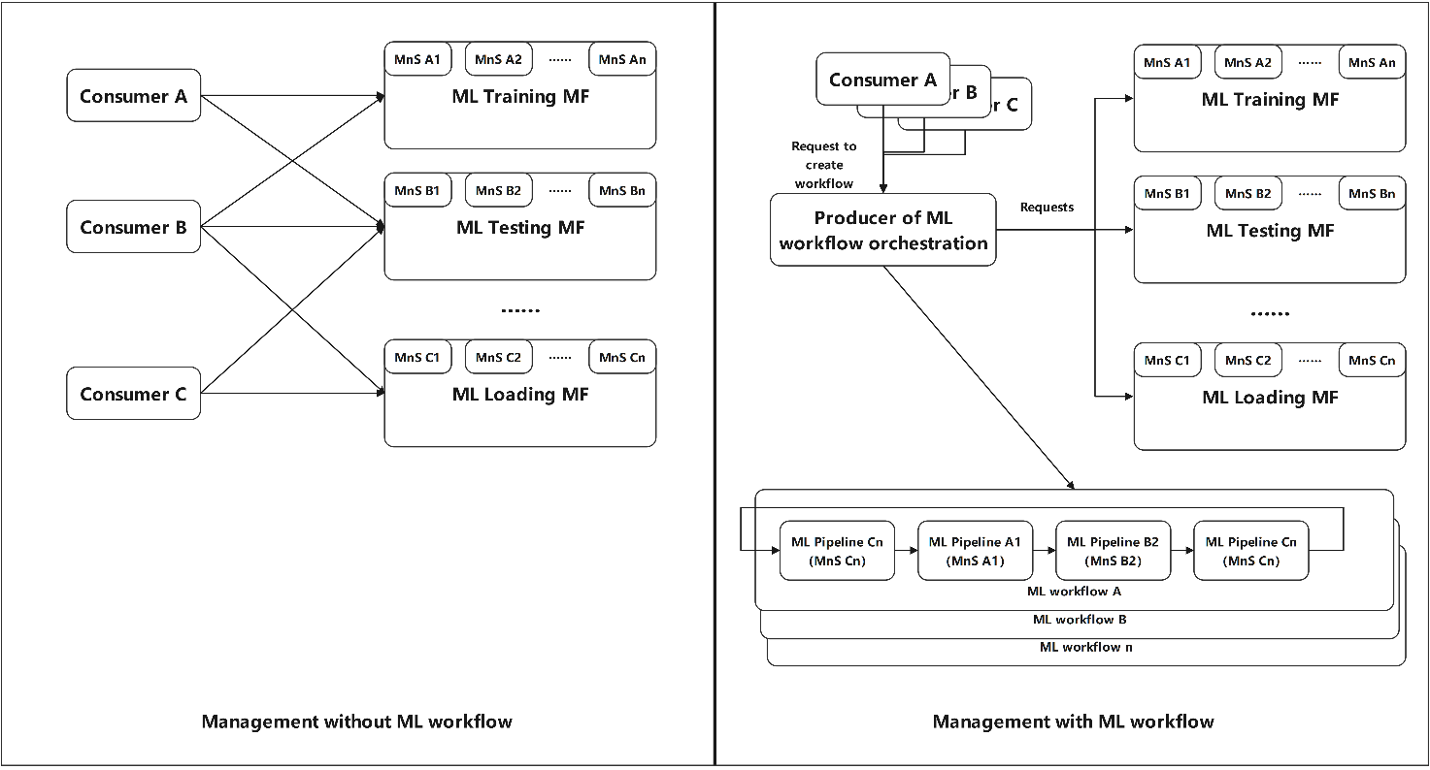
Figure 5.A.1.1-1: Utilization of an ML workflow to manage ML model lifecycle

5.A.1.2 Use cases

5.A.1.2.2 Management of an ML workflow
An ML workflow could be a logic management entity containing a group of ML pipelines. The ML pipelines represent MnSs with specific sequence, e.g., a workflow contains the pipelines of ML pre-specialized training, ML testing, ML fine-tuning, ML testing, Reinforcement learning, ML testing.
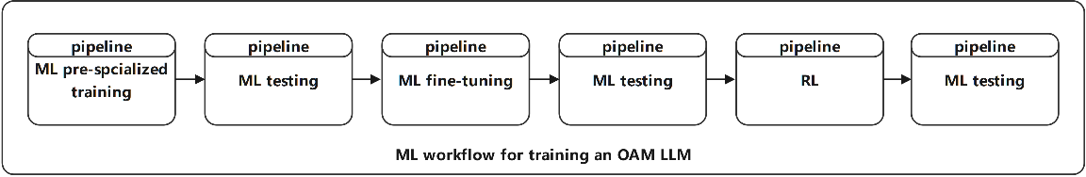
Figure 5.A.1.1-1: Example of an ML workflow for training an OAM LLM
The advantage of an ML workflow is its reusability, reduction of request, and the operator will have an overall insight when there is a large amount of ML models being trained, operating and updating. For example, the consumer creates a coverage optimization task for a specific subnetwork ML model and wish to continuously ensure the stable iteration of ML model lifecycle, e.g., the LLM is used for network fault root-cause analysis and intelligent recovery. There perhaps are updating workflow, monitoring workflow or data collection workflow.
The consumer should have the capability to create, update, and delete ML workflow and configure the ML pipeline as the ML workflow component. The consumer may also wish to store some typical ML workflows for further reuse.

Besides, the consumer may want to control pipeline behaviors on how the policies for ML workflow should obey. For example, the consumer may want the ML pipeline returns an empty item even if the pipeline returns no data during execution. The consumer may also want the ML pipeline executes only once, with data from the first item it receives. The consumer may also want to set the policy rules when an execution fails or on error.

5.A.X.4 Potential requirements
REQ- AIML _WORKFLOW-1: The MnS producer of management of ML workflow should have a capability to enable an authorized MnS consumer to create, store, update, and delete an ML workflow.

REQ-AIML_WORKFLOW-2: The MnS producer of management of ML workflow should have a capability to configure enable an authorized MnS consumer to create, associate, configure and delete an ML pipeline within the a specific workflow.

REQ-AIML_WORKFLOW-3: The MnS producer of management of ML workflow should have the capability to execute the ML workflow based on trigger policy configured by the MnS consumer.

5.A.X.5 Possible solutions

* * * End of Changes * * * *

