3GPP TSG-SA5 Meeting #163 S5-254634
Wuhan, China, 13 - 17 October 2025

Source: Rakuten Mobile, Inc.
Title: Pseudo-CR on TR 28.869 NRM updates for NF Deployment LCM
Document for: Approval
Agenda item: 6.19.6
Spec: 3GPP TR 28.869
Version: 1.6.0
Work Item: FS_Cloud_OAM

Comments
This contribution proposes some NRM attributes for LCM of NF Deployment.

Proposed Changes
* * * First Change * * * *

5.2.1.3 Potential solutions
Introduce a generic orchestration and management entity that interacts with 3GPP management system for LCM of NF Deployment instance via the new deployment management reference point.
The figure 5.2.1.3-1 below illustrates the interaction between 3GPP management system and orchestration and management entity in simplified view:
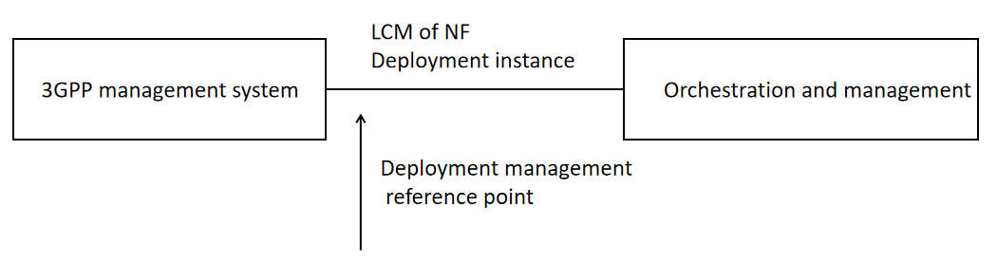
Figure 5.2.1.3-1: Lifecycle management of NF Deployment instance
The deployment management reference point includes the interfaces that 3GPP supports today with ETSI NFV MANO but not limited to it, e.g. Kubernetes based API. For the case of NFV-MANO the deployment management reference point includes the exchange of information over the interfaces that 3GPP supports with ETSI NFV-MANO (ETSI GS NFV-IFA 013 [8] and ETSI GS NFV-IFA 008 [9]).
Within the 3GPP Management system, a Provisioning MnS consumer interacts with a Provisioning MnS producer to pass NRM attributes. Within the scope of the current study, a new element named as NFDeploymentParametersList can be added to ManagedFunction IOC (currently defined in clause 4.3.4.2 of TS 28.662) to manage LCM of NF Deployment(s). This new attribute can be included if the ManagedFunction instance is realized by one or more NF Deployment instance(s). Otherwise, this attribute shall be absent. The updated ManagedFunction IOC can be seen below:
Attribute Name | S | isReadable | isWritable | isInvariant | isNotifyable
vnfParametersList | CM | T | T | F | T
peeParametersList | CM | T | T | F | T
priorityLabel | O | T | T | F | T
supportedPerfMetricGroups | O | T | F | F | T
supportedTraceMetrics | O | T | F | F | T
nfDeploymentParametersList | CM | T | T | F | T

NOTE: The relationship between VNF and NF Deployment needs to be studied. Hence, the relationship between vnfParametersList and nfDeploymentParametersList needs to be further studied as well.
The nfDeploymentParametersList attribute can be further described in clause 4.4.1 of TS 28.662 as below:
nfDeploymentParametersList | This attribute contains the parameter set of the NF Deployment instance(s) corresponding to an NF Deployment. Each entry in the list contains:  - nfDeploymentInstanceId: NF Deployment instance identifier corresponds to the software instance running in the cloud. This may be managed by industry standards such as a future evolution of ETSI NFV or other industry solutions.  - nfDeploymentDescId (optional): Identifier of the descriptor which is a deployment template that describes a NF Deployment in terms of its deployment and operational requirements.  - nfDeploymentFlavourId (optional): Identifier corresponding to the size of the deployment. This refers to the supported flavours in the NF Deployment descriptor. | type: String  multiplicity: *  isOrdered: False  isUnique: True  defaultValue: None  isNullable: False

* * * End of Changes * * * *

