3GPP TSG-SA5 Meeting #162 S5-254036d5
Goteborg, Sweden, 25 - 29 August 2025

Source: Ericsson
Title: Pseudo-CR on TR 28.881 Add issue, requirements and potential solution for intent traceability
Document for: Approval
Agenda item: 6.20.1
Spec: 3GPP TR 28.881
Version: V0.0.0
Work Item: FS_IDMS_MN_Ph4

Comments
An intent consumer (owner) submits an intent to a single intent management function. In some cases, in order to fulfil the intent an intent handling function may need to further submit intent(s) to other intent handling functions for fulfilment. Such handling can occur multiple times across intent handling functions across multiple management and/or domain layers.
For example, TS 28.312 clause 4.2.3 shows an intent MnS producer in communication services layer may submit an intent towards an Intent MnS producer in the communication services provider (CSP) layer. To fulfil the original intent the CSP producer creates additional intents which are then submitted to intent handling functions in the network operator (NOP) and network equipment provider (NEP) domains.
There is currently no specified method to identify that such handling has occurred and is an impediment to traceability of the intent fulfilment. This submission proposes a method to enhance the IDMS intent model to contain such information.
This contribution proposes toadd a new issue for intent traceability.
This pCR is related to WT-7.

4 Detailed proposal
1st Change

4.X Use Case#X: Intent traceability

4.X.1 Description
An intent consumer (owner) submits an intent to a single intent handling function. In some cases, in order to fulfil the intent an intent handling function may need to submit additional intent(s) to other intent handling functions. Such handling can occur multiple times across intent handling functions across multiple management and/or domain layers.
An operator/administrator needs visibility of the relationships between intents which have been created by the system. Since these are being created within/by the management systems (and not explicit consumers the operator may implement) it’s important to know where they came from to allow ‘trace-back’ to the original consumer intent which started the cascade of subsequent intents. There is however no identified method, standardized or otherwise, which allows for such traceability.
Since intents can result in new intent(s) to multiple intent handling functions, likely with different implementations, it is insufficient to rely on external mechanisms such as logging or local network management audit tools to trace the intent. The information identifying each intent handling function which has handled the intent must be preserved along with the intent itself and accessible/meaningful within the content of each intent handling function.
The following figure provides an overview of such information and its handling:

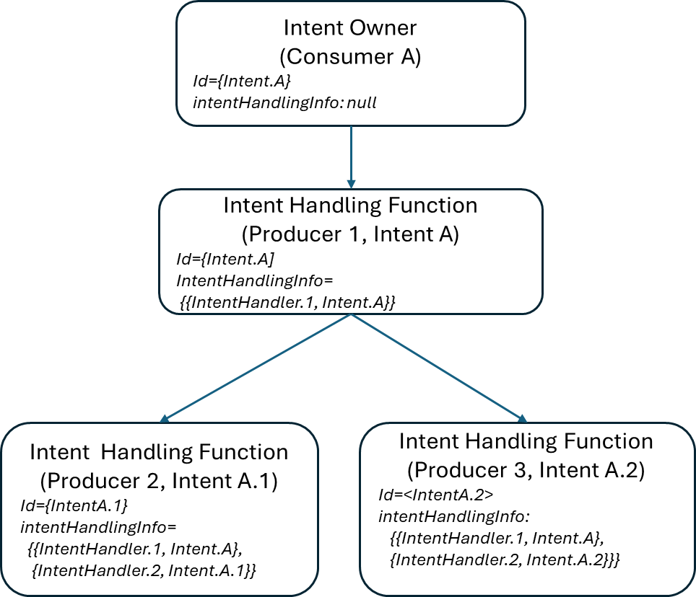
Figure 5.X.1-1: Intent traceability information handling

4.X.2 Potential requirements
REQ-Intent_Trace-1: The intent driven MnS producer should provide information in the intent to identify that an intent has been handled by a particular intent handling function.
REQ-Intent_Trace-2: The intent driven MnS producer should provide information (as defined in REQ-Intent_Trace_1) to identify any subsequent intents created by it as part of fulfilment.
REQ-Intent_Trace-3: The intent driven MnS producer should provide information (as defined in REQ-Intent_Trace_1) identifying the intent handling functions to subsequent intent(s) to allow traceability of the intent across multiple intent handling functions.
REQ-Intent_Trace-34: The intent driven MnS producer should provide a capability allowing

End of changes

