3GPP TSG-SA5 Meeting #162 S5-254036d2
Goteborg, Sweden, 25 - 29 August 2025

Source: Ericsson
Title: Pseudo-CR on TR 28.881 Add issue, requirements and potential solution for intent traceability
Document for: Approval
Agenda item: 6.20.1
Spec: 3GPP TR 28.881
Version: V0.0.0
Work Item: FS_IDMS_MN_Ph4

Comments
An intent consumer (owner) submits an intent to a single intent management function. In some cases, in order to fulfil the intent an intent handling function may need to further submit intent(s) to other intent handling functions for fulfilment. Such handling can occur multiple times across intent handling functions across multiple management and/or domain layers.
For example, TS 28.312 clause 4.2.3 shows an intent MnS producer in communication services layer may submit an intent towards an Intent MnS producer in the communication services provider (CSP) layer. To fulfil the original intent the CSP producer creates additional intents which are then submitted to intent handling functions in the network operator (NOP) and network equipment provider (NEP) domains.
There is currently no specified method to identify that such handling has occurred and is an impediment to traceability of the intent fulfilment. This submission proposes a method to enhance the IDMS intent model to contain such information.
This contribution proposes toadd a new issue for intent traceability.
This pCR is related to WT-7.

4 Detailed proposal
1st Change

4.X Issue#X: Intent traceability

4.X.1 Description
An intent consumer (owner) submits an intent to a single intent handling function. In some cases, in order to fulfil the intent an intent handling function may need to submit additional intent(s) to other intent handling functions. Such handling can occur multiple times across intent handling functions across multiple management and/or domain layers.
There is however no identified method, standardized or otherwise, which allows for traceability as an intent is propagated to various intent handling functions.
Since intents can be propagated to multiple intent handling functions, likely with different implementations, it is insufficient to rely on external mechanisms such as logging or local network management audit tools to trace the intent. The information identifying each intent handling function which has handled the intent must be propagated along with the intent itself and accessible/meaningful within the content of each intent handling function.
The following figure provides an overview of such information and its handling:
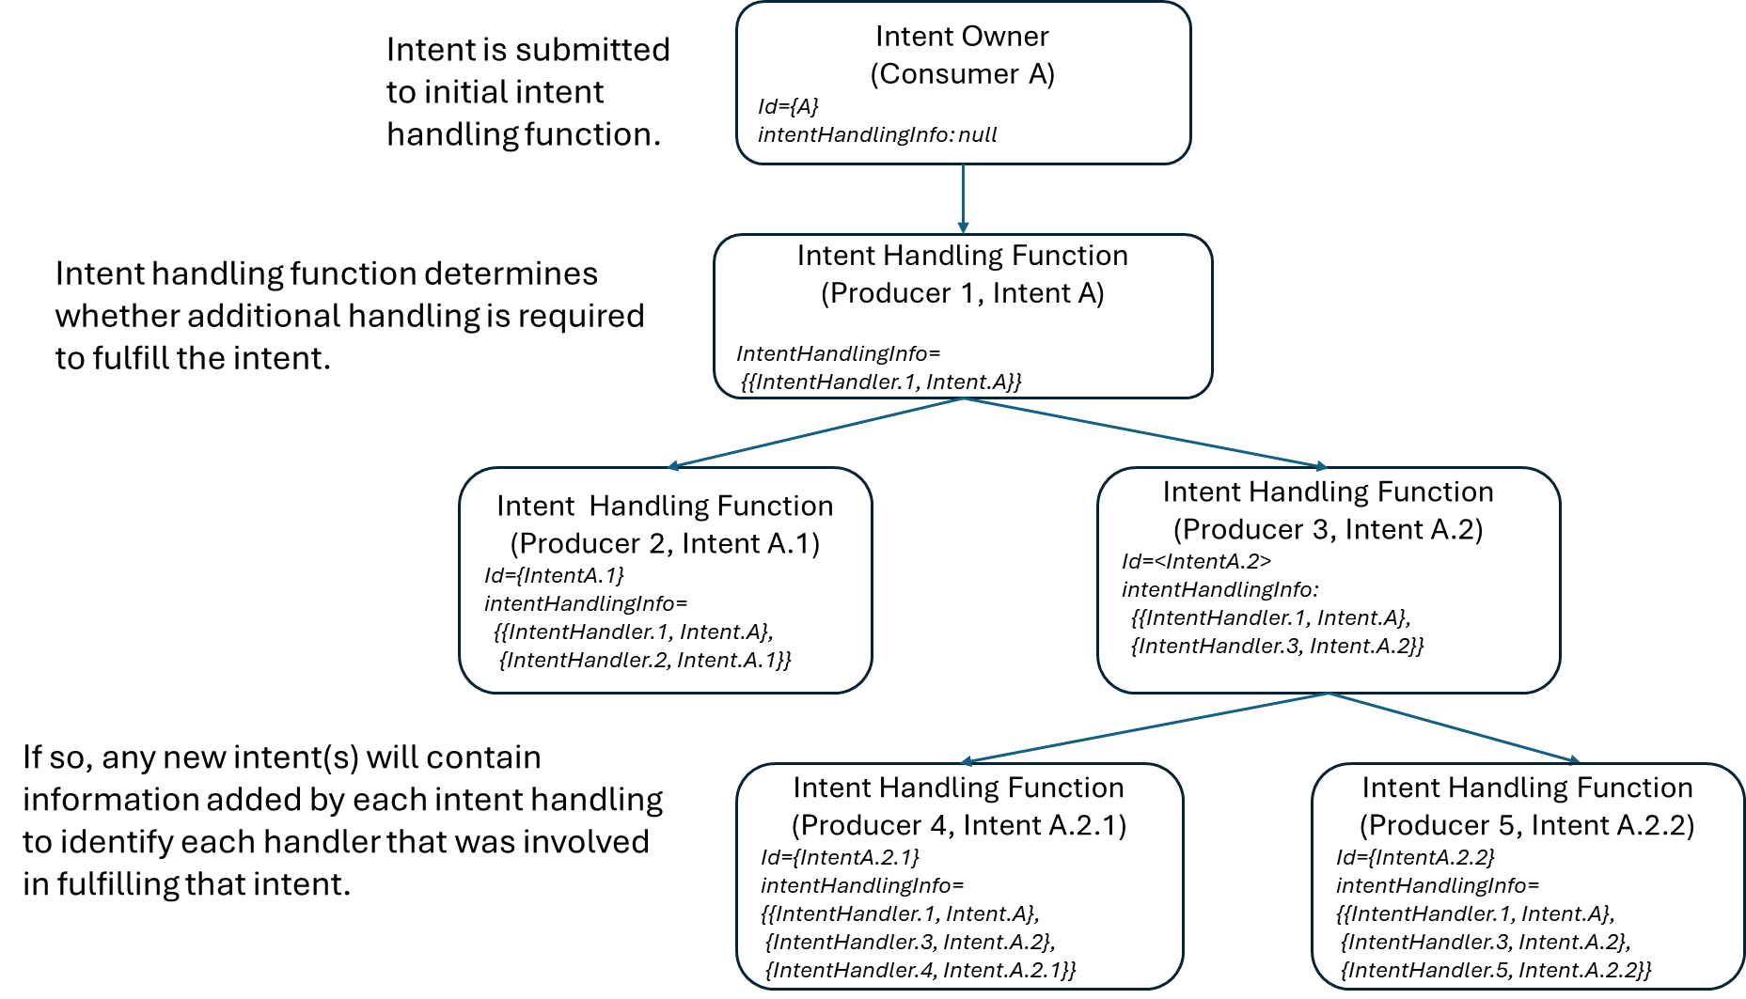
Figure 5.X.1-1: Intent traceability information handling

4.X.2 Potential requirements
REQ-Intent_Trace-1: The intent driven MnS producer should provide information in the intent to identify that an intent has been handled by a particular intent handling function.
REQ-Intent_Trace-2: The intent driven MnS producer should provide information (as defined in REQ-Intent_Trace_1) to identify any subsequent intents created by it as part of fulfilment.
REQ-Intent_Trace-3: The intent driven MnS producer should propagate information (as defined in REQ-Intent_Trace_1) identifying the intent handling functions to subsequent intent(s) to allow traceability of the intent across multiple intent handling functions.

4.X.3 Potential solutions

4.X.3.1 Potential solution #1
This solution proposes adding a new read-only attribute in Intent IOC (new datatype) which MnS producer uses to provide information to trace the handling of an intent across multiple intent handling functions. The MnS producer provides this information and propagates it as new intent(s) are created as part of fulfilment.
The attribute would provide:
- the identity of each intent handling function which handled the intent
- the identity of each intent resulting from the handling
The handling of the information would be:
- upon receipt of a new intent, the MnS producer indicates it handled the intent by adding its identity to the attribute
- in cases where the MnS producer creates new intent(s), it propagates the information from the source intent to the new intent(s)
When no further handling is required, no further update is made to the information.

4.X.4 Evaluation of potential solutions
Solution 1 is a simple, technology agnostic and flexible method to provide traceability for an intent.

End of changes

