**3GPP TSG-SA5 Meeting #162 *S5-254016d4***

Goteborg, Sweden, 25- 29 Aug 2025

**Source: Rakuten Mobile, Inc.**

**Title: Pseudo-CR on pCR TR 28.869 Updates to declarative descriptor-based LCM**

**Document for: Approval**

**Agenda item: 6.19.6**

**Spec: 3GPP TR 28.869**

**Version: 1.5.1**

**Work Item: FS_Cloud_OAM/Study on Cloud Aspects of Management and Orchestration**

**Comments**

This change adds options to support Kubernetes-based solutions in the lifecycle of NF Deployment instances.

**Proposed Changes**

* * * First Change * * * *

##### 5.2.3.3.2 Use of deployment management reference point based on declarative descriptor

In this solution the 3GPP management system interacts with an orchestration and management system using the deployment management reference point as described in clause 5.2.1.3 for creation of a NF Deployment instance. The deployment requirements for creating NF Deployment instance(s) are conveyed from the 3GPP management system to the orchestration and management system via a declarative descriptor.

Figure 5.2.3.3.2-1 depicts a high-level view of proposed procedure for creation of a NF Deployment instance based on declarative descriptor.

Figure 5.2.3.3.2-1: Interaction between 3GPP management system and orchestration and management system using deployment management reference point based on declarative descriptor

The declarative descriptor provides a declaration in high-level on what to be achieved by the orchestration and management system rather than how to achieve it.

If the orchestration and management system is ETSI NFV MANO, the interactions over deployment management reference point are as specified in clause 7.10 of 28.531 [7]. For the case of NFV-MANO, the declarative descriptor is VNFD,as per ETSI NFV specifications (see ETSI GS NFV-IFA 011 [22]). If another orchestration and management system is considered, updates are needed in TS 28.531 [7] and possibly other specifications to describe the interactions over the deployment management reference point and to define the declarative descriptor.

NOTE: In case the orchestration and management system is ETSI NFV MANO, VNFD is defined to convey the deployment requirement information. The ETSI GS NFV-IFA 007 [19] defines the Instantiate VNF interface for NF Deployment creation use case. For other industry solutions, currently there is no standardized descriptor.

* * * Next Change * * * *

##### 5.2.4.3.Y Use of deployment management reference point based on declarative descriptor

In the cloud industry, declarative descriptors are used for life cycle management of NF Deployments. The below section provides one example of using declarative descriptor for modification of NF Deployment instance(s).

In this solution, the 3GPP management system interacts with an orchestration and management system using the deployment management reference point as described in clause 5.2.1.3 for modification of NF Deployment instance(s). The deployment requirements for modifying NF Deployment instance(s) are conveyed from the 3GPP management system to the orchestration and management system via an updated version of the declarative descriptor that was used for creation of the NF Deployment instance.

Figure 5.2.4.3.Y-1 depicts a high-level view of proposed procedure for modification of a NF Deployment instance based on declarative descriptor.

Figure 5.2.4.3.Y-1: Interaction between 3GPP management system and orchestration and management system using deployment management reference point based on declarative descriptor

For the case of NFV-MANO, the declarative descriptor is an updated VNFD as per ETSI NFV specifications (see ETSI GS NFV-IFA 011 [22]).

NOTE: In case the orchestration and management system is ETSI NFV MANO, an updated VNFD can be used to convey the modified deployment requirement information. The ETSI GS NFV-IFA 007 [19] defines the interface (Change VNF package operation) for the VNF lifecycle management operations. For other industry solutions, currently there is no standardized descriptor.

* * * Next Change * * * *

##### 5.2.5.3.Z Use of deployment management reference point based on declarative descriptor

In the cloud industry, declarative descriptors are used for life cycle management of NF Deployments. The below section provides one example of using declarative descriptor for termination of NF Deployment instance(s).

In this solution, the 3GPP management system interacts with an orchestration and management system using the deployment management reference point as described in clause 5.2.1.3 for termination of NF Deployment instance(s).

Figure 5.2.5.3.Z-1 depicts a high-level view of proposed procedure for termination of a NF Deployment instance based on declarative descriptor.

Figure 5.2.5.3.Z-1: Interaction between 3GPP management system and orchestration and management system using deployment management reference point based on declarative descriptor

For the case of NFV-MANO, if VNFD was used to instantiate a NF Deployment instance, it can be terminated using the ‘Terminate VNF’ operation as defined in ETSI GS NFV-IFA 007 [19].

The other option is to delete the same declarative descriptor used during the creation of NF Deployment(s) over the deployment management reference point.

* * * Next Change * * * *

#### 5.2.6.3 Potential solutions

##### 5.2.6.3.1 Use of deployment management reference point

In the proposed solution, the 3GPP management system interacts with the orchestration and management entity to request the horizontal scaling of a specific NF Deployment instance.

To request the horizontal scaling of a specific NF Deployment instance, the 3GPP management system interact with the orchestration and management entity to request the horizontal scaling of specific NF Deployment instance. For the horizontal scaling request, the 3GPP management system can specify, for example, the component instances of the NF Deployment instance(s) or NF Deployment instance(s) to be scaled and the maximum number of scaled instances.

For the configuration of the scaling information for the orchestration and management entity to automatically trigger the horizontal scaling of the NF Deployment instance, the 3GPP management system can specify the scaling information. The scaling information can specify for example: the targeted NF Deployment instance, the activation/de-activation of autoscaling, the horizontal scaling triggering metrics or conditions (e.g. CPU usage level, memory usage level, and any other custom metrics), the minimum and maximum number of horizontally scaled instances, the cool-down period (i.e. waiting time before further horizontally scaling the NF Deployment instance) and the sync period (i.e. how often to check the defined triggering metrics).

These high-level interactions are shown in Figure 5.2.6.3.1-1.

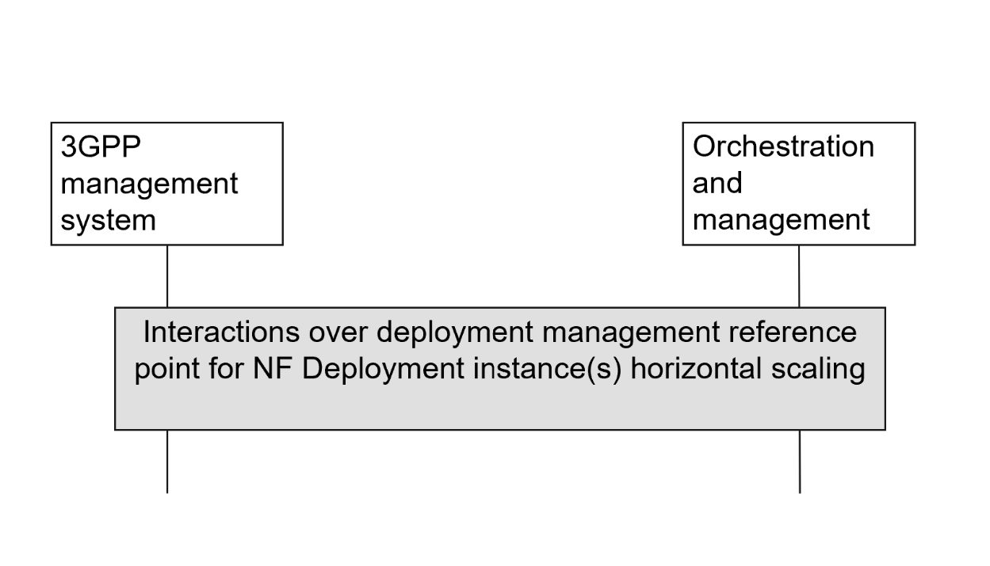

Figure 5.2.6.3.1-1: High-level interactions between the 3GPP management system and the orchestration and management entity to scale NF Deployment instance(s)

If the orchestration and management entity is ETSI NFV MANO, the interactions over deployment management reference point are as specified in clause 7.11 of 28.531 [7]. If another orchestration and management entity is considered, updates are needed in TS 28.531 [7] and possibly other specifications to describe the interactions over the deployment management reference point.

##### 5.2.6.3.2 Use of deployment management reference point based on declarative descriptor

In the cloud industry, declarative descriptors are used for life cycle management of NF Deployments. The below section provides one example of using declarative descriptor for scaling of NF Deployment instance(s).

In this solution, the 3GPP management system interacts with an orchestration and management system using the deployment management reference point as described in clause 5.2.1.3 for scaling of NF Deployment instance(s). The deployment requirements for scaling NF Deployment instance(s) are conveyed from the 3GPP management system to the orchestration and management system via an updated version of the declarative descriptor that was used for creation of the NF Deployment instance.

Figure 5.2.6.3.2-1 depicts a high-level view of proposed procedure for scaling of a NF Deployment instance based on declarative descriptor.

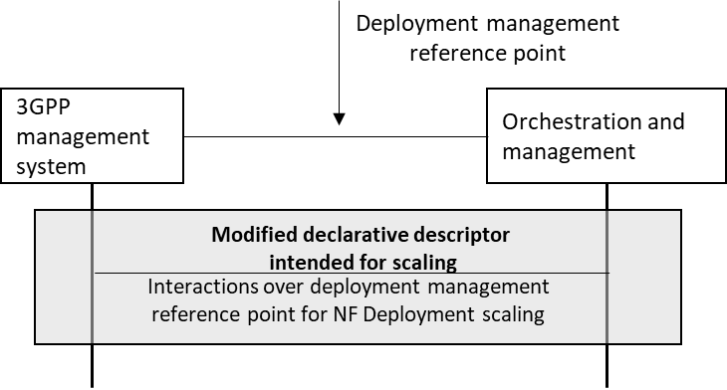

Figure 5.2.6.3.2-1: Interaction between 3GPP management system and orchestration and management system using deployment management reference point based on declarative descriptor

For the case of NFV-MANO, the declarative descriptor is an updated VNFD as per ETSI NFV specifications (see ETSI GS NFV-IFA 011 [22]).

NOTE: In case the orchestration and management system is ETSI NFV MANO, an updated VNFD can be used to convey the scaled deployment requirement information. The ETSI GS NFV-IFA 007 [19] defines the interface (Scale VNF or Scale VNF to Level operation) for the VNF lifecycle management operations. For other industry solutions, currently there is no standardized descriptor.

* * * End of Changes * * * *