**3GPP TSG-SA5 Meeting #162 *S5-254016d1***

Goteborg, Sweden, 25- 29 Aug 2025

**Source: Rakuten Mobile, Inc.**

**Title: Pseudo-CR on pCR TR 28.869 Updates to declarative descriptor-based LCM**

**Document for: Approval**

**Agenda item: 6.19.6**

**Spec: 3GPP TR 28.869**

**Version: 1.5.1**

**Work Item: FS_Cloud_OAM/Study on Cloud Aspects of Management and Orchestration**

**Comments**

This change adds options to support Kubernetes-based solutions in the lifecycle of NF Deployment instances.

**Proposed Changes**

* * * First Change * * * *

# 2 References

The following documents contain provisions which, through reference in this text, constitute provisions of the present document.

- References are either specific (identified by date of publication, edition number, version number, etc.) or non‑specific.

- For a specific reference, subsequent revisions do not apply.

- For a non-specific reference, the latest version applies. In the case of a reference to a 3GPP document (including a GSM document), a non-specific reference implicitly refers to the latest version of that document *in the same Release as the present document*.

[1] 3GPP TR 21.905: "Technical Specification Group Services and System Aspects; Vocabulary for 3GPP Specifications".

[2] ETSI GS NFV-IFA 049: "Network Functions Virtualisation (NFV) Release 5; Architectural Framework; VNF generic OAM functions and other Paas Services specification".

[3] ETSI GR NFV-EVE 019: "Network Functions Virtualisation (NFV);Architectural Framework; Report on VNF generic OAM functions".

[4] 3GPP TR 28.834: "Technical Specification Group Services and System Aspects; Study on management of cloud-native Virtualized Network Functions (VNF)".

[5] SP-230764 New WID on Management of cloud-native Virtualized Network Functions.

[6] 3GPP TS 28.526: "Technical Specification Group Services and System Aspects; Telecommunication management; Life Cycle Management (LCM) for mobile networks that include virtualized network functions; Procedures".

[7] 3GPP TS 28.531: "Technical Specification Group Services and System Aspects; Management and orchestration; Provisioning".

[8] ETSI GS NFV-IFA 013 (V4.5.1) (2023-09): "Network Function Virtualisation (NFV); Release 4; Management and Orchestration; Os-Ma-nfvo reference point - Interface and Information Model Specification".

[9] ETSI GS NFV-IFA 008 (V4.3.1) (2022-05): "Network Function Virtualisation (NFV); Release 4; Management and Orchestration; Ve-Vnfm reference point - Interface and Information Model Specification".

[10] 3GPP TS 28.532: "Technical Specification Group Services and System Aspects; Management and orchestration; Generic management services".

[11] ETSI GR NFV 003 (V1.8.6): "Network Functions Virtualisation (NFV); Terminology for Main Concepts in NFV".

[12] 3GPP TS 28.555: "Technical Specification Group Services and System Aspects; Management and orchestration; Network policy management for 5G mobile networks; Stage 1".

[13] ETSI GR NFV-IFA 023 (V3.1.1): "Network Functions Virtualisation (NFV); Management and Orchestration; Report on Policy Management in MANO; Release 3".

[14] 3GPP TS 28.552: "Technical Specification Group Services and System Aspects; Management and orchestration; 5G performance measurements".

[15] 3GPP TS 28.554: "Technical Specification Group Services and System Aspects; Management and orchestration; 5G end to end Key Performance Indicators (KPIs)".

[16] 3GPP TS 28.533: "Technical Specification Group Services and System Aspects; Management and orchestration; Architecture framework".

[17] 3GPP TS 28.541: "Technical Specification Group Services and System Aspects; Management and orchestration; 5G Network Resource Model (NRM); Stage 2 and stage 3".

[18] ETSI GS NFV 006: "Network Functions Virtualisation (NFV) Release 4; Management and Orchestration; Architectural Framework Specification".

[19] ETSI GS NFV-IFA 007: "Network Functions Virtualisation (NFV) Release 5; Management and Orchestration; Or-Vnfm reference point - Interface and Information Model Specification".

[20] ETSI GS NFV-IFA 008: "Network Functions Virtualisation (NFV) Release 5; Management and Orchestration; Ve-Vnfm reference point - Interface and Information Model Specification".

[21] ETSI GS NFV-IFA 010: "Network Functions Virtualisation (NFV) Release 5; Management and Orchestration; Functional requirements specification".

[22] ETSI GS NFV-IFA 011: "Network Functions Virtualisation (NFV) Release 5; Management and Orchestration; VNF Descriptor and Packaging Specification".

[23] ETSI GS NFV-IFA 013: "Network Functions Virtualisation (NFV) Release 5; Management and Orchestration; Os-Ma-nfvo reference point - Interface and Information Model Specification".

[24] ETSI GS NFV-IFA 014: "Network Functions Virtualisation (NFV) Release 5; Management and Orchestration; Network Service Templates Specification".

[25] ETSI GR NFV-IFA 029: "Network Functions Virtualisation (NFV) Release 3; Architecture;Report on the Enhancements of the NFV architecture towards "Cloud-native" and "PaaS".

[26] ETSI GS NFV-IFA 036: "Network Functions Virtualisation (NFV) Release 5; Management and Orchestration; Requirements for service interfaces and object model for container cluster management and orchestration specification".

[27] ETSI GR NFV-IFA 038: "Network Functions Virtualisation (NFV) Release 4; Architectural Framework; Report on network connectivity for container-based VNF".

[28] ETSI GS NFV-IFA 040: "Network Functions Virtualisation (NFV) Release 5; Management and Orchestration; Requirements for service interfaces and object model for OS container management and orchestration specification".

[29] ETSI GR NFV-IFA 043: "Network Functions Virtualisation (NFV) Release 5; Architectural Framework; Report on enhanced container networking".

[30] ETSI GS NFV-SOL 001: "Network Functions Virtualisation (NFV) Release 5; Protocols and Data Models; NFV descriptors based on TOSCA specification".

[31] ETSI GS NFV-SOL 002: "Network Functions Virtualisation (NFV) Release 5; Protocols and Data Models; RESTful protocols specification for the Ve-Vnfm Reference Point".

[32] ETSI GS NFV-SOL 003: "Network Functions Virtualisation (NFV) Release 5; Protocols and Data Models; RESTful protocols specification for the Or-Vnfm Reference Point".

[33] ETSI GS NFV-SOL 004: "Network Functions Virtualisation (NFV) Release 5; Protocols and Data Models; VNF Package and PNFD Archive specification".

[34] ETSI GS NFV-SOL 005: "Network Functions Virtualisation (NFV) Release 5; Protocols and Data Models; RESTful protocols specification for the Os-Ma-nfvo Reference Point".

[35] ETSI GS NFV-SOL 016: "Network Functions Virtualisation (NFV) Release 4; Protocols and Data Models; NFV-MANO procedures specification".

[36] ETSI GS NFV-SOL 018: "Network Functions Virtualisation (NFV) Release 5; Protocols and Data Models; Profiling specification of protocol and data model solutions for OS Container management and orchestration".

[37] ETSI GS NFV-SOL 020: "Network Functions Virtualisation (NFV) Release 5; Protocols and Data Models Specification of protocols and data models for Container Infrastructure Service Cluster Management".

[38] ETSI GS NFV-IFA 027: "Network Functions Virtualisation (NFV) Release 5; Management and Orchestration; Performance Measurements Specification".

[39] ETSI GR NFV-EVE 021: "Network Functions Virtualisation (NFV) Release 5; Evolution and Ecosystem; Report on energy efficiency aspects for NFV".

[40] ETSI GS NFV-IFA 053: "Network Functions Virtualisation (NFV) Release 5; Management and Orchestration; Requirements and interface specification for Physical Infrastructure Management".

[41] 3GPP TS 23.501: "Technical Specification Group Services and System Aspects;System architecture for the 5G System (5GS); Stage 2".

[42] CNCF Cloud Native Definition v1.1.

NOTE: Available at <https://github.com/cncf/toc/blob/main/DEFINITION.md>.

[43] "The twelve-factor app".

NOTE: Available at <https://12factor.net>.

[44] ETSI GR NFV-EVE 022: "Network Functions Virtualisation (NFV) Release 5; Architectural Framework; Report on VNF configuration".

[45] 3GPP TS 28.622: "Telecommunication management; Generic Network Resource Model (NRM) Integration Reference Point (IRP); Information Service (IS)".

[46] "OpenTelemetry"

NOTE: Available at <https://opentelemetry.io/>.

[47] "Extend the Kubernetes API with CustomResourceDefinitions | Kubernetes".

NOTE: Available at <https://kubernetes.io/docs/tasks/extend-kubernetes/custom-resources/custom-resource-definitions/>.

[48] "Operator Pattern | Kubernetes".

NOTE: Available at <https://kubernetes.io/docs/concepts/extend-kubernetes/operator/>.

[XX] "Custom Resources | Kubernetes".

NOTE: Available at https://kubernetes.io/docs/concepts/extend-kubernetes/api-extension/custom-resources/

* * * Next Change * * * *

##### 5.2.3.3.2 Use of deployment management reference point based on declarative descriptor

In this solution the 3GPP management system interacts with an orchestration and management system using the deployment management reference point as described in clause 5.2.1.3 for creation of a NF Deployment instance. The deployment requirements for creating NF Deployment instance(s) are conveyed from the 3GPP management system to the orchestration and management system via a declarative descriptor.

Figure 5.2.3.3.2-1 depicts a high-level view of proposed procedure for creation of a NF Deployment instance based on declarative descriptor.

Figure 5.2.3.3.2-1: Interaction between 3GPP management system and orchestration and management system using deployment management reference point based on declarative descriptor

The declarative descriptor provides a declaration in high-level on what to be achieved by the orchestration and management system rather than how to achieve it.

If the orchestration and management system is ETSI NFV MANO, the interactions over deployment management reference point are as specified in clause 7.10 of 28.531 [7]. For the case of NFV-MANO, the declarative descriptor is VNFD,as per ETSI NFV specifications (see ETSI GS NFV-IFA 011 [22]). If another orchestration and management system is considered, updates are needed in TS 28.531 [7] and possibly other specifications to describe the interactions over the deployment management reference point and to define the declarative descriptor.

NOTE: In case the orchestration and management system is ETSI NFV MANO, VNFD is defined to convey the deployment requirement information. The ETSI GS NFV-IFA 007 [19] defines the Instantiate VNF interface for NF Deployment creation use case. For other industry solutions, currently there is no standardized descriptor.

* * * Next Change * * * *

##### 5.2.4.3.Y Use of deployment management reference point based on declarative descriptor

In this solution, the 3GPP management system interacts with an orchestration and management system using the deployment management reference point as described in clause 5.2.1.3 for modification of NF Deployment instance(s). The deployment requirements for modifying NF Deployment instance(s) are conveyed from the 3GPP management system to the orchestration and management system via an updated version of the declarative descriptor that was used for creation of the NF Deployment instance.

Figure 5.2.4.3.Y-1 depicts a high-level view of proposed procedure for modification of a NF Deployment instance based on declarative descriptor.

Figure 5.2.4.3.Y-1: Interaction between 3GPP management system and orchestration and management system using deployment management reference point based on declarative descriptor

For the case of NFV-MANO, the declarative descriptor is an updated VNFD as per ETSI NFV specifications (see ETSI GS NFV-IFA 011 [22]).

NOTE: In case the orchestration and management system is ETSI NFV MANO, an updated VNFD can be used to convey the modified deployment requirement information. The ETSI GS NFV-IFA 007 [19] defines the interface (Change VNF package operation) for the VNF lifecycle management operations. For other industry solutions, currently there is no standardized descriptor.

NOTE: Other than ETSI NFV MANO, there are currently no standardized solutions for modification of NF Deployment(s) using declarative descriptor. Other industry solutions, not described in this clause, are also possible.

* * * Next Change * * * *

##### 5.2.5.3.Z Use of deployment management reference point based on declarative descriptor

In this solution, the 3GPP management system interacts with an orchestration and management system using the deployment management reference point as described in clause 5.2.1.3 for termination of NF Deployment instance(s).

Figure 5.2.5.3.Z-1 depicts a high-level view of proposed procedure for termination of a NF Deployment instance based on declarative descriptor.

Figure 5.2.5.3.Z-1: Interaction between 3GPP management system and orchestration and management system using deployment management reference point based on declarative descriptor

For the case of NFV-MANO, if VNFD was used to instantiate a NF Deployment instance, it can be terminated using the ‘Terminate VNF’ operation as defined in ETSI GS NFV-IFA 007 [19].

The other option is to delete the same declarative descriptor used during the creation of NF Deployment(s) over the deployment management reference point.

NOTE: Other than ETSI NFV-MANO, there are currently no standardized solutions for termination of NF Deployment(s) using declarative descriptor. Other industry solutions, not described in this clause, are also possible.

* * * Next Change * * * *

#### 5.2.6.3 Potential solutions

##### 5.2.6.3.1 Use of deployment management reference point

In the proposed solution, the 3GPP management system interacts with the orchestration and management entity to request the horizontal scaling of a specific NF Deployment instance.

To request the horizontal scaling of a specific NF Deployment instance, the 3GPP management system interact with the orchestration and management entity to request the horizontal scaling of specific NF Deployment instance. For the horizontal scaling request, the 3GPP management system can specify, for example, the component instances of the NF Deployment instance(s) or NF Deployment instance(s) to be scaled and the maximum number of scaled instances.

For the configuration of the scaling information for the orchestration and management entity to automatically trigger the horizontal scaling of the NF Deployment instance, the 3GPP management system can specify the scaling information. The scaling information can specify for example: the targeted NF Deployment instance, the activation/de-activation of autoscaling, the horizontal scaling triggering metrics or conditions (e.g. CPU usage level, memory usage level, and any other custom metrics), the minimum and maximum number of horizontally scaled instances, the cool-down period (i.e. waiting time before further horizontally scaling the NF Deployment instance) and the sync period (i.e. how often to check the defined triggering metrics).

These high-level interactions are shown in Figure 5.2.6.3.1-1.

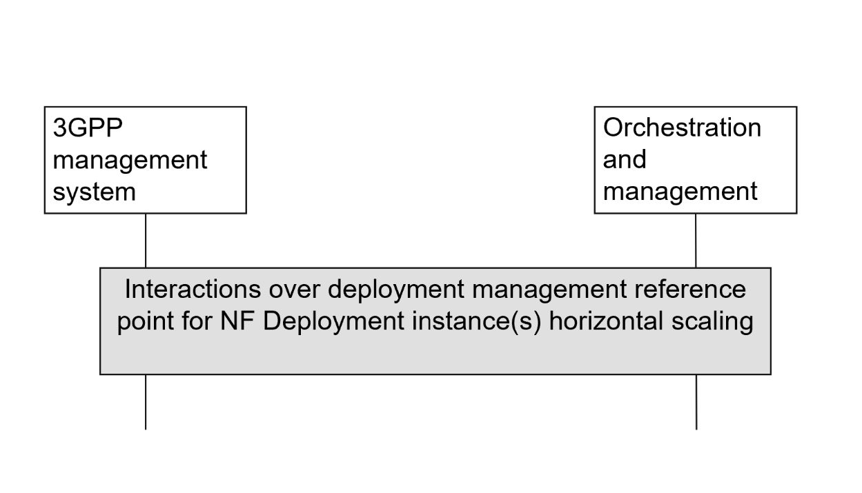

Figure 5.2.6.3.1-1: High-level interactions between the 3GPP management system and the orchestration and management entity to scale NF Deployment instance(s)

If the orchestration and management entity is ETSI NFV MANO, the interactions over deployment management reference point are as specified in clause 7.11 of 28.531 [7]. If another orchestration and management entity is considered, updates are needed in TS 28.531 [7] and possibly other specifications to describe the interactions over the deployment management reference point.

##### 5.2.6.3.2 Use of deployment management reference point based on declarative descriptor

In this solution, the 3GPP management system interacts with an orchestration and management system using the deployment management reference point as described in clause 5.2.1.3 for scaling of NF Deployment instance(s). The deployment requirements for scaling NF Deployment instance(s) are conveyed from the 3GPP management system to the orchestration and management system via an updated version of the declarative descriptor that was used for creation of the NF Deployment instance.

Figure 5.2.6.3.2-1 depicts a high-level view of proposed procedure for scaling of a NF Deployment instance based on declarative descriptor.

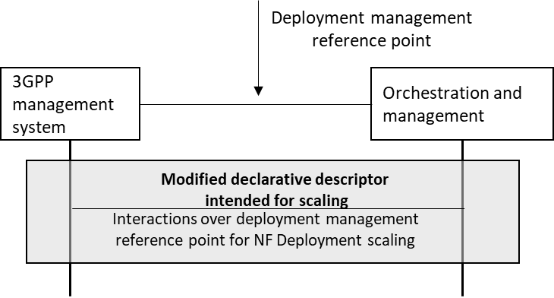

Figure 5.2.6.3.2-1: Interaction between 3GPP management system and orchestration and management system using deployment management reference point based on declarative descriptor

For the case of NFV-MANO, the declarative descriptor is an updated VNFD as per ETSI NFV specifications (see ETSI GS NFV-IFA 011 [22]).

NOTE: In case the orchestration and management system is ETSI NFV MANO, an updated VNFD can be used to convey the scaled deployment requirement information. The ETSI GS NFV-IFA 007 [19] defines the interface (Scale VNF or Scale VNF to Level operation) for the VNF lifecycle management operations. For other industry solutions, currently there is no standardized descriptor.

NOTE: Other than ETSI NFV MANO, there are currently no standardized solutions for scaling of NF Deployment(s) using declarative descriptor. Other industry solutions, not described in this clause, are also possible.

* * * End of Changes * * * *