3GPP TSG-SA5 Meeting #162 S5-253921

Stor-Göteborg, Sweden, 25th Aug 2025 - 29th Aug 2025
CR-Form-v12.3
CHANGE REQUEST
 | 28.310 | CR | 0088 | rev | 1 | Current version: | 19.1.0
For HELP on using this form: comprehensive instructions can be found at
http://www.3gpp.org/Change-Requests.

Proposed change affects: | UICC apps |  | ME |  | Radio Access Network | x | Core Network

Title: | Rel-19 CR TS 28.310 Add solution on Energy saving optimization for multi-carrier RAN scenarios
Source to WG: | Nokia
Source to TSG: | S5
Work item code: | Energy_OAM_Ph3 |  |  |  |  |  | Date: |  |  | 2025-08-11
Category: | B |  |  |  |  |  | Release: |  |  | Rel-19
 | Use one of the following categories:  F (correction)  A (mirror corresponding to a change in an earlier release)  B (addition of feature),  C (functional modification of feature)  D (editorial modification)  Detailed explanations of the above categories can  be found in 3GPP TR 21.900. |  |  |  |  |  |  |  | Use one of the following releases:  Rel-8 (Release 8)  Rel-9 (Release 9)  Rel-10 (Release 10)  Rel-11 (Release 11)  …  Rel-17 (Release 17)  Rel-18 (Release 18)  Rel-19 (Release 19)  Rel-20 (Release 20)
Reason for change: |  | This CR proposes a solution for the use case and requirements on Energy saving optimization for multi-carrier RAN scenarios.
Summary of change: |  | A procedure for energy saving optimization for multi-carrier RAN scenarios is added
Consequences if not approved: |  | There will be no solution for the agreed requirements
Clauses affected: |  | 6.2.2.1.X (New), A.X (New)
 |  | Y | N
Other specs |  |  | x | Other core specifications |  |  |  | TS/TR ... CR ...
affected: |  |  | x | Test specifications |  |  |  | TS/TR ... CR ...
(show related CRs) |  | X |  | O&M Specifications |  |  |  | TS 28.541 CR 1560
Other comments: |  | Stage 2 and Stage 3 updates are proposed in TS 28.541 CR 1560
This CR's revision history: |  | S5-253325 is revised to S5-253921

1st Change

6.2.2.1.X Energy saving optimization for multi-carrier RAN scenarios with several partially or fully overlaid capacity booster cells
Figure 6.2.2.1.X-1 depicts a procedure that describes how MnS producer of ES optimization configures the MnS producer of Centralized ES with characteristics that enable the optimization of energy saving.
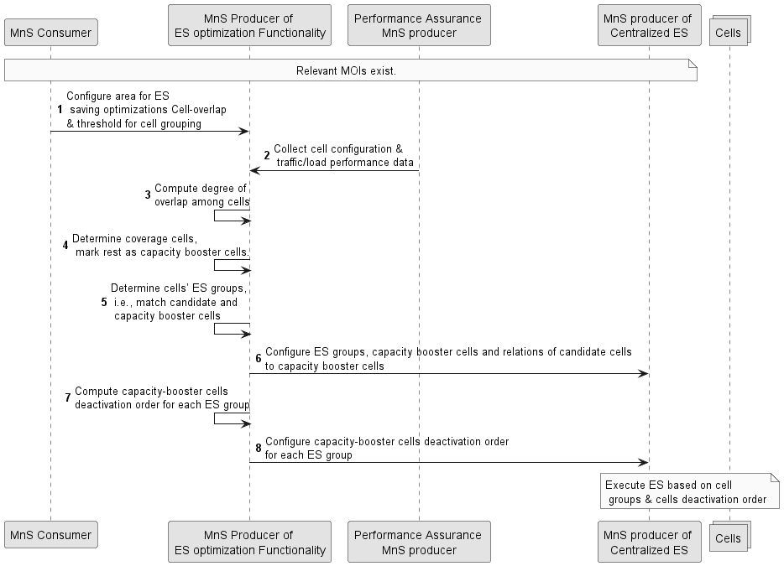

Figure 6.2.2.1.X-1: Energy saving optimization for multi-carrier RAN scenarios
1) The MnS consumer for ES optimization (e.g., the operator) configures the MnS producer for ES optimization with the area for which energy saving optimizations shall be computed. It also configures the threshold for cell-overlap grouping, which is the threshold at which cells that overlap by more than that threshold are considered to be within the same ES group. The degree to which cells overlap is measured in percentage where 0 percent indicates not overlap, while 100 percent indicates complete overlap. The threshod is minimum overlap at which to consider two cells as having adequate overlap to be in the same group.
2) The MnS producer for ES optimization collects the configuration data and traffic load performance measurements from all cells in the configured area from the Data Collection and Reporting MnS producer. The configuration data can include antenna tilts and azimuths, and cell transmit power.
3) The MnS producer for ES optimization computes degree of overlap among cells, which is the degree to which the cells overlap with one another. An example way of computing the overlap is by computing the pathloss for the two cells. Then those locations that have signal strengths above the minimum RSRP (typically approx. -100dBm) are considered to be locations (pixels or geographical bins) where the cells overlap. The degree of overlap is the percentage of pixels where overlap is detected. For example, if the overlap threshold is 80%, then the MnS producer of ES optimization considers the cells which have an overlap greater than or equal to 80% of the total area covered of the cells.
4) The MnS producer for ES optimization determines the coverage cells, i.e., the minimum cells that together provide full coverage for the area. These, which can be computed, for example, based on configured cell information, are marked as coverage cells and the rest marked as capacity booster cells.

5) The MnS producer for ES optimization applies the provided cell-overlap grouping threshold to determine the cells whose degree of overlap is higher than the cell-overlap grouping threshold and so belong to the same ES group. For example, based on the area covered by the cells. The ES group contains at least one coverage cell and atleast two capacity booster cell. The ES group matches area of candidate and capacity booster cells, i.e., the best coverage cells to compensate for the coverage of the respective capacity booster cells.
6) The MnS producer for ES optimization configures Centralized SON ES function with the computed ES group (i.e., the capacity booster cells and the matching of candidate cells to capacity booster cells).
7) The ES group may contain more than one capacity booster cell, so the Centralized SON ES function needs to be configured with the order/sequence in which the capacity booster cells are deactivated (i.e., sequence of entering energy saving state). The MnS producer for ES optimization computes the order of deactivating capacity booster cells for each ES group.
8) The MnS producer for ES optimization configures the Centralized SON ES function with the computed order of deactivating capacity booster cells for each ES group.
9) Centralized SON ES function executes ES based on configured cell groups and capacity booster cells deactivation order.

Next Change

A.X Energy saving optimization for multi-carrier RAN scenarios

@startuml
'title Centralized Energy saving optimization for multi-carrier RAN scenarios
skinparam Shadowing false
autonumber
skinparam monochrome true

participant "MnS Consumer" as ESCons
participant "MnS Producer of \nES optimization Functionality” as ESOpt
participant "Performance Assurance \nMnS producer" as DSource
participant "MnS producer of \nCentralized ES" as ESFun
collections "Cells" as cells

Note over ESCons, ESFun: Relevant MOIs exist.

ESCons -> ESOpt: Configure area for ES\n saving optimizations Cell-overlap \n& threshold for cell grouping

ESOpt <- DSource: Collect cell configuration &\n traffic/load performance data

ESOpt <- ESOpt: Compute degree of \noverlap among cells
ESOpt <- ESOpt: Determine coverage cells,\n mark rest as capacity booster cells.

ESOpt <- ESOpt: Determine cells’ ES groups, \n i.e., match candidate and\n capacity booster cells
ESOpt -> ESFun: Configure ES groups, capacity booster cells and relations of candidate cells \nto capacity booster cells

ESOpt <- ESOpt: Compute capacity-booster cells \ndeactivation order for each ES group
ESOpt -> ESFun: Configure capacity-booster cells deactivation order \nfor each ES group

Note over ESFun, cells: Execute ES based on cell\n groups & cells deactivation order

@enduml

End of change

