3GPP TSG-SA5 Meeting #162 S5-253913
Goteborg, Sweden, 25 - 29 August 2025
CR-Form-v12.3
CHANGE REQUEST
 | 28.531 | CR | 0247 | rev | 1 | Current version: | 19.1.0
For HELP on using this form: comprehensive instructions can be found at
http://www.3gpp.org/Change-Requests.

Proposed change affects: | UICC apps |  | ME |  | Radio Access Network | X | Core Network

Title: | Procedure for IAB-node configuration
Source to WG: | Ericsson
Source to TSG: | SA5
Work item code: | NR_MOBILE_IAB_OAM |  |  |  |  |  | Date: |  |  | 2025-08-15
Category: | B |  |  |  |  |  | Release: |  |  | Rel-19
 | Use one of the following categories:  F (correction)  A (mirror corresponding to a change in an earlier release)  B (addition of feature),  C (functional modification of feature)  D (editorial modification)  Detailed explanations of the above categories can  be found in 3GPP TR 21.900. |  |  |  |  |  |  |  | Use one of the following releases:  Rel-8 (Release 8)  Rel-9 (Release 9)  Rel-10 (Release 10)  Rel-11 (Release 11)  …  Rel-17 (Release 17)  Rel-18 (Release 18)  Rel-19 (Release 19)  Rel-20 (Release 20)
Reason for change: |  | This is nomative work for Rel-19 study on management of IAB nodes.
Summary of change: |  | Add procedure IAB-node configuration.
Consequences if not approved: |  | Miss the procedure for IAB-node configuration.
Clauses affected: |  | 7.x, C.x
 |  | Y | N
Other specs |  |  | X | Other core specifications |  |  |  | TS/TR ... CR ...
affected: |  |  | X | Test specifications |  |  |  | TS/TR ... CR ...
(show related CRs) |  |  | X | O&M Specifications |  |  |  | TS/TR ... CR ...
Other comments:
This CR's revision history:

1st Change

2 References
The following documents contain provisions which, through reference in this text, constitute provisions of the present document.
- References are either specific (identified by date of publication, edition number, version number, etc.) or non-specific.
- For a specific reference, subsequent revisions do not apply.
- For a non-specific reference, the latest version applies. In the case of a reference to a 3GPP document (including a GSM document), a non-specific reference implicitly refers to the latest version of that document in the same Release as the present document.
[1] 3GPP TR 21.905: "Vocabulary for 3GPP Specifications".
[2] 3GPP TS 28.525: "Telecommunication management; Life Cycle Management (LCM) for mobile networks that include virtualized network functions; Requirements".
[3] ETSI GS NFV-IFA 013 (V4.5.1) (2023-09): "Network Function Virtualisation (NFV); Release 4; Management and Orchestration; Os-Ma-nfvo reference point - Interface and Information Model Specification".
[4] 3GPP TS 28.530: "Management and orchestration; Concepts, use cases and requirements".
[5] 3GPP TS 22.261 "Service requirements for next generation new services and markets".
[6] 3GPP TS 28.541: "Management and orchestration; 5G Network Resource Model (NRM); Stage 2 and stage 3".
[7] Void.
[8] 3GPP TS 28.532: "Management and orchestration; Generic management services".
[9] GSMA NG.116 Generic Network Slice Template v9.0 (2023-04-27) - NG.116-v9.0.pdf (gsma.com).
[10] 3GPP TS 23.501: "Technical Specification Group Services and System Aspects;System Architecture for the 5G System;Stage 2".
[11] 3GPP TS 38.300: "Technical Specification Group Radio Access Network;NR; NR and NG-RAN Overall Description;Stage 2".
[12] ETSI GS NFV-IFA 014 (V4.2.1) (2021-05): "Network Function Virtualisation (NFV); Release 4; Management and Orchestration; Network Service Templates Specification".
[13] 3GPP TS 28.622: "Telecommunication management; Generic Network Resource Model (NRM) Integration Reference Point (IRP); Information Service (IS)".
[14] ETSI GS NFV-IFA 011 (V4.3.1) (2022-06): "Network Function Virtualisation (NFV); Release 4; Management and Orchestration; VNF Descriptor and Packaging Specification".
[15] ETSI GS NFV-IFA 008 (V4.3.1) (2022-05): "Network Function Virtualisation (NFV); Release 4; Management and Orchestration; Ve-Vnfm reference point - Interface and Information Model Specification".
[16] 3GPP TS 28.623: "Telecommunication management; Generic Network Resource Model (NRM) Integration Reference Point (IRP); Solution Set (SS) definitions".
[17] 3GPP TS 32.158: "Management and orchestration; Design rules for REpresentational State Transfer (REST) Solution Sets (SS)".
[18] 3GPP TS 38.401: "Technical Specification Group Radio Access Network; NG-RAN; Architecture description".
[x] 3GPP TS 28.315: “Management and orchestration; Plug and Connect; Procedure flows”.

2nd Change

7.x Procedure of IAB-node configuration
The Figure 7.x-1 illustrates the procedure of IAB-node configuration based on its location.
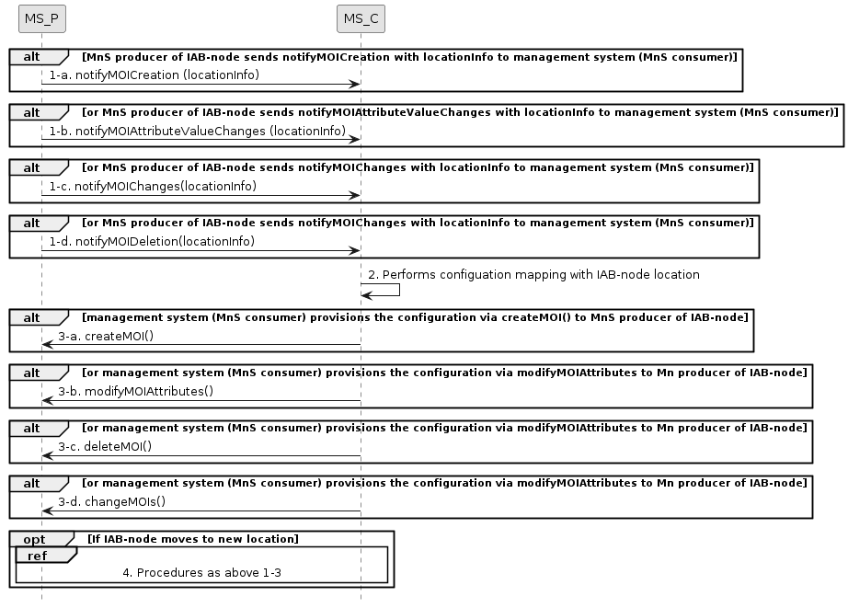
Figure 7.x-1 IAB-node configuration
1) After IAB-node connecting to 3GPP management system via PnC (see TS 28.315 [x] clause 5.6), the provisioning MnS producer of IAB-node sends location information via any of the following notifications:
- notifyMOICreation
- notifyMOIAttributeValueChanges
- notifyMOIChanges
- notifyMOIDeletion
2) The provisioning MnS consumer (management system) perfoms configuration mapping with IAB-node location.
3) The provisioning MnS consumer (management system) provisions IAB-node configuration via any of the following operations upon the reception of notifications:
- createMOI
- modifyMOIAttributes
- deleteMOI
- changeMOIs
4) When IAB-node moves to a new location which may connect to a different management system based on its location (see TS 28.315 [x] clause 5.6), procedures of step 1) to 3) as above are repeated for mobile IAB-node to obtain configuration based on its location.

2nd Change

C.x Procedure of IAB-node configuration

@startuml
skinparam shadowing false
skinparam monochrome true
hide footbox

participant “MS_P” as MnS_Producer
participant "MS_C" as MnS_Consumer
alt MnS producer of IAB-node sends notifyMOICreation with locationInfo to management system (MnS consumer)
MnS_Producer -> MnS_Consumer: 1-a. notifyMOICreation (locationInfo)
End
alt or MnS producer of IAB-node sends notifyMOIAttributeValueChanges with locationInfo to management system (MnS consumer)
MnS_Producer -> MnS_Consumer: 1-b. notifyMOIAttributeValueChanges (locationInfo)
End
alt or MnS producer of IAB-node sends notifyMOIChanges with locationInfo to management system (MnS consumer)
MnS_Producer -> MnS_Consumer: 1-c. notifyMOIChanges(locationInfo)
End
alt or MnS producer of IAB-node sends notifyMOIChanges with locationInfo to management system (MnS consumer)
MnS_Producer -> MnS_Consumer: 1-d. notifyMOIDeletion(locationInfo)
End
MnS_Consumer -> MnS_Consumer: 2. Performs configuation mapping with IAB-node location
alt management system (MnS consumer) provisions the configuration via createMOI() to MnS producer of IAB-node
MnS_Consumer -> MnS_Producer: 3-a. createMOI()
End
alt or management system (MnS consumer) provisions the configuration via modifyMOIAttributes to Mn producer of IAB-node
MnS_Consumer -> MnS_Producer: 3-b. modifyMOIAttributes()
End
alt or management system (MnS consumer) provisions the configuration via modifyMOIAttributes to Mn producer of IAB-node
MnS_Consumer -> MnS_Producer: 3-c. deleteMOI()
End
alt or management system (MnS consumer) provisions the configuration via modifyMOIAttributes to Mn producer of IAB-node
MnS_Consumer -> MnS_Producer: 3-d. changeMOIs()
End
opt If IAB-node moves to new location
ref over MnS_Producer, MnS_Consumer
4. Procedures as above 1-3
end ref
end opt
@enduml

End of change

