3GPP TSG-SA5 Meeting #162 S5-253897
Stor-Göteborg, Sweden, 25th August 2025 - 29th August 2025
CR-Form-v12.3
CHANGE REQUEST
 | 32.422 | CR | 0529 | rev | 1 | Current version: | 19.3.0
For HELP on using this form: comprehensive instructions can be found at
http://www.3gpp.org/Change-Requests.

Proposed change affects: | UICC apps |  | ME |  | Radio Access Network | x | Core Network | X

Title: | Rel-19 CR TS 32.422 Trace Failure Notification
Source to WG: | Ericsson
Source to TSG: | S5
Work item code: | Data_SREP |  |  |  |  |  | Date: |  |  | 2025-08-15
Category: | F |  |  |  |  |  | Release: |  |  | Rel-19
 | Use one of the following categories:  F (correction)  A (mirror corresponding to a change in an earlier release)  B (addition of feature),  C (functional modification of feature)  D (editorial modification)  Detailed explanations of the above categories can  be found in 3GPP TR 21.900. |  |  |  |  |  |  |  | Use one of the following releases:  Rel-8 (Release 8)  Rel-9 (Release 9)  Rel-10 (Release 10)  Rel-11 (Release 11)  …  Rel-17 (Release 17)  Rel-18 (Release 18)  Rel-19 (Release 19)  Rel-20 (Release 20)
Reason for change: |  | As discussed and concluded in TR 28.873, the Trace Failure Notification is currently specified in TS 32.422 for trace-related purposes only.  To ensure consistent failure handling across management use cases, the Trace Failure Notification mechanism should be generalized to cover Trace, MDT, RRC report, and QoE procedures as well.
Summary of change: |  | Enhance the Trace Failure Notification
Consequences if not approved: |  | Impossible to report Failure Notification for Trace, RRC report, and MDT procedures
Clauses affected: |  | 4.1.1.1.2, 4.1.2.1.2, 4.2.1, 4.x (new)
 |  | Y | N
Other specs |  |  | x | Other core specifications |  |  |  | TS/TR ... CR ...
affected: |  |  | x | Test specifications |  |  |  | TS/TR ... CR ...
(show related CRs) |  |  | X | O&M Specifications |  |  |  | TS/TR ... CR ...
Other comments:
This CR's revision history:

*** START OF NEXT CHANGE ***

4.1.1.1.2 General management activation mechanisms for 5GS
In 5GS the management trace activation utilizes the Services Based Management Architecture (SBMA) defined in TS 28.533 [48]. The NE is configured with Trace Control and Configuration parameters via interaction between Provisioning MnS (see definitions in TS 28.532 [47]) consumer and Provisioning MnS producer. Figure 4.1.1.1.2-1 below illustrates the 5GS management activation where the role of a Provisioning MnS producer is played by the NE and the role of a Provisioning MnS consumer is played by the Management System. The configured NE shall not propagate the received Trace Control and Configuration parameters to any other NE's - whether or not it is involved in the actual recording of the call.
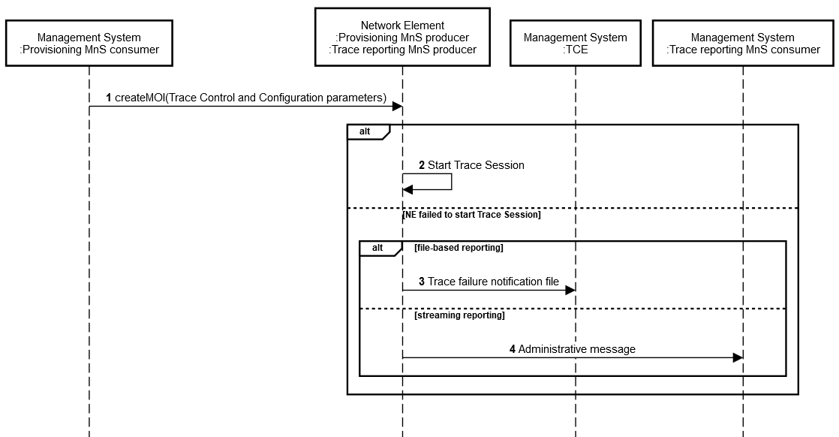
Figure 4.1.1.1.2-1: Overview of management activation for 5GS
Once configured with Trace Control and Configuration parameters, the NE shall activate the Trace Session. If the NE failed to activate the Trace Session in a file-based reporting case, a Trace failure notification shall be sent as specified in section 4.x.
*** START OF NEXT CHANGE ***

4.1.2.1.2 General signalling activation mechanisms for 5GS
In 5GS the signaling trace activation utilizes the Services Based Management Architecture (SBMA) defined in TS 28.533 [48]. A 5GC NE is configured with Trace Control and Configuration parameters via interaction between Provisioning MnS (see definitions in TS 28.532 [47]) consumer and Provisioning MnS producer. Figure 4.1.2.1.2-1 below illustrates the 5GS signaling activation where the role of a Provisioning MnS producer is played by the 5GC NE and the role of a Provisioning MnS consumer is played by the Management System.
In case of home subscriber trace (i.e. in the HPLMN), the Trace Session activation shall go to the 5GC NE which played as the Provisioning MnS producer, such as UDM, AMF and SMF. Instances where the home subscriber is roaming in a VPLMN, the Provisioning MnS producer may initiate a trace in that VPLMN. The VPLMN may reject such requests.
In case of foreign subscriber trace (i.e. the HPLMN operator wishes to trace foreign subscribers roaming in his PLMN), the Trace Session activation shall go to the 5GC NE located in the PLMN operator (i.e. the 5GC NE belongs to VPLMN as described in clause 4.2.4 of TS 23.501 [40], such as AMF/SMF).
Depending on the Trace Control and Configuration parameters received, the configured 5GC NE shall propagate the activation to selected NE's in the entire network – RAN and Core Network.
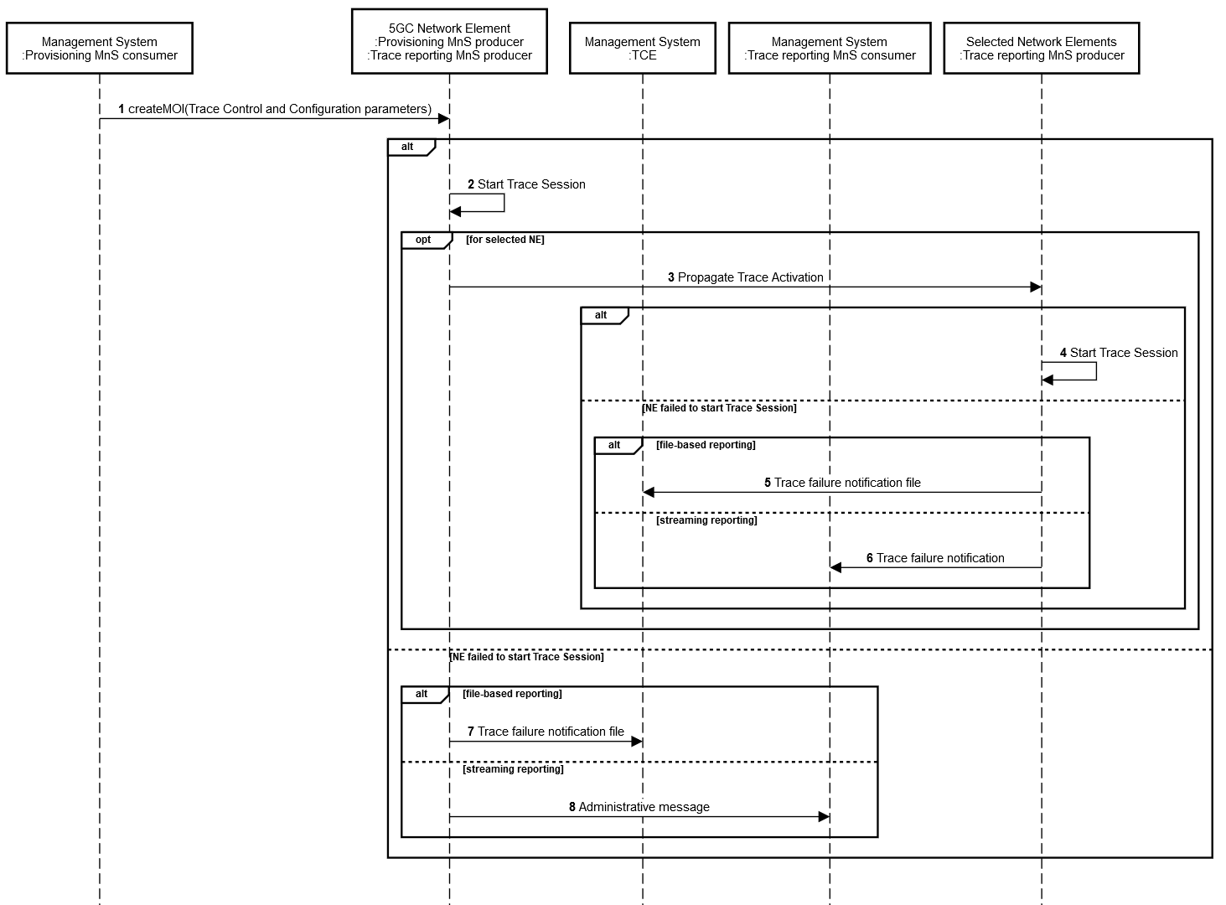
Figure 4.1.2.1.2-1: Overview of signaling activation for 5GS
If the NE failed to activate the Trace Session in a file-based reporting case, a Trace failure notification shall be sent as specified in section 4.x.
*** START OF NEXT CHANGE ***

4.2.1 General
The Trace Session activation contains the triggering events parameter. The actual start/stop triggering events corresponding to the values of the triggering events parameter are defined in triggering events tables in sub-clause 5.1 in the present document.
If a UMTS or EPS NE failed to start the Trace Recording Session, a Trace failure notification file shall be sent to the TCE, and the Trace failure notification has the the same parameters as the notification notifyTraceRecordingSessionFailure defined in 3GPP TS 32.442 [24], the Trace failure notification file XML schema is defined in Annex A.
If a 5GS NE failed to start the Trace Recording Session in a file-based reporting case, a Trace failure notification file shall be sent as specified in section 4.x
*** START OF NEXT CHANGE ***

4.x Trace failure notification
In the event of a failure during Trace Session activation / deactivation (for Trace, MDT, 5GC UE level measurements collection, RCEF reporting, RLF reporting, or RRC reporting) or during Trace Recording Session Start / Stop triggering (for Trace, MDT, or 5GC UE level measurements collection), a MnS producer shall report this failure to the MnS consumer.
In the case of file-based reporting, a Trace failure notification file shall be sent to the TCE. The Trace failure notification file XML schema is defined in Annex A.
In the case of streaming-based reporting, a Trace administrative messages shall be sent to the Trace Reporting MnS consumer. These trace administrative messages are sent as Common Trace Payload of Streaming Trace Record as specified in subclause 5.2.1 of TS 32.423[3]. Trace administrative messages are defined in subclause 5.2.4 of TS 32.423[3]. Additionally, an Alarm may be reported via the Fault Supervision MnS, as defined in TS 28.532 [47].
*** END OF CHANGE ***

