3GPP TSG-SA5 Meeting #162 S5-253889
Goteborg, Sweden, 25 - 29 August 2025
CR-Form-v12.3
CHANGE REQUEST
 | 28.537 | CR | 0044 | rev | 1 | Current version: | 19.2.1
For HELP on using this form: comprehensive instructions can be found at
http://www.3gpp.org/Change-Requests.

Proposed change affects: | UICC apps |  | ME |  | Radio Access Network | x | Core Network | x

Title: | Rel-19 CR TS 28.537 Correction for Deployment Scenario Description
Source to WG: | Nokia
Source to TSG: | SA5
Work item code: | MADCOL_Ph2 |  |  |  |  |  | Date: |  |  | 2025-08-11
Category: | F |  |  |  |  |  | Release: |  |  | Rel-19
 | Use one of the following categories:  F (correction)  A (mirror corresponding to a change in an earlier release)  B (addition of feature),  C (functional modification of feature)  D (editorial modification)  Detailed explanations of the above categories can  be found in 3GPP TR 21.900. |  |  |  |  |  |  |  | Use one of the following releases:  Rel-8 (Release 8)  Rel-9 (Release 9)  Rel-10 (Release 10)  Rel-11 (Release 11)  …  Rel-17 (Release 17)  Rel-18 (Release 18)  Rel-19 (Release 19)  Rel-20 (Release 20)
Reason for change: |  | As per SBMA principle, the MnS Producer and MnS Consumer definition are role based. This CR corrects the depiction of MnS Producer as the cosumer of MnS Registry by using the terms MnS Producer and MnS Consumer for registeration and discovery operations.
Summary of change: |  | Corrects the depiction of MnS Producer as the cosumer of MnS Registry
Consequences if not approved: |  | Incorrect terms used in the document
Clauses affected: |  | 5.3
 |  | Y | N
Other specs |  |  | N | Other core specifications |  |  |  | TS/TR ... CR ...
affected: |  |  | N | Test specifications |  |  |  | TS/TR ... CR ...
(show related CRs) |  |  | N | O&M Specifications |  |  |  | TS/TR ... CR ...
Other comments:
This CR's revision history:

Start of change

3.1 Terms
For the purposes of the present document, the terms given in 3GPP TR 21.905 [1] and the following apply. A term defined in the present document takes precedence over the definition of the same term, if any, in 3GPP TR 21.905 [1].
Trace metrics: This term is defined in TS 32.422 [6].
Discovery MnS Producer: MnS Producer exposing the interface to register with MnS Registry
Discovery MnS Consumer: MnS Consumer for Discovery MnS Producer

Next change

5.3 Usage of MnS Registry for different deployment scenarios
Following are potential deployment scenarios for MnS Registry (i.e. act as discover MnS producer):
- Deployment scenario #1: Separate MnSRegistry. The MnS Registry and a concrete MnS producer are implemented by separate management functions. MnS Registry with associated discovery MnS Producer, provides interfaces to discovery MnS Consumer for discovery operation. In this scenario, the MnS Registry is used to store the MnS information (i.e. MnSInfo) for MnS instances and management capability information for management data (i.e. MgmtDataInfo) provided by different MnFs, especially for different MnFs from different vendors using discovery MnS Producer interface. Following is one example, MnF_1 needs to register MnSInfo_1 and MgmtDataInfo_1 in the MnS Registry (using discovery MnS Producer interface) implemented in MnF=Registry, and MnF_2 needs to discover/retrieve the MnSInfo_1 and MgmtDataInfo_1 from MnF=Registry (using discovery MnS Producer interface) to consume MnS_1 provided by MnF_1. In this scenario, MnS Registry needs to support both registry and discovery/retrieve capabilities which is provided via discovery MnS Producer interface.

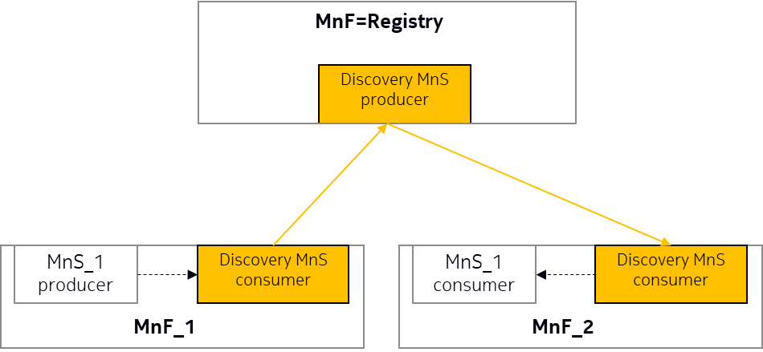
Figure 5.3-1 Example of Separate MnSRegistry deployment scenario
- Deployment scenario #2: Embedded MnSRegistry. The MnsRegistry and a concrete MnS producer are hosted by the same entity with an implementation specific interface between them. The MnS Registry is embedded in an MnF and used to store the MnS Information (i.e. MnSInfo) for MnS instances and management capability information for management data (i.e. MgmtDataInfo) provided by the MnF itself. Following is one example, MnF_2 needs to retrieve/discover MnSInfo_1 and MgmtDataInfo_1 in the MnSRegistry embedded in MnF_1. In this scenario, MnS Registry (using discovery MnS Producer interface) supports discovery/retrieve capabilities only.

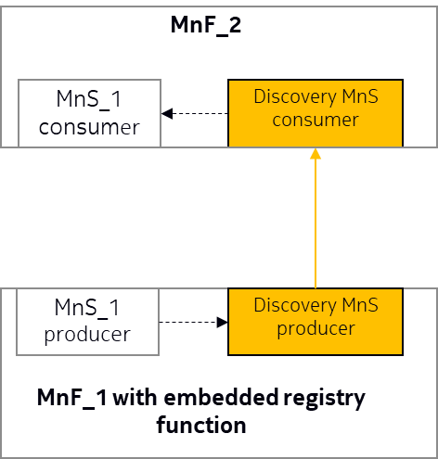
Figure 5.3-2 Example of Embedded MnSRegistry deployment scenario
End of change

