3GPP TSG-SA5 Meeting #162 S5-253879
Goteborg, Sweden, 25 - 29 August 2025

Source: Ericsson Korea Partners Co Ltd
Title: Clarify NDT management service
Document for: Approval
Agenda item: 6.19.5.1
Spec: TS 28.561
Version: 1.0.0
Work Item: NDT

Comments
Description in 4.2 is not correct. MnS consumer cannot request an NDT MnS but request is directed to MnS producer. The management functions that should be able to invoke NDT are not only “network intelligence and automation” MnF, but anyone playing the role of an NDT MnS Consumer (e.g. MDAF, AIML, etc.)
---
Rev1: According to comments received during SA5#162, removed the words “for analysis” from the first sentence added.

Proposed Changes
* * * First Change * * * *

4.2 NDT Management Service
NDT MnS Producer enables an authorized consumer to request the modelling of a network scenario and to receive the output report. The simulation/emulation capabilities provided by the NDT MnS Producer can be invoked by management functions, e.g., MDAF, AIML Inference Function, Intent Handling Function, when playing the role of an NDT MnS Consumer, to support their intelligence and automation functionality.
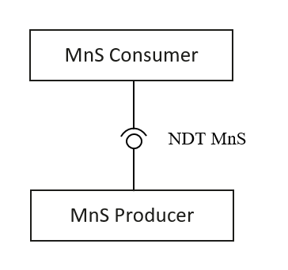
Figure 4.2-1

* * * End of Changes * * * *

