3GPP TSG-SA5 Meeting #162 S5-253849
Goteborg, Sweden, 25 - 29 August 2025

Title: Reply LS on signalling feasibility of dataset and parameter sharing
Response to: R2-2503169/S5-253287
Release: Release 19
Work Item: NR_AIML_air-Core

Source: SA5
To: RAN2
Cc: RAN, SA, RAN1, RAN3, SA2, SA3

Contact person: Shi Xiaoli
shixiaoli@huawei.com

Send any reply LS to: 3GPP Liaisons Coordinator, mailto:3GPPLiaison@etsi.org
Attachments: None
- Overall description
SA5 would like to thank RAN2 for sharing the LS on signaling feasibility of dataset and parameter sharing.
RAN2 discussed the candidate solutions and feasibility of standardized signaling for NW-side sharing dataset/model parameter to UE or UE-side training entity for below options (copy from RAN2’s LS):
- Dataset sharing consisting of {(Target CSI, CSI feedback)}
- Encoder parameter sharing
- Encoder parameter sharing + dataset sharing consisting of {target CSI}
The LS concluded on the following approach for non-OTA transferring of dataset/model parameters.
Alternative 1 (non-OTA approach):
gNB -> NW dataset/model parameters collection entity -> UE training entity (a server inside MNO or an OTT server)
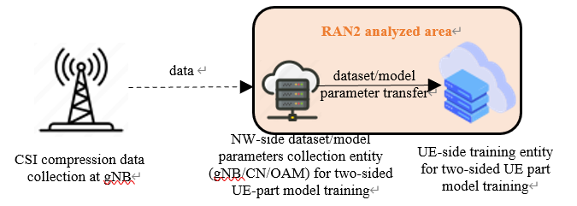
NOTE: The data transfer (up to RAN1 further details on what to transfer) between gNB and NW dataset/model parameters collection entity (OAM/CN) in Alternative 1, if needed, is up to RAN3/SA2/SA5.

The LS asks SA5 to confirm RAN2 assumption on non-OTA candidate solutions described in Table 1.

Table 1. non-OTA candidate solutions
Option | Impacted WG | Specification impact/Implementation impact
OAM -> UE-side training entity (a server inside MNO or an OTT server), where OAM is NW-side dataset/model parameter collection entity | SA5, SA3 | Up to SA5  (any intermediate node between OAM and UE-side OTT server is up to SA5; CN involvement if needed is up to SA2/SA5 discussion)
CN -> UE-side training entity (a server inside MNO or an OTT server), where CN is NW-side dataset/model parameter collection entity | SA2, SA3 | Up to SA2  (any intermediate node between CN and UE-side OTT server is up to SA2)
gNB -> OAM/CN -> UE-side training entity (a server inside MNO or an OTT server), where gNB is NW-side dataset/model parameter collection entity | RAN3, SA2, SA5, SA3 | Up to RAN3, SA2, SA5  (any intermediate node between gNB/OAM, OAM/UE-side OTT server, CN/UE-side OTT server is up to RAN3/SA2/SA5)

SA5 feedback:
SA5 Rel-19 existing data collection architecture supports the data transmission from gNB to OAM using the reporting and collection mechanisms defined in TS 28.622. The data that can be collected and reported correspond to management data (e.g., Trace/MDT data, PM, KPI) as defined in TS 32.422, TS 28.552 and TS 28.554. SA5 confirms that it is feasible for OAM to transfer the NW-side dataset/model parameter to UE-side training entity, as long as:
1) The UE-side training entity becomes an authorized MnS consumer.
2) The NW-side dataset/model parameter (collected from gNB) can fit into the SA5 definition for management data.
For 2), SA5 needs more details on these NW-side dataset/model parameter to evaluate whether dataset/model parameter can fit into the SA5 definition for management data. Based on this evaluation and TSG RAN2 progress, SA5 may need to enhance existing managing management data functionalities described in TS 28.537.

- Actions
To RAN2
ACTION: SA5 kindly asks RAN2 to take the above feedback into account and to confirm if SA5 assumption is correct.
- Dates of next TSG SA WG5 meetings
SA5#163 13 October - 17 October 2025 China
SA5#164 17 November - 21 November 2025 Dallas , US

