**3GPP TSG-SA5 Meeting #162 *S5-253843***

Goteborg, Sweden, 25 - 29 August 2025

**Source: Huawei, CATT**

**Title: Discussion on signalling feasibility of dataset and parameter sharing**

**Document for: Endorsement**

**Agenda Item: 6.19.1.1**

# 1 Decision/action requested

***In this box give a very clear / short /concise statement of what is wanted.***

# 2 References

1. S5-252337 (R2-2500015), Reply LS on signalling feasibility of dataset and parameter sharing
2. RP-251870, New WI: Artificial Intelligence (AI)/Machine Learning (ML) for NR air interface enhancements
3. TS 28.533, Management and orchestration; Architecture framework
4. TS 28.537, Management and orchestration; Management capabilities

# 3 Rationale

## 3.1 Background

SA5 received LS response from RAN2 [1], which provides the non-OTA candidate solutions and asks SA5 to confirm RAN2 assumption:

**For non-OTA approaches**, i.e., ‘NW dataset/model parameters collection entity -> UE training entity (a server inside MNO or an OTT server)’, RAN2 identified the following candidate solutions (see below Table 1). **From RAN2 point of view, it is assumed they can be supported within Rel-19 existing architecture framework.** RAN3, SA2, and SA5 can further confirm the above RAN2 assumption. Furthermore, it does not preclude RAN3/SA2/SA5 to identify other candidate solutions beyond options listed below.

Table 1. non-OTA candidate solutions

|  |  |  |
| --- | --- | --- |
| **Option** | **Impacted WG** | **Specification impact/Implementation impact** |
| OAM -> UE-side training entity (a server inside MNO or an OTT server), where OAM is NW-side dataset/model parameter collection entity | SA5, SA3 | Up to SA5  (any intermediate node between OAM and UE-side OTT server is up to SA5; CN involvement if needed is up to SA2/SA5 discussion) |
| CN -> UE-side training entity (a server inside MNO or an OTT server), where CN is NW-side dataset/model parameter collection entity | SA2, SA3 | Up to SA2  (any intermediate node between CN and UE-side OTT server is up to SA2) |
| gNB -> OAM/CN -> UE-side training entity (a server inside MNO or an OTT server), where gNB is NW-side dataset/model parameter collection entity | RAN3, SA2, SA5, SA3 | Up to RAN3, SA2, SA5  (any intermediate node between gNB/OAM, OAM/UE-side OTT server, CN/UE-side OTT server is up to RAN3/SA2/SA5) |

In the RAN #108 WG meeting, RP-251870 [2] New WI on AIML for NR air interface Ph 2 has been approved. There is a check point for SA WG for “standardized parameter exchange and dataset exchange” as following:

**Inter-vendor training collaboration** for two-sided AI/ML models

* Fully defined/specified reference model (“Direction C”) with RAN1 scalability study outcome taken into account [RAN4/RAN1] – check-point in RAN#110 upon RAN4 feedback
  + Specification of standardized encoder model structure plus parameter exchange (“Direction A, sub-option 3a-1” without target CSI sharing) leveraging defined/reference model of “Direction C” and taking RAN1 scalability study outcome into account [RAN4/RAN1/RAN2/RAN3] – check-point in RAN#110 upon SA WG feedback
* Specification of standardized dataset format/content plus dataset exchange (“Direction A, sub-option 4-1”) [RAN1/RAN2/RAN3/RAN4] – check-point in RAN#110 upon SA WG feedback

Therefore, this contribution analyzes the non-OTA candidate solutions of such reply LS for feasibility of dataset and parameter sharing, and provides corresponding solutions and proposals.

## 3.2 Analysis of the potential solutions for SA5

Regarding the non-OTA candidate solutions in [1], the following candidate options are related to SA5.

* OAM -> UE-side training entity (a server inside MNO or an OTT server), where OAM is NW-side dataset/model parameter collection entity
* gNB -> OAM/CN -> UE-side training entity (a server inside MNO or an OTT server), where gNB is NW-side dataset/model parameter collection entity

### 3.2.1 Analysis of OAM -> UE-side training entity

For this solution, the aspects that SA5 needs to standardize only involves the data transmission part from OAM to UE-side training entity.

SA5 supports the Service Based Management Architecture (SBMA) in TS 28.533 [3] and an MnS is a set of offered capabilities for management and orchestration of network and services. The enterprise customers also can be the MnS consumer use these set of management services. The related reference specification text as follows:

------------------------------------------------------------Start of TS 28.533-------------------------------------------------------------

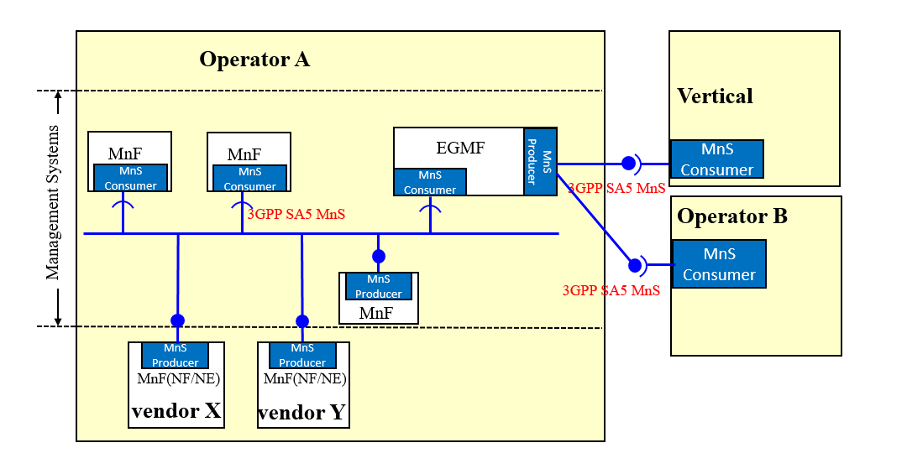

Figure 5.5-1: Example of MnS usage flexibility

Different set of management services may be used for the interoperability between different players. Figure 5.x -1 illustrates an example showing the MnSs may be used, using the MnS flexibility. These players can be PLMM Organizations (e.g., Operator A, Operator B) and enterprise customers (e.g., Vertical).

------------------------------------------------------------End of TS 28.533-------------------------------------------------------------

The corresponding requirements defined in TS 28.537 defines managing management data functionalities. The related reference specification text as follows:

------------------------------------------------------------Start of TS 28.537-------------------------------------------------------------

6 Managing management data

6.1 Producing and reporting management data

6.1.1 Description

Management data is referring to data produced by radio access network functions, core network functions or management functions and used for management purposes. Management data specified by 3GPP for 5G management is classified into 5G performance measurements as defined by TS 28.552 [4], 5G end to end key performance indicators as defined by TS 28.554 [5] and Trace metrics as defined by TS 32.423 [8]. The combined performance measurements and key performance indicators are also called performance metrics.

Partially omitted……

NOTE: The term "management data specified by 3GPP" relates to

- 5G performance measurements as defined by TS 28.552 [4]

- 5G end to end key performance indicators as defined by TS 28.554 [5], and

- Trace metrics as defined by TS 32.423 [8].

-------------------------------------------------------------End of TS 28.537-------------------------------------------------------------

-------------------------------------------------------------Start of TS 32.422-------------------------------------------------------------

Trace metrics: Messages, measurements and reports which can be traced by the 3GPP specified Subscriber and Equipment Trace framework. These include trace messages, MDT measurements (Immediate MDT, Logged MDT, Logged MBSFN MDT), RLF, RCEF, RRC reports and 5GC UE level measurements.

-------------------------------------------------------------End of TS32.422-------------------------------------------------------------

Therefore, it is feasible for OAM to transfer the NW-side dataset/model parameter to UE-side training entity, as long as:

1) The UE-side training entity becomes an authorized MnS consumer.

2) The NW-side dataset/model parameter (collected from gNB) can fit into the SA5 definition for management data.

### 3.2.2 Analysis of gNB -> OAM -> UE-side training entity

For this solution, the aspects that SA5 needs to standardize involves the following:

* gNB->OAM

In currently SA5 definition, the data collection architecture related to data collection supports the data transmission from gNB to OAM. The OAM can collect the data such as Trace/MDT measurements, RLF and RRC failure reports defined in TS 32.422/TS 32.423, 5G PMs defined in TS 28.552, 5G KPIs defined in TS 28.554 etc., and report the data using the reporting mechanism via file-based reporting (TS 28.532) or streaming-based reporting (TS 28.532, TS 28.550).

Therefore, it is feasible for OAM to become NW-side dataset/model parameter collection entity within Rel-19 existing architecture framework to support the data transmission from gNB to OAM.

* OAM-> UE-side training entity

The same analysis applies as for clause 3.2.1.

## 3.3 Proposed way forward for SA5

Based on the analysis above, we think SA5 Rel-19 architecture supports the data transmission from gNB to OAM. For data transmission/model parameter transmission from OAM to UE-side training entity, it is feasible for OAM to transfer the collected data to UE-side training entity, as long as the UE-side training entity becomes an authorized MnS consumer.

It is proposed to take the analysis above into consideration when drafting the LS reply.

**Proposal: It is proposed to draft the LS reply to RAN2 as follows:**

* **SA5 Rel-19 architecture supports the data transfer from gNB to OAM.**
* **For data transmission/model parameter transfer from OAM to UE-side training entity, it is feasible for OAM to transfer the collected data to UE-side training entity, as long as:**

**1) The UE-side training entity is an authorized MnS consumer.**

**2) The NW-side dataset/model parameter (collected from gNB) conforms to the SA5 definition for management data.**

# 4 Detailed proposal

It is proposed to take the analysis above into consideration when drafting the LS reply.

**Proposal: It is proposed to draft the LS reply to RAN2 as follows:**

* **SA5 Rel-19 architecture supports the data transfer from gNB to OAM.**
* **For data transmission/model parameter transfer from OAM to UE-side training entity, it is feasible for OAM to transfer the collected data to UE-side training entity, as long as:**

**1) The UE-side training entity is an authorized MnS consumer.**

**2) The NW-side dataset/model parameter (collected from gNB) conforms to the SA5 definition for management data.**