**3GPP TSG-SA5 Meeting #162 *S5-253422rev1***

Goteborg, Sweden, 25 - 29 August 2025

|  |  |  |  |  |  |  |  |  |
| --- | --- | --- | --- | --- | --- | --- | --- | --- |
| *CR-Form-v12.3* | | | | | | | | |
| **CHANGE REQUEST** | | | | | | | | |
|  | | | | | | | | |
|  | **28.105** | **CR** | **DraftCR** | **rev** | **-** | **Current version:** | **19.2.0** |  |
|  | | | | | | | | |
| *For* [***HE******LP***](http://www.3gpp.org/3G_Specs/CRs.htm#_blank)*on using this form: comprehensive instructions can be found at* [*http://www.3gpp.org/Change-Requests*](http://www.3gpp.org/Change-Requests)*.* | | | | | | | | |
|  | | | | | | | | |

|  |  |  |  |  |  |  |  |  |
| --- | --- | --- | --- | --- | --- | --- | --- | --- |
| ***Proposed change affects:*** | UICC apps |  | ME |  | Radio Access Network | **X** | Core Network | **X** |

|  |  |  |  |  |  |  |  |  |  |  |
| --- | --- | --- | --- | --- | --- | --- | --- | --- | --- | --- |
|  | | | | | | | | | | |
| ***Title:*** | Input to DraftCR Rel-19 TS 28.105 Add Procedure for ML Model LCM | | | | | | | | | |
|  |  | | | | | | | | | |
| ***Source to WG:*** | ZTE Corporation, NEC | | | | | | | | | |
| ***Source to TSG:*** | SA5 | | | | | | | | | |
|  |  | | | | | | | | | |
| ***Work item code:*** | AIML_MGT_Ph2 | | | | |  | ***Date:*** | | | 2025-08-01 |
|  |  | | | |  | |  | | |  |
| ***Category:*** | **B** |  | | | | | ***Release:*** | | | Rel-19 |
|  | *Use one of the following categories:* ***F*** *(correction)* ***A*** *(mirror corresponding to a change in an earlier release)* ***B*** *(addition of feature),* ***C*** *(functional modification of feature)* ***D*** *(editorial modification)*  Detailed explanations of the above categories can be found in 3GPP [TR 21.900](http://www.3gpp.org/ftp/Specs/html-info/21900.htm). | | | | | | | | *Use one of the following releases: Rel-8 (Release 8) Rel-9 (Release 9) Rel-10 (Release 10) Rel-11 (Release 11) … Rel-17 (Release 17) Rel-18 (Release 18) Rel-19 (Release 19)  Rel-20 (Release 20)* | |
|  |  | | | | | | | | | |
| ***Reason for change:*** | | TS 28.105 currently omits the generic life-cycle procedures for ML models—training, testing, deployment, and inference. This contribution fills that gap by adding clear, end-to-end procedures that significantly enhance readability. | | | | | | | | |
|  | |  | | | | | | | | |
| ***Summary of change:*** | | Add procedures for trianing, testing, depolyment, and inference of ML model. | | | | | | | | |
|  | |  | | | | | | | | |
| ***Consequences if not approved:*** | | Relevant procedures are missing. | | | | | | | | |
|  | |  | | | | | | | | |
| ***Clauses affected:*** | | 7.x (new), A.x(new) | | | | | | | | |
|  | |  | | | | | | | | |
|  | | **Y** | **N** |  | | | |  | | |
| ***Other specs*** | |  | **X** | Other core specifications | | | | TS/TR ... CR ... | | |
| ***affected:*** | |  | **X** | Test specifications | | | | TS/TR ... CR ... | | |
| ***(show related CRs)*** | |  | **X** | O&M Specifications | | | | TS/TR ... CR ... | | |
|  | |  | | | | | | | | |
| ***Other comments:*** | | No impact on Stage 3 | | | | | | | | |
|  | |  | | | | | | | | |
| ***This CR's revision history:*** | |  | | | | | | | | |

***Start of the First Change***

## 7.x Generic Procedure for AI/ML management

## 7.x.2 Procedure for Consumer Initiated ML Model Testing

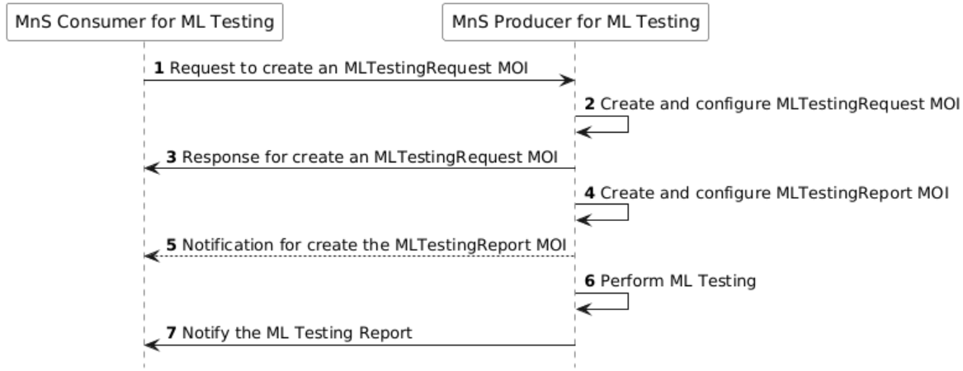

**Figure 7.x.2-1: Procedure for Consumer Initiated ML Model Testing**

Step 1. MnS Consumer sends a request to create an MLTestingRequest MOI (see createMOI operation defined in TS 28.532 [11]) to MnS Producer with the ML model testing information, where the MLTestingFunction or MLTrainingFunction acts as the MnS Producer for ML testing. The detailed ML model testing information sees attributes of the concrete MLTestingRequest IOC defined in clause 7.3a.

Step 2. Based on the received request, the MnS Producer creates the concrete MLTestingRequest MOI (i.e. instance of MLTestingRequest IOC) and configure the new created MLTestingRequest MOI with the received ML model testing information.

Step 3. MnS Producer sends a response (see createMOI operation defined in TS 28.532[11]) to the MnS Consumer.

Step 4. MnS Producer creates and configures the concrete MLTestingReport MOI (i.e. instance of MLTestingReport IOC).

Step 5 (optional). MnS Producer sends a notification to the MnS Consumer for creating MLTestingReport MOI.

Note: The step 2-5 above is an example for triggering ML Model testing and there is no restriction on the sequence.

Step 6. Based on the created MLTestingRequest MOI, MnS Producer performs the ML model testing for specific ML Model(s).

Note: step 4 and step 6 are exchangeable.

Pre-condition: The Consumer have a subscription on the ML Testing Report.

Step 7. MnS Producer notifies the ML testing report to the MnS consumer.

## 7.x.4 Procedure for Consumer Initiated AI/ML Inference based on AIMLInferenceFunction

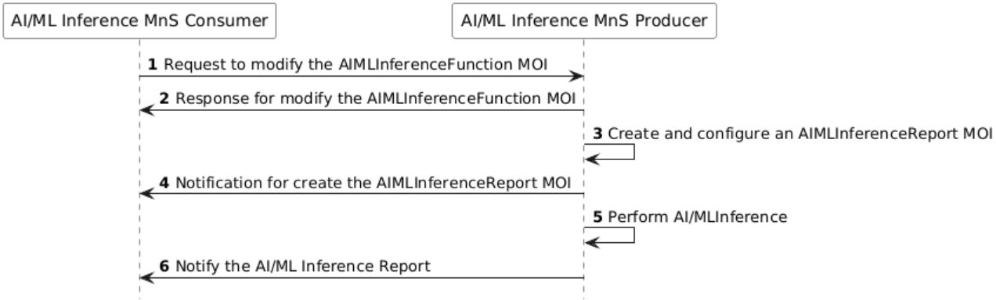

**Figure 7.x.1-1: Procedure for Consumer Initiated AI/ML Inference**

Step 1. AI/ML Inference MnS Consumer sends a request to modify the AIMLInferenceFunction MOI (see modifyMOIAttributes operation defined in TS 28.532 [11]) to AI/ML Inference MnS Producer with the inference information, where the AIMLInferenceFunction acts as the AI/ML Inference MnS Producer. The detailed inference information sees attributes of the concrete AIMLInferenceFunction IOC defined in clause 7.3a.

Step 2. AI/ML Inference MnS Producer sends a response (see modifyMOIAttributes operation defined in TS 28.532[11]) to the AI/ML Inference MnS Consumer.

Step 3. Based on the received request, the AI/ML Inference MnS Producer creates and configures the concrete AIMLInferenceReport MOI (i.e. instance of AIMLInferenceReport IOC).

Step 4. AI/ML Inference MnS Producer sends a notification to the AI/ML Inference MnS Consumer for creating AIMLInferenceReport MOI.

Note: The step 2-4 above is an example for triggering AI/ML Inference and there is no restriction on the sequence.

Step 5. AI/ML Inference MnS Producer performs the AI/ML Inference.

Step 6. AI/ML Inference MnS Producer notifies the AI/ML Inference report to the AI/ML Inference MnS consumer.

Note: the AIML inference procedure should be revisited to align with the NRM.

***End of the First Change***

***Start of the Second Change***

Annex A (informative):  
PlantUML source code for NRM class diagrams

# A.X Generic Procedure for AI/ML management

## A.X.2 Procedure for Consumer Initiated ML Model Testing

@startuml

hide footbox

autonumber

participant "MnS Consumer for ML Testing" #white

participant "MnS Producer for ML Testing" #white

"MnS Consumer for ML Testing" -> "MnS Producer for ML Testing": Request to create an MLTestingRequest MOI

"MnS Producer for ML Testing" -> "MnS Producer for ML Testing": Create and configure MLTestingRequest MOI

"MnS Producer for ML Testing" -> "MnS Consumer for ML Testing": Response for create an MLTestingRequest MOI

"MnS Producer for ML Testing" -> "MnS Producer for ML Testing": Create and configure MLTestingReport MOI

"MnS Producer for ML Testing" --> "MnS Consumer for ML Testing": Notification for create the MLTestingReport MOI

"MnS Producer for ML Testing" -> "MnS Producer for ML Testing": Perform ML Testing

"MnS Producer for ML Testing" -> "MnS Consumer for ML Testing": Notify the ML Testing Report

@enduml

## A.X.4 Procedure for Consumer Initiated AI/ML Inference

@startuml

hide footbox

autonumber

participant "AI/ML Inference MnS Consumer" #white

participant "AI/ML Inference MnS Producer" #white

"AI/ML Inference MnS Consumer" -> "AI/ML Inference MnS Producer": Request to modify the AIMLInferenceFunction MOI

"AI/ML Inference MnS Producer" -> "AI/ML Inference MnS Consumer": Response for modify the AIMLInferenceFunction MOI

"AI/ML Inference MnS Producer" -> "AI/ML Inference MnS Producer": Create and configure an AIMLInferenceReport MOI

"AI/ML Inference MnS Producer" -> "AI/ML Inference MnS Consumer": Notification for create the AIMLInferenceReport MOI

"AI/ML Inference MnS Producer" -> "AI/ML Inference MnS Producer": Perform AI/ML Inference

"AI/ML Inference MnS Producer" -> "AI/ML Inference MnS Consumer": Notify the AI/ML Inference Report

@enduml

***End of the Second Change***