**3GPP TSG-SA5 Meeting #162 *S5-253350rev1***

Goteborg, Sweden, 25 - 29 August 2025

**Source: NTT Docomo**

**Title: Pseudo-CR on TR28.869 terminology alignment**

**Document for: Approval**

**Agenda item: 6.19.6**

**Spec: 3GPP TR 28.869**

**Version: 1.5.1**

**Work Item: FS_Cloud_OAM**

**Comments**

Terminology alignment and editorial fixes

**Proposed Changes**

* * * First Change * * * *

# 1 Scope

The present document studies aspects related to management and orchestration of the 5GS ; specifically, use of ETSI VNF generic OAM functions [2], use of industry solutions including ETSI NFV MANO, open source and other solutions for management (including life cycle management and other management aspects) of network functions deployed in the cloud, and support of different cloud deployment scenarios.

* * * Next Change * * * *

2 References

The following documents contain provisions which, through reference in this text, constitute provisions of the present document.

- References are either specific (identified by date of publication, edition number, version number, etc.) or non‑specific.

- For a specific reference, subsequent revisions do not apply.

- For a non-specific reference, the latest version applies. In the case of a reference to a 3GPP document (including a GSM document), a non-specific reference implicitly refers to the latest version of that document *in the same Release as the present document*.

[1] 3GPP TR 21.905: "Technical Specification Group Services and System Aspects; Vocabulary for 3GPP Specifications".

…

[xx] 3GPP TS 28.311: "Technical Specification Group Services and System Aspects; Management and orchestration; Network policy management for mobile networks based on Network Function Virtualization (NFV) scenarios"

[yy] 3GPP TS 28.556: "Technical Specification Group Services and System Aspects; Management and orchestration; Network policy management for 5G mobile networks; Stage 2 and stage 3"

* * * Next Change * * * *

# 3 Definitions of terms, symbols and abbreviations

## 3.1 Terms

For the purposes of the present document, the terms given in 3GPP TR 21.905 [1] and the following apply. A term defined in the present document takes precedence over the definition of the same term, if any, in 3GPP TR 21.905 [1].

**VNF generic OAM function:** defined in ETSI GS NFV-IFA 049 [2].

**Virtualized Network Function:** defined in ETSI GR NFV 003 [11].

**Message bus:** a mechanism for sending and receiving messages between distributed systems via a middleware messaging infrastructure.

**NF Deployment**: A NF Deployment represents the software deployment used to realize a part of, or the full function of one 3GPP network functions, designed to run on a cloudified and virtualized environment.

* * * Next Change * * * *

## 3.3 Abbreviations

For the purposes of the present document, the abbreviations given in 3GPP TR 21.905 [1] and the following apply. An abbreviation defined in the present document takes precedence over the definition of the same abbreviation, if any, in 3GPP TR 21.905 [1].

CNF Cloud Native Function

CSP Communication Service Provider

LCM Life Cycle Management

* * * Next Change * * * *

### 4.1.2 Summary of TR 28.834 use cases related to generic OAM functions

In TR 28.834 [4], clauses 5.1, 5.2 and 5.3 are the use cases related to generic OAM functions, which are about using the "VNF configuration manager function", "Traffic enforcer function", "VNF metrics aggregator function" and " VNF metrics analyser function".

In clause 5, the above use cases describe the use case scenarios of the interaction process between the generic OAM functions and the 3GPP management system based on the content of ETSI GR NFV-EVE 019 [3] and give some potential related requirements, while clause 6 provides a simple analysis and does not have specific solutions.

This study carries out further research on the use of generic OAM functions based on ETSI GS NFV-IFA 049 [2].

* * * Next Change * * * *

## 4.2 Terminology considerations

### 4.2.1 Terminology and concepts used in the present document

3GPP network function (NF) is specified in TS 23.501 [41], as follows:

- *Network Function*: A 3GPP adopted or 3GPP defined processing function in a network, which has defined functional behaviour and 3GPP defined interfaces.

According to the definition of an NF Deployment in clause 3.1, to support cloud native concepts in 3GPP, an NF Deployment represents the software deployment used to realize a part of, or the full function of, one or multiple 3GPP network functions. The use of NF Deployment is not limited by any specific virtualization technology, e.g. VM based, or container based. A NF Deployment instance is a deployed software instance designed to run on a cloudified and virtualized environment, deployed and managed using technologies and principles evolving in the cloud eco system.

One fundamental cloud native principle is to partition systems into smaller, separately manageable parts. This allows for faster and more automated upgrades, improve operational efficiency and shorter time to market for new services.

The present study proposes, but does not limit, to use NF Deployment as concept and terminology in the present document. The instance(s) of NF Deployment is/are created, modified, or terminated through LCM related operations using an orchestration and management system.

* * * Next Change * * * *

### 4.2.2 Terminology alignment with ETSI NFV

In ETSI NFV according to ETSI GR NFV 003 [11]:

- terms virtualization and cloudification are used interchangeably.

- the terms "cloud-native VNF" and "cloud-native NF" are used interchangeably.

- a containerized NF, a container-based NF, a containerized VNF, and a container-based VNF refer to the same concept (i.e. VNF whose software components are deployed within OS containers) and are used interchangeably.

- the descriptor is VNFD, as per ETSI NFV specifications (see ETSI GS NFV-IFA 011 [22]).

- The term NF Deployment used in this document corresponds to the term VNF used in NFV.

The above relationships and terminology are considered for example by ETSI GS NFV-IFA 049 [2] when describing the use of VNF generic OAM functions.

* * * Next Change * * * *

### 4.4.4 Relevance of cloud-native design principles to 3GPP OAM

Table 4.4.4-1 provides a summary mapping between the "Twelve-factor app" and "CNCF’s cloud-native principles". Hence, where factors and principles are understood to be related, they are indicated on the same row in the table 4.4.4-1.

**Table 4.4.4-1: Mapping between "Twelve-factor app" and "CNCF’s cloud-native principles"**

|  |  |
| --- | --- |
| **Factor** | **Cloud-native principle** |
| 1 – Codebase | Repeatable deployment process |
| 2 – Dependencies |  |
| 3 – Configuration |  |
| 4 – Backing services |  |
| 5 – Build, release, and run |  |
| 6 – Processes | Micro-services design  Loosely coupled |
| 7 – Port binding |  |
| 8 – Concurrency | Dynamic scalability |
| 9 – Disposability | Resiliency |
| 10 – Dev/Prod parity |  |
| 11 – Logs | Observability |
| 12 – Administrative processes |  |
|  | Containerization |
|  | Immutable infrastructure |
|  | Declarative API |

The present document does not study and define the exact set of cloud native principles a CNF adheres to. It is not up to the 3GPP management system to mandate that network functions adhere to cloud-native principles in their design. Nevertheless, from a 3GPP management perspective, it is considered that a CNF can have the following aspects:

- Highly scalable based on microservices.

- Deployed using container technologies, and.

- Multiple management interfaces to support multiple management applications.

The impact of the cloud-native design principles on the 3GPP management system needs to be investigated further.

* * * Next Change * * * *

## 4.5 Cloud deployment types

Management and orchestration solution for cloud deployments can support different types of cloud which the Communication Service Providers (CSPs) can use to deploy their solutions. Cloud deployments vary depending on the underling cloud environment based on ownership, scale, and access, as well as the cloud's nature and purpose. Typical cloud deployments in the industry include public-cloud, where the cloud infrastructure services are provided over the internet and available to the public, private-cloud, where the cloud services are accessible to one consumer, e.g. an organization and not reachable through internet, and hybrid-cloud, which is a combination of public and private clouds. Additionally, there are multi-cloud deployments, which consist of cloud infrastructure solutions provided by different cloud providers. It is important that CSPs are provided with support for various cloud deployment types and the desired level of control on managing the deployments.

* * * Next Change * * * *

5 Use cases, potential requirements, and potential solutions

5.1 Use of VNF generic OAM functions

5.1.1 Use case #1: NF Deployment configuration management

5.1.1.1 Description

Besides allocation and configuration of the necessary resources, to bring up a NF deployment into operation, i.e. full instance provisioning and configuration of the corresponding NF deployment instances needs to take place. Configuration actions can also be performed during the NF deployment instance operation.

An operator needs to be able to manage and orchestrate through the 3GPP management system the configuration of the NF deployment (i.e., cloud native VNF instances according to ETSI NFV terminology). The operator needs to be able to perform through the 3GPP management system, operations like set and query configuration information.

For data governance reasons, the operator needs to be able to control the location where configuration data is stored. Additional information is needed that can be used by the MnS producer to support operations like:

- backup configuration information.

- rollback configuration information (e.g., after reverting software to a previous stable version).

- remove unnecessary configuration files (e.g., very old versions).

The descriptions in this use case (i.e., requirements, solutions and evaluation) refer to the non-application parameters of NF deployments.

5.1.1.2 Potential requirements

**REQ-CVNF_CM-1** The 3GPP management system should have the capability to perform configuration operations for NF Deployment instances.

**REQ-CVNF_CM-2** The reference point between the 3GPP management system and external OAM entities should have the capability enabling the 3GPP management system to interact with external (non-3GPP) configuration management entities for the purpose of performing configuration operations for NF Deployment instances.

5.1.1.3 Potential solutions

5.1.1.3.1 VNF Configuration Manager function

This solution introduces a platform entity that interacts with the 3GPP management system via a new reference point for performing the configuration management of NF Deployment.

This solution proposes the use of the VNF Configuration Manager function defined in ETSI GS NFV-IFA 049 [2]. Some key functionalities supported by the VNF Configuration Manager function are the capability to convey configuration information to one or more NF Deployment instances, the capability to perform pre-configuration actions (e.g. create configuration backup) and post-configuration actions (e.g. rollback running configuration) and the capability to query configuration information of NF Deployment instances.

From the perspective of the 3GPP management system, MnS provisioning handles configuration of managed NFs defined by 3GPP, which include the necessary configuration related to the behavior and role of a NF (e.g., configuration of a gNB CU UP function). The 3GPP management system fully understands the semantics of this kind of configuration since it is needed to ensure that the 3GPP mobile network operates as intended by the network operator.

The VNF Configuration Manager does not understand the semantics of the configuration information that is conveyed to the NF Deployment instances (both application configuration parameters and non-application configuration parameters).

Figure 5.1.1.3.1-1 depicts the interaction and reference point between 3GPP management system and the VNF Configuration Manager.



**Figure 5.1.1.3.1-1: Interaction and reference point between 3GPP management system and VNF Configuration Manager**

The present solution addresses the potential requirements REQ-CVNF_CM-1 and REQ-CVNF_CM-2.

This potential solution related to option 2 in clause 5.1.5.

The VNF Configuration Manager resides outside the 3GPP management system domain. 3GPP management system entities like MnF and MnS provisioning service producers, can interact with the VNF Configuration Manager through the interface specified in ETSI GS NFV-IFA 049 [2].

EXAMPLE: An MnS producer used to support planned Configurations according to 3GPP TS 28.572, can interact with the VNF Configuration Manager to convey and activate the configuration for application parameters of an NF Deployment.

5.1.1.3.2 Network Configuration Manager function

This solution introduces a platform entity that interacts with the 3GPP management system via a new reference point for performing the configuration management of NF Deployments.

This solution considers the use of the Network Configuration Manager function defined in ETSI GS NFV-IFA 049 [2]. The Network Configuration Manager function can be used to set network configuration information related to one or more NF Deployment instances. For example, the Network Configuration Manager can be used to configure the NF Deployment Connection Points (CPs), NF Deployment networking for VNF instances in a service mesh, etc.

Figure 5.1.1.3.2-1 depicts the interaction and reference point between 3GPP management system and the Network Configuration Manager.



**Figure 5.1.1.3.2-1: Interaction and reference point between 3GPP management system and Network Configuration Manager**

The present solution addresses the potential requirements REQ-CVNF_CM-1 and REQ-CVNF_CM-2.

This potential solution related to option 2 in clause 5.1.5.

5.1.1.3.3 Configuration Server

This solution introduces a platform entity that interacts with the 3GPP management system via a new reference point for performing the configuration management of NF Deployments.

This solution proposes the use of a Configuration Server introduced in ETSI GR NFV-EVE 022 [44]. The Configuration Server can be understood as a logically centralized storage for configuration, without limiting the implementation of the storage. In addition, Configuration Server services can be used to store and fetch configuration data, convert configuration data formats, validate configuration data schema and apply version control for configuration data. The interface exposed and operations supported by the Configuration Server are defined in ETSI GS NFV‑IFA 049 [2].

NOTE: Implementation of the Configuration Server, e.g. structure of configuration data, format of storage is not in scope of the present solution.

Figure 5.1.1.3.3-1 depicts the interaction and reference point between 3GPP management system and the Configuration Server.



**Figure 5.1.1.3.3-1: Interaction and reference point between 3GPP management system and Configuration Server**

As depicted in Figure 5.1.1.3.3-1, a consumer of the Configuration Server interfaces could be other VNF generic OAM function such as the VNF Configuration Manager defined in ETSI GS NFV-IFA 049 [2] or the 3GPP management system.

The solution enables the 3GPP management system having the capability to handle configuration data, like distributing, fetching and transforming configuration data, for one or multiple NF Deployments .

The present solution addresses the potential requirements REQ-CVNF_CM-1 and REQ-CVNF_CM-2.

This potential solution related to option 2 in clause 5.1.5.

5.1.1.3.4 Using the existing 3GPP provisioning management service and ETSI NFV MANO

In this solution a MnS producer offering the MnS provisioning service directly interacts with the NF Deployment for NF Deployment application specific parameters configuration purposes.

- The 3GPP management system configures NF Deployment with NF Deployment application specific parameters by utilizing already defined 3GPP provisioning MnS (as defined in clause 11.1 of TS 28.532 [10]).

- The 3GPP management system interacts with NFV-MANO to configure NF Deployment non-application parameters (as defined in clause 5.1.18 of TS 28.531[7]).

This solution is not using the VNF Generic OAM functions described in ETSI ISG NFV-IFA049 [2].

This potential solution related to option 1 in clause 5.1.5.

5.1.1.3.5 Proposed updates in the 3GPP management system

From a 3GPP management system point of view, additional information is needed by the MnS producer to support:

- backup of configuration data.

­- rollback of configuration data.

- removal of unnecessary configuration files (e.g., very old versions).

5.1.1.3.6 Using the existing 3GPP provisioning management service

In this solution a MnS producer offering the MnS provisioning service directly interacts with the NF Deployment for both NF Deployment application specific parameters configuration and NF Deployment non-application parameters purposes.

- The 3GPP management system configures the NF Deployment with NF Deployment application specific parameters by utilizing the already defined 3GPP provisioning MnS (as defined in clause 11.1 of TS 28.532 [10]) and the network resource model defined in TS 28.541 [7].

- The 3GPP management system configures the NF Deployment with NF Deployment non-application specific parameters by utilizing already defined 3GPP provisioning MnS (as defined in clause 11.1 of TS 28.532 [10]) and the VsDataContainer IOC defined in TS 28.622 [45]. The NF Deployment non-application parameters (including both standardized and non-standardized parameters) can be carried by the VsDataContainer IOC.

This solution provides a unified solution for configuring both NF Deployment application specific parameters configuration and NF Deployment non-application specific parameters by utilizing the existing 3GPP provisioning management service. This mechanism also supports the association between NF Deployment application specific parameters configuration and NF Deployment non-application specific parameters configuration, for example, add VsDataContainer name contained by EP_RP to carry the CpConfiguration defined in ETSI NFV IFA 008 [9] to support association between 3GPP defined EP_RP with ETSI NFV defined External Connection Point. Further, this solution supports carrying any type of configuration data that is required to support specific implementations.

The solution focusses on using 3GPP provisioning MnS for both NF Deployment application and non-application configuration. How the MnS producer perform the configuration activities for the NF Deployment is implementation specific. 3GPP Provisioning MnS don’t understand semantics of the NF Deployment non-application parameters.

This potential solution is related to option#3 in clause 5.1.5.

5.1.2 Use case #2：NF Deployment policy management

5.1.2.1 Description

3GPP TS 28.311 [xx] contains the architecture, requirements, use cases, procedures and definitions of interfaces for policy management for 4G networks. 3GPP TS 28.555 [12] specifies the concepts, requirements and use cases for network policy management in 5G networks. It is suitable for use cases where 3GPP and MANO interact for policy management (see the policy categories in ETSI GR NFV-IFA 023 [13] Table 6.2.2-1 for details) and lacks support for the NF deployments. This use case considers the scenarios where the 3GPP management architecture is flexible to interact with ETSI NFV MANO and other solutions for the policy management of NF Deployments.

The 3GPP management system needs to implement policy management for NF Deployments, which might be implemented by a Microservice-based architecture. This architecture can split a single application into multiple small services, each of them can run independently. However, it will also bring many challenges, such as a large number of services will have complex dependencies, resulting in complex deployment. In this case, policy management is needed to help improve efficiency.

The descriptions in this use case (i.e., requirements, solutions and evaluation) refer to the non-application parameters of NF deployments.

5.1.2.2 Potential requirements

**REQ-policy-1** The 3GPP management system should have the capability to manage policies for the NF Deployments.

**REQ-policy-2** The reference point between 3GPP management system and external OAM entity should support the capability enabling the 3GPP management system to interact with external (non-3GPP) policy management entities to perform the policy management forNF Deployments.

5.1.2.3 Potential solutions

5.1.2.3.1 Policy Agent

As shown in figure 5.1.2.3.1-1, this solution introduces a platform entity that interacts with 3GPP management system for policy management of NF Deploymentsvia a new PaaS reference point.

This solution proposes using the Policy Agent function defined in ETSI GS NFV-IFA 049 [2], which can interact with the VNF generic OAM function, other PaaS Service, and NF Deploymentsfor assisting on the execution and decision-making of policies.

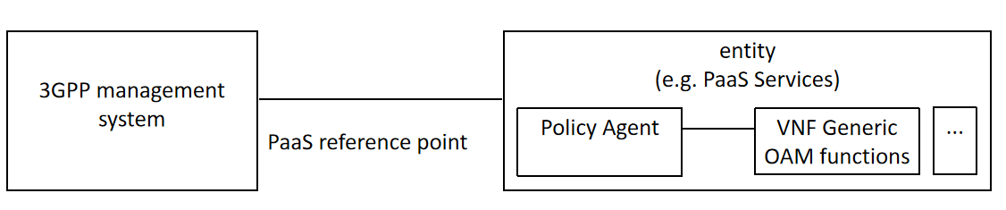

**Figure 5.1.2.3.1-1: Potential solution for Cloud-native VNF policy management using the Policy Agent**

The solution improves the efficiency in handling policies associated to various entities by interacting with VNF generic OAM functions and other PaaS Services, and enables the 3GPP management system having the capability to manage policies for the NF Deploymentswith or without interaction with NFV-MANO functions.

The present solution addresses the potential requirement REQ-policy-1 and REQ-policy-2.

This potential solution related to option 2 in clause 5.1.5.

5.1.2.3.2 Use of existing 3GPP provisioning management service and ETSI NFV MANO

In this solution a MnS producer offering the MnS provisioning service directly interacts with the NF Deploymentsfor policy management purposes.

- The 3GPP management system configures NF Deploymentapplication specific policies according to TS 28.556 [yy] and by utilizing already defined 3GPP provisioning MnS (as defined in clause 11.1 of TS 28.532[10]).

- 3GPP management system interacts with NFV-MANO to configure NF Deploymentnon-application policy parameters (as defined in clause 5.1.18 of TS 28.531[7]).

This solution is not using the VNF Generic OAM functions described in ETSI ISG NFV-IFA049 [2].

This potential solution related to option 1 in clause 5.1.5.

5.1.3 Use case #3: NF Deployment Traffic management

5.1.3.1 Description

Effective traffic management for NF Deployments is essential to ensure high quality of service levels. Nevertheless, especially in containerized deployments additional challenges need to be considered since many OS containers realizing the NF Deployment instances are usually deployed per host, while OS containers are often created and destroyed rapidly, requiring the network to adapt quickly to topological changes. In the context of a NF Deployments, traffic management includes controlling the inbound/outbound traffic to, from and within the NF Deployment instance.

Traffic management actions to be considered in a 3GPP management system context are, for example, controlling the rate of incoming requests to prevent overloading services and directing traffic within NF Deployment instances. These actions can surge in the context of diverse OAM procedures of maintenance, re-configuration, and upgrade of NFs, etc. managed through the 3GPP management system.

The 3GPP management system needs to be able to support an operator to manage and orchestrate the traffic management actions for NF Deployment instances.

The descriptions in this use case (i.e., requirements, solutions and evaluation) refer to the non-application parameters of NF deployments.

5.1.3.2 Potential requirements

**REQ-CVNF_TM-1** The 3GPP management system should have the capability to support traffic management within NF Deployment instances.

**REQ-CVNF_TM-2** The reference point between 3GPP management system and external OAM entity should have the capability enabling the 3GPP management system to interact with external (non-3GPP) traffic management entities for the purpose of performing traffic management for NF Deployment instances.

5.1.3.3 Potential solutions

5.1.3.3.1 Traffic Enforcer function

As shown in figure 5.1.3.3.1-1, this solution introduces a platform entity that interacts with 3GPP management system for traffic management of NF Deployments via a new PaaS reference point.

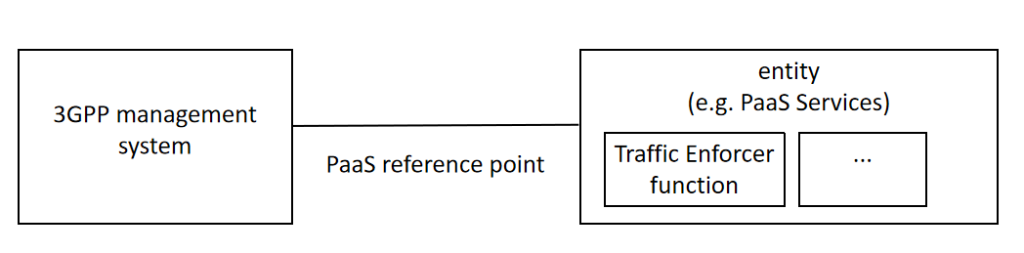

**Figure 5.1.3.3.1-1: Traffic management of cloud native VNF**

The solution proposes using Traffic Enforcer function defined in ETSI GS ISG NFV-IFA 049 [2], which is one of the VNF generic OAM functions. Some key functionalities supported by the Traffic Enforcer function are the capability to perform the required traffic blocking and rerouting operations within NF Deployment instances.

According to ETSI GS ISG NFV-IFA 049 [2] Traffic Enforcer functionality can be called by functions residing inside the 3GPP management system or other VNF generic OAM functions (e.g. the Upgrade VNF function) or other PaaS Services (e.g. the Policy Agent).

The present solution addresses the potential requirement REQ-CVNF_TM-2.

5.1.4 Use case #4: NF Deployment Upgrade

5.1.4.1 Description

NF Deploymentupgrades typically address known bugs and issues, leading to more stable and reliable operations. In addition, NF Deploymentupgrades can include new features and functionalities and/or security patches that fix vulnerabilities. NF Deploymentupgrades ensure that NF Deploymentsremain compatible with the latest standards specification facilitating the seamless integration with existing and new NF Deploymentsand management systems.

In the industry different NF Deploymentupgrade strategies are met in practice such as blue-green updates (traffic is served by a part of the network using the old version, while another part of the network is updated and tested with the new version) and canary updates (small subset of systems is updated and is also used to serve part of the traffic, before updating the entire production environment). In both cases, proper setup and configuration is needed, such as transferring of images, transferring of configuration files, configuring the load balancers, etc.

Both virtualization dependent (e.g. NF Deploymentnetwork configuration, virtual or physical resource management) and virtualization independent aspects (e.g. NF Deploymentrelated) can be considered during a NF Deploymentupgrade.

When NF Deploymentsare considered, upgrades become challenging due to the multiple components, software artifacts and configuration files to be handled.

An operator needs to be able to manage and orchestrate through the 3GPP management system the upgrade of the NF DeploymentF instances. The operator needs to be able to perform through the 3GPP management system, operations like set and query upgrade files information.

The descriptions in this use case (i.e., requirements, solutions and evaluation) refer to the non-application parameters of NF deployments.

5.1.4.2 Potential requirements

**REQ-CVNF_UP-1** The 3GPP management system should have the capability to upgrade NF Deploymentinstances.

**REQ-CVNF_UP-2** The reference point between 3GPP management system and external OAM entity should have the capability enabling the 3GPP management system to interact with external (non-3GPP) upgrade management entities for the purpose of upgrading NF Deploymentinstances.

5.1.4.3 Potential solutions

5.1.4.3.1 Upgrade VNF function

This solution introduces a platform entity that interacts with the 3GPP management system via a new reference point for performing the upgrade of NF Deployments.

This solution proposes the use of the Upgrade VNF function defined in ETSI GS NFV-IFA049 [2]. Some key functionalities supported by the Upgrade VNF function are, for example, the capability to modify the software of a VNF to another version and the capability to add resources to a running NF Deploymentinstance during an upgrade by coordinating with NF Deploymentmanagement function(s) responsible for managing the resources of the NF Deploymentinstance.

The VNF upgrade can be supported by the change NF Deploymentpackage procedures, which are followed based on the information available in the NF Deployment descriptor and/or updated NF Deployment Package files. The Upgrade VNF function can be also used to orchestrate an upgrade for multiple cloud-native NF Deploymentss. It can also manage both virtualization dependent and virtualization independent aspects.

To perform the intended functionality, the Upgrade VNF function can interact with other entities, as illustrated in the following examples.

EXAMPLE 1: In the case of ETSI NFV based solutions, the Upgrade VNF function can coordinate with the VNFM, which executes the lifecycle according to the NFV-MANO procedures including handling the removal/addition/modification of resources.

EXAMPLE 2: To update the network configuration of the connection points of a NF Deployment instance , the Upgrade VNF function can interact with the Network Configuration Manager defined in ETSI GS NFV-IFA 049 [2].

A consumer of the Upgrade VNF function interfaces can be the 3GPP management system over a reference point between the 3GPP management system and the platform providing VNF generic OAM and other PaaS Services. This is depicted in figure 5.1.4.3.1-1.



**Figure 5.1.4.3.1-1: Interaction and reference point between 3GPP management system and Upgrade VNF function**

The solution enables the 3GPP management system having the capability to manage the upgrade of NF Deployments by interacting with the Upgrade VNF function, who takes the responsibility of handling the various components, artifacts and configurations files and the necessary interactions with the cloud related management and orchestration system.

The present solution addresses the potential requirements REQ-CVNF_UP-1 and REQ-CVNF_UP-2.

This potential solution related to option 2 in clause 5.1.5.

5.1.4.3.2 Use of existing 3GPP provisioning management service and ETSI NFV MANO

In this solution a MnS producer offering the MnS provisioning service directly interacts with the NF Deployment for VNF upgrade purposes. The 3GPP management system upgrade NF Deployment with VNF application specific items by utilizing the already defined 3GPP provisioning MnS (as defined in clause 11.1 of TS 28.532[10]).

3GPP management system interacts with NFV-MANO to upgrade NF Deployment non-application items (as defined in clause 5.1.18 of TS 28.531[7]).

This solution is not using the VNF Generic OAM functions described in ETSI ISG NFV-IFA049 [2].

This potential solution related to option 1 in clause 5.1.5.

5.1.5 Relationship between 3GPP Management System (SBMA) and ETSI NFV VNF generic OAM functions and NFV-MANO

The decoupling of software and hardware in NFV gave rise to the need to delineate the concerns of application-level management versus virtualization-related management. NF Deployment application specific parameters are related to the behavior and services provided by the NF, which in the 3GPP context are therefore 3GPP service related and defined by 3GPP, whilst the NF Deployment non-application specific parameters (i.e. non-3GPP service related) are related to the virtualization aspects of the NF and consider the aspects on how software entities can be deployed and operated on virtualized infrastructure platform. Following are the details:

- The MO attributes, which are defined by 3GPP, can be regarded to be NF Deployment application specific parameters.

- The NF Deployment instance specific information defined in ETSI NFV specifications can be regarded to be NF Deployment non-application specific parameters.

NOTE: The NF Deployment application specific parameters are referred as virtualization-independent items in ETSI IFA 049 [2], VNF non-application specific parameters are referred as virtualization dependent items in ETSI IFA 049 [2].

Regarding the relationship between the VNF generic OAM functions framework and 3GPP management system (SBMA) defined in 3GPP TS 28.533 [16] the following can be considered:

Like in the case of NFV-MANO, VNF generic OAM functions reside outside the 3GPP management system (SBMA).

In SBMA, a MnS producer can consume management interfaces provided by NFV-MANO and can expose a corresponding service to MnS consumers. Similarly for the case of VNF Generic OAM functions in SBMA, a MnS producer can consume management interfaces provided by VNF generic OAM functions and can expose a corresponding service to MnS consumers.

Following are the two options to illustrate the relation between 3GPP management system (SBMA), VNF generic OAM functions and NFV-MANO.

NOTE: The name of NF Deployment application parameters and NF Deployment non-application parameters needs to be revisited during normative phase.

**Option#1:**

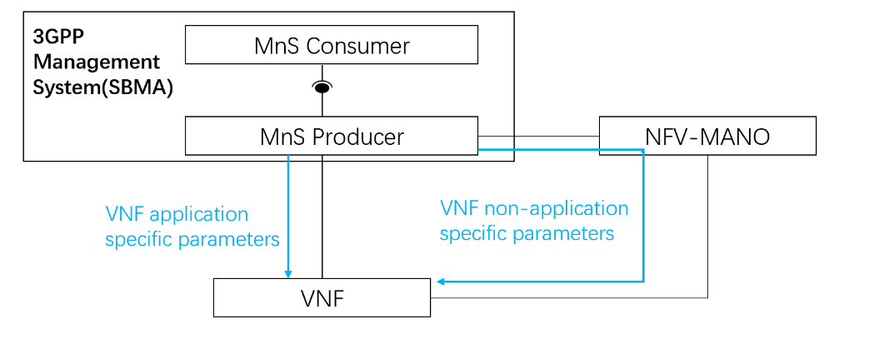

**Figure 5.1.5-1: Use of 3GPP MnS and ETSI NFV MANO to manage VNF**

In this option, 3GPP management system (SBMA) configures/manages NF realized by VNF(s) with VNF application specific parameters by utilizing already defined 3GPP MnSs (e.g. provisioning MnS). 3GPP management system interacts NFV-MANO to configure/manage NF realized by VNF(s) with VNF non-application specific configurations.

**Option#2:**

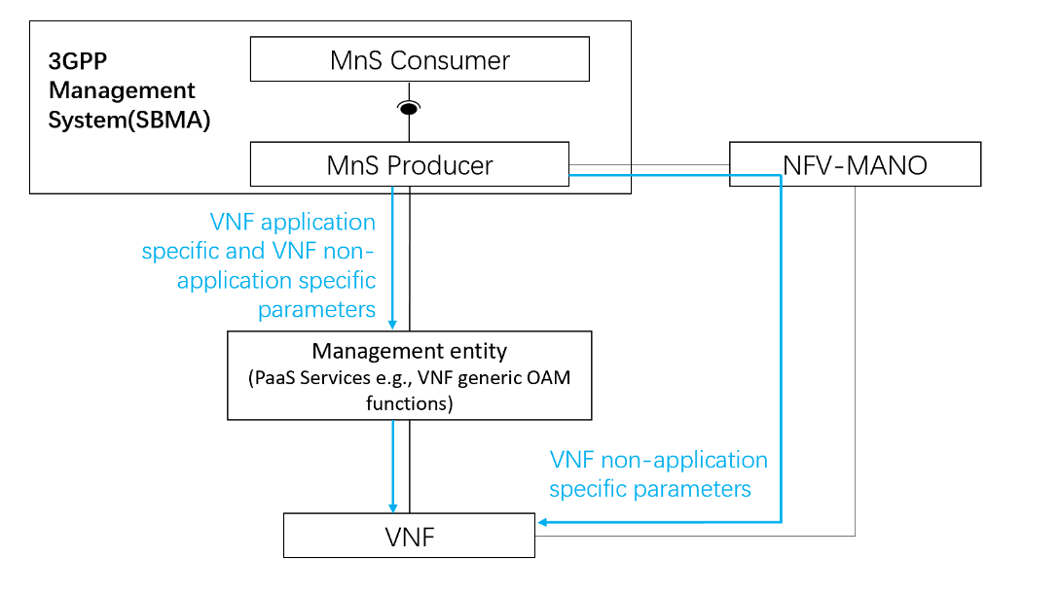

**Figure 5.1.5-2: Interactions between SBMA and VNF Generic OAM Functions**

In this option, 3GPP management system (SBMA) still manages NF Deployment non-application specific parameters with NFV-MANO by utilizing already defined 3GPP MnSs. In addition the 3GPP management system interacts with PaaS Services defined in ETSI ISG NFV-IFA 049 [2] (i.e., VNF Generic OAM functions) to manage NF Deployment non-application specific aspects (typically those which are not managed by NFV-MANO or resulting from NFV-related orchestration procedures) but also NF Deployment application specific aspects (e.g., NF Deployment configuration backup etc.).

In the case of VNF application specific aspects, VNF generic OAM functions, which do not process the semantics of application specific parameters, serving simply as utility functions in the cloud-native platform with specific OAM capabilities.

**Option#3:**

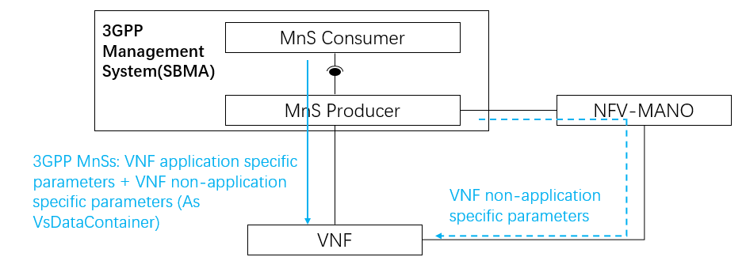

**Figure 5.1.5-3: Use of 3GPP MnS as unified solution**

In this option, 3GPP management system (SBMA) configures/manages NF realized by NF Deployment (s) with NF Deployment application specific parameters and NF Deployment non-application specific parameters (typically those which are not managed by NFV-MANO or resulting from NFV-related orchestration procedures) by utilizing already defined 3GPP MnSs (e.g. provisioning MnS). The NF Deployment non-application specific parameters can be carried within VsDataContainer defined in TS 28.622 [45]. The NF Deployment application specific parameters and VNF non-application specific parameters can be specified by MnS consumer or derived from MnS Producer.

For NF Deployment non-application parameters which standardized by ETSI NFV, 3GPP Management System can use 3GPP MnSs with VsDataContainer to configure NF Deployment or interact with NFV-MANO (see the "dotted-line") to configure VNF.

In the case of VNF non-application specific aspects, the 3GPP MnSs don’t understand the semantics of NF Deployment non-application specific parameters. This solution serves simply to provide unified OAM capabilities for managing NF realized by NF Deployment (s).

* * * Next Change * * * *

## 5.2 Use of industry solutions for management of NF Deployments

### 5.2.1 Use case #1: 3GPP management architecture evolution to support LCM of NF Deployment instance

#### 5.2.1.1 Description

3GPP specificationsspecify the interaction with ETSI NFV MANO for the LCM of the virtualized part of NF Deployments. The requirements, use cases and procedures for the management of NF containing the virtualized part are specified in TS 28.531[7] for 5G network. The interfaces for the interaction with ETSI NFV MANO are provided via Os-Ma-nfvo and the Ve-Vnfm-em reference points specified in ETSI GS NFV-IFA013 [8] and ETSI GS NFV-IFA008 [9].

There are newly developed and evolved industry solutions for management and orchestration of cloud native applications that leverage industry standards, e.g. Kubernetes based solution. Such industry solutions including ETSI NFV MANO and non ETSI NFV MANO can be used to address challenges related to NF Deployment instances e.g. for hybrid cloud deployments that deploy cloud native applications with hyperscale cloud providers. This use case considers the scenarios where the 3GPP management architecture is flexible to support use of ETSI NFV MANO and Non ETSI NFV MANO for the LCM of NF Deployment instance.

* * * Next Change * * * *

##### 5.2.2.3.2 Solution #2: Management data streaming for NF Deployments

The proposed solution relies on existing streaming mechanisms to stream management data between the MnS producer and MnS consumer (as defined in clause 12.5 of TS 28.532[10]) as shown in Figure 5.2.2.3.2-1.

The proposed solution supports cloud-native deployments on the MnS producer and MnS consumer sides which comes with the benefits of scalability, redundancy and fault-tolerance. If the MnS producer(s) leverage micro-service-based stateless architectures typical of cloud-native deployments, then it’s implementation specific how the MnS producers keep track of the stateful nature of the web-socket connection.

**Figure 5.2.2.3.2-1: Management data streaming for cloud-native NF deployments**

#### 5.2.2.4 Evaluation of solutions

**Solution #1** in clause 5.2.2.3.1 provides data streaming based on message bus. The proposed solution implies impacts on the 3GPP management system to support the streaming of management data based on message bus. This includes:

1. Impact to existing streaming data reporting service defined in TS 28.532: to support message bus-based data reporting from the MnS producer, a new streaming data reporting service needs to be introduced.
2. Impact to MnS producer due to the generality of data streaming service.

**Solution #2** in clause 5.2.2.3.2 shows how management data can be streamed with minimal impact to the existing MnS producers. The proposed solution relies on existing SA5 defined mechanisms for streaming management data between the MnS producer and the MnS consumer. It implies no impacts on the 3GPP management system.

* * * Next Change * * * *

# 6 Conclusions and recommendations

Editor's Note: This clause captures the conclusions and the recommendations of the study.

## 6.1 General conclusion

The present document mainly studied the following several categories:

- In clause 4, the terminology and concepts have been studied.

- In clause 5.1, the use cases are about the configuration, maintenance (i.e., upgrade and traffic management) and policy management for cloud-native VNFs. The related different solutions are based on existing functionalities provided by the 3GPP management system and/or the usage of VNF generic OAM functions/PaaS Services.

- In clause 5.2.1, 5.2.3, 5.2.4, 5.2.5 and 5.2.6, the use cases are about the lifecycle management of NF Deployment. The related different solutions can include ETSI NFV-MANO, but are not limited to it.

- In clause 5.2.2, the use cases are about the management data streaming for Network Functions in supporting cloud native.

- In clause 5.2.7, the use case is about observability for Network Functions in supporting cloud native.

- In clause 5.3, the use case is about the placement of Network Functions to support different cloud deployment scenarios while there are no solutions available for this use case in this document.

* * * End of Changes * * * *