3GPP TSG-SA5 Meeting #154 S5-241263d2
Changsha, China, 15 - 19 April 2024 Revision of S5-241217

Source: Ericsson Spain, Nokia

Title: pCR TR 28.879 Add list with the different types of external MnS consumers

Document for: Approval
Agenda Item: 6.19.21

1 Decision/action requested
The group is asked to discuss and approve the proposal

2 References
[1] S5-241213 Discussion paper on exposure
[2] 3GPP TR 28.879 Management and orchestration; Study on OAM for service management and exposure to external consumers (Release 19), v0.1.0, 2024-02.
[3] 3GPP TR 28.824 Study on network slice management capability exposure

3 Rationale
The DP in [1] asks SA5 Working Group to agree on and endorse six (6) issues. The DP also highlights the intention to prepare different pCRs to capture the main insights of these issues.
The present pCR addresses issue #5, which notes the following: “It is needed to provide examples of functional entities that can become external MnS consumers, to shed light on how the concept of external MnS consumer concept fits into the existing telco exposure initiatives, making sure terminology and scope of discussion is consistent across different SDOs”.
When looking into the 3GPP exposure framework (clause 3.1), it can be noticed that it includes CAPIF. CAPIF provides a discovery mechanism to gain access to 3GPP APIs, including SA2 APIs (network services), SA5 APIs (OAM/CH services) and SA6 APIs (application enablement services over 5GS/EPS). This mechanism is an example of discovery mechanism defined outside SA5, and thus fits with the definition of external MnS consumer (“MnS consumer that has discovered an MnS via a discovery mechanism which is not defined in 3GPP SA5”).
In this vein, it is worth noting that:
- Application Layer components always complies with the external MnS consumer definition, since they always need CAPIF to gain access to MnSs (OAM/CH services box).
- When accessing to MnS (OAM/CH services box) using CAPIF, Application Enablement services over 5GS/EPS comply to the external MnS consumer definition.
- When accessing to MnS (OAM/CH services box) using Soutbound Interface (network APIs), Application Enablement services over 5GS/EPS do not comply to the external MnS consumer definition.
See further details with the red arrows below.
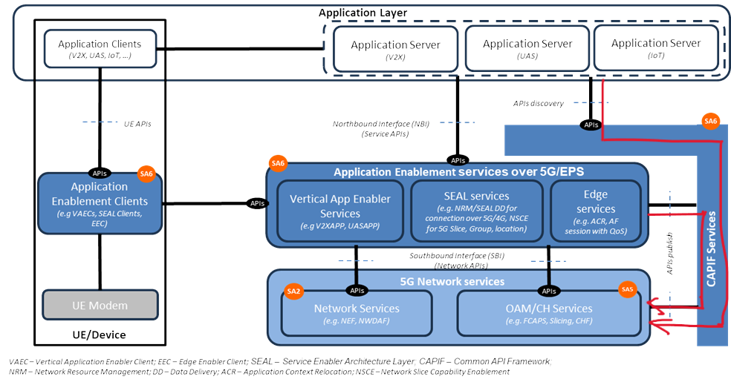

When looking the Open Gateway ecosystem (clause 3.2), it is noted that Open Gateway services (defined by GSMA) are offered through dev-friendly APIs (specified and maintained by CAMARA and TM Forum). Some service provisioning and monitoring actions on 5G managed resources, including network slicing. In such a case, the invocation of these dev-friendly APIs needs to be mapped into one or more calls to MnSs. The Open Gateway Transformation Function is in charge of this mapping and MnS invocation. To that end, the Open Gateway Transformation Function needs to be able to discover MnSs. In this regard, one realizes that the Open Gateway Transformation Function complies with the external consumer definition, when it gains access to MnS via CAPIF.

4 Detailed proposal
This contribution proposes to take action as detailed in the rationale, by providing in [2] a list of the different functional entities that can become external MnS consumers.
This contribution addresses WT-1 of FS_MExpo.

1st Change

2 References
The following documents contain provisions which, through reference in this text, constitute provisions of the present document.
- References are either specific (identified by date of publication, edition number, version number, etc.) or non-specific.
- For a specific reference, subsequent revisions do not apply.
- For a non-specific reference, the latest version applies. In the case of a reference to a 3GPP document (including a GSM document), a non-specific reference implicitly refers to the latest version of that document in the same Release as the present document.
[1] 3GPP TR 21.905: "Vocabulary for 3GPP Specifications".
[a] 3GPP TS 28.531 Management and orchestration; Provisioning
[b] 3GPP TS 23.435 Procedures for Network Slice Capability Exposure for Application Layer Enablement Service
[c] 3GPP TS 23.222 Common API Framework for 3GPP Northbound APIs; stage 2

2nd Change

3 Definitions of terms, symbols and abbreviations

3.1 Terms
For the purposes of the present document, the terms given in 3GPP TR 21.905 [1] and the following apply. A term defined in the present document takes precedence over the definition of the same term, if any, in 3GPP TR 21.905 [1].

3.2 Symbols
For the purposes of the present document, the following symbols apply:
<symbol> <Explanation>

3.3 Abbreviations
For the purposes of the present document, the abbreviations given in 3GPP TR 21.905 [1] and the following apply. An abbreviation defined in the present document takes precedence over the definition of the same abbreviation, if any, in 3GPP TR 21.905 [1].
OAM Operation, Administration and Maintenance
CAPIF Common API Framework
NSCE Network Slice Capability Exposure
NWDAF Network Data Analytics Function
NEF Network Exposure Function
NSACF Network Slice Access Control Function
MDA Management Data Analytics
CEF Charging Enablement Function
VAE Vertical App Enabler

3rd Change

4 Concepts and Background

4.z Examples of external MnS consumers
Figure X provides examples of functional entities that can become external MnS consumers. Table A elaborates on the rationale.

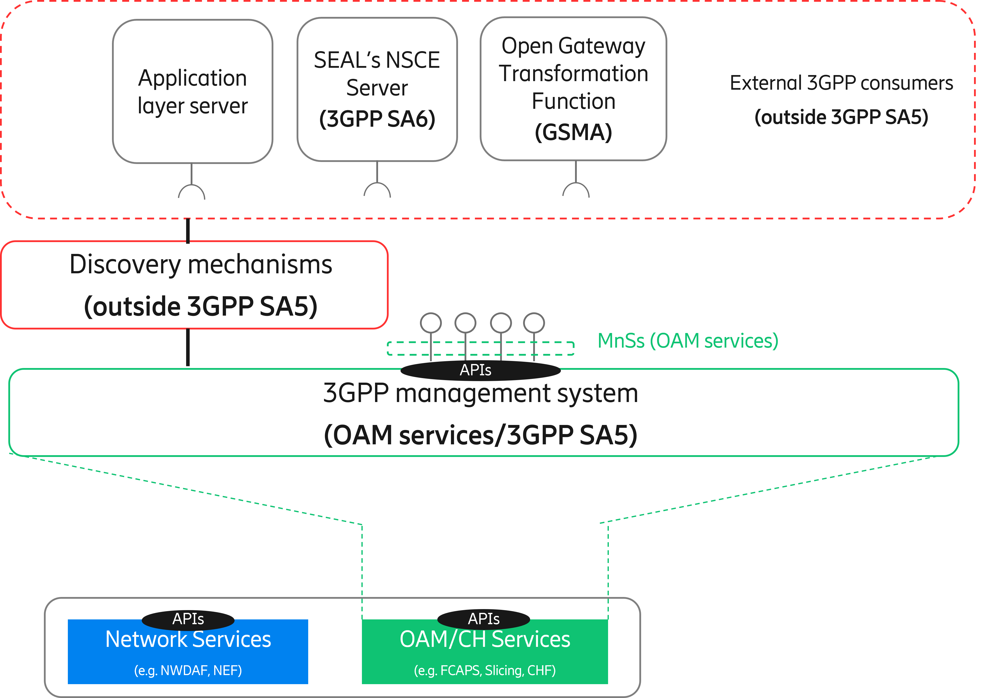
Figure X: Examples external MnS consumers.

Table A: Examples of external MnS consumers.
Functional Entity | Justification
Application Layer Server | Any 3rd party application that gains access (discover and consume) to MnSs using a discovery mechanism defined outside SA5 is an external MnS consumer. The logic of this application is on 3rd party and outside standardization.
SEAL’s NSCE server | Network Slice Capability Exposure (NSCE) is a SEAL service that provides add-on slicing capabilities to vertical customers’ applications. NSCE has a server and multiple clients (installed on vertical customer’s devices). NSCE server consumes slicing capabilities related to OAM (i.e., MnSs) and 5G network services (i.e., NEF APIs, NWDAF APIs, NSAFF APIs), and process them (aggregation, abstraction, filtering, etc.) in order to build vertical-oriented slicing functionality to applications.  The set of operations/notifications that are eligible for consumption by NSCE server are specified in TS 28.531 [a], and conceptually grouped under the NSCE-OAM interface in TS 23.435 [b]. To gain access to slicing capabilities related to OAM, NSCE server can use a discovery mechanism defined outside SA5. In this regard, the NSCE server becomes an external (network slice / network slice subnet) MnS consumer.
Open Gateway Transformation Function | Open Gateway services (defined by GSMA) are offered through dev-friendly APIs (specified and maintained by CAMARA and TM Forum). Some services provisioning and monitoring actions on 5G managed resources, including network slicing. In such a case, the invocation of these dev-friendly APIs needs to be mapped into one or more calls to MnSs. The Open Gateway Transformation Function is in charge of this mapping and MnS invocation. To that end, the Open Gateway Transformation needs to be able to discover MnS. In this regard, one can realize that the Open Gateway Transformation Function complies with the external MnS consumer when it gains access to MnSs using a discovery mechanism defined outside SA5.

It is worth noting that the functional entities represented as examples of external MnS consumers:
- provides a non-exhaustive list; the only aim is to provide clarity on how external MnS consumer concept fits with the background of telco exposure initiatives reported in the background.
- are all optional; the decision to deploy these functional entities or not is up to operator discretion.
- perform the role of “API invokers, when the discovery mechanism these entities use to gain access to MnSs is the mechanism provided by CAPIF.

End of changes

