3GPP TSG-SA5 Meeting #154 S5-242065
Changsha, China, 15 - 19 April 2024

CR-Form-v12.1
CHANGE REQUEST
 | 32.422 | CR | 0449 | rev | 1 | Current version: | 18.2.0
For HELP on using this form: comprehensive instructions can be found at
http://www.3gpp.org/Change-Requests.

Proposed change affects: | UICC apps |  | ME |  | Radio Access Network | X | Core Network | X

Title: | R18 CR 32.422 user consent alignment
Source to WG: | Ericsson, AT&T, Verizon, Huawei, China Unicom, China Telecom, DTAG, CMCC
Source to TSG: | S5
Work item code: | 5GMDT_Ph2 |  |  |  |  |  | Date: |  |  | 2024-04-04
Category: | F |  |  |  |  |  | Release: |  |  | Rel-18
 | Use one of the following categories:  F (correction)  A (mirror corresponding to a change in an earlier release)  B (addition of feature),  C (functional modification of feature)  D (editorial modification)  Detailed explanations of the above categories can  be found in 3GPP TR 21.900. |  |  |  |  |  |  |  | Use one of the following releases:  Rel-8 (Release 8)  Rel-9 (Release 9)  Rel-10 (Release 10)  Rel-11 (Release 11)  …  Rel-15 (Release 15)  Rel-16 (Release 16)  Rel-17 (Release 17)  Rel-18 (Release 18)
Reason for change: |  | As agreed in the last SA5 meeting, MDT activation shall be based on the OAM configured user-consent-request. However, the current text does not clearly define when an MDT configuration contains both MDT measurements subject to user consent and not subject to user consent.  The proposal is that, in management-based MDT activation, a RAN shall select the UE based on the user consent information only if those MDT measurement subject to user consent. For all other measurements specified in the MDT collection, the RAN should not consider user consent when selecting UEs.  Same requirement on signalling-based MDT procedure.
Summary of change: |  | Clairfy the user consent procedure
Consequences if not approved: |  | Uncleared user consent procedure which could lead to incorrect implementations
Clauses affected: |  | 4.9.1, 4.9.2
 |  | Y | N
Other specs |  |  | X | Other core specifications |  |  |  | TS/TR ... CR ...
affected: |  |  | X | Test specifications |  |  |  | TS/TR ... CR ...
(show related CRs) |  |  | X | O&M Specifications |  |  |  | TS/TR ... CR ...
Other comments:
This CR's revision history: |  | Revision of S5-241135

*** START OF NEXT CHANGE ***

4.9.1 Signalling based MDT
In case of signalling based MDT, getting user consent before activating the MDT functionality is required because of privacy and legal obligations. It is the Operator’s responsibility to collect user consent before initiating an MDT for a specific IMSI, IMEI number or SUPI.
Collecting the user consent shall be done via customer care process. The user consent information availability should be considered as part of the subscription data and as such this shall be provisioned in the UDM database.
The following figure summarizes the functionality.
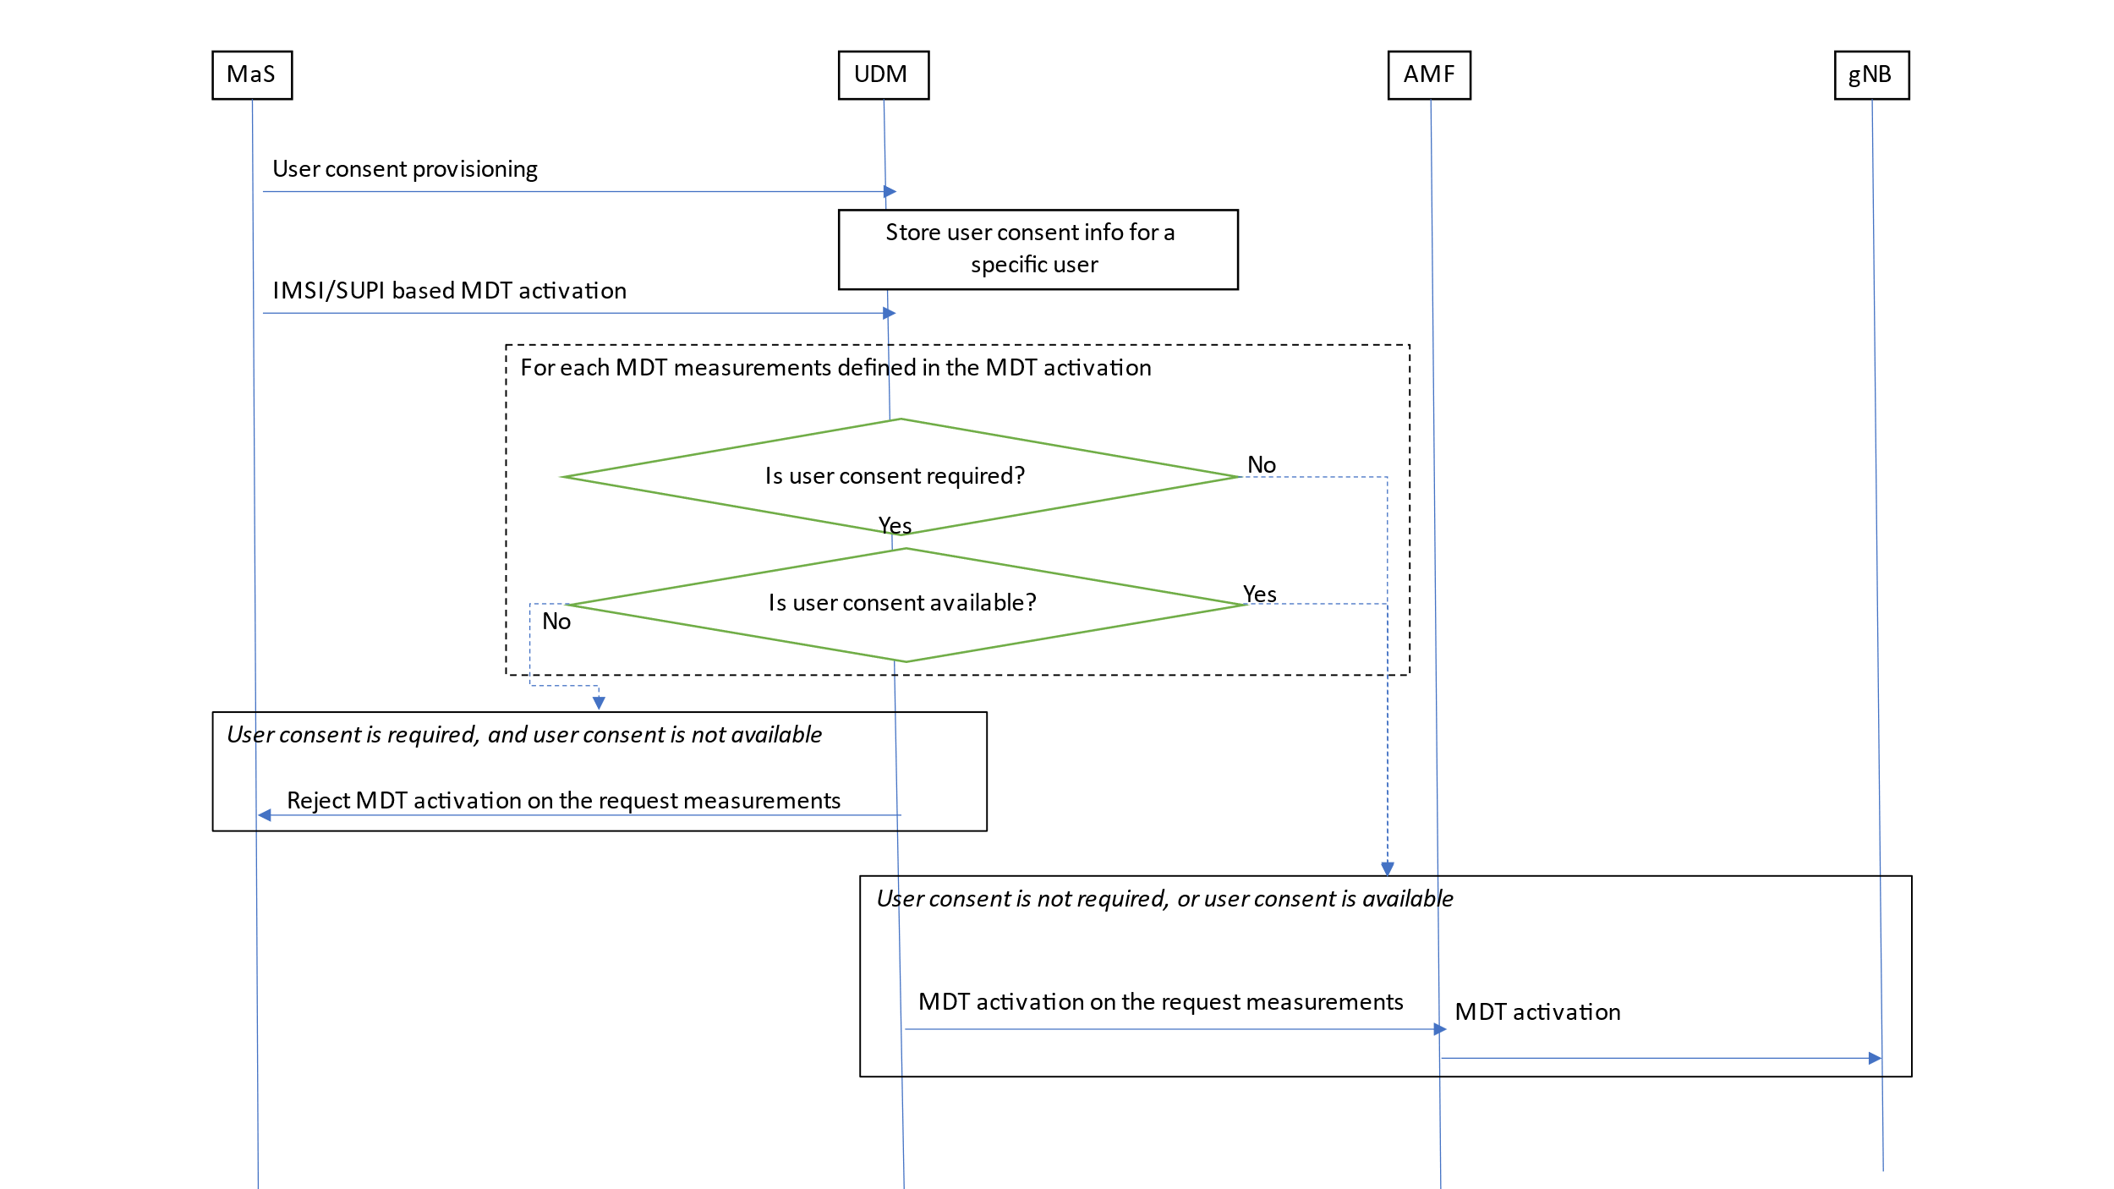

Figure 4.9.1.1: Example for delivering user consent information in signalling based MDT
When the IMSI/IMEI(SV)/SUPI based MDT is activated, it is targeted the UDM.
The UDM shall check the MDT user consent requirements configured by OAM.
If one or more MDT measurement name(s) is/are specified in MDT activation, the UDM shall:
- For user-consent-required MDT measurement name(s), start a Trace Session for the given subscriber if the user consent is available.
- For user-consent-required MDT measurement name(s), not start a Trace Session for the given subscriber if the user consent is not available.
- For user-consent-not-required MDT measurement name(s), start a Trace Session for the given subscriber without considering user consent.
As the user consent availability information is stored as part of the subscription data it should also be transferred to the AMF during update location procedure. This is required if the signalling based MDT is started from AMF. In that case, same user consent checking is required as in the UDM case.
It should also be possible to handle user consent revocation. The process of user consent revocation shall be done also via customer care process and the user consent availability information should be updated in the UDM DB when a user consent revocation happens.
If the user consent revocation happens during an ongoing Trace Session with MDT, it is not required to stop and deactivate the Trace Recording Session, Trace Session, respectively, immediately, i.e., to stop an ongoing Trace Recording Session in case of Immediate MDT revocation. A notification to the management system should be sent and the management system should deactivate the Trace Session.
*** START OF NEXT CHANGE ***

4.9.2 Management based MDT
The following figure summarizes the functionality.
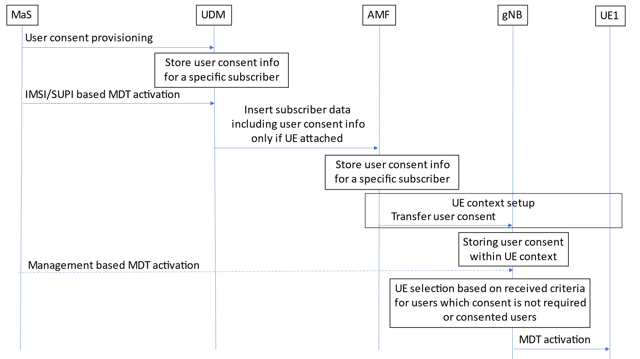
Figure 4.9.2.1: Example for delivering user consent information in management based MDT
When UE attaches to the network, the UDM shall forward the user consent information, stored in the UDM database, to the corresponding AMF. When the AMF receives the user consent information it shall store it in its subscriber database.
The AMF shall also check the roaming status of the user. If the user is within its home operator’s PLMNs and the user has given its consent, the AMF shall send the Management based MDT PLMN List IE to the gNB during the UE context setup procedure (INITIAL CONTEXT SETUP REQUEST message, see TS 38.413 [49]). Otherwise, the AMF shall not send the Management based MDT PLMN List IE to the gNB.
If the result of the roaming status check indicates a home subscriber, AMF shall forward the already stored user consent information to the corresponding gNB as part of Management based MDT PLMN List IE.
When the management based MDT activation is sent to gNB, the gNB shall check the MDT user consent requirements configured by OAM.
If one or more MDT measurement name(s) is/are specified in MDT activation, gNB shall:
- For user-consent-required MDT measurement name(s), select the UE if the Management based MDT PLMN List IE is available for the UE.
- For user-consent-required MDT measurement name(s), not select the UE if the Management based MDT PLMN List IE is not available for the UE.
- For user-consent-not-required MDT measurement name(s), select the UE for the MDT measurement name(s) without considering the availability of the Management based MDT PLMN List IE.
The AMF shall forward the received Management based MDT PLMN List IE during N2 based handovers to the target node in the HANDOVER REQUEST message. Furthermore, in case of path switch request procedure, the AMF shall forward the received Management based MDT PLMN List IE to the corresponding gNB in PATH SWITCH REQUEST ACKNOWLEDGE message, see TS 38.413 [49].
AMF subscribes to UDM SDM API to get notification on any changes of the UE AM subscription data, including the changes on MDT user consent information which is part of the UE AM subscription data. When being notified by the UDM about an MDT user consent information change, the AMF shall subsequently signal the updated Management Based MDT PLMN Modification List IE to the gNB in UE CONTEXT MODIFICATION REQUEST message, see TS 38.413 [49].

*** END OF CHANGE ***

