S5-242039

3GPP TSG-SA5 Meeting #154 revision of S5-241307

15 - 19 April 2024, Changsha, Hunan, China

Source: Nokia

Title: Rel-19 DP 28.914 Intent Negotiations

Document for: Approval

Agenda Item: 6.19.3

1 Decision/action requested
The group is asked to discuss and agree on the proposal.

2 References
None

3 Discussion
Some intent feasibility has been agreed in R18. However intent feasibility is related to other intent related negotiations. For an intent that is desired by the MnS consumer, there is no guarantee that the MnS producer can deliver it the way the consumer desires. It could be that the producer does not fully understand the intent or that the MnS producer has multiple alternatives on how to realize the intent. Intent negotiation includes all interactions that enable the MnS consumer and producer to agree on the details of the intent, its fulfillment, or its results. There can be many cases that are related although can in general be grouped into 2 categories – those related to the evaluation of an intent and those related to the fulfilment of an intent.
- OAM Requirement-1 The MnS producer should support a capability enabling an MnS authorized consumer to provide an intent with an indication whether the intent is for feasibility checking or for fulfillment.

These use cases cover the study objectives for WT-3.1 Intent negotiation functionalities

3.1 Use cases, Procedures and OAM requirements related to the evaluation of an intent
3.1.1 Use case 1: Feasibility Checking
The MnS consumer has an intent and would like to confirm if the intent is feasible, and in case it is infeasible, what causes it to be infeasible or what changes could be made to make the intent feasible.
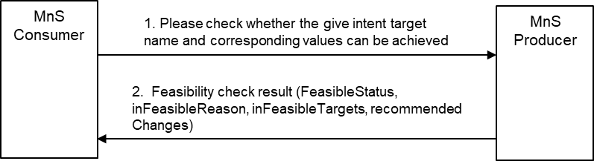
Figure 3.1.1-1:
The MnS consumer creates an intent indicating that it should be checked for feasibility.
If the intent is infeasible, the MnS producer may provide a feasibility check report containing one of the following:
- a binary result that the intent infeasible or not – this is already supported in TS28.312
  - The MnS producer should provide a reason for why the intent is infeasible – this is already supported in TS28.312, with the current reasons as conflict, invalid expression/syntax.
- a detailed report indicating what causes the intent to be infeasible – indicating which intentExpectation or expectationTarget is feasible or not -say using a binary flag for each aspect (intentExpectation and expectationTarget).
  - The MnS producer should support an infeasibility report that lists infeasible expectations and infeasible targets with the infeasible expectations.
  - The MnS producer may support new infeasibility reasons to infeasible targets/expectations, e.g., conflict, invalid expression, etc.
- a report indicating what is achievable for each intent aspect (intentExpectation and expectationTarget) that is infeasible.
  - The MnS producer should support an achievable outcomes report that lists the achievable outcomes for each infeasible targets within an infeasible expectation.
- OAM Requirement-10 The MnS producer should support a capability to provide an infeasibility report that lists infeasible expectations and infeasible targets within the infeasible expectations.
- OAM Requirement-11The MnS producer may support a capability to provide information on infeasibility reasons for any infeasible targets/expectations, e.g., conflict, invalid expression, etc.
- OAM Requirement-6 The MnS producer should support a capability enabling an MnS consumer to provide an intent with information on the MnS consumer’s relative importance of their intent expectations or expectation Targets.
- OAM Requirement 12 The MnS producer should support a capability to provide an achievable outcome report that lists the alternative (achievable outcomes) for each infeasible targets within an infeasible expectation.
- OAM Requirement-14 The MnS producer should support a capability enabling an MnS consumer to provide an intent with an indication for the type of feasibility check report to be provided.
This use case addresses aspects on three study objectives:
- WT-3.1.1 Management capability to enable MnS producer to ask the MnS consumer to decide which out of many possible outcomes is preferred from the MnS consumer’s perspective.
- WT-3.1.2 Management capability to enable MnS consumer to verify or check the feasibility if proposed intent expectation is possible for an MnS producer.
- WT-3.1.3 Management capability to enable MnS consumer to explore the best value that can be achieved from an specific intent expectation or target.
3.1.2 Use case 2: Checking achievable outcomes
The MnS consumer wants to know the possible achievable outcomes for a given intent regardless of whether the intent is feasible or infeasible. The MnS consumer creates an intent that should be evaluated by the MnS producer be see what the MnS producer can deliver.
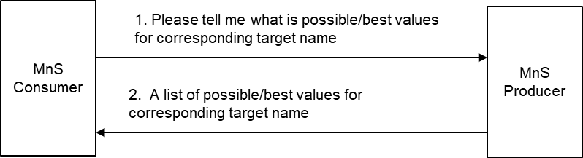
Figure 3.1.2-1:
Subsequently, the MnS producer provides a report indicating what is achievable for each intent aspect (intentExpectation and expectationTarget) within that intent. The MnS producer should support an achievable outcomes report that lists the achievable outcomes for each target within an expectation of the intent.
- OAM Requirement-1: The MnS producer should support a capability enabling an MnS consumer to provide an intent with a request for the MnS producer to provide information on the alternative outcomes that can be achieved by the MnS producer for that intent.
This use case addresses aspects on this study objective:
- WT-3.1.3 Management capability to enable MnS consumer to explore the best value that can be achieved from an specific intent expectation or target.

Note: The possibility that the feasibility check includes a request to reserve the related resources is FFS
3.1.3 Use case 3: Checking best achievable outcome on a given target
The MnS consumer wants to know the best possible achievable outcome for a given intent target.
Note: The best achievable values cannot be provided for multiple targets as there is no way of defining best involving multiple targets.
Note: The best possible achievable outcome should have no (negative) impact on other targets or contexts in the intent or on other intents or intent expectations.
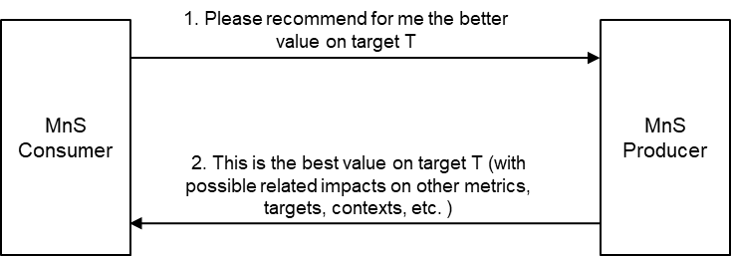
Figure 3.1.3-1:
The MnS consumer creates an intent that should be evaluated by the MnS producer with an indication of the specific target that is priority among other others.
Subsequently, the MnS producer provides a report indicating what is achievable for the stated intent target. The report may include the related impact on other targets in the intent or on other metrics and contexts. The MnS producer should support an achievable outcomes report that lists the achievable outcomes for each target within an expectation of the intent.
- OAM Requirement-1: The MnS producer should support a capability enabling an MnS consumer to provide an intent with a request for the MnS producer to provide information on the best possible outcome on an intent target.
Note: In the cases where the intent includes multiple targets, this would imply multiple back and forth interactions where the consumer checks each individual target
This use case addresses aspects on three study objectives:
- WT-3.1.3 Management capability to enable MnS consumer to explore the best value that can be achieved from an specific intent expectation or target.
3.1.3 Use case 3: Checking best achievable outcome on an intent or intent expectation
The MnS consumer wants to know the best possible achievable outcome for a given intent or intent expectation.
Note: To determine the best achievable outcomes for an intent or intent expectation, the producer should be provided with consumer’s way of evaluating the different combinations of outcomes on multiple targets within the intent or intent expectation.
Note: The best possible achievable outcome should have no (negative) impact on other intents or intent expectations.
Figure 3.1.3-1:
The MnS consumer creates an intent that should be evaluated by the MnS producer with an indication of the specific target that is priority among other others.
Subsequently, the MnS producer provides a report indicating what is achievable for the stated intent target. The report may include the related impact on other targets in the intent or on other metrics and contexts. The MnS producer should support an achievable outcomes report that lists the achievable outcomes for each target within an expectation of the intent.
- OAM Requirement-1: The MnS producer should support a capability enabling an MnS consumer to provide an intent with a request for the MnS producer to provide information on the best possible outcome on an intent target.
This use case addresses aspects on three study objectives:
- WT-3.1.3 Management capability to enable MnS consumer to explore the best value that can be achieved from an specific intent expectation or target.

3.2 Use cases, Procedures and OAM requirements on Negotiation on fulfilment of intents
3.2.1 Overview
There are multiple negotiations that can happen for an intent that is feasible, many of them employing interaction that are similar to the negotiations for determining feasibility of an intent.

3.2.1 Use case 4: Intent recommendation
The MnS consumer wants to know what the MnS producer recommends what to be applied for particular intent characteristics. The MnS consumer creates an intent which may be feasible or infeasible (e.g., missing target values) and asks the MnS producer to recommend what changes should be made to the intent or other intents to make the intent feasible.
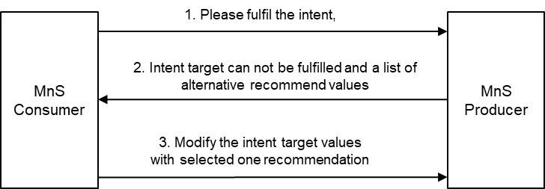
Figure 3.2.1-1:
Subsequently, the MnS producer provides a (intent modification recommendation) report indicating the changes to be applied to the intent to make the intent feasible. The MnS producer should support a recommended-changes report that lists the proposed candidate changes to each infeasible target within an infeasible expectation.
Note: the nature of the report and what can be included if FFS
- OAM Requirement-2: The MnS producer should support a capability enabling an MnS consumer to provide an intent with a request for the MnS producer to recommend what changes should be made to the intent or other intents to make the intent feasible.
- OAM Requirement-13 The MnS producer may support a capability to provide a report indicating what changes could be applied to the intent (i.e., deleting some of the intentExpectations and/or expectationTarget(s) or the changing the properties of intentExpectations and/or expectationTarget(s)) to make the intent feasible.
This use case addresses aspects on two study objectives:
- WT-3.1.2 Management capability to enable MnS consumer to verify or check the feasibility if proposed intent expectation is possible for an MnS producer.
- WT-3.1.3 Management capability to enable MnS consumer to explore the best value that can be achieved from an specific intent expectation or target.

3.2.2 Use case 5.1: MnS consumer advises MnS producer on preferred alternatives
The MnS consumer wants an intent fulfilled. The intent is feasible, but the MnS producer has multiple alternatives for how to realize the intent,. The MnS producer wants the MnS consumer to advise on their (the MnS consumer’s) preference among these alternatives.
Note 1: The nature of alternatives, whether intent target values, approaches, DNs (e.g. of affected functions or / closed loops), actions e.g. a set of recommended actions if FFS
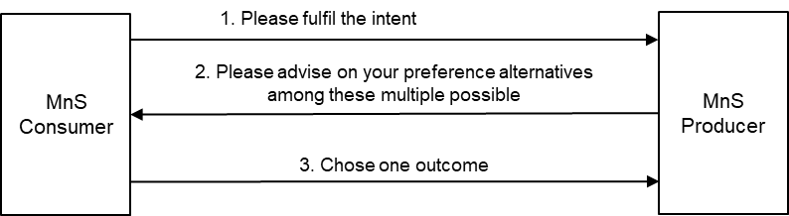
Figure 3.2.2-1:
The MnS consumer creates a feasible intent to be fulfilled.
The MnS producer determines that there are multiple alternatives, so the MnS producer:
- indicates (and requests the MnS consumer to select among) the alternatives that the MnS producer is able to apply/achieve.
Given the alternatives, the MnS consumer takes one or both of the two actions,
- Chooses and indicates the preferred alternative.
- Defines the relative importance of their expectation Targets so that the MnS producer may consider these in deciding upon the solution/ solution approach/ closed loops/ action/ outcome to be applied/deployed/achieved.

- OAM Requirement-3: The MnS producer should support a capability to provide to an MnS consumer an intent report indicating the alternatives that the MnS producer can support for the provided intent, intent expectations, or expectation Targets., e.g., the alternative closed loops (and their configurations) that it can deploy.

- OAM Requirement-7 The MnS producer should support a capability to provide to an MnS consumer an intent report indicating alternative outcomes and a request for the MS consumer to provide an evaluation of the outcomes.
- OAM Requirement-4: The MnS producer should support a capability to request an MnS consumer to indicate its preference among a set of alternatives that the MnS producer can support for the provided intent, intent expectations, or expectation Targets., e.g., the alternative closed loops (and their configurations) that it can deploy.
- OAM Requirement-5: The MnS producer should support a capability enabling an MnS consumer to provide to the MnS producer information indicating the MnS consumer’s preference among alternatives that the MnS producer can support for the provided intent, intent expectations, or expectation Targets., e.g., the alternative closed loops (and their configurations) that it can deploy.
This use case addresses aspects on two study objectives:
- WT-3.1.1 Management capability to enable MnS producer to ask the MnS consumer to decide which out of many possible outcomes is preferred from the MnS consumer’s perspective.
- WT-4 Study how Intent Utility Function can be used to allow Intent driven MnS consumer to improve priority handling by assigning relative preferences to Expectations. Study whether utility may impact existing use cases.

3.2.3 Use case 5.2: MnS consumer advises MnS producer on appropriateness of selected alternatives
The MnS consumer wants an intent fulfilled and the MnS producer has multiple alternatives for how to realize the intent, e.g., multiple alternative solutions/ solution approaches/ closed loops/ actions/ outcomes. The MnS producer choses one among these alternatives and then checks to see if fully satisfies the MnS consumer’s requirements.

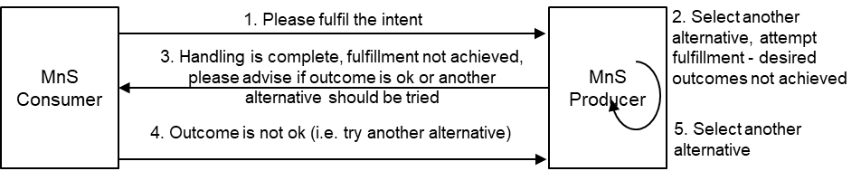
Figure 3.2.3-1:
The MnS consumer creates a feasible intent to be fulfilled.
The MnS producer determines that there are multiple alternatives, so the MnS producer:
- chooses and applies/ deploys one of the alternative solutions/ solution approaches/ closed loops/ actions.
- indicates to MnS consumer that handling is completed and requests the MnS consumer to evaluate the extent to which the applied/ deployed alternative solution/ solution approach/ closed loop/ action satisfies the MnS consumer’s needs.
The MnS consumer provides their evaluation of the extent to which the achieved with the selected solution/ solution approach/ closed loop/ action outcome is acceptable.
This use case addresses aspects on two study objectives:
- WT-3.1.1 Management capability to enable MnS producer to ask the MnS consumer to decide which out of many possible outcomes is preferred from the MnS consumer’s perspective.
- WT-4 Study how Intent Utility Function can be used to allow Intent driven MnS consumer to improve priority handling by assigning relative preferences to Expectations. Study whether utility may impact existing use cases.
3.2.4 Use case 5.3: MnS consumer advises MnS producer on how to select among alternatives
The MnS consumer wants an intent fulfilled and the MnS producer has multiple alternatives for how to realize the intent. The MnS producer wants the MnS consumer to guide the MnS producer on how to decide among these alternatives.
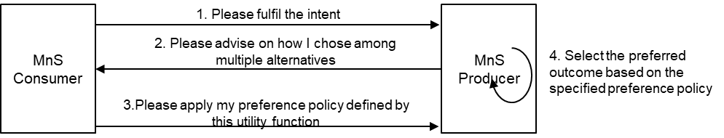
Figure 3.2.4-1:
The MnS consumer creates a feasible intent to be fulfilled. The MnS producer determines that there are multiple alternatives, so the MnS producer:
- indicates the alternative to the MnS consumer that there are multiple alternatives and requests the MnS consumer to advise on the policy to be used to select among the alternatives.
Then, the MnS consumer defines the relative importance of their expectation Targets so that the MnS producer may consider these in deciding upon alternatives.

Note 2: the multiple steps may also be avoided if the MnS consumer submits an intent that includes this policy to be used to select among the alternatives (see Figure 3.2.4-2)
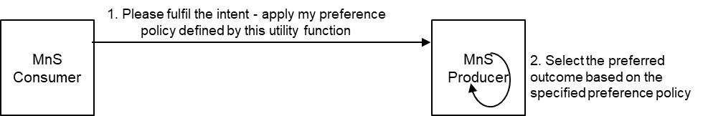
Figure 3.2.4-2:
3.2.6 Use case 5.4: MnS consumer advises MnS producer on how to better achieve the targets
The MnS consumer wants an intent fulfilled and the MnS producer has multiple alternatives for how to realize the intent. The MnS producer independently choses the alternative to be applied but allows the MnS consumer to provide information that guarantee better satisfaction.
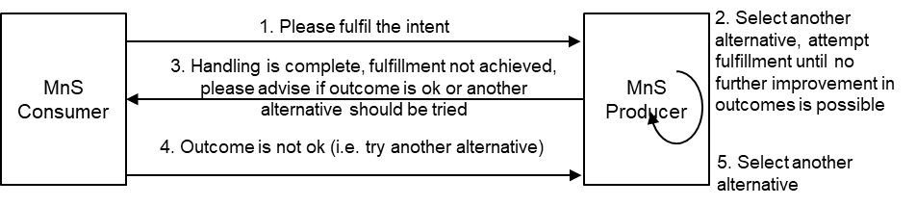
Figure 3.2.5-2:
The MnS consumer creates a feasible intent to be fulfilled.
The MnS producer applies a selected alternative to fulfill the intent. After continuously attempting to fulfil the intent, the Mns producer determines that following the selected approach, there is nothing more that the MnS producer can do to achieve better outcomes. At the point, the MnS producer reports the fulfillment outcomes (imperfect fulfillment) and indicates to the MnS consumer that if the MnS consumer is unsatisfied with the outcomes, the MnS consumer should provide extra information to help select a better solution/ solution approach/ closed loop/ action/ outcome.
If unsatisfied, the MnS consumer reconfigures the intent with a utility function that indicates the MnS consumer’s relative importance of their expectation Targets. The MnS consumer could in addition also provide their policy for evaluating of the extent to which they are satisfied with the selected approach (see Figure 3.2.5-2).
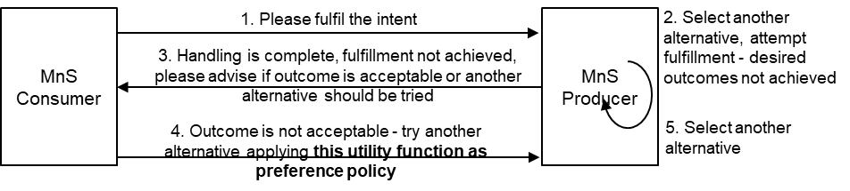
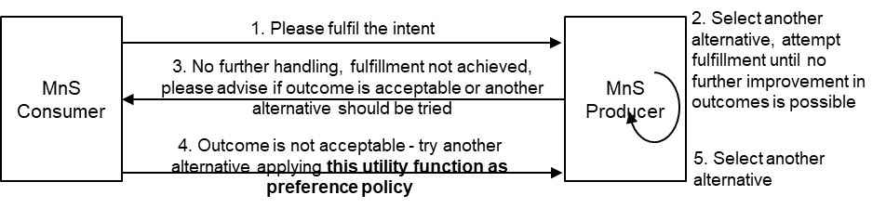
Figure 3.2.5-2:
- OAM Requirement-8 The MnS producer should support a capability enabling an MnS consumer to provide information on the MnS consumer’s policy for evaluating the effectiveness of any fulfilment outcomes.
- OAM Requirement-9 The MnS producer should support a capability enabling an MnS consumer to provide an intent with information on the MnS consumer’s policy for evaluating the effectiveness of any fulfilment outcomes.
This use case addresses aspects on this study objective:
- WT-4 Study how Intent Utility Function can be used to allow Intent driven MnS consumer to improve priority handling by assigning relative preferences to Expectations. Study whether utility may impact existing use cases.

3.3 Proposed way forward for SA5
It is proposed to Capture new OAM use case descriptions and requirements (from above section 3.1 and 3.2) in TR 28.914:
It is proposed to extend the solutions on intent feasibility in TS28.312

4 Detailed proposal
It is requested to:
- endorse the following use cases as described insection 3.1 and the proposal made in section 3.3
  - Feasibility Checking
  - Checking achievable outcomes
  - Checking best achievable outcome on a given target
  - Checking best achievable outcome on an intent or intent expectation
  - Intent recommendation
  - MnS consumer advises MnS producer on preferred alternatives
  - MnS consumer advises MnS producer on appropriateness of selected alternatives
  - MnS consumer advises MnS producer on how to select among alternatives
  - MnS consumer advises MnS producer on how to better achieve the target
- endorse the OAM requirements as listed in sections 3.1 and the proposal made in section 3.3

