3GPP TSG-SA5 Meeting #154 S5-242026d2
Changsha, China, 15 - 19 April 2024
CR-Form-v12.1
CHANGE REQUEST
 | 28.405 | CR | 0135 | rev | 1 | Current version: | 18.6.0
For HELP on using this form: comprehensive instructions can be found at
http://www.3gpp.org/Change-Requests.

Proposed change affects: | UICC apps |  | ME |  | Radio Access Network | X | Core Network | X

Title: | Rel-18 CR TS 28.405 add area scope in QMC
Source to WG: | Huawei, Ericsson
Source to TSG: | S5
Work item code: | eQoE |  |  |  |  |  | Date: |  |  | 2024-03-28
Category: | B |  |  |  |  |  | Release: |  |  | Rel-18
 | Use one of the following categories:  F (correction)  A (mirror corresponding to a change in an earlier release)  B (addition of feature),  C (functional modification of feature)  D (editorial modification)  Detailed explanations of the above categories can  be found in 3GPP TR 21.900. |  |  |  |  |  |  |  | Use one of the following releases:  Rel-8 (Release 8)  Rel-9 (Release 9)  Rel-10 (Release 10)  Rel-11 (Release 11)  …  Rel-15 (Release 15)  Rel-16 (Release 16)  Rel-17 (Release 17)  Rel-18 (Release 18)
Reason for change: |  | As defined in RAN3 TS 38.413 in clause 9.3.1.224, the “UE Application Layer Measurement Configuration Information” message contains “CHOICE Area Scope of QMC”, that is, gNB can check area scope of QoE measurement via Area Scope of QMC (i.e., NW area scope), and it is provided to gNB via NG-AP. Therefore, in the signalling based QMC procedure, the areascope should be included in QMCJob.  As defined in RAN3 TS 38.413, area scope include cell based, TA based and TAI based. Therefore, the definition of areascope should include these three types.
Summary of change: |  | Add areascope attribute in QMCJob.  Add “TAI based” in the definition of areascope.
Consequences if not approved: |  | It would be unclear to perform signalling based QMC in specific area.
Clauses affected: |  | 4.6.1.1, 4.6.1.2, 5.4
 |  | Y | N
Other specs |  |  | X | Other core specifications |  |  |  | TS/TR ... CR ...
affected: |  |  | X | Test specifications |  |  |  | TS/TR ... CR ...
(show related CRs) |  |  | X | O&M Specifications |  |  |  | TS/TR ... CR ...
Other comments:
This CR's revision history:

1st modified section

4.6 Signalling based activation in NR

4.6.1 Activation of measurement collection for a UE in NR

4.6.1.0 General
Activation of measurement collection for a UE can be done after UE is registered or before UE Registration procedure.

4.6.1.1 Activation of QoE measurement task after completion of UE registration procedure
Figure 4.6.1.1-1 and the text below describe the activation of QoE measurement collection after completion of UE registration procedure.

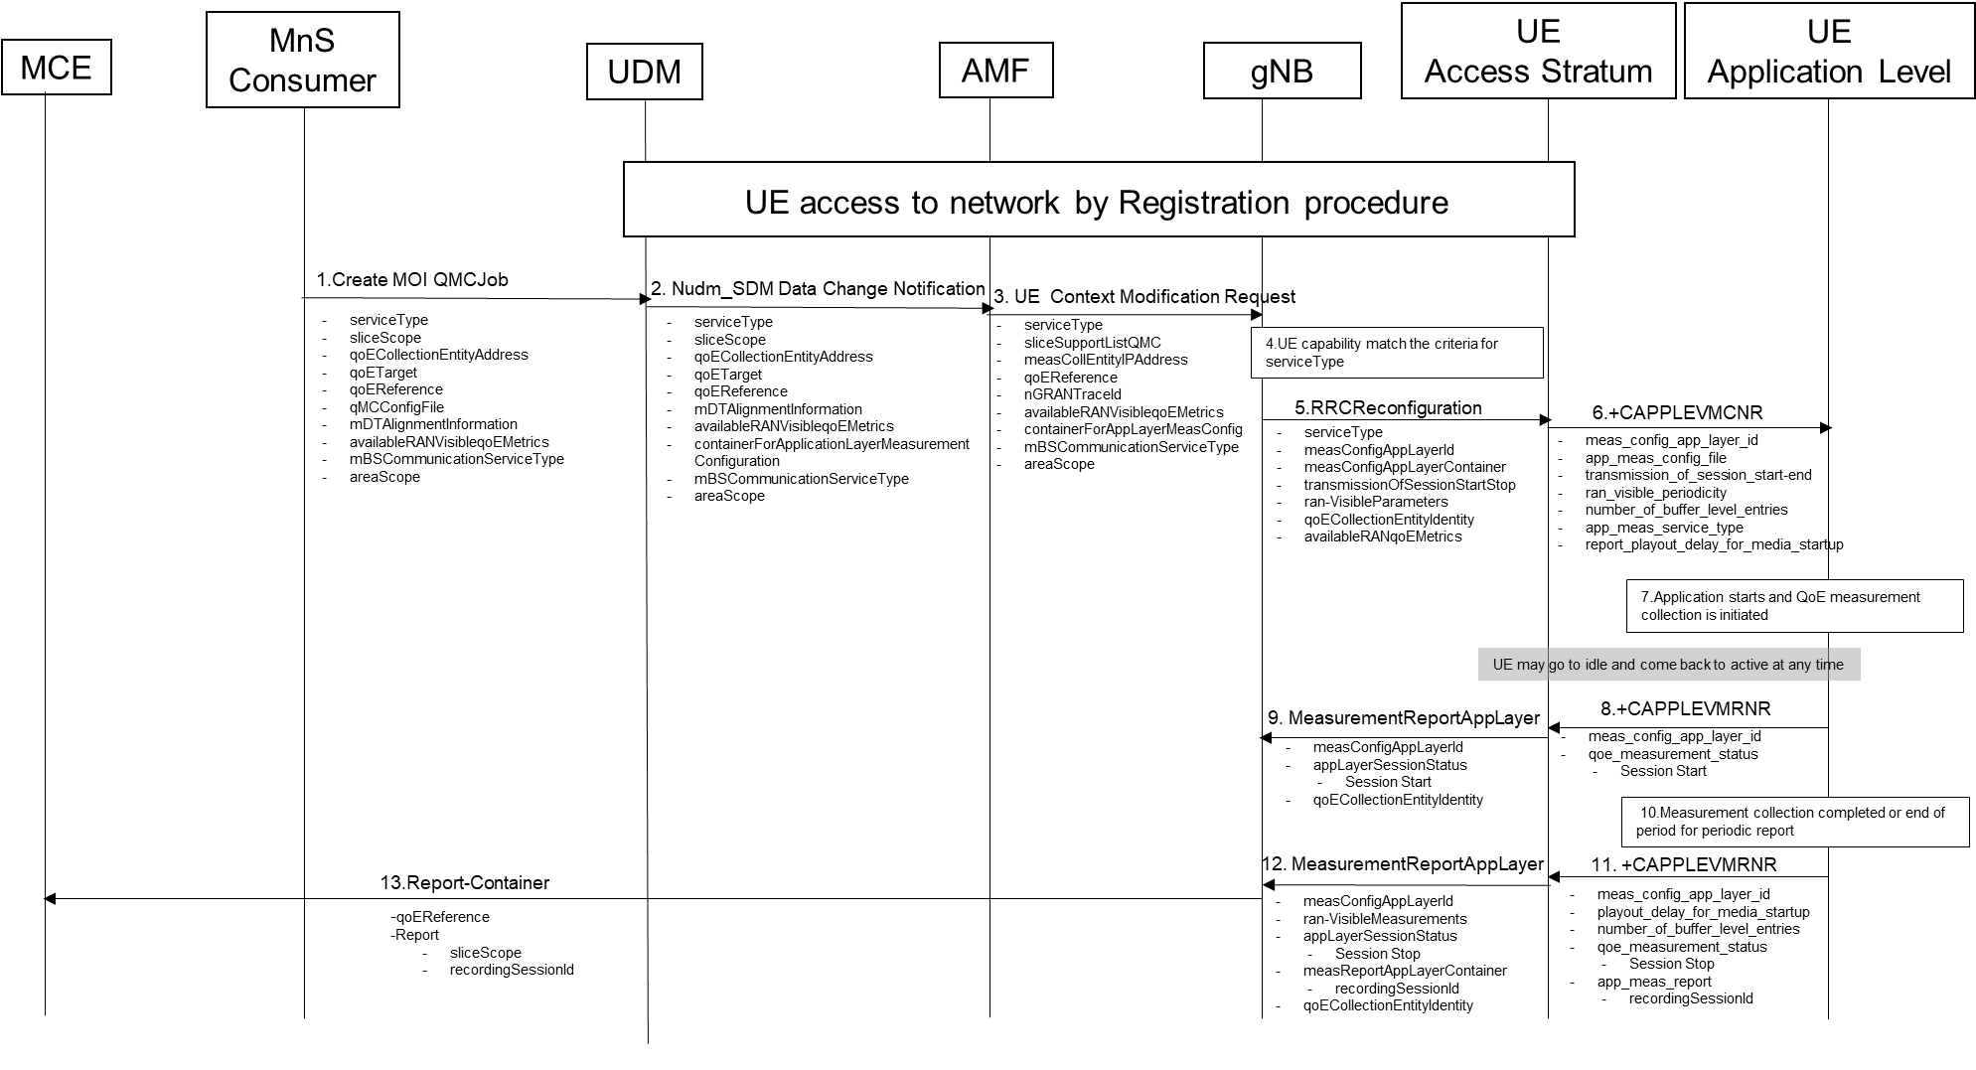
Figure 4.6.1.1-1: QMC activation and reporting example in NR after UE is registered

1. The MnS Consumer sends createMOI request for QMCJob to UDM that controls the impacted gNB(s), and includes the parameters: serviceType, sliceScope,areaScope, qoECollectionEntityAddress, qoETarget, qoEReference, mDTAlignmentInformation, availableRANqoEMetrics and qMCConfigFile.
2. The UDM inserts subscriber related data and forwards it to the AMF.
3. The AMF forwards the configuration parameters serviceType, areaScope,sliceSupportListQMC, measCollEntityIPAddress, qoEReference, nGRANTraceId, availablerANqoEMetrics and containerForAppLayerMeasConfig in message UE Context Modification Request to the impacted gNB.
4. The gNB checks if the UE capability matches the criteria for serviceType in the QoE measurement configuration information.
5. If the UE has the wanted UE capability, the gNB starts a UE request session and stores the associated qoECollectionEntityAddress, sends the message RRCReconfiguration to the UE including serviceType, measConfigAppLayerId, transmissionOfSessionStartStop, ran-VisibleParameters and measConfigAppLayerContainer.
If QoE measurement configuration pertains to MBS communication service, the gNB translates the qoECollectionEntityAddress into qoECollectionEntityIdentity and includes qoECollectionEntityIdentity in the RRCReconfiguration.
NOTE: The IE measConfigAppLayerId indicates the identity of the application layer measurement configuration, see [11].
6. The access stratum in the UE sends an unsolicited response to the application level including app-meas_service_type, meas_config_app_layer_id, transmission_of_session_start-end, ran_visible_periodicity, number_of_buffer_level_entries, report_playout_delay_for_media_startup, and app-meas_config_file. The unsolicited response is for the AT command +CAPPLEVMCNR which is sent from UE Application Level to UE Access Stratum during Registration procedure.
7. When the application for the specified serviceType starts, the QMC is initiated. To specify the session which is started, the application generates a recordingSessionId.
8. The application layer sends the AT command +CAPPLEVMRNR [7] including meas_config_app_layer_id and qoe_measurement_status that indicates that a session is started to the access stratum.
9. The UE sends the message MeasurementReportAppLayer including measConfigAppLayerId, appLayerSessionStatus and qoECollectionEntityIdentity to the gNB.
10. When the QMC is completed or at the end of period for periodic report, the recorded information is collected in a QMC report, see [6], [7] or [13].
11. The application layer sends the AT command +CAPPLEVMRNR [7] including meas_config_app_layer_id, playout_delay_for_media_startup, number_of_buffer_level_entries, qoe_measurement_status indicating that session has ended and app-meas_report including recordingSessionId to the access stratum.
12. The UE sends the message MeasurementReportAppLayer including measConfigAppLayerId, appLayerSessionStatus, ran-VisibleMeasurements and measReportAppLayerContainer including recordingSessionId and qoECollectionEntityIdentity to the gNB.
13. The gNB translates the qoECollectionEntityIdentity to the qoECollectionEntityAddress, if it is needed, and sends the QMC report to the MCE associated to the qoEReference. The report contains the qoEReference and the RAN transparent container including the recordingSessionId and sliceScope, which contains only the S-NSSAI used. Note that the qoEReference is mapped to the measConfigAppLayerId at gNB on the previous step and is included in QMC report.
Next modified section

4.6.1.2 Activation of QoE measurement task before UE Registration procedure to the network
Figure 4.6.1.2-1 and the text below describe the activation of QoE measurement collection before UE registration procedure to the network.
The AMF receives and stores QoE measurement collection job as part of API: Nudm_SDM. Then the same procedure for activation of measurement collection job is applied as after completion of UE registration procedure, except that instead of UE Context Modification Request the message Initial Context Setup Request is sent, see 4.6.1.1.

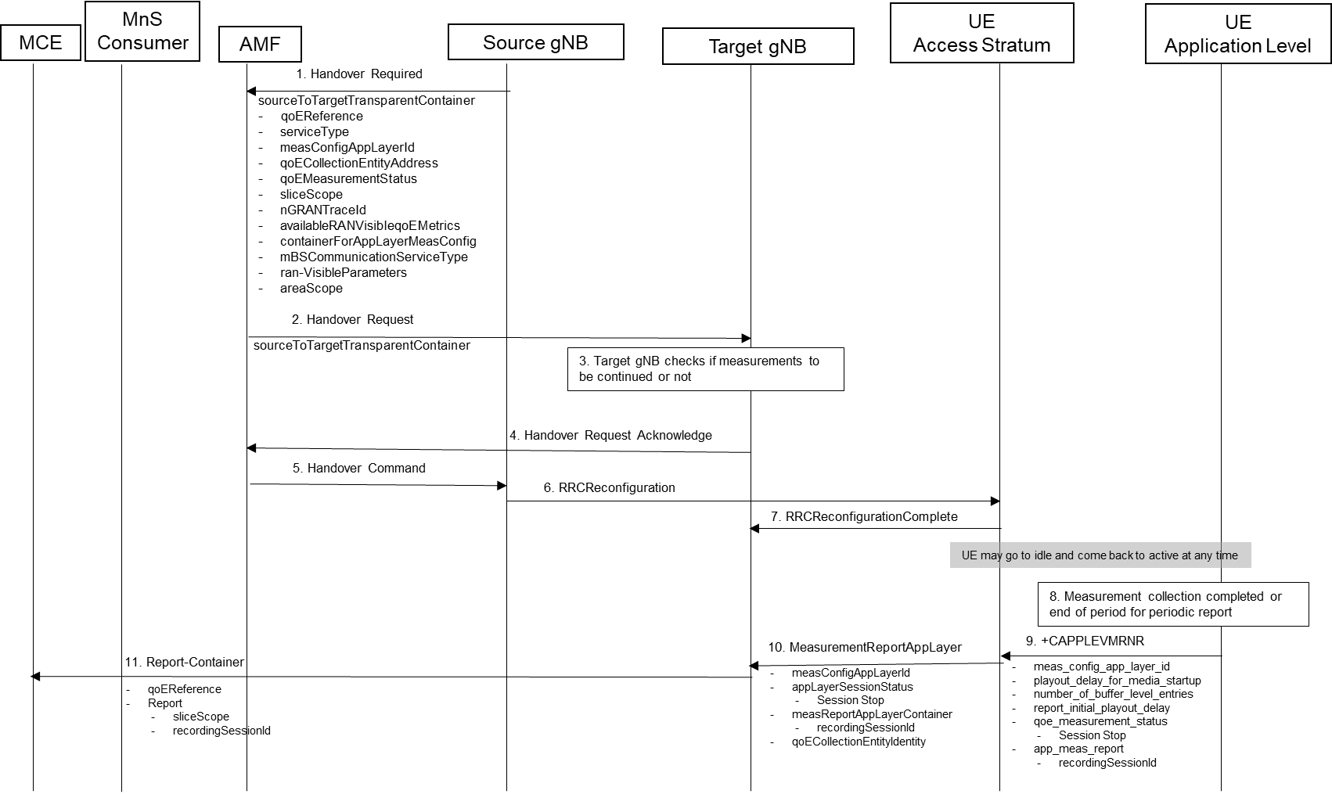
Figure 4.6.1.2-1: QMC activation and reporting example in NR before UE Registration procedure to the network
Next modified section

5.4 Area scope (CM)
The area scope parameter defines the area in terms or cells or Tracking Area/Routing Area/Location Area where the QMC shall take place. If the parameter is not present the QMC shall be done throughout the PLMN specified in PLMN target.
The area scope parameter in UMTS is either:
- List of cells, identified by CGI. Maximum 32 CGI can be defined.
- List of Routing Area, identified by RAI. Maximum of 8 RAIs can be defined.
- List of Location Area, identified by LAI. Maximum of 8 LAIs can be defined.
The area scope parameter in LTE is either:
- list of cells, identified by E-UTRAN-CGI. Maximum 32 CGI can be defined.
- List of Tracking Area, identified by TAC. Maximum of 8 TAC can be defined.
The area scope parameter in NR is either:
- list of cells, identified by N-CGI. Maximum 32 NCGI can be defined.
- List of Tracking Area, identified by TAC. Maximum of 8 TAC can be defined.
- List of Tracking Area Identity, identified by TAC with associated plmn-Identity perTAC-List containing the PLMN identity for each TAC. Maximum of 8 TAI can be defined. For further details see also TS 38.331[8].
The parameter is mandatory if area based QMC is requested.

End modified section

