3GPP TSG-SA5 Meeting #154 S5-242009d1
Changsha, China, 15 - 19 April 2024 Revision of S5-241214

Source: Ericsson Spain

Title: pCR TR 28.879 Add background on existing telco exposure initiatives

Document for: Approval
Agenda Item: 6.19.21

1 Decision/action requested
The group is asked to discuss and approve the proposal

2 References
[1] S5-241213 Discussion paper on exposure
[2] 3GPP TR 28.879 Management and orchestration; Study on OAM for service management and exposure to external consumers (Release 19), v0.1.0, 2024-02.

3 Rationale
The DP in [1] asks SA5 Working Group to agree on and endorse six (6) issues. The DP also highlights the intention to prepare different pCRs to capture the main insights of these issues.
The present pCR addresses issue #1, which notes the following: “it is needed to acknowledge the existing exposure frameworks, including 3GPP exposure framework and GSMA Open Gateway, their scope of activity, and the synergies/boundaries with respect to SA5”.
The present pCR also addresses issue #3, by providing management services eligible for discovery and consumption to any authorized MnS consumer, and making their relationships with existing telco initiatives.

4 Detailed proposal
This contribution proposes to take action as detailed in the rationale, by allocating clauses 3.1-3.3 from [1] into TR 28.879 [2].
This contribution addresses WT-1 of FS_MExpo.

1st Change

2 References
The following documents contain provisions which, through reference in this text, constitute provisions of the present document.
- References are either specific (identified by date of publication, edition number, version number, etc.) or non-specific.
- For a specific reference, subsequent revisions do not apply.
- For a non-specific reference, the latest version applies. In the case of a reference to a 3GPP document (including a GSM document), a non-specific reference implicitly refers to the latest version of that document in the same Release as the present document.
[1] 3GPP TR 21.905: "Vocabulary for 3GPP Specifications".
[m] SP-231669: “LS on collaboration and alignment of 3GPP defined application enablers with GSMA Open Gateway”.
[a] 3GPP TS 23.434 Service Enabler Architecture Layer for Verticals (SEAL); Functional architecture and information flows
[b] 3GPP TS 23.255 Application layer support for Vehicle-to-Everything (V2X) services; Functional architecture and information flows
[c] 3GPP TS 23.286 Application layer support for Uncrewed Aerial Systems (UAS) services; Functional architecture and information flows
[d] 3GPP TS 23.545 Application layer support for Factories of the Future (FF)
[e] 3GPP TS 23.542 Application layer support for Personal IoT Networks
[f] 3GPP TS 23.554 Application architecture for MSGin5G Service; Stage 2
[g] 3GPP TS 23.222 Common API Framework for 3GPP Northbound APIs; stage 2
[h] 3GPP TS 29.222 Common API Framework for 3GPP Northbound APIs; stage 3
[i] 3GPP TS 33.122 Security aspects of Common API Framework (CAPIF) for 3GPP Northbound APIs
[j] “The Ecosystem for Open Gateway NaaS API Development”, white paper, June 2023 [link]
[k] “GSMA Operator Platform Group – Requirements and Architecture”, version 5.0, July 2023 [link]
[l] 3GPP TS 28.533 Management and Orchestration; Architecture framework

2nd Change

3 Definitions of terms, symbols and abbreviations

3.1 Terms
For the purposes of the present document, the terms given in 3GPP TR 21.905 [1] and the following apply. A term defined in the present document takes precedence over the definition of the same term, if any, in 3GPP TR 21.905 [1].

3.2 Symbols
For the purposes of the present document, the following symbols apply:
<symbol> <Explanation>

3.3 Abbreviations
For the purposes of the present document, the abbreviations given in 3GPP TR 21.905 [1] and the following apply. An abbreviation defined in the present document takes precedence over the definition of the same abbreviation, if any, in 3GPP TR 21.905 [1].
WG Working Group
OAM Operation, Administration and Maintenance
SEAL Service Exposure Abstraction Layer
VAE Vertical App Enabler
CAPIF Common API Framework
CCF CAPIF Core Function

5GC 5G Core
EAS Edge Application Server
EDN Edge Data Network
EES Edge Enabler Server
EEC Edge Enabler Client
ECS Edge Configuration Server
V2X Vehicular-to-Everything
UAS Uncrewed Aerial Systems
FF Factories of the Future
NaaS Network as a Service
GSMA GSM Association
OPG Operator Platform Group
OPAG Operator Platform API Group
WAS Whole Agreement Services
CSP Communication Service Provider
NEF Network Exposure Function

3rd Change

4 Concepts and Background

4.x Background on existing telco exposure initiatives

4.x.1 3GPP exposure framework
3GPP standard exposure technologies hide the complexity of 5G and offer 3rd party applications a simple, secure, use-case-oriented configuration interface to the 5G system. The exposure interfaces will be quite valuable to a multitude of industrial use cases (i.e., non-telco use cases, with requirements beyond secure and reliable connectivity), allowing industry verticals to make use of the key features and performance that 5G has to offer in a simple and straightforward manner.
The development of solutions for exposure in 3GPP is led by SA6 WG. Figure X pictures the latest status of the 3GPP exposure framework. As seen, the framework consists of a set of Application Enablement Services (Edge, SEAL, Vertical App Enabler) that pursue one mission: to provide means to 3rd parties to rapidly develop and deploy new vertical-oriented applications (Application Layer) over 3GPP system (Network and OAM/CH). To that end, Application Enablement services offer industry-tailored APIs (Northbound Interface – service APIs) that build on 3GPP system APIs (Southbound Interface – network APIs). All these APIs are documented in 3GPP Technical Specifications and made available under the 3GPP GitLab repository.

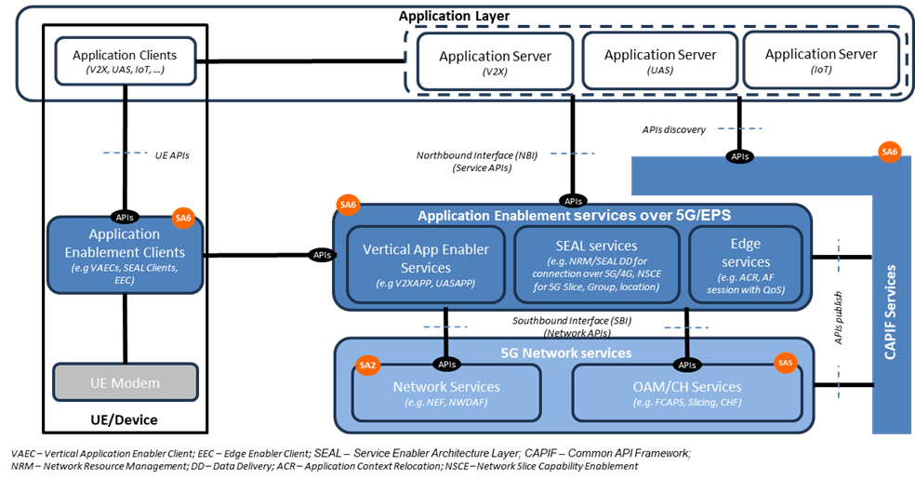
Figure X: 3GPP exposure framework. Figure extracted from [m].

SA6 WG realized soon that managing all these APIs, especially in an environment where 3rd parties are developing applications, will also require a management layer that enforces the strong security policies defined by SA3 WG (e.g., Mutual TLS Authentication). This is where CAPIF comes to the picture. Common API Framework (CAPIF) is defined to manage access to all 3GPP APIs, in a consistent and uniform way with regards to publication, discovery and access control, among other functionalities. The operator can use CAPIF as an entry point for the Application Layer to gain access to 3GPP APIs, including not only the APIs offered by Application Enablement services (SA6), but also the APIs offered by the 3GPP system (SA2 and SA5).
Table A provides a more detailed description of all the components mentioned above.
Table A: Components of the 3GPP exposure framework
Component | Description
3GPP system | Also referred to “5G Network Services” in Figure A, it includes:  - Network Services: groups all the capabilities related to 3GPP SA2. These are made available through Core network functions, e.g. Network Exposure Function (NEF).  - OAM/CH services: groups all the capabilities related to 3GPP SA5. These capabilities are offered through MnSs by producers.
Edge Services | It includes services for hosting edge computing applications, while consolidating edge computing standardization in 3GPP. These servicesprovide various capabilities such as rich discovery of the edge application servers (EAS), service continuity between multiple edge data networks (EDN), interworking with the core network, and APIs for EASs to integrate with the edge hosting environments. The main components building out this layer are:  - Edge Enabler Server (EES), primarily responsible for enabling discovery of EASs.  - Edge Enabler Client (EEC), providing support functions, such as EAS discovery to the application clients in the device.  - Edge Configuration Server (ECS), providing configurations to the EEC to connect with targeted EAS(s).  Note that the Edge Computing Layer only consumes network capability set from the 3GPP system (see Figure X)
Service Exposure Abstraction Layer (SEAL) | It provides a set of core services that are common to industry verticals. The motivation is largely to avoid redefining the individual services for each vertical industry, thereby lowering the deployment costs for operators, and significantly reducing the barrier of adoption and the time-to-market for integrating new verticals to the 3GPP ecosystem. SEAL services are specified in TS 23.434 [a], and include location management, group management, configuration management, identity management, key management, network resource management, data delivery, notification management, network slice capability enablement (NSCE) and application data analytics enablement
Vertical AppEnabler (VAE) | It provides vertical-specific service enablers. In contrast to the SEAL, VAE targets service specific vertical applications. As of today, the verticals service enablers are defined for:  - automotive applications referred to as vehicle-to-anything (V2X) communications [b].  - drone applications known as uncrewed aerial systems (UAS) [c]  - Industry 4.0/OT applications, also referred to as factories of the future (FF) [d]  - Personal IoT networks [e]  - Message communication in massive IoT, also referred to as MSGIn5G [f].
Common API Framework (CAPIF) | Started in Release 15, CAPIF services are listed in TS 23.222 [g] and specified in TS 29.222 [h] with security aspects being addressed in TS 33.122 [i]. It provides a unified Northbound API framework across network/application functions, to facilitate a harmonized approach for API exposure within 3GPP. This framework builds upon three main components:  - API invokers: they represent consumers of 3GPP APIs.  - CAPIF Core Function (CCF): responsible for managing onboarding of API invokers, and access control (authentication, authorization) when trying to gain access to 3GPP APIs.  - API provider domain: collection of functions (discovery, registration, publishing, auditability) required to allow authorized API invokers to consume 3GPP APIs. They implement agents that allow API producers to make APIs available through CAPIF.
Application Layer | This layer represents the 3rd party applications that want to gain access (discover and consume) 3GPP APIs, to develop and deploy new vertical services.

4.x.2 GSMA Open Gateway
The development of telco capability exposure (also coined “Network as a Service”, NaaS) requires a collaborative workspace that bring together incumbent telco standard bodies with IT/cloud communities, industry associations and open-source projects. An effective collaboration among organizations needs to be based on a clear demarcation on their scope of work, avoiding their participating organizations running overlapping activities or duplicate efforts; otherwise, NaaS may risk ending up with a fragmented ecosystem. To that end, the GSM Association (GSMA) launched Open Gateway in MWC Barcelona 23. GSMA Open Gateway mission is twofold: i) to provide a governance framework for NaaS, covering technical and business aspects; ii) to get operator commitment to launch universal NaaS API services in 2023.
Open Gateway initiative recognizes that NaaS the concept builds on the work developed by three organizations – see Table B. The role of the different organizations and their relationship is graphically shown in Figure Y.
Table B: Organizations participating in GSMA Open Gateway initiative.
Organization | Description of Activity
Linux Foundation’s CAMARA | it represents the “exposure” doctrine, i.e., how capabilities are exposed for external consumption through 3rd party facing APIs. CAMARA defines these APIs and is responsible for their hosting and release management. 3rd party facing APIs are dev-friendly (semantics tailored to service and business needs of 3rd parties) and open (following Apache2.0 license).
GSMA | it represents i) the “technical” doctrine, by specifying how 3rd party facing APIs are to be supported by underlying telco capabilities; and ii) the “business” doctrine, with the definition of agreement templates for federation between the operator networks and for relationship with 3rd parties, ensuring a consistent yet fair commercial framework for exposing services. GSMA conducts the technical workstream through OPG/OPAG (Operator Platform Group / Operator Platform API Group) and the business workstream through WAS (Wholesale Agreement Services) group.
TM Forum | it represents the “operational” doctrine, i.e., how 3rd party facing APIs are to be operated and managed, to make a commercial product out of them. Aspects such as 3rd party onboarding, application registration, access control and billing aspects are in scope.

On the one hand, scope of “GSMA” is restricted to the telco domain. GSMA prescribes the capabilities that all operators must make available for 3rd parties, to ensure global reach and scale. These must-be capabilities are referred to as Open Gateway services. The GSMA is also responsible for i) the prioritization and roadmap management of Open Gateway services, according to market needs and commercial readiness of underlying technologies; and ii) architecting the platform that individual operators will use to realize, federate, and expose Open Gateway services.

On the other hand, the focus of “CAMARA” and “TM Forum is on the dev-friendly APIs that allows programmatic access to Open Gateway services. As seen in the bottom of Figure Y, these APIs can be clustered into three groups: service APIs, service management APIs and operate APIs. For further information on these APIs, see [k].
Each Communication Service Provider (CSP) exposes APIs through the Open Gateway Transformation Function (Figure Y). Deployed as an internal component of GSMA Operator Platform [k] the Open Gateway Transformation Function is tasked with defining and enforcing the mapping between the dev-friendly APIs (towards 3rd party applications) and network APIs (towards 3GPP system). The mapping logic is not standardized, though GSMA provide non-prescriptive guidelines on a per API basis. For the interaction with OAM systems, the white paper in [10] notes that transformation function may interact with TM Forum (Open API portfolio) and 3GPP SA5 (management services).

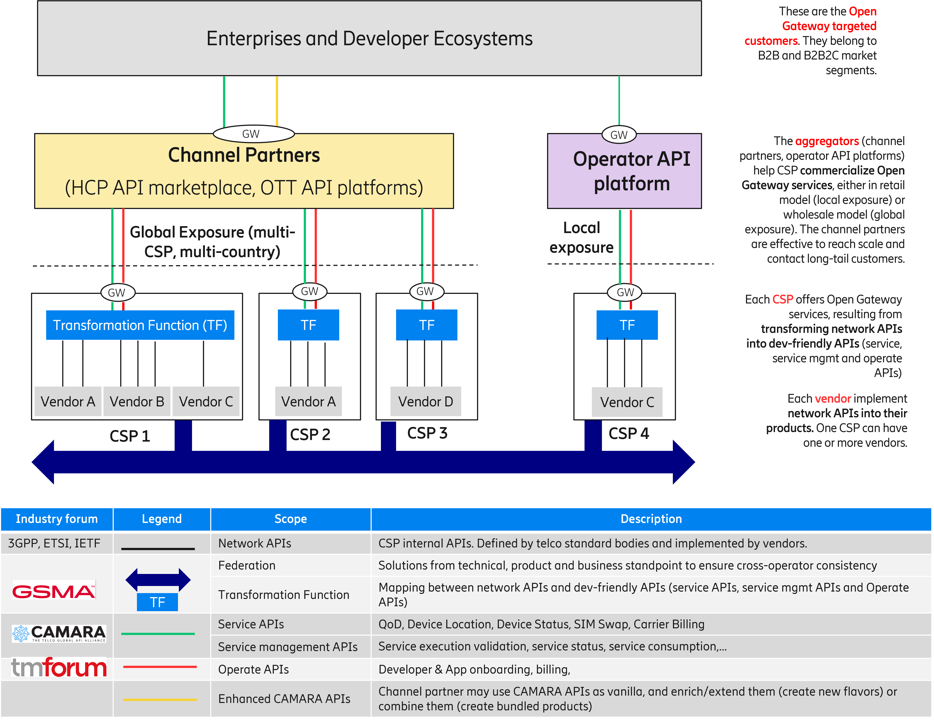
Figure Y: GSMA Open Gateway ecosystem.

4th Change

Annex A 3GPP management capabilities
SA5 WG is responsible for developing, maintaining, and evolving solutions building up the 3GPP management system. The relationship of the 3GPP management system with the state-of-the-art initiatives (clause 4.x) can be summarized as follows:
- Corresponds to the “OAM/CH services” box inside 3GPP system (see Figure X).
- Is a collection of solutions, from one or more vendors, that reside within the CSP domain (see Figure Y).
- Provides management capabilities which are realized via network APIs (see Figure Y).
The table below provides a (non-exhaustive) list of the management capabilities that can be provided by 3GPP management system. This list builds on the information available in TS 28.533 [l], Annex F, complementing it with mechanisms that are non-CRUD based.
Table Z: 3GPP management system capabilities.
Management Capability | Mechanisms | Solutions
 |  | RESTFUL | NETCONF/ YANG
Performance data collection control | CRUD operations (TS 28.532) + PM control NRM fragment (TS 28.622) | X | X
 | CRUD operation (TS 28.532) + managementDataCollection NRM fragment (TS 28.622) | X | X
 | Measurement job control (TS 28.550) | X
Performance data report | CRUD operations (TS 28.532) + PM control NRM fragment (TS 28.622) | X | X
 | File data reporting service (TS 28.532) | X
 | Streaming data reporting service (TS 28.532) | X
Performance data monitoring | CRUD operations (TS 28.552) + Threshold monitoring control NRM fragment (TS 28.622) | X | X
Trace/MDT data collection control | CRUD operations (TS 28.532) + Trace control NRM fragment (TS 28.622) | X | X
 | CRUD operation + managementDataCollection NRM fragment (TS28.532+TS 28.622) | X | X
Trace/MDT data report | File data reporting service (TS 28.532) | X
 | CRUD operations (TS 28.532) + File retrieval NRM fragment (TS 28.622) | X | X
 | Streaming data reporting service (TS 28.532)
Fault data control | CRUD operations (TS 28.532) + FM control NRM fragment (NRM | X | X
 | Fault supervision data control service (TS 28.532)
Fault data report | CRUD operations (TS 28.532) + FM control NRM fragment (NRM | X | X
 | Fault supervision data report service (TS 28.532)
QoE control | CRUD operations (TS 28.532) + QMC control NRM fragment (TS 28.532) | X | X
Service registry and discovery | CRUD operations (TS 28.532) + MnS Registry NRM fragment (TS 28.622) | X | X
Subscription | CRUD operations (TS 28.532) + Notification subscription control NRM fragment (TS 28.622) | X | X
AI/ML management | CRUD operations (TS 28.532) + ML Training NRM fragment (TS 28.105) | X | X
Management Data Analytics | CRUD operations (TS 28.532) + MDA request & report NRM fragment (TS 28.105) | X | X
NR Provisioning | CRUD operations (TS 28.532) + NR NRM fragment (TS 28.541) | X | X
5GC Provisioning | CRUD operations (TS 28.532) + 5GC NRM fragment (TS 28.541) | X | X
Network Slice Provisioning | CRUD operations (TS 28.541) + Network slice NRM fragment (TS 28.541) | X | X
 | Network slicing provisioning service (TS 28.531) | X
SON Policy | CRUD operations (TS 28.541) + NRM fragments for DANR/ DES/ DRACH/ DMRO/ DPCI/ CES / CPCI/ DLBO / CC O management (TS 28.541) | X | X
Intent Driven Management | CRUD operations (TS 28.532) + Intent NRM fragment (TS 28.312) | X | X
Edge Computing Provisioning | CRUD operations (TS 28.532) + Edge NRM fragment (TS 28.538) | X | X
Communication Service Assurance | CRUD operations (TS 28.532) + Assurance NRM fragment (TS 28.536) | X | X

End of changes

