3GPP TSG-SA5 Meeting #154 S5-241213d2
Changsha, China, 15 - 19 April 2024 Revision of S5-242007

Source: Ericsson Spain

Title: Discussion paper on exposure

Document for: Information
Agenda Item: 6.19.21

1 Decision/action requested
The group is asked to discuss and endorse the proposal

2 References
[1] 3GPP TS 23.434 Service Enabler Architecture Layer for Verticals (SEAL); Functional architecture and information flows
[2] 3GPP TS 23.255 Application layer support for Vehicle-to-Everything (V2X) services; Functional architecture and information flows
[3] 3GPP TS 23.286 Application layer support for Uncrewed Aerial Systems (UAS) services; Functional architecture and information flows
[4] 3GPP TS 23.545 Application layer support for Factories of the Future (FF)
[5] 3GPP TS 23.542 Application layer support for Personal IoT Networks
[6] 3GPP TS 23.554 Application architecture for MSGin5G Service; Stage 2
[7] 3GPP TS 23.222 Common API Framework for 3GPP Northbound APIs; stage 2
[8] 3GPP TS 29.222 Common API Framework for 3GPP Northbound APIs; stage 3
[9] 3GPP TS 33.122 Security aspects of Common API Framework (CAPIF) for 3GPP Northbound APIs
[10] “The Ecosystem for Open Gateway NaaS API Development”, white paper, June 2023 [link]
[11] “GSMA Operator Platform Group – Requirements and Architecture”, version 5.0, July 2023 [link]
[12] SP-231728 Study on Enhanced OAM for management exposure to external consumers.
[13] 3GPP TS 28.530 Management and orchestration; Concepts, use cases and requirements
[14] 3GPP TR 28.824 Study on network slice management capability exposure
[15] 3GPP TS 28.319 Management and orchestration; Access Control for Management Services
[16] 3GPP TS 28.531 Management and orchestration; Provisioning
[17] 3GPP TS 23.435 Procedures for Network Slice Capability Exposure for Application Layer Enablement Service
[18] SP-231669: “LS on collaboration and alignment of 3GPP defined application enablers with GSMA Open Gateway”.

3 Rationale

3.1 3GPP exposure framework
3GPP standard exposure technologies hide the complexity of 5G and offer 3rd party applications a simple, secure, use-case-oriented configuration interface to the 5G system. The exposure interfaces will be quite valuable to a multitude of industrial use cases (i.e., non-telco use cases, with requirements beyond secure and reliable connectivity), allowing industry verticals to make use of the key features and performance that 5G has to offer in a simple and straightforward manner.

The development of solutions for exposure in 3GPP is led by SA6 WG. Figure 1 pictures the latest status of the 3GPP exposure framework, according to what SA reported in [1]. As seen, the framework consists of a set of Application Enablement services (Edge, SEAL, Vertical App Enabler) that pursue one mission: to provide means to 3rd parties to rapidly develop and deploy new vertical-oriented applications (Application Layer) over 3GPP system (Network and OAM/CH). To that end, Application Enablement services offer industry-tailored APIs (Northbound Interface – service APIs) that build on 3GPP system APIs (Southbound Interface – network APIs). All these APIs are documented in 3GPP Technical Specifications and made available under the 3GPP GitLab repository.

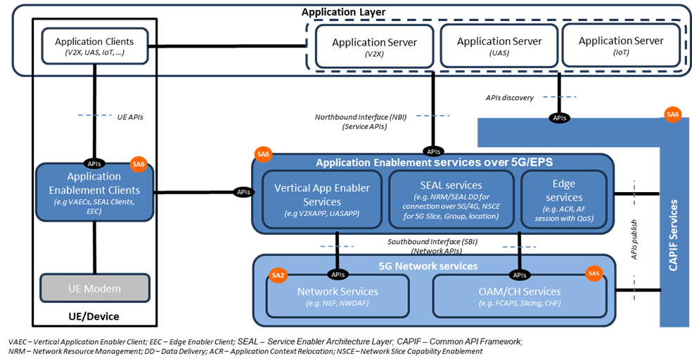
Figure 1: 3GPP exposure framework. Figure extracted from [18].

SA6 WG realized soon that managing all these APIs, especially in an environment where 3rd parties are developing applications, will also require a management layer that enforces the strong security policies defined by SA3 WG (e.g., Mutual TLS Authentication). This is where CAPIF comes to the picture. CAPIF is the “Common API Framework” defined to manage access to all 3GPP APIs, in a consistent and uniform way with regards to publication, discovery and access control, among other functionalities. The operator can use CAPIF as an entry point for the application layer to gain access to 3GPP APIs, including not only the APIs offered by the Application Enablement services (SA6), but also the APIs offered by the 3GPP system (SA2 and SA5).

Table 1 provides a more detailed description of all the components mentioned above.
Table 1: Components of the 3GPP exposure framework
Component | Description
3GPP system | Also referred to ‘5G Network Services’ in the figure, it includes:  - Network Services: groups all the capabilities related to 3GPP SA2. These are made available through Core Network Functions, e.g. Network Exposure Function (NEF).  - OAM/CH services: groups all the capabilities related to 3GPP SA5. These capabilities are offered through MnSs by producers.
Edge Services | It includes services for hosting edge computing applications, while consolidating edge computing standardization in 3GPP. These services provide various capabilities such as rich discovery of the edge application servers (EAS), service continuity between multiple edge data networks (EDN), interworking with the core network, and APIs for EASs to integrate with the edge hosting environments. The main components building out this layer are:  - Edge Enabler Server (EES), primarily responsible for enabling discovery of EASs.  - Edge Enabler Client (EEC), providing support functions, such as EAS discovery to the application clients in the device.  - Edge Configuration Server (ECS), providing configurations to the EEC to connect with targeted EAS(s).  Note that the Edge Computing Layer only consumes network capability set from the 3GPP system (see Figure 1)
Service Exposure Abstraction Layer (SEAL) | It provides a set of core services that are common to industry verticals. The motivation is largely to avoid redefining the individual services for each vertical industry, thereby lowering the deployment costs for operators, and significantly reducing the barrier of adoption and the time-to-market for integrating new verticals to the 3GPP ecosystem. SEAL services are specified in TS 23.434 [1], and include location management, group management, configuration management, identity management, key management, network resource management, data delivery, notification management, network slice capability enablement (NSCE) and application data analytics enablement
Vertical Application Enabler (VAE) | It provides vertical-specific service enablers. In contrast to the SEAL, VAE targets service specific vertical applications. As of today, the verticals service enablers are defined for:  - automotive applications referred to as vehicle-to-anything (V2X) communications [2].  - drone applications known as uncrewed aerial systems (UAS) [3]  - Industry 4.0/OT applications, also referred to as factories of the future (FF) [4]  - Personal IoT networks [5]  - Message communication in massive IoT, also referred to as MSGIn5G [6].
Common API Framework (CAPIF) | Started in Release 15, CAPIF services are listed in TS 23.222 [7] and specified in TS 29.222 [8] with security aspects being addressed in TS 33.122 [9]. It provides a unified Northbound API framework across network/application functions, to facilitate a harmonized approach for API exposure within 3GPP. This framework builds upon three main components:  - API invokers: they represent consumers of 3GPP APIs.  - CAPIF Core Function (CCF) responsible for managing onboarding of API invokers, and access control (authentication, authorization) when trying to gain access to 3GPP APIs.  - API provider domain: collection of functions (discovery, registration, publishing, auditability) required to allow authorized API invokers to consume 3GPP APIs. They implement agents that allow API producers to make APIs available through CAPIF.
Application Layer | This layer represents the 3rd party applications that want to gain access (discover and consume) 3GPP APIs, to develop and deploy new vertical services.

3.2 GSMA Open Gateway
The development of telco capability exposure (also coined “Network as a Service”, NaaS) requires a collaborative workspace that bring together incumbent telco standard bodies with IT/cloud communities, industry associations and open-source projects. An effective collaboration among organizations needs to be based on a clear demarcation on their scope of work, avoiding their participating organizations running overlapping activities or duplicate efforts; otherwise, NaaS may risk ending up with a fragmented ecosystem. To that end, GSMA launched Open Gateway in MWC Barcelona 23. GSMA Open Gateway mission is twofold: i) to provide a governance framework for NaaS, covering technical and business aspects; ii) to get operator commitment to launch universal NaaS API services in 2023.
Open Gateway initiative recognizes that NaaS the concept builds on the work developed by three organizations. The role of the different organizations and their relationship is graphically shown in Figure 2.
Table 2. Organizations participating in GSMA Open Gateway initiative.
Organization | Description of Activity
Linux Foundation’s CAMARA | it represents the “exposure” doctrine, i.e., how capabilities are exposed for external consumption through 3rd party facing APIs. CAMARA defines these APIs and is responsible for their hosting and release management. 3rd party facing APIs are dev-friendly (semantics tailored to service and business needs of 3rd parties) and open (following Apache2.0 license).
GSMA | it represents i) the “technical” doctrine, by specifying how 3rd party facing APIs are to be supported by underlying telco capabilities; and ii) the “business” doctrine, with the definition of agreement templates for federation between the operator networks and for relationship with 3rd parties, ensuring a consistent yet fair commercial framework for exposing services. GSMA conducts the technical workstream through OPG/OPAG (Operator Platform Group / Operator Platform API Group) and the business workstream through WAS (Wholesale Agreement Services) group.
TM Forum | it represents the “operational” doctrine, i.e., how 3rd party facing APIs are to be operated and managed, to make a commercial product out of them. Aspects such as 3rd party onboarding, application registration, access control and billing aspects are in scope.

On the one hand, scope of GSMA is restricted to the telco domain. GSMA prescribes the capabilities that all operators must make available for 3rd parties, to ensure global reach and scale. These must-be capabilities are referred to as Open Gateway services. The GSMA is also responsible for i) the prioritization and roadmap management of Open Gateway services, according to market needs and commercial readiness of underlying technologies; and ii) architecting the platform that individual operators will use to realize, federate and expose Open Gateway services.

On the other hand, the focus of CAMARA and TM Forum is on the dev-friendly APIs that allows programmatic access to Open Gateway services. As seen in the bottom of Figure 2, these APIs can be clustered into three groups: service APIs, service management APIs and operate APIs. For further information on these APIs, see [10].
Each CSP exposes APIs through the Open Gateway Transformation Function (Figure 2). Deployed as an internal component of GSMA Operator Platform [11] the Open Gateway Transformation Function is tasked with defining and enforcing the mapping between the dev-friendly APIs (towards 3rd party applications) and network APIs (towards 3GPP system). The mapping logic is not standardized, though GSMA provide non-prescriptive guidelines on a per API basis. For the interaction with OAM systems, the white paper in [10] notes that transformation function may interact with TM Forum (Open API portfolio) and 3GPP SA5 (management services).

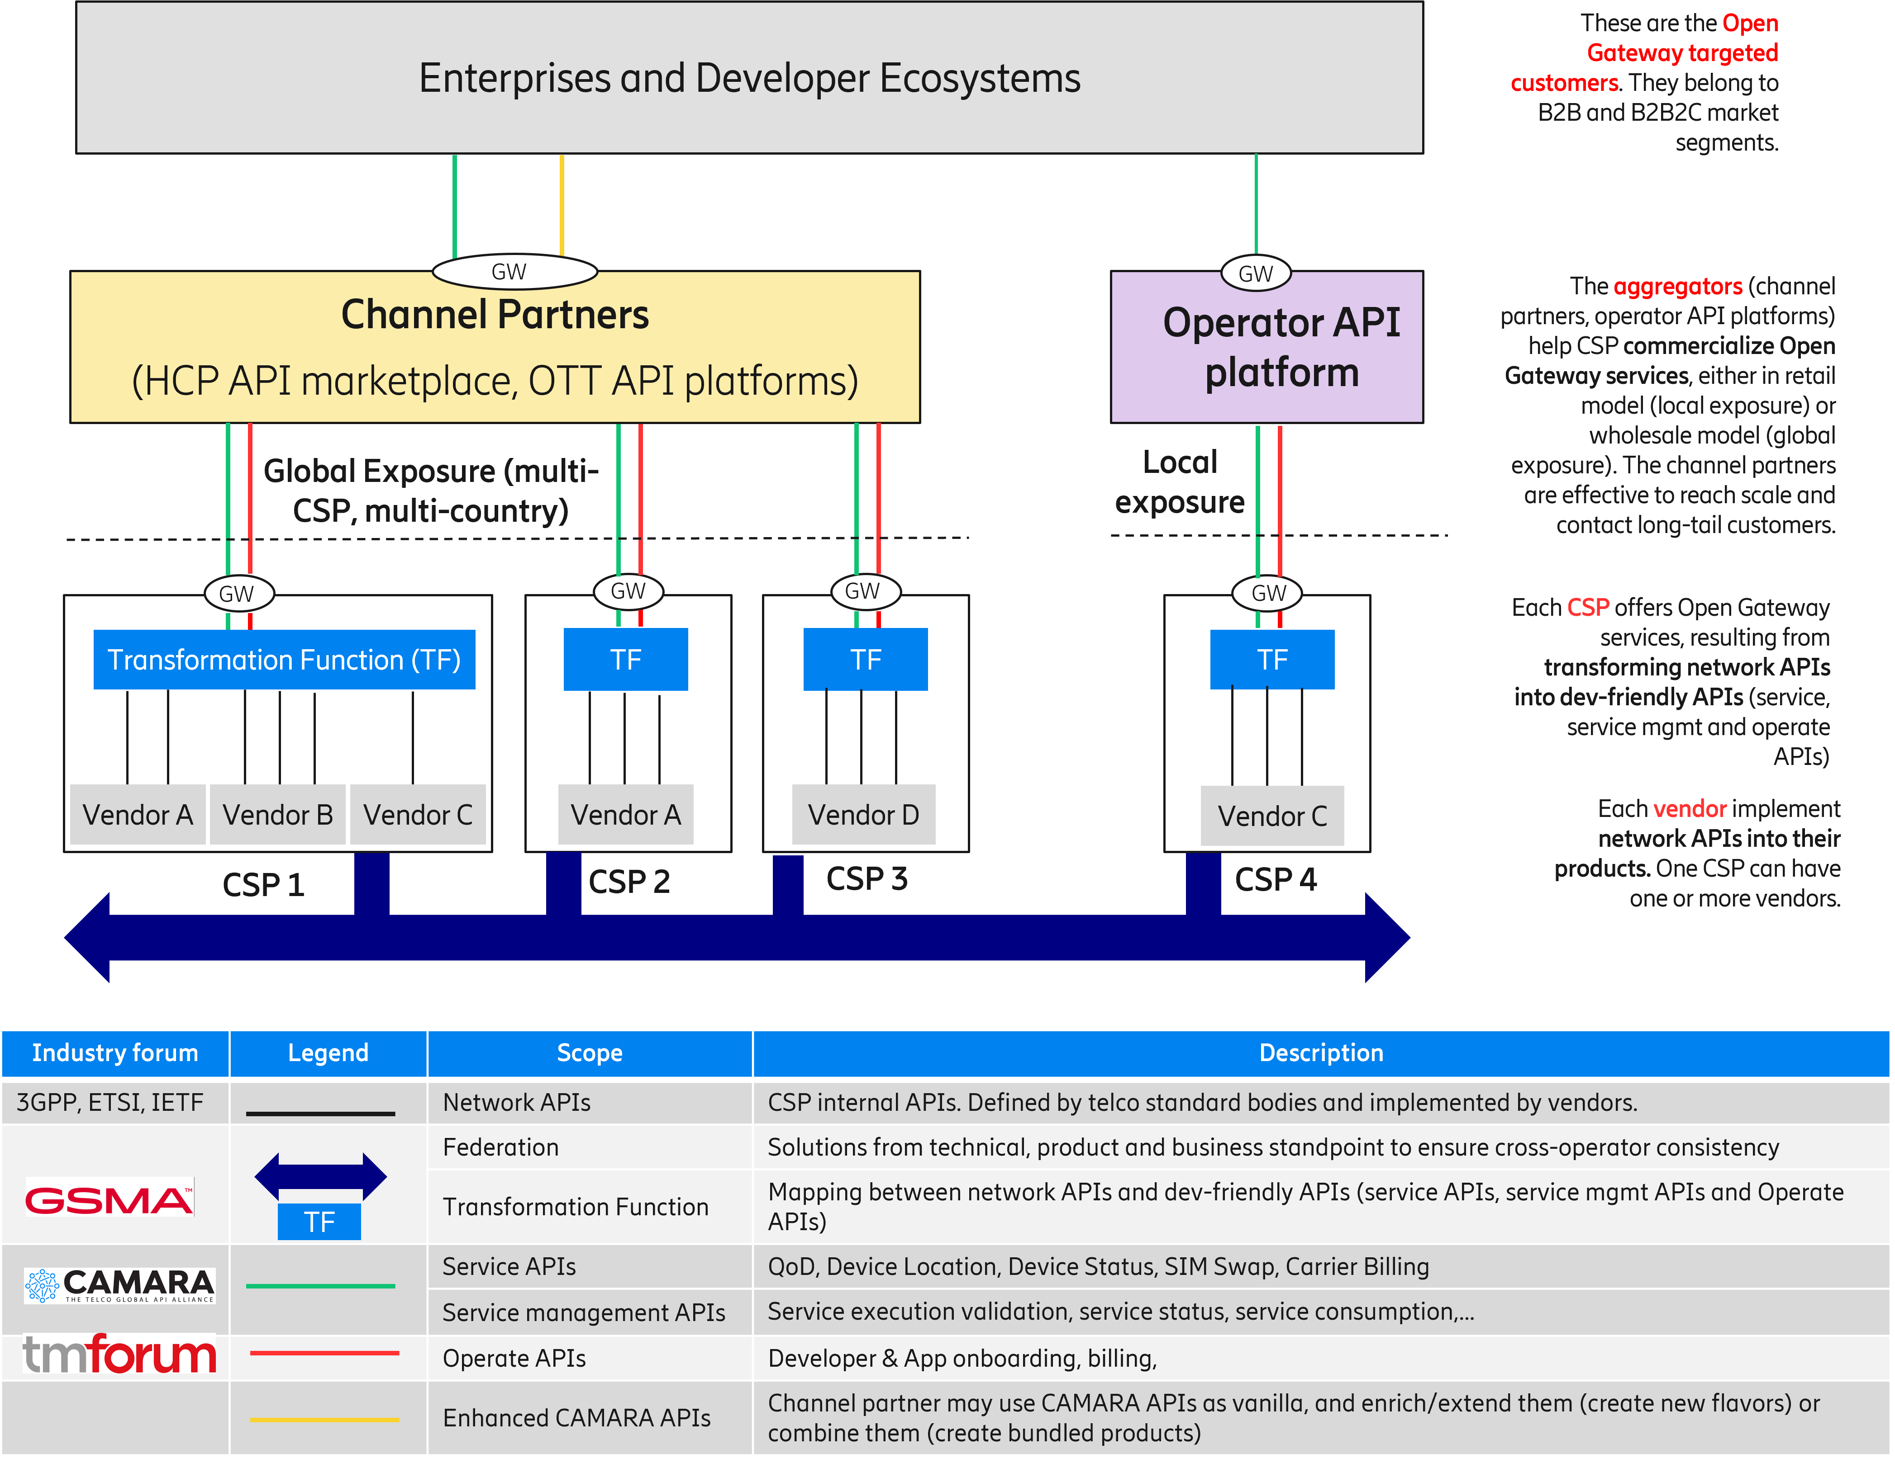
Figure 2: Open Gateway ecosystem.

3.3 3GPP management capabilities
SA5 WG is responsible for developing, maintaining, and evolving solutions building up the 3GPP management system. The relationship of the 3GPP management system with the state-of-the-art initiatives (clause 3.1 and clause 3.2) can be summarized as follows:
- Corresponds to the “OAM/CH services” box inside 3GPP system (see Figure 1).
- Is a collection of solutions, from one or more vendors, that reside within the CSP domain (see Figure 2).
- Provides management capabilities which are realized via network APIs (see Figure 2).
The table below provides a (non-exhaustive) list of the management capabilities that can be provided by 3GPP management system. This list builds on the information available in TS 28.533 [22], Annex F, complementing it with mechanisms that are non-CRUD based.
Table 3: 3GPP management system capabilities.
Management Capability | Mechanisms | Solutions
 |  | RESTFUL | NETCONF/ YANG
Performance data collection control | CRUD operations (TS 28.532) + PM control NRM fragment (TS 28.622) | X | X
 | CRUD operation (TS 28.532) + managementDataCollection NRM fragment (TS 28.622) | X | X
 | Measurement job control (TS 28.550) | X
Performance data report | CRUD operations (TS 28.532) + PM control NRM fragment (TS 28.622) | X | X
 | File data reporting service (TS 28.532) | X
 | Streaming data reporting service (TS 28.532) | X
Performance data monitoring | CRUD operations (TS 28.552) + Threshold monitoring control NRM fragment (TS 28.622) | X | X
Trace/MDT data collection control | CRUD operations (TS 28.532) + Trace control NRM fragment (TS 28.622) | X | X
 | CRUD operation + managementDataCollection NRM fragment (TS28.532+TS 28.622) | X | X
Trace/MDT data report | File data reporting service (TS 28.532) | X
 | CRUD operations (TS 28.532) + File retrieval NRM fragment (TS 28.622) | X | X
 | Streaming data reporting service (TS 28.532)
Fault data control | CRUD operations (TS 28.532) + FM control NRM fragment (NRM | X | X
 | Fault supervision data control service (TS 28.532)
Fault data report | CRUD operations (TS 28.532) + FM control NRM fragment (NRM | X | X
 | Fault supervision data report service (TS 28.532)
QoE control | CRUD operations (TS 28.532) + QMC control NRM fragment (TS 28.532) | X | X
Service registry and discovery | CRUD operations (TS 28.532) + MnS Registry NRM fragment (TS 28.622) | X | X
Subscription | CRUD operations (TS 28.532) + Notification subscription control NRM fragment (TS 28.622) | X | X
AI/ML management | CRUD operations (TS 28.532) + ML Training NRM fragment (TS 28.105) | X | X
Management Data Analytics | CRUD operations (TS 28.532) + MDA request & report NRM fragment (TS 28.105) | X | X
NR Provisioning | CRUD operations (TS 28.532) + NR NRM fragment (TS 28.541) | X | X
5GC Provisioning | CRUD operations (TS 28.532) + 5GC NRM fragment (TS 28.541) | X | X
Network Slice Provisioning | CRUD operations (TS 28.541) + Network slice NRM fragment (TS 28.541) | X | X
 | Network slicing provisioning service (TS 28.531) | X
SON Policy | CRUD operations (TS 28.541) + NRM fragments for DANR/ DES/ DRACH/ DMRO/ DPCI/ CES / CPCI/ DLBO / CC O management (TS 28.541) | X | X
Intent Driven Management | CRUD operations (TS 28.532) + Intent NRM fragment (TS 28.312) | X | X
Edge Computing Provisioning | CRUD operations (TS 28.532) + Edge NRM fragment (TS 28.538) | X | X
Communication Service Assurance | CRUD operations (TS 28.532) + Assurance NRM fragment (TS 28.536) | X | X

3.4 External MnS Consumer concept

3.4.1 Definition
As of today, there does not exist a definition for external consumer concept; actually, in the study item description [12], the only reference made on this concept is as follows: “[…] external consumers (i.e. outside 3GPP)/verticals”. This reference is clearly not sufficient, since:
- It does not clarify what external consumer concept means and represents; without this information, it is difficult to contextualize and circumscribe/restrict the discussion within this study item.
- It uses instances of a role (i.e., service consumer) and a stakeholder (i.e., vertical) interchangeably; this is not correct, because of two reasons. On the one hand, one stakeholder can be flexibly mapped into one or more roles (and the other way round), as per the actor-role model described in TS 28.530 [13]. On the other hand, 3GPP management system builds on the SBMA principles, focusing on service producer and consumer roles, regardless of which specific stakeholders take on these roles. The latter represents business-like discussions that shall be avoided in SA5, because they may engage both OAM and CH sub-groups in endless non-technical discussions that, in the best case, may lead to conclusions that has nothing to do with purposes related to interoperability and multi-vendor integration. Examples of these discussions include the landscape of stakeholders that can benefit from 3GPP management capabilities (see TR 28.824 [14], clause 4.2.1) and their business relationships (e.g., B2B, B2B2C); all of them shall be avoided in OAM and CH sub-groups.
- The “outside 3GPP” wording can be interpreted in multiple different ways, since there are no clear boundaries of what 3GPP covers today or not, especially in the service and application layer, where 3GPP exposure framework (led by 3GPP SA6, see clause 3.1) and Open Gateway initiative (led by GSMA, in cooperation with TM Forum and CAMARA, see clause 3.2) compete for the same space. A clear example of this competition can be noticed between SEAL/VAE Layer and Open Gateway Transformation Function: both provide functionality to vertical customers and application service providers using service APIs; they differ in API design rules and consumption patterns, though.

In this regard, it is proposed to provide a definition of an external MnS consumer for 3GPP SA5, as follows:
“External MnS consumer: an MnS consumer that has discovered an MnS via a discovery mechanism which is not defined in 3GPP SA5. CAPIF [7] is an example of a framework providing such discovery mechanism”.
This definition:
- Does not dig into ‘behind-the-scene’ details of MnS consumer (e.g., who is the stakeholder behind this consumer, which is the business relationship with the operator, etc), thus complying with point 2.
- Does not dig into ‘outside/inside’ 3GPP, thus complying with point 3.
- Allows to set the demarcation point with the work done in other study items (e.g., FS_eSBMA_ph3) for discovery issues.

3.4.2 Contextualizing the concept into the existing telco initiatives
When looking into the 3GPP exposure framework (clause 3.1), it can be noticed that it includes CAPIF. CAPIF provides a discovery mechanism to gain access to 3GPP APIs, including SA2 APIs (network services), SA5 APIs (OAM/CH services) and SA6 APIs (application enablement services over 5GS/EPS). This mechanism is an example of discovery mechanism defined outside SA5, and thus fits with the definition of external MnS consumer (“MnS consumer that has discovered an MnS via a discovery mechanism which is not defined in 3GPP SA5”).
In this vein, it is worth noting that:

- Application Layer components always complies with the external MnS consumer definition, since they always need CAPIF to gain access to MnSs (OAM/CH services box).
- When accessing to MnS (OAM/CH services box) using CAPIF, Application Enablement services over 5GS/EPS comply to the external MnS consumer definition.
- When accessing to MnS (OAM/CH services box) using Soutbound Interface (network APIs), Application Enablement services over 5GS/EPS do not comply to the external MnS consumer definition.

See further details with the red arrows below.
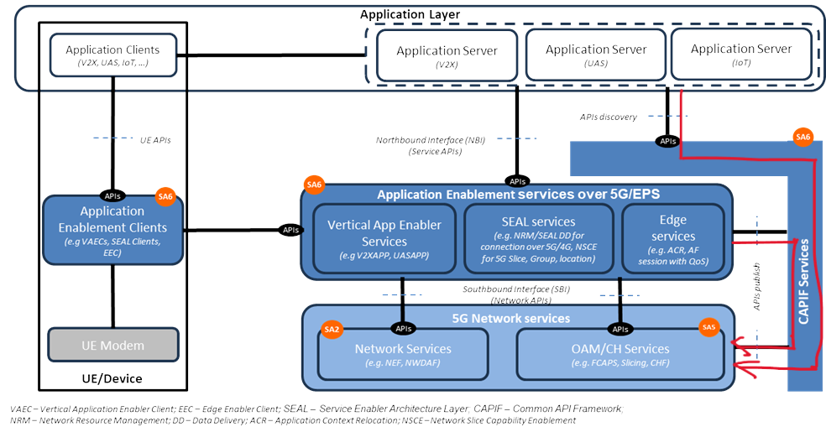

When looking the Open Gateway ecosystem (clause 3.2), it is noted that Open Gateway services (defined by GSMA) are offered through dev-friendly APIs (specified and maintained by CAMARA and TM Forum). Some service provisioning and monitoring actions on 5G managed resources, including network slicing. In such a case, the invocation of these dev-friendly APIs needs to be mapped into one or more calls to MnSs. The Open Gateway Transformation Function is in charge of this mapping and MnS invocation. To that end, the Open Gateway Transformation Function needs to be able to discover MnSs. In this regard, one realizes that the Open Gateway Transformation Function complies with the external consumer definition, when it gains access to MnS via CAPIF.

3.4.3 Examples of external MnS consumers
Based on the points made in clause 3.4.2, some examples of MnS consumers can be illustrated
Figure X provides examples of functional entities that can become external MnS consumers. Table A elaborates on the rationale.

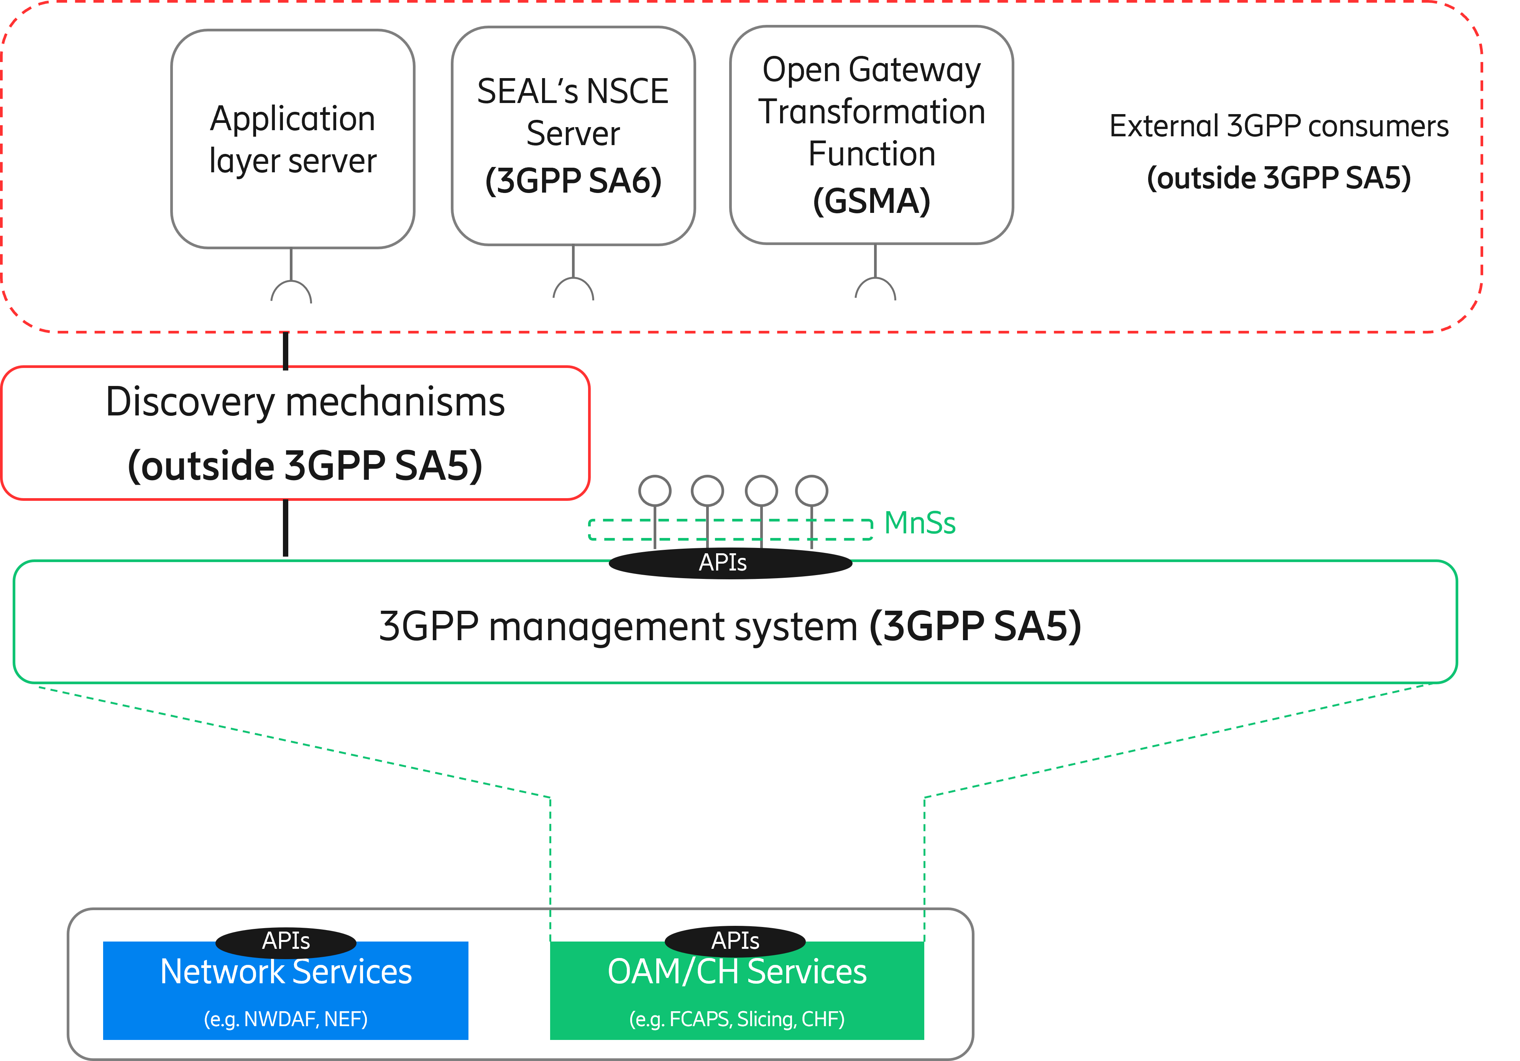
Figure X: Examples external MnS consumers.

Table A: Examples of external MnS consumers.
Functional Entity | Justification
Application Layer Server | Any 3rd party application that gains access (discover and consume) to MnSs using a discovery mechanism defined outside SA5 is an external MnS consumer. The logic of this application is on 3rd party and outside standardization.
SEAL’s NSCE server | Network Slice Capability Exposure (NSCE) is a SEAL service that provides add-on slicing capabilities to vertical customers’ applications. NSCE has a server and multiple clients (installed on vertical customer’s devices). NSCE server consumes slicing capabilities related to OAM (i.e., MnSs) and 5G network services (i.e., NEF APIs, NWDAF APIs, NSCAF APIs), and process them (aggregation, abstraction, filtering, etc.) in order to build vertical-oriented slicing functionality to applications.  The set of operations/notifications that are eligible for consumption by NSCE server are specified in TS 28.531 [16], and conceptually grouped under the NSCE-OAM interface in TS 23.435 [17]. To gain access to slicing capabilities related to OAM, NSCE server can use a discovery mechanism defined outside SA5. In this regard, the NSCE server becomes an external (network slice / network slice subnet) MnS consumer.
Open Gateway Transformation Function | Open Gateway services (defined by GSMA) are offered through dev-friendly APIs (specified and maintained by CAMARA and TM Forum). Some services provisioning and monitoring actions on 5G managed resources, including network slicing. In such a case, the invocation of these dev-friendly APIs needs to be mapped into one or more calls to MnSs. The Open Gateway Transformation Function is in charge of this mapping and MnS invocation. To that end, the Open Gateway Transformation needs to be able to discover MnS. In this regard, one can realize that the Open Gateway Transformation Function complies with the external MnS consumer when it gains access to MnSs using a discovery mechanism defined outside SA5.

It is worth noting that the functional entities represented as examples of external MnS consumers:
- provides a non-exhaustive list; the only aim is to provide clarity on how external MnS consumer concept fits with the background of telco exposure initiatives reported in the background.
- are all optional; the decision to deploy these functional entities or not is up to operator discretion.
- perform the role of “API invokers, when the discovery mechanism these entities use to gain access to MnSs is the mechanism provided by CAPIF.

4 Detailed proposal
The group is asked to agree and endorse the following issues:
Issue #1: It is needed to acknowledge the existing exposure initiatives, including 3GPP exposure framework (clause 3.1) and GSMA Open Gateway (clause 3.2), their scope of activity, and the synergies/boundaries with respect to SA5.
Issue #2: It is needed in SA5 to avoid discussion on which stakeholders can become external MnS consumers, as these represent business-like discussions that may engage the SA5 OAM and CH groups in endless discussions that, in the best case, may lead to conclusions that has nothing to do with purposes related to interoperability and multi-vendor integration. Examples of these discussions include the landscape of stakeholders that can benefit from 3GPP management capabilities (see [14], clause 4.2.1) and their commercial relationships (e.g., B2B, B2B2C). These discussions are held in the exposure frameworks noted in issue #1; the role of SA5 is to enforce the decisions informed from these exposure frameworks.
Issue #3: The 3GPP management system provides a set of management services, which are listed in Table 3. All these services are eligible for discovery and consumption to any authorized MnS consumer. Whether this consumer is internal or external is irrelevant, as long as the consumer is duly authorized. In other words, the decision on which MnSs can be discovered/consumed by each consumer cannot rely on whether the consumer is internal or external; otherwise, this would require knowing which stakeholders are behind each consumer, going back to the highly discouraged discussions noted in issue #2.
Issue #4: It is needed to have a formal definition for external MnS consumer concept in SA5, as discussed in clause 3.4.1. This definition should:
- Comply with the SBMA foundations governing 3GPP management system.
- Adhere to the prescriptions noted in issue #2.
Issue #5: It is needed to provide examples of functional entities that can become external MnS consumers, to shed light on how the concept of external MnS consumer concept fits into the existing telco exposure initiatives, making sure terminology and scope of discussion is consistent across different SDOs.

To reflect on the above tenets, the following pCRs targeting TR 28.879 have been prepared. All of them aim to address WT-1 of the FS_MExpo.

TDoc | Title | Related issue
S5-242009 | pCR TR 28.879 Add background on existing telco exposure initiatives | 1, 3
S5-242010 | pCR TR 28.879 Add definition of external MnS consumer concept | 4
S5-242163 | pCR TR 28.879 Add list with the different types of external MnS consumers | 5

