S5-241991

3GPP TSG-SA5 Meeting #154 revision of S5-241418

15 - 19 April 2024, Changsha, Hunan, China

Source: Nokia

Title: Dynamic CCL creation

Document for: Approval

Agenda Item: 6.19.4

1 Decision/action requested
Discuss and agree on the text

2 References
[1] 3GPP TR 28.867-010 “Closed control loop management”.

3 Rationale
CCLs automate the management of network resources thereby taking control away from operators, so CCLs need to be managed including the creation of CCLs. This pCR introduces the use cases for management of Dynamic creation of CCLs.

4 Detailed proposal

Start of First change

4 Concepts and background
4.1 Introduction and Overview
4.1.X Closed Control Loop Management Capabilities
CCLs automate the management of network resources thereby taking control away from operators. The behaviors of the CCLs need thus to be directed by operators as consumers of CCL management services. The characteristics and behaviors of the CCLs can be managed by the Mns consumer. The 3GPP management system should provide capabilities that enable a consumer to:
- manage the execution of CCLs. E.g. to request for and be notified about the instantiation of CCLs. For instance, if the consumer wants to request for instantiation of an Energy saving CL for 10,000 cells.
- Compose or request for and be notified about the composition of a CCL from a set of specific components (such as analytics services or SON functions)
- manage a closed loop composed from multiple components.
Next change

5. Use Cases
5.Y1 Use case Y1: Dynamic CCL Creation
5.Y1.1 Description
5.Y1.1.1 Overview
CCLs may be dynamically realized. There are two aspects to dynamically realization of CCLs – dynamic instantiation of a CCL from an existing template and dynamically composing the CCL.

5.Y1.1.2 Dynamic instantiation of CCLs
The MnS consumer could request for a CCL to be dynamically instantiated, e.g. for a CCL of a stated type or that matches a set of stated characteristics (e.g. goal) to be instantiated. The CCL may also be required to be instantiated only when certain conditions are met.

5.Y1.1.3 Dynamic composition of CCLs
A CCL may be composed on stages provided by different management functions or management services. i.e., the CCLs is assembled on demand by MnS consumers, using capabilities offered by the Management system, e.g., from independent management functions. The CCLs components, as well as the communication and interoperation between components, are based the different 3GPP management services.

5.Y1.1.4 Examples for scenarios for Dynamic composition of CCLs
5.Y1.1.4 .1 Composition from management Functions
Different management functions may be used to realize the different stages of a closed loop, for example, an MDA function may realize the analytics stage of the CCL while a MDA function may realize the decision stage of the CCL.

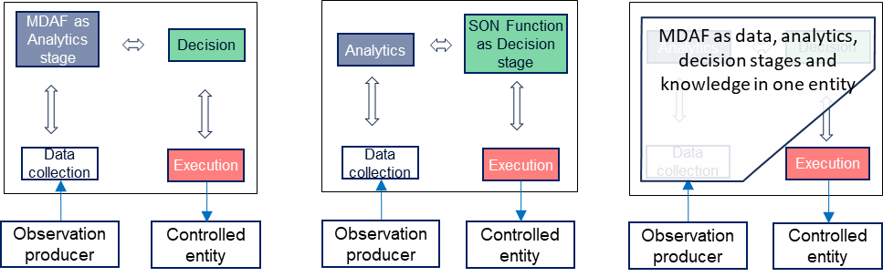
Figure 4.4.2-1: Management functions as stages of a closed control loop

5.Y1.1.4.2 Composition from management services
Different management services may be used to realize the different stages of a closed loop, i.e. the management service provides the output expected from a specific stage. For example, a capability of the MDA MnS realize an analytics stage of the CCL while another capability may realize a specific data collection stage of the CCL.
a)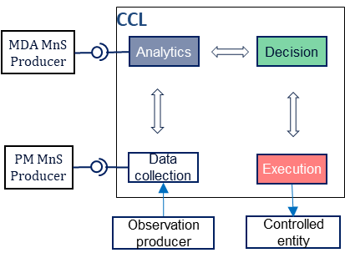 b)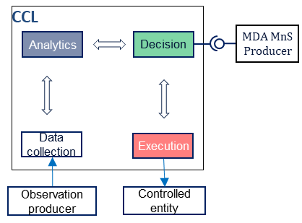
Figure 4.4.3-1: management services used as implementations of CCL stages: a) MDA MnS and PM job the respective implementations of the analysis and data collection stages and b) MDA MnS as the implementation of the decision stage
The MnS consumer should be enabled to manage the composition of such a CCL. The MnS consumer could request for and be notified about the composition of a CCL from a set of specific components (i.e., specific management functions or management services). The request could indicate components with specific given capabilities (such as analytics services with specific analytics types) which should be combined to achieve the closed loop. Moreover, the request could be for composition of a CCL required to achieve a specific set of desired outcomes or goals.

5.Y1.2 Potential Requirements
REQ-CCL-CRTN-1: The CCL MnS Producer should support a capability enabling the MnS consumer to request for a CCL of a specific type to be instantiated.
REQ-CCL-CRTN-2: The CCL MnS Producer should support a capability enabling a CCL to be dynamically instantiated when a given set of conditions are fulfilled.
REQ-CCL-CRTN-3: The CCL MnS Producer should support a capability enabling the MnS consumer to be notified when a CCL is dynamically instantiated.
REQ-CCL-CRTN-4: The CCL MnS Producer should support a capability enabling the MnS consumer to request for a CCL (instance) to be composed from a set of management function types or instances or management services.
REQ-CCL-CRTN-5: The CCL MnS Producer should support a capability enabling the MnS consumer to request for a CCL (instance) to be composed to include a set of management function types or instances or management services.
REQ-CCL-CRTN-6: The CCL MnS Producer should support a capability enabling the MnS consumer to request for a CCL (instance) to be composed to include set of management management services supporting a set of stated capabilities.
REQ-CCL-CRTN-7: The CCL MnS Producer should support a capability enabling the MnS consumer to request for a CCL (instance) to be composed to fulfil a set of stated desired outcomes.
REQ-CCL-CRTN-8: The CCL MnS Producer should support a capability enabling the MnS consumer to dynamically manage the the stages of a CCL (instance), e.g. to change the management functions that constitute the stages of the CCL (instance) without recomposing the CCL.
REQ-CCL-CRTN-9: The CCL MnS Producer should support a capability enabling the MnS consumer to be notified when a CCL (instance) is composed or recomposed.

5.Y1.3 Potential Solutions
TBD
5.Y1.4 Evaluation of solutions
TBD
End of modifications

