**3GPP TSG- Meeting #**

**, , -**

|  |  |  |  |  |  |  |  |  |
| --- | --- | --- | --- | --- | --- | --- | --- | --- |
| *CR-Form-v12.3* | | | | | | | | |
| **CHANGE REQUEST** | | | | | | | | |
|  | | | | | | | | |
|  |  | **CR** |  | **rev** |  | **Current version:** |  |  |
|  | | | | | | | | |
| *For* [***HE******LP***](http://www.3gpp.org/3G_Specs/CRs.htm#_blank)*on using this form: comprehensive instructions can be found at* [*http://www.3gpp.org/Change-Requests*](http://www.3gpp.org/Change-Requests)*.* | | | | | | | | |
|  | | | | | | | | |

|  |  |  |  |  |  |  |  |  |
| --- | --- | --- | --- | --- | --- | --- | --- | --- |
| ***Proposed change affects:*** | UICC apps |  | ME |  | Radio Access Network | **X** | Core Network | **X** |

|  |  |  |  |  |  |  |  |  |  |  |
| --- | --- | --- | --- | --- | --- | --- | --- | --- | --- | --- |
|  | | | | | | | | | | |
| ***Title:*** |  | | | | | | | | | |
|  |  | | | | | | | | | |
| ***Source to WG:*** | , Intel | | | | | | | | | |
| ***Source to TSG:*** | S5 | | | | | | | | | |
|  |  | | | | | | | | | |
| ***Work item code:*** |  | | | | |  | ***Date:*** | | |  |
|  |  | | | |  | |  | | |  |
| ***Category:*** |  |  | | | | | ***Release:*** | | |  |
|  | *Use one of the following categories:* ***F*** *(correction)* ***A*** *(mirror corresponding to a change in an earlier release)* ***B*** *(addition of feature),* ***C*** *(functional modification of feature)* ***D*** *(editorial modification)*  Detailed explanations of the above categories can be found in 3GPP [TR 21.900](http://www.3gpp.org/ftp/Specs/html-info/21900.htm). | | | | | | | | *Use one of the following releases: Rel-8 (Release 8) Rel-9 (Release 9) Rel-10 (Release 10) Rel-11 (Release 11) … Rel-17 (Release 17) Rel-18 (Release 18) Rel-19 (Release 19)  Rel-20 (Release 20)* | |
|  |  | | | | | | | | | |
| ***Reason for change:*** | | Figure 7.3a.4.1.1-2: NRM fragment for AI/ML inference function has defined the association of AIMLSupportedFunction to the MLEntity and/or AIMLInferenceFunction, where AIMLSupportedFunction may be represented by the functions: MDAFunction, AnLFFunction, DMROFunction, DLBOFunction and DESManagementFunction. The reference for where these functions are defined are missing. | | | | | | | | |
|  | |  | | | | | | | | |
| ***Summary of change:*** | | Add reference details to Information Model for NRM fragment for AI/ML inference function. | | | | | | | | |
|  | |  | | | | | | | | |
| ***Consequences if not approved:*** | | lead to incorrect and incomplete implementation. | | | | | | | | |
|  | |  | | | | | | | | |
| ***Clauses affected:*** | | 7.1.2,7.3a.4.1.1 | | | | | | | | |
|  | |  | | | | | | | | |
|  | | **Y** | **N** |  | | | |  | | |
| ***Other specs*** | |  | **X** | Other core specifications | | | | TS/TR ... CR ... | | |
| ***affected:*** | |  | **X** | Test specifications | | | | TS/TR ... CR ... | | |
| ***(show related CRs)*** | | **X** |  | O&M Specifications | | | | TS/TR ... CR ... S5-241238 | | |
|  | |  | | | | | | | | |
| ***Other comments:*** | |  | | | | | | | | |
|  | |  | | | | | | | | |
| ***This CR's revision history:*** | |  | | | | | | | | |

|  |
| --- |
| **Start of modification** |

### 7.1.2 Associated information entities and local labels

Table 7.1.2-1

|  |  |
| --- | --- |
| Label reference | Local label |
| 3GPP TS 28.104 [2], IOC, MDAFunction | MDAFunction |
| 3GPP TS 28.541 [18], IOC, NWDAFFunction | NWDAFFunction |
| 3GPP TS 28.541 [18], IOC, AnLFFunction | AnLFFunction |
| 3GPP TS 28.541 [18], IOC, DMROFunction | DMROFunction |
| 3GPP TS 28.541 [18], IOC, DLBOFunction | DLBOFunction |
| 3GPP TS 28.541 [18], IOC, DESManagementFunction | DESManagementFunction |

|  |
| --- |
| **Next of modification** |

### x7.3a.4 Information model definitions for ML inference phase

#### 7.3a.4.1 Class diagram

##### 7.3a.4.1.1 Relationships

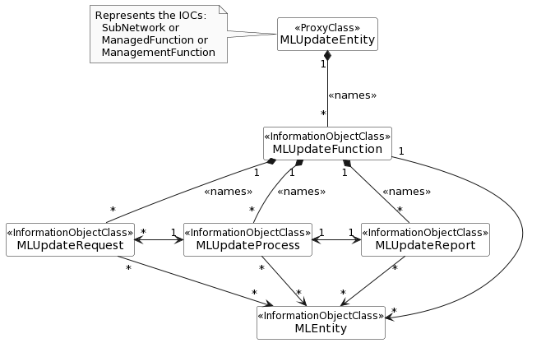

Figure 7.3a.4.1.1-1: NRM fragment for ML update

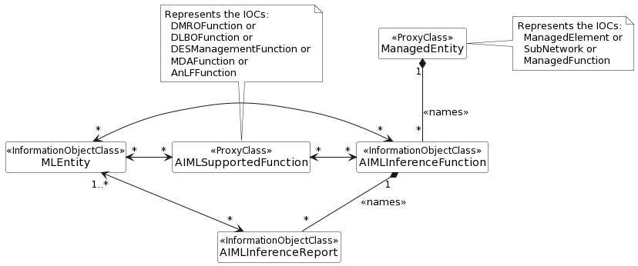

NOTE X: The ManagedEntity and AIMLSupportedFunction shall not represent the same MOI.

NOTE Y: For AnLFFunction, DMROFunction, DLBOFunction, and DESManagementFunction see [18] and for MDAFunction see [2]

Figure 7.3a.4.1.1-2: NRM fragment for AI/ML inference function

|  |
| --- |
| **End of modification** |