3GPP TSG-SA5 Meeting #154 S5-241938d1

Changsha, Hunan Province, China, 15th Apr 2024 - 19th Apr 2024
CR-Form-v12.3
CHANGE REQUEST
 | 28.105 | CR | 0105 | rev | - | Current version: | 18.3.0
For HELP on using this form: comprehensive instructions can be found at
http://www.3gpp.org/Change-Requests.

Proposed change affects: | UICC apps |  | ME |  | Radio Access Network | X | Core Network | X

Title: | Rel-18 CR TS 28.105 Correct ML Training Class Diagram
Source to WG: | Ericsson India Private Limited
Source to TSG: | S5
Work item code: | AIML_MGT |  |  |  |  |  | Date: |  |  | 2024-04-05
Category: | F |  |  |  |  |  | Release: |  |  | Rel-18
 | Use one of the following categories:  F (correction)  A (mirror corresponding to a change in an earlier release)  B (addition of feature),  C (functional modification of feature)  D (editorial modification)  Detailed explanations of the above categories can  be found in 3GPP TR 21.900. |  |  |  |  |  |  |  | Use one of the following releases:  Rel-8 (Release 8)  Rel-9 (Release 9)  Rel-10 (Release 10)  Rel-11 (Release 11)  …  Rel-17 (Release 17)  Rel-18 (Release 18)  Rel-19 (Release 19)  Rel-20 (Release 20)
Reason for change: |  | Correct ML Training Class Diagram to fit the described solution for ML Training.
Summary of change: |  | .  Correct Association of MLTrainingRequest, MLTrainingReport, MLTrainingProcess, MLEntity and MLEnitiyCoordnatonGroup.
Consequences if not approved: |  | leads to incorrect implementation.
Clauses affected: |  | 7.3a and A.2
 |  | Y | N
Other specs |  |  | X | Other core specifications |  |  |  | TS/TR ... CR ...
affected: |  |  | X | Test specifications |  |  |  | TS/TR ... CR ...
(show related CRs) |  |  | X | O&M Specifications |  |  |  | TS/TR ... CR ...
Other comments:
This CR's revision history:

Start of modification

7.3a Information model definitions for AI/ML operational phases

7.3a.1 Information model definitions for ML Training

7.3a.1.1 Class diagram

7.3a.1.1.1 Relationships
This clause depicts the set of classes (e.g. IOCs) that encapsulates the information relevant to ML model training. For the UML semantics, see TS 32.156 [13].

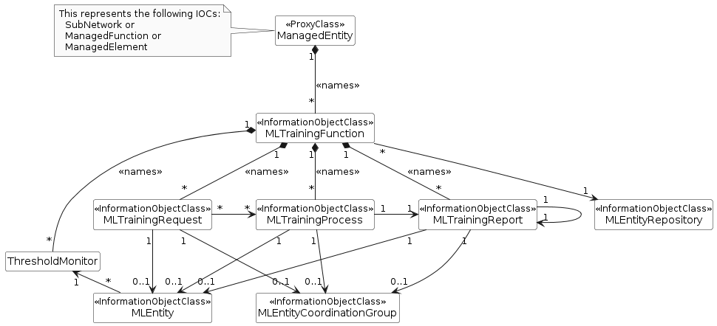
Figure 7.3a.1.1.1-1: NRM fragment for ML training

Next modification

A.2 PlantUML code for Figure 7.3a.1.1.1-1: NRM fragment for ML model training

@startuml
skinparam ClassStereotypeFontStyle normal
skinparam ClassBackgroundColor White
skinparam shadowing false
skinparam monochrome true
hide members
hide circle
'skinparam maxMessageSize 250
skinparam nodesep 60

class ManagedEntity <<ProxyClass>>
class MLEntity <<InformationObjectClass>>
class MLEntityCoordinationGroup <<InformationObjectClass>>
class MLTrainingFunction <<InformationObjectClass>>
class MLTrainingRequest <<InformationObjectClass>>
class MLTrainingReport <<InformationObjectClass>>
class MLTrainingProcess <<InformationObjectClass>>
class MLEntityRepository <<InformationObjectClass>>

ManagedEntity "1" *-- "*" MLTrainingFunction: <<names>>
MLTrainingFunction "1" *-- "*" MLTrainingProcess: <<names>>
MLTrainingFunction "1" *-- "*" MLTrainingRequest: <<names>>
MLTrainingFunction "1" *-- "*" MLTrainingReport: <<names>>
MLTrainingFunction "1" *-- "*" ThresholdMonitor : <<names>>

MLTrainingFunction "*" --> "1" MLEntityRepository
MLTrainingProcess "1" -r-> "1" MLTrainingReport
MLTrainingProcess "*" <-l- "*" MLTrainingRequest
MLTrainingRequest "1" --> "0..1" MLEntity
MLTrainingRequest "1" -r-> "0..1" MLEntityCoordinationGroup
MLTrainingReport "1" --> "0..1" MLEntity
MLTrainingReport "1" --> "0..1" MLEntityCoordinationGroup
MLTrainingProcess "1" --> "0..1" MLEntity
MLTrainingProcess "1" --> "0..1" MLEntityCoordinationGroup
MLEntity"*" -l-> "1" ThresholdMonitor
MLTrainingReport "1" -r-> "1" MLTrainingReport

note left of ManagedEntity
This represents the following IOCs:
SubNetwork or
ManagedFunction or
ManagedElement
end note

@enduml

End of modification

