3GPP TSG-SA5 Meeting #154 S5-241934

Changsha, CHINA, 15 Apr - 19 Apr 2024
CR-Form-v12.1
CHANGE REQUEST
 | 28.105 | CR | 0104 | rev | 1 | Current version: | 18.3.0
For HELP on using this form: comprehensive instructions can be found at
http://www.3gpp.org/Change-Requests.

Proposed change affects: | UICC apps |  | ME |  | Radio Access Network |  | Core Network | X

Title: | Rel-18 CR 28.105 Clarification of AIML function management scenario for CN
Source to WG: | Huawei
Source to TSG: | S5
Work item code: | AIML_MGT |  |  |  |  |  | Date: |  |  | 2024-04-05
Category: | F |  |  |  |  |  | Release: |  |  | Rel-18
 | Use one of the following categories:  F (correction)  A (mirror corresponding to a change in an earlier release)  B (addition of feature),  C (functional modification of feature)  D (editorial modification)  Detailed explanations of the above categories can  be found in 3GPP TR 21.900. |  |  |  |  |  |  |  | Use one of the following releases:  Rel-8 (Release 8)  Rel-9 (Release 9)  Rel-10 (Release 10)  Rel-11 (Release 11)  …  Rel-15 (Release 15)  Rel-16 (Release 16)  Rel-17 (Release 17)  Rel-18 (Release 18)
Reason for change: |  | Several clarification of CN domain when deploying AI/ML functionalities,  1, cross-domain management system can be the consumer for both RAN and CN domain.  2, NWDAF can be categorized as CN domain  3, in scenario 1, it is mainly about ML training function and AI/ML inference function located in the domain-specific management system as shown in Figure 4a.2-1. So the description for CN domain needs to be updated to fit in scenario 1.  4, scenario for NWDAF is missing.
Summary of change: |  | Clarification on CN domain when deploying AI/ML functionalities.
Consequences if not approved: |  | The deployment of AI/ML functionalities in CN domain is not clear.
Clauses affected: |  | 4a.2
 |  | Y | N
Other specs |  |  | x | Other core specifications |  |  |  | TS/TR ... CR ...
affected: |  |  | x | Test specifications |  |  |  | TS/TR ... CR ...
(show related CRs) |  |  | x | O&M Specifications |  |  |  | TS/TR ... CR ...
Other comments:
This CR's revision history: |  | Revision of S5-241249

1st Change

4a.2 AI/ML functionalities management scenarios
The ML training function and/or AI/ML inference function can be located in the RAN, CN, cross domain management system (i.e. a management function for RAN or CN), or Network Function.
For MDA, the ML training function can be located inside or outside of MDAF. The AI/ML inference function is in the MDAF.
For NWDAF, the ML training function can be located in NWDAF or management system, the AI/ML inference function is in the NWDAF.
For RAN, the ML training function and AI/ML inference function can both be located in the gNB, or the ML training function can be located in the management system and AI/ML inference function is located in the gNB.
Therefore, there might exist several location scenarios for ML training function and AI/ML inference function.
Scenario 1:
The ML training function and AI/ML inference function are both located in the 3GPP management system (e.g. RAN domain management function). For instance, for RAN domain-specific MDA, the ML training function and AI/ML inference functions for MDA can be located in the RAN domain-specific MDAF. As depicted in figure 4a.2-1.
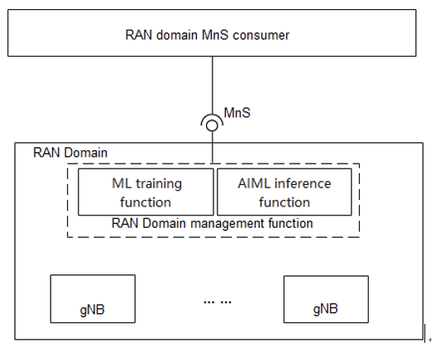
Figure 4a.2-1: Management for RAN domain analytics
Similarly, for CN domain-specific MDA the ML training function and AI/ML inference function can be located in CN domain-specific MDAF.
Scenario 2:
The ML training function is located in the 3GPP RAN domain-specific management function while the AI/ML inference function is located in gNB. See figure 4a.2-2.
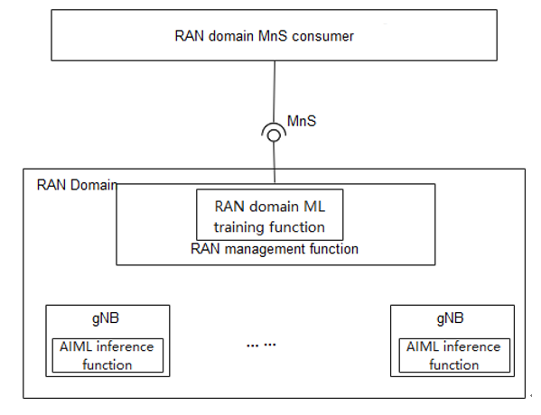
Figure 4a.2-2: Management where the ML training is located in RAN domain management function and AI/ML inference is located in gNB
Scenario 3:
The ML training function and AI/ML inference function are both located in the gNB. See figure 4a.2-3.
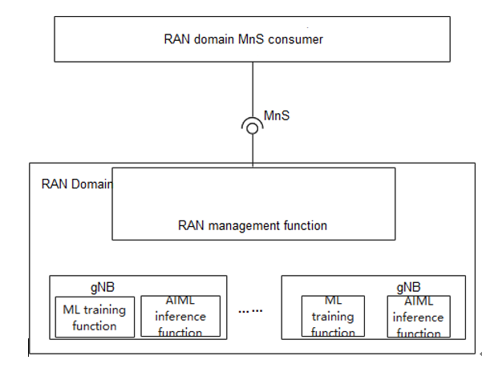
Figure 4a.2-3: Management where the ML training and AI/ML inference are both located in gNB

Scenario 4:
For NWDAF, the ML training function and AI/ML inference function are both located in the NWDAF. See figure 4a.2-4.
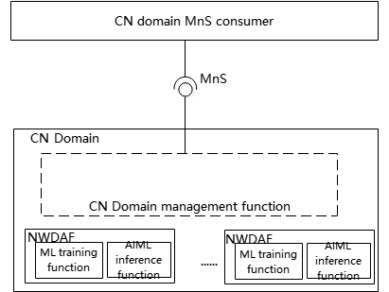

Figure 4a.2-4: Management where the ML training and AI/ML inference are both located in CN

End of Change

