3GPP TSG-SA5 Meeting #154 S5-241778rev1

Changsha, CHINA, 15 Apr - 19 Apr 2024

Source: CATT

Title: Discussion paper on charging aspects of Satellite access Phase 3

Document for: Discussion
Agenda Item: 7.5

1 Decision/action requested
Discuss the Satellite Charging.

2 References
[1] 3GPP TS 22.261: "Service requirements for the 5G system"
[2] 3GPP TR 23.700-29:" Study on integration of satellite components in the 5G architecture"
[3] 3GPP TS 32.256: "Telecommunication management; Charging management; 5G connection and mobility domain charging; stage 2".
[4] 3GPP TS 32.257: " Edge computing domain charging".

3 Rationale

3.1 Feedback form NWM
No. | Company name | Comments
1 | VODAFONE Group Plc | CS-2 comment: Not sure the rental of a satellite should be part of the scope of this work. The rental of computing resources in a satellite seems more like something subject to study from a 3GPP charging perspective.  [CATT]: CS-2: From my understanding, the satellite resource rental is the same as the edge enabling infrastructure resource usage. In the edge computing charging of TS 32.257, there are charging scenarios for the edge enabling infrastructure resource usage EAS deployment, etc. So, the charging scenarios for satellite resource usage may also be studied.
2 | Huawei | CS-3 comment: Who would be the charged party for the store and forward satellite operation? Any use case for this charging scenario?  - [CATT]: For this scenario, the UE would be the charged party. The UE（e.g. an IoT） may be in the ocean and only a satellite that supports the store and forward satellite operation flies over it, the UE would like to send the information to the 5GC(on the ground) and request the satellite to store and forward the data. The charging solution for how much and how long the data of the UE stored in the satellite 5GC needs to be studied.  CS-4 comment: Which part of the UE-satellite-UE communicaiton goes to IMS voice? Maybe a little more elaboration on the architecture would be helpful. Thank you.  [CATT]: CS-4：The UE-satellite-UE communication scenario is focused on the support of IMS voice. This architecture for this case has not been determined by SA2 until now. There are mainly proposed two architectures :  The PSA UPF anchored by the IMS PDU session is on the ground and the UPF acting as UL CL/BP/local PSA is to be deployed onboard the satellite; All the IMS components are on the ground.  gNB, UPF, and IMS-AGW are deployed on the same satellite
3 | Mattrix | I guess we need to wait at least for SA2 TR conclusion before any study in SA5 charging can be really started  [CATT]: I have added the corresponding sentence in the SID.  Will the SA6 study "Study on application enablement for Satellite access enabled 5G Services" expected to be considered once SA6 will have their conclusion?  [CATT]: I have checked with my SA6 colleague and the result is the SA6 study has no charging requirement. It's just an internal discussion about AF, not related to NEF.  Such WT levels split is not needed in my view. As usual these will be the way the TR will be structured  [CATT]: We have updated this WT in the SID to include more details.
4 | CSCN | CS-2 comment:  For satellite leasing scenarios, there are several possible business models:  1. Satellite Backhaul  2. Edge computing via UPF deployed on the satellite  3. Local switch via UPF deployed on the satellite  4. gNB onboard shared between multiple operators  As satellite resources are scarce, in the above scenarios, a satellite may need to be leased to several operators, and the rental fee may be charged based on the actual traffic of each operator,even each operator has quota restrictions.The traffic of individual users and the aggregated traffic of each operator may need to be counted.  The charging between different organizations may need to be studied.  [CATT] : Discuss about business models

3.2 Background and Motivation
3GPP has discussed the Satellite access Phase 3.
The following requirements on charging aspects for satellite access have been specified by SA1 in TS 22.261[1]:
- A 5G system with satellite access supporting Store and Forward (S&F) Satellite operation shall be able to collect charging information per UE or per application (e.g., number of UEs, data volume, duration, involved satellites).
- A 5G system with satellite access shall be able to collect charging information for a UE registered to a HPLMN or a VPLMN, for UE-Satellite-UE communication.
- In a 5G system with satellite access, charging data records associated with satellite access(es) shall include the location of the associated UE(s) with satellite access.
NOTE: The precision of the location of the UE can be based on the capabilities of the UE or of the network.
In Rel-19, SA2 is studying the following three key issues in TR 23.700-29[2]:
- Key Issue #1: Support of Regenerative-based satellite access
- Key Issue #2: Support of Store and Forward Satellite operation
- Key Issue #3: Support of UE-satellite-UE communication
To have a better understanding of the above KI, clarify the architectures as follows:
The Fig.1 shows the high-level 5G network architecture for the regenerative-based satellite access. The deployment of a gNB on a satellite for regenerative based satellite access for LEO/MEO deployment is to be studied by SA2. Since the satellite flies all the time, the UE can be handed over during the time that the UE’s area is in coverage of both satellites. The enhanced TA management considering the change of supported TA list for a RAN node on-board is studying by SA2.

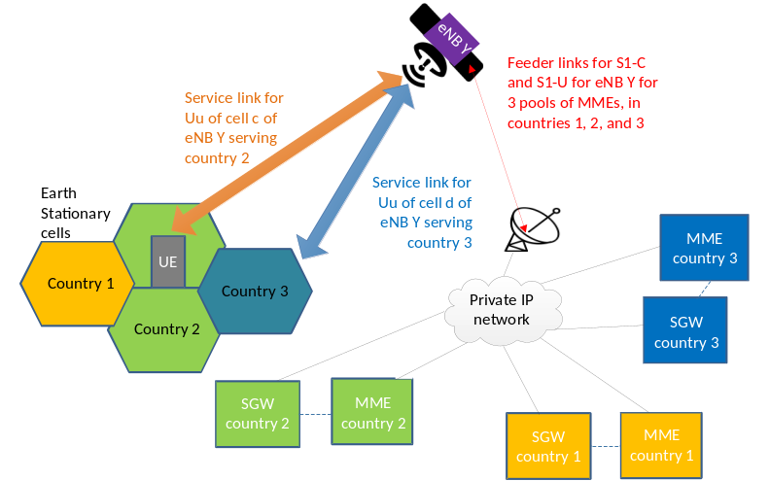
Figure 1: Basic concept of eNB/gNB on satellite
The new capability that Store and Forward Satellite operation is an operation mode of a 5G system with satellite-access, allows the satellite to store and forward data when satellite connectivity is intermittently/temporarily unavailable. The Fig.2 shows the high-level network architecture for Store and Forward Satellite operation. For "S&F Satellite operation" mode, the end-to-end exchange of signalling/data traffic is now handled as a combination of two steps not concurrent in time (step A and B in Figure2). In step A, signalling/data exchange between the UE and the satellite takes place, without the satellite being simultaneously connected to the ground network (i.e. the satellite is able to operate the service link without an active feeder link connection). In step B, connectivity between the satellite and the ground network is established so that communication between the satellite and the ground network can take place. So, the satellite moves from being connected to the UE in step A to being connected to the ground network in step B.
The S&F Satellite operation is especially suited for the delivery of delay-tolerant/non-real-time satellite services (i.e. CIoT/MTC, SMS). To support S&F Satellite operation for such services, the minimum necessary set of core network elements/network functions can also be deployed on the satellite. SA2 still studied which CN can be deployed on the satellite.
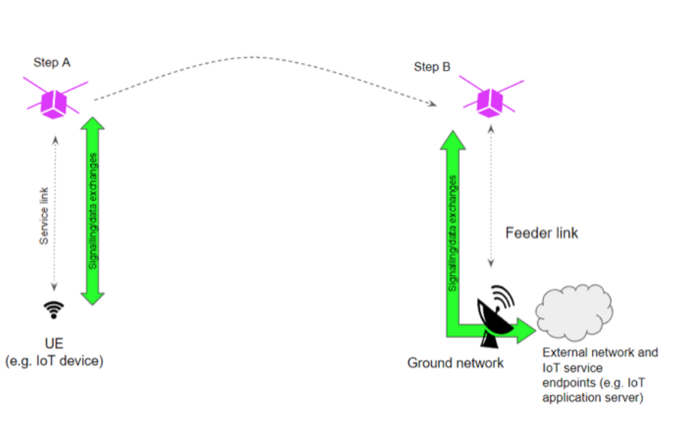
Figure 2: Illustration of "S&F Satellite operation" modes in a 5G system with satellite access
The UE-satellite-UE communication scenario is that UEs can communicate using satellite access without the user plane traffic going to the ground network. The Fig.3 shows the high-level network architecture for UE-satellite-UE communication. It is expected that a link to the ground, via ISL to another satellite with a link to a ground gateway, or via multiple other satellites using ISLs to another satellite with a link to ground gateway or direct from the serving satellite to a ground gateway, is always available. To support UE-satellite-UE communication for IMS voice, the minimum necessary set of core network elements/network functions can also be deployed on the satellite.
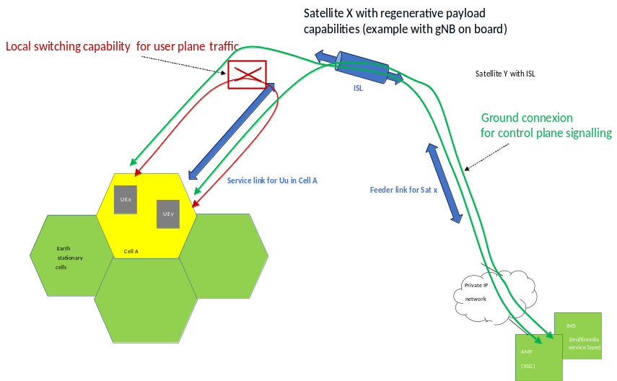
Figure 3: Basic concept of UEs- SAT- UEs communications on satellite in same cell with ISL
To further support the integration of satellite into 5GS, the charging aspects of Satellite access Phase 3 should be considered. This contribution is to provide an analysis on this aspect.

3.3 Observations
According to the current work for Satellite access Phase 3, we think there maybe following impacts on charging to be considered.

3.3.1 End user charging when gNB deployed on the satellite
For the regenerative-based satellite access, UE is basically stationary and the satellites fly over all the time, leading to the frequent disconnection and re-connection of N2 interface of an AMF. Considering the change of the supported TA list for a RAN node on-board, solution#2 and solution #4 in the TR 23.700-29[2] propose to enhance the TA management by notifying AMF/MME of the RAN node’s support TA list periodically or on demand. Since charging data records associated with satellite access(es) include the location of the associated UE(s) with satellite access, the trigger conditions in AMF for charging specified in TS 32.256 [3] may be influenced by the enhancement of the TA report enhancement.
Moreover, in order to support the regenerative-based satellite access, Solution#8 proposes two new RAT types (i.e. REGENERATIVE_MEO, REGENERATIVE_LEO) to enhance the PCC/QoS control in the TR 23.700-29[2]. The RAT Type information for Regenerative-based satellite access takes into account the decision of CN PDB, Policy and QoS. The enhancement of the RAT types needs to be considered by charging group.
This document proposes to consider the particular charging procedure, charging information and CDR for mobility charging via satellite, in charging aspect.

3.3.2 Charging for store and forward satellite operation related to delay-tolerant communication services
For the store and forward satellite operation scenario, the UE(e.g. an IoT) may be in the ocean and only the satellite that supports the store and forward satellite operation flies over it, the UE would like to send the information to the 5GC(on the ground) and request the satellite to store and forward the data. For this case, the UE can be charged, either by the MNO or Satellite Service Provider, on the store and forward satellite service via satellite.
In the TR 23.700-29[2], there are mainly three architectuers for the support of Store and Forward Satellite operation:
- Arch 1: splitting AMF MME into several TN part and one Non-TN part. AMF-T/AMF-NT is Buffer/Store N2 messages until the satellite is available. The URE(UE Reachability Estimation) is proposed to deployed on ground for AMF-T to query UE reachability info
- Arch 2: Only gNB and AMF/MME are on the satellite;
- Arch3: gNB, AMF, UPF and SMF are on the satellite, the UDM may be also on the satellite.
For Arch 1, there are several satellites involved to support the UE to register the 5GC and store and forward data successfully. The other two architectures may use one satellite to support the UE for the satellite store and forward service.
Due to the scarcity of satellite resources, SA2 also has proposed solutions to negotiate how long and how much the data of UE can be stored on the satellite. Therefore, the charging solutions for how much and how long the data of the UE stored in the satellite 5GC needs to be studied. The charging information per UE or per application (e.g., number of UEs, data volume, duration, involved satellites) also needs to be studied.
This document proposes to consider the particular charging procedure, charging information and CDR for store and forward satellite operation charging via satellite, in charging aspect.

3.3.3 Charging for UE-satellite-UE communication related to IMS voice
The UE-satellite-UE communication scenario is focused on the support of IMS voice. For example, the IMS voice calls through the UE-satellite-UE communication link can significantly reduce the load on the feeder link and minimize end-to-end delays between UEs.
In the TR 23.700-29[2], there are mainly two architectuers for the support of UE-satellite-UE communication:
- The PSA UPF anchored by the IMS PDU session is on the ground and the UPF acting as UL CL/BP/local PSA is to be deployed onboard the satellite; All the IMS components are on the ground.
- gNB, UPF, and IMS-AGW are deployed on the same satellite
Both architectures have no impact on P-CSCF/S-CSCF. The charging information for a UE registered to a HPLMN or a VPLMN, for UE-Satellite-UE communication needs to be studied.

3.3.4 Satellite infrastructure resource usage/ gNB and CN deployment charging
Since gNB and a necessary set of CN 3GPP functions are being considered deployed on the satellite, the operators may rent the satellite to deploy them. As there are charging scenarios for the edge enabling infrastructure resource usage and EAS deployment in the edge computing charging of TS 32.257[4], the satellite infrastructure resource usage and the gNB/CN deployment charging are similar to the charging scenarios in TS 32.257[4]. So, the charging scenarios for satellite resource usage and the gNB/CN deployment may need to be studied.

4 Detailed proposal
SA5 is asked to agree to investigate charging aspects in support of satellite access phase 3 in 5GS as follows:
- Possible charging scenarios and potential charging requirements related to the satellite access phase 3;
- Potential charging solutions for the satellite access phase 3.
- investigates possible new charging aspects for the following key items:
  - End user charging when gNB deployed on the satellite
  - Store and forward satellite operation charging
  - UE-satellite-UE communication charging
  - Satellite infrastructure resource usage/ gNB and CN deployment charging

