Source: Editor / Audio SWG
Title: Pdoc ATIAS-1 v0.7.0
Agenda Item: 7.6

Table of Contents
1 Introduction 2
2 Test Configurations 3
2.1 Definition of UE types 3
2.1.1 Introduction 3
2.1.2 Handset Mode (Send + Receive) 4
2.1.3 Headset Mode (Send + Receive) 4
2.1.4 Handheld Mode (Send + Receive) 5
2.1.5 Table-mounted Mode (Send + Receive) 6
2.1.6 Loudspeaker Mode (Receive) 7
2.1.7 Electrical interface (Send + Receive) 8
3 Test Conditions 9
3.1 UE configuration 9
3.2 Test Equipment 10
4 Candidate sending side test methods and requirements 10
4.1 Sending frequency response of captured Ambisonics components 10
4.2 Sending directional response of captured Ambisonics haracteri 10
4.2.1 Angular-dependent sensitivity 10
4.3 Direction of arrival estimation under free-field propagation conditions 12
4.3.1 Definition 12
4.3.2 Test conditions 12
4.3.3 Comments for DOA test method design 14
4.4 Directivity test of FOA using virtual microphones 15
4.5 Scene-based audio spatial separation with two simultaneous acoustic sources in free-field propagation conditions and FOA decoding 18
4.5.1 Definition 18
4.5.2 Test conditions 18
4.5.3 Measurement 20
4.5.4 Annex A: Test signal and analysis for spatial separation with simultaneous acoustic sources 21
4.6 Spatial separation for multiple acoustic sources based on multichannel output 25
4.6.1 Test conditions 25
4.6.2 Measurement 27
4.7 Test method for simultaneous multiple acoustic sources utilizing real speech 29
4.7.1 Test setup 29
4.7.2 Test signal 29
4.7.3 Metrics 30
4.8 Spatial perception test for stereo UE in ATIAS 34
4.8.1 Definition 34
4.8.2 Test Conditions 34
4.8.3 Test Configurations 34
4.9 Sending side audio performance assessment for Immersive Audio Systems in wind noise 36
4.9.1 Introduction 37
4.9.2 Recommendations for wind noise simulations for terminal testing 40
5 Candidate receiving side test methods and requirements 41
5.1 Receiving loudness 41
5.1.1 General 41
5.1.2 Requirements 41
5.1.3 Test condons 41
5.2 Receiving frequency characteristics 42
5.2.1 General 42
5.2.2 Requirements 42
5.2.3 Test conditions 42
5.2.4 Receiving with binaural rendering: measurement for object-based audio 43
5.3 Receiving with binaural rendering: inter-channel time difference 43
5.3.1 General 43
5.3.2 Requirements 44
5.3.3 Test conditions 44
5.3.4 Measurement for object-based audio 44
5.3.5 Measurement for scene-based audio 45
5.3.6 Measurement for metadata-assisted spatial audio 45
5.4 Receiving with binaural rendering: source angle dependent band level difference 46
5.4.1 General 46
5.4.2 Requirements 46
5.4.3 Test conditions 47
5.4.4 Measurement for object-based audio 47
5.4.5 Measurement for scene-based audio 48
5.4.6 Measurement for metadata-assisted spatial audio 48
5.5 Receiving with channel-based coding and loudspeaker rendering: channel order 48
5.5.1 General 48
5.5.2 Requirements 48
5.5.3 Test conditions 48
5.5.4 Measurement of channel order 48
References 50
Revision history 52

Introduction

The ATIAS work item intends to specify test methods for objective characterization of terminals for 3GPP immersive services along with requirements. This Permanent Document collects candidate test methods and associated requirements that will form a pool out of which selected methods and requirements will be incorporated into TS 26.260 (Objective test methodologies for the evaluation of immersive audio systems) and, respectively, TS 26.261 (Terminal audio quality performance requirements for immersive audio services).
Several of the clauses below have retained explanations and examples from the original input documents. This may in some cases not be suitable for a specification text and it is expected that further editing will be necessary when incorporating the texts into the specifications.

Test Configurations
[Editor’s note: Collect general test setups in this clause, similar to TS 26.132 clause 5. The individual test descriptions could then point to this clause.]
[

Definition of UE types

Introduction
The definition of UE types for immersive communication terminals is not as clear and trivial as in the "traditional" test specifications 3GPP TS 26.131 [9] and TS 26.132 [10]. Due to the variety of new applications that are enabled by IVAS codec, it is expected that the capture and playback audio format might not necessarily be the same in send and receive direction. Thus, the classification of UE types should be defined as follows:
- The UE type is composed of "SND-UE-type" and "RCV-UE-type".
- The SND-UE-type is defined as the combination of a certain audio capturing mode (acoustic or electric) and a negotiated IVAS format.
- The RCV-UE-type is defined as the combination of a negotiated IVAS format and a certain audio playback mode (acoustic or electric).
- Each audio capturing/playback mode corresponds to a specific physical test arrangement.
UEs might support multiple IVAS formats in send and receive direction, which are negotiated during call setup. At least one supported IVAS format shall be tested in both directions, which is selected according to the following priority:
1) Format specified by the manufacturer.
2) Preference of the UE, as indicated during negotiation in SDP.
3) Test operator selects format based on form factor and envisioned use case of the UE.
The IVAS format for both directions shall be documented in the test report. Other available supported formats may be tested as well to ensure best-possible compatibility with other UE types.
While the IVAS formats are clearly defined, capturing/playback modes and corresponding interfaces were not yet discussed. The following subclauses suggest several UE type definitions, which might be applicable for SND and/or RCV. All UE type definitions with acoustical interfaces assume that microphones and loudspeakers/headset of the UE are either integrated into the device or that a device and any necessary additional equipment (like e.g., headset, microphone array, loudspeaker array) are associated to each other and bundled by the manufacturer.
NOTE: It is expected that many UEs supporting immersive audio will only provide an electrical interface, but not such associated equipment. In this case, the test setup according to clause 2.7 applies. However, to investigate the performance of the UE (without applying requirements) in combination with typical third-party equipment for certain applications, the test setups with acoustical interfaces described in the following subclauses may be used for this purpose.
The physical test arrangement used for UE testing in send and receive direction is in general specified by the manufacturer by:
- Referencing one of the following subclauses,
- Referencing a test arrangement from other standards (e.g., ITU-T P.340),
- Specifying an individual test arrangement.
In case no instructions on the test arrangement are provided by the manufacturer, the test operator shall select one based on the envisioned use case, form factor, etc. from either one of the following subclauses or from other standards. If no suitable test arrangement can be identified for certain UEs with acoustical interface, the test operator should set up an individual or modify an existing arrangement. In any case, the arrangement used for testing shall be described in the test report.

Handset Mode (Send + Receive)
Not applicable for immersive communication due to the following reasons:
- A handset device is typically held close to the user's head, i.e., mouth and (a single) ear.
- RCV: Monaural listening cannot provide any spatial/immersive audio.
- SND: Even if the device provides multiple input microphones, it is always positioned close to the user's mouth, which does not allow to encode any spatial information into the uplink signal (for e.g., object-based audio format).
The EVS-Interop mono mode of IVAS should be tested according to 3GPP TS 3GPP TS 26.131 [9] and TS 26.132 [10].
There might be some applications also in handset mode for some immersive audio formats, for example to capture ambient sound at the near end. Such scenarios are a kind of extension to the traditional mono telephony and are not excluded in general. However, so far, no test methods have been proposed for handset mode, thus it is suggested to leave out this mode for now.

Headset Mode (Send + Receive)
The test setup for headset UE for send and receive directions is shown in Figure 1. It applies to all head-worn terminals, which are typically connected via wired or wireless link (e.g., analogue jack, Bluetooth, or USB) to a device with sufficient computation power (e.g., mobile phone). Optionally, the device might provide head tracking data that can be used for rendering audio in the receive direction.
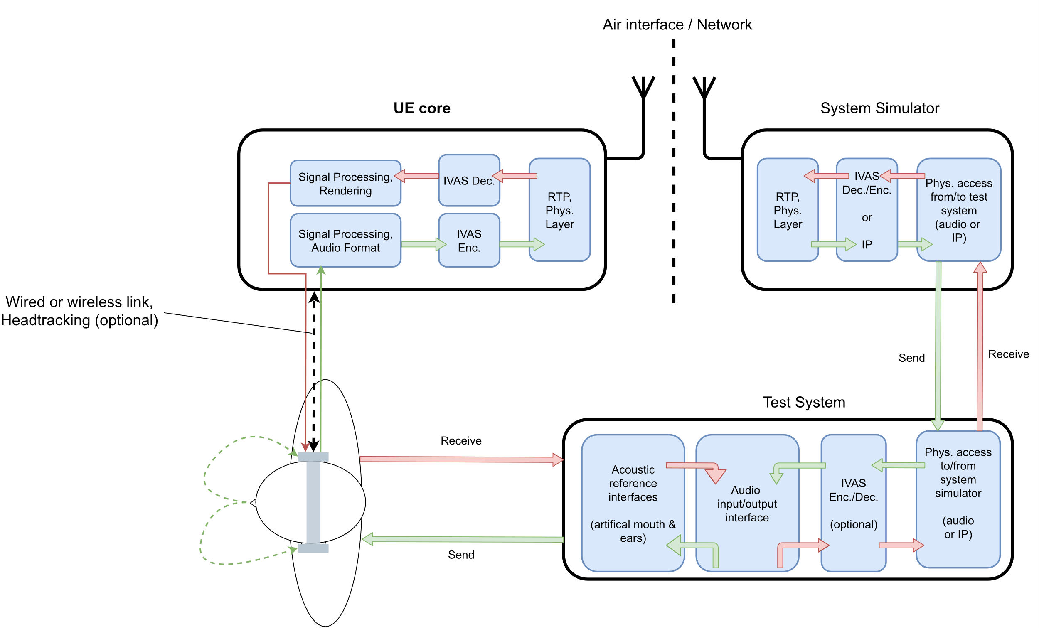
Figure 1: Headset UE and test equipment

Handheld Mode (Send + Receive)
The test setup for handheld hands-free UE for send and receive directions is shown in Figure 2. It applies to all devices that can be held in front of the user.
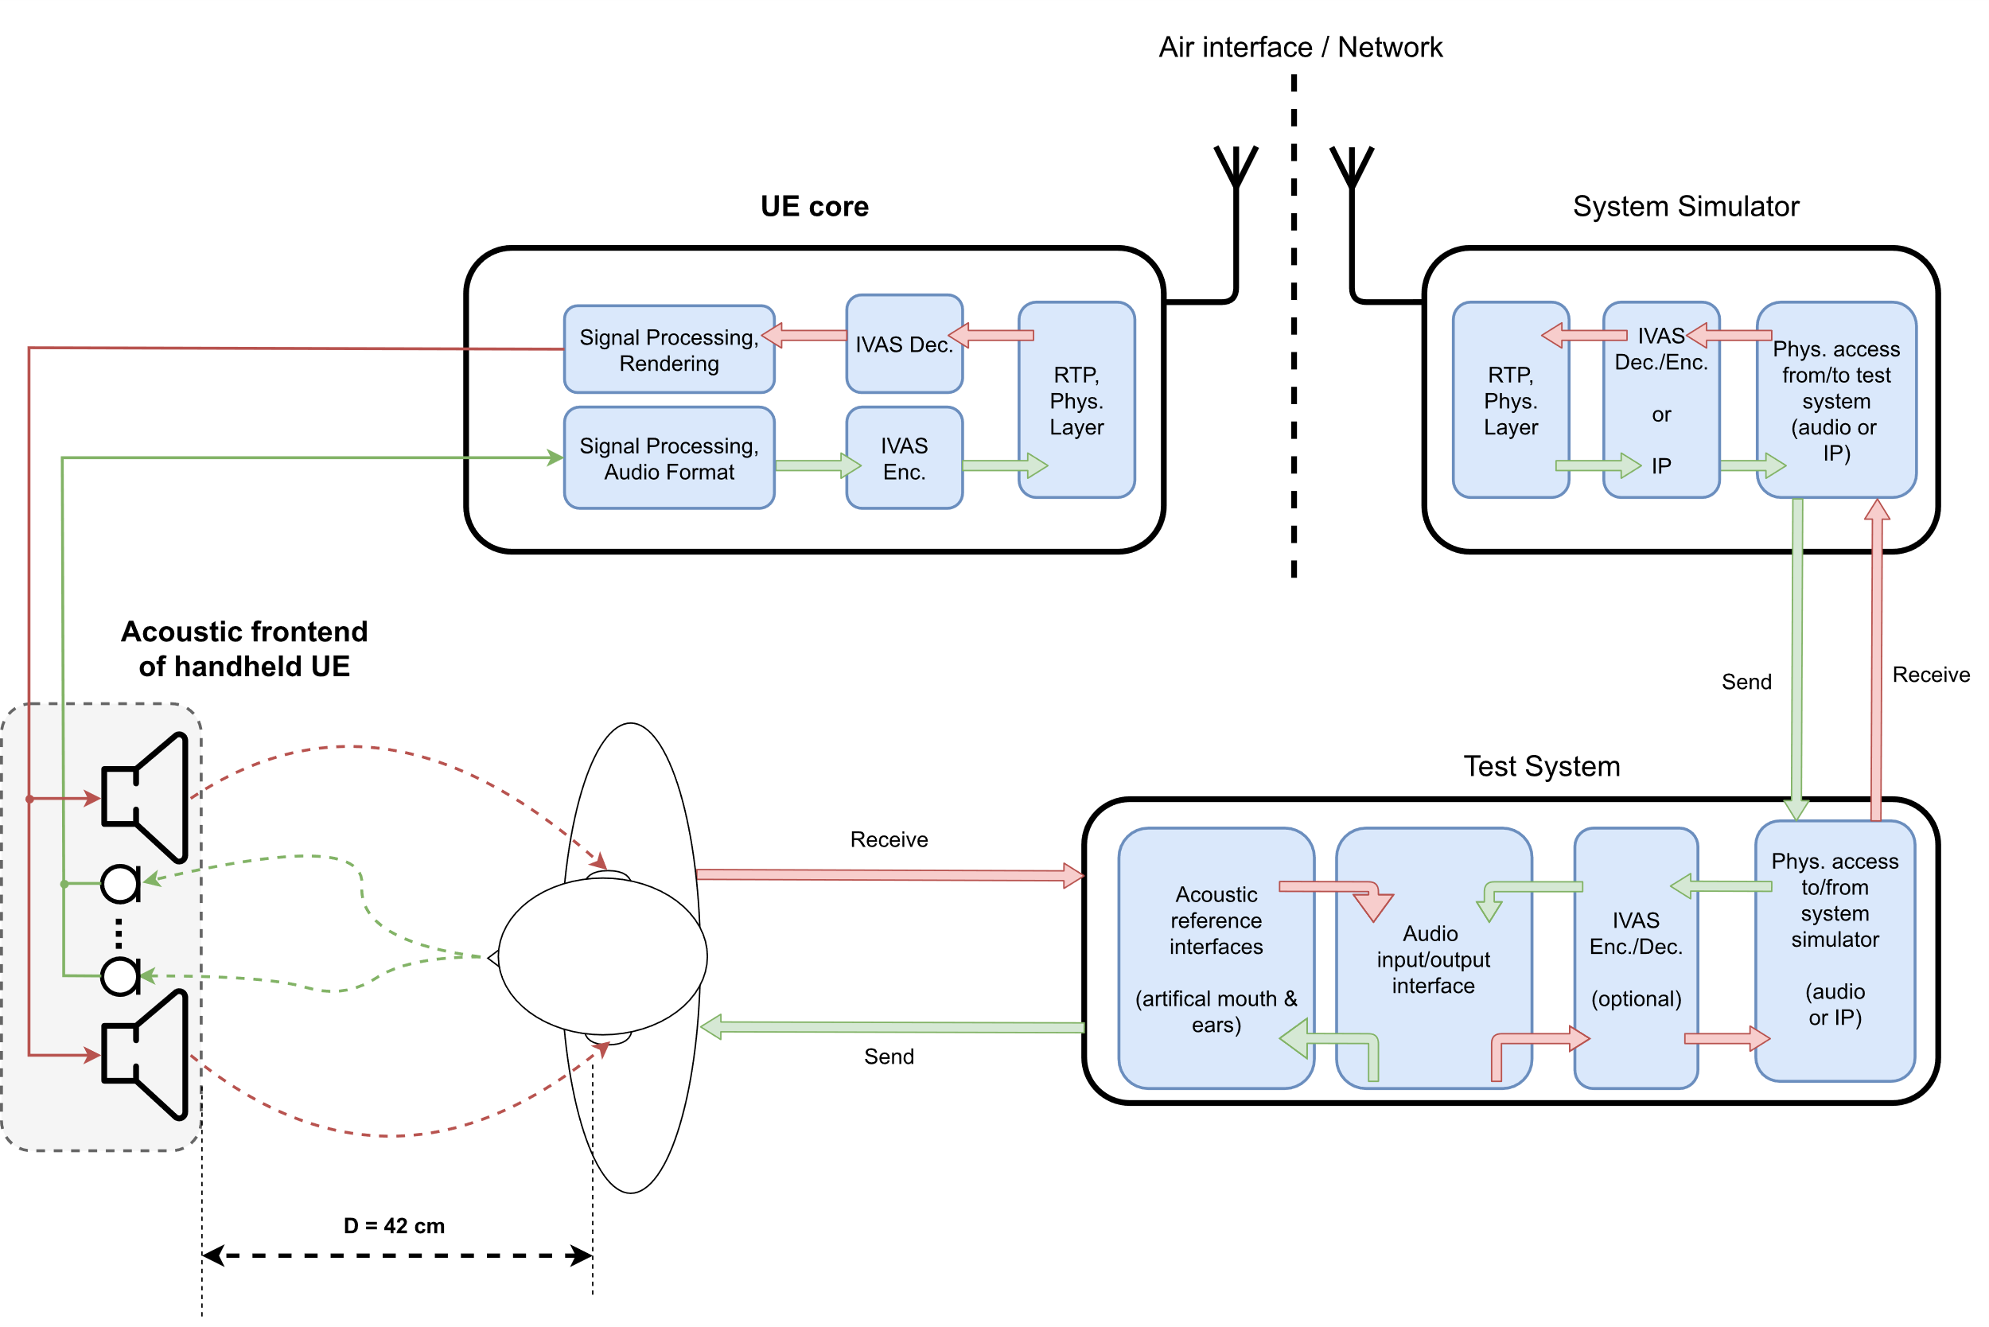
Figure 2: Handheld hands-free UE and test equipment

The distance D = 42 cm between HATS reference point (HRP) and center of the UE is used in TS 26.132 [5], but different geometries of this setup could also be considered (for e.g., multi-talker scenarios or speech from certain angles).

Table-mounted Mode (Send + Receive)
The test setup for table-mounted hands-free UE for send and receive directions is shown in Figure 3. It applies to all hands-free devices that are intended for usage on tables (like e.g., conference devices). In contrast to handheld UE, the reflections of the table are explicitly included in the test setup.
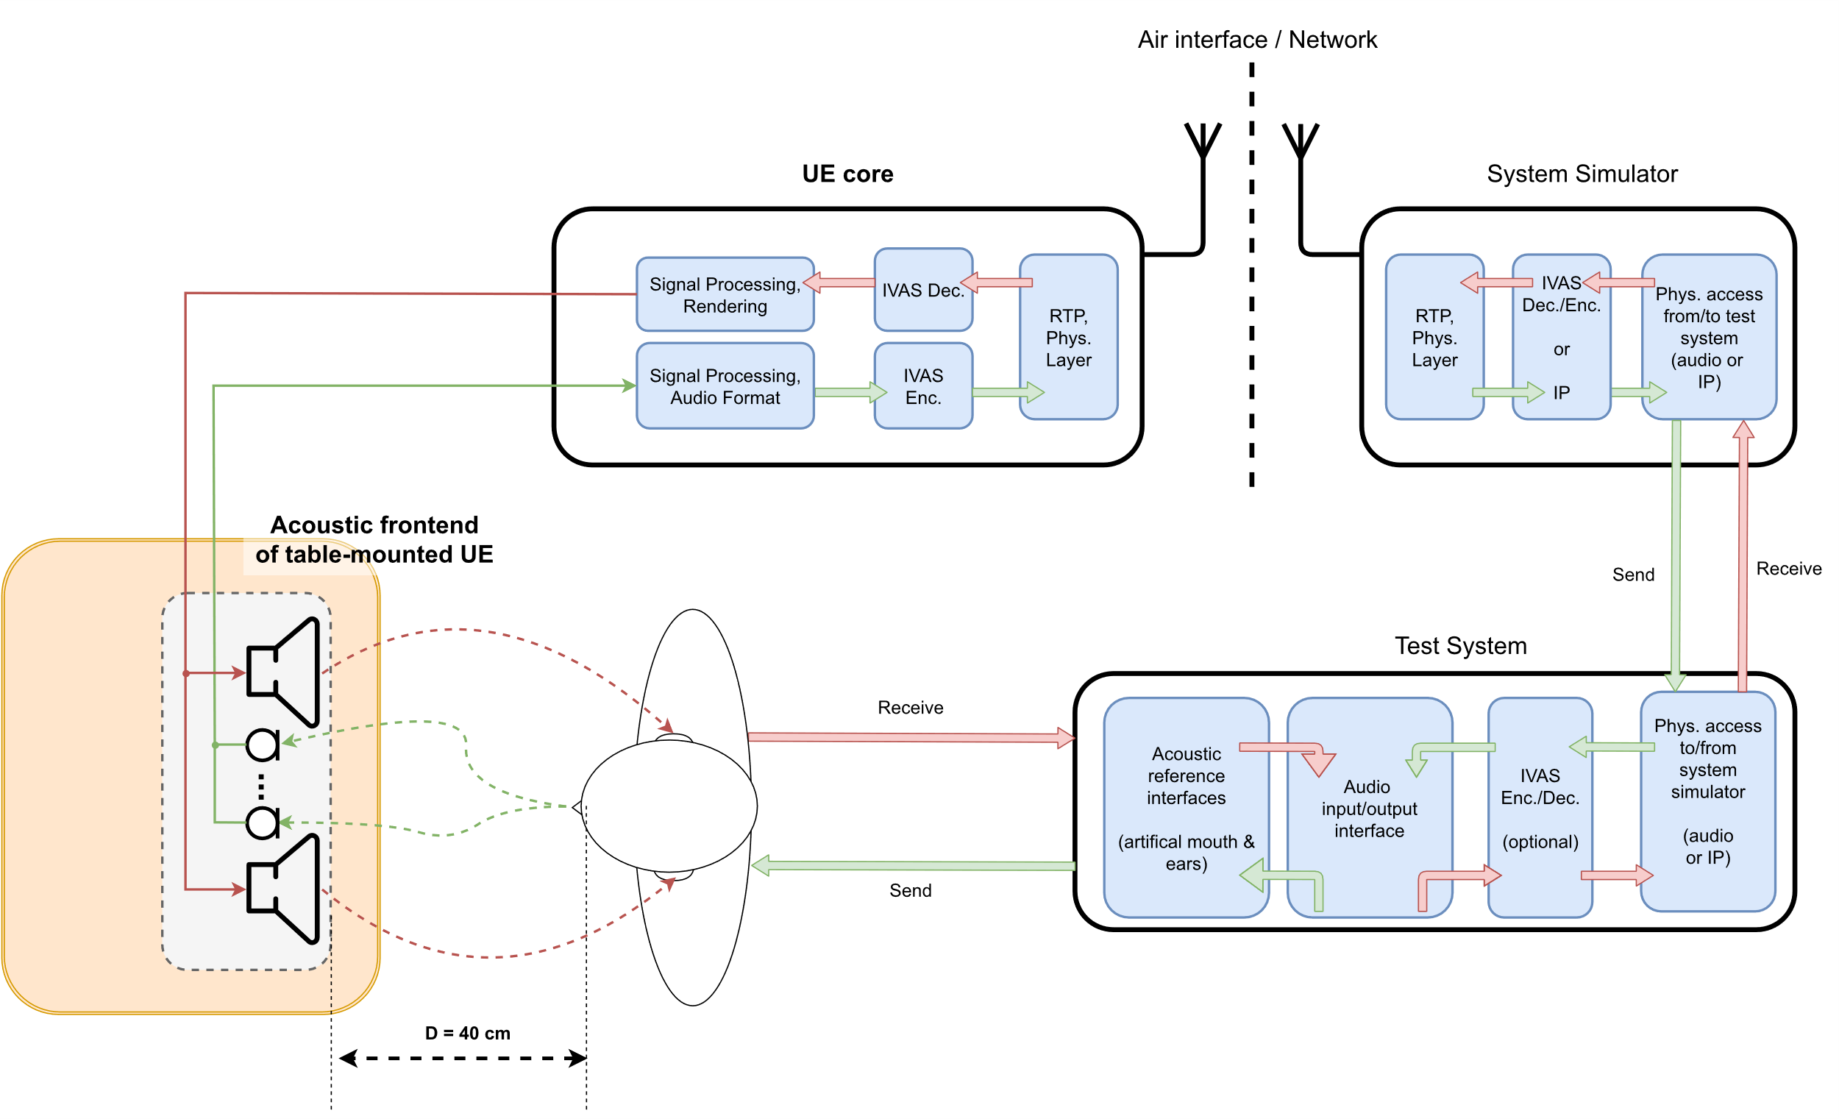
Figure 3: Table-mounted hands-free UE and test equipment
Figure 3 shows an example with a distance of D = 40 cm between front of the UE and lip reference plane, which corresponds to the desktop hands-free setup as specified in Recommendation ITU-T P.341 [6], which is also referenced in 3GPP TS 26.132 (width W = 40 cm, height H = 30 cm). In general, multiple sub-setups could be considered for this UE type, like e.g., the “group audio terminal” position (clause 4.2.4 of P.341 [6]) or the softphone/laptop-based setups 3GPP TS 26.132 [5].
NOTE: The term “table-mounted hands-free” is suggested here instead of “desktop hands-free”, as used in e.g., TS 26.132. The intention for this is to explicitly address also different/larger setups like e.g., conferencing scenarios with multiple microphones and loudspeaker arrays.

Loudspeaker Mode (Receive)
The test setup for loudspeaker hands-free UE for receive direction is shown in Figure 4. It applies to advanced (mostly larger) playback systems and/or in case the previous RCV-UE-types are not applicable to a certain device.
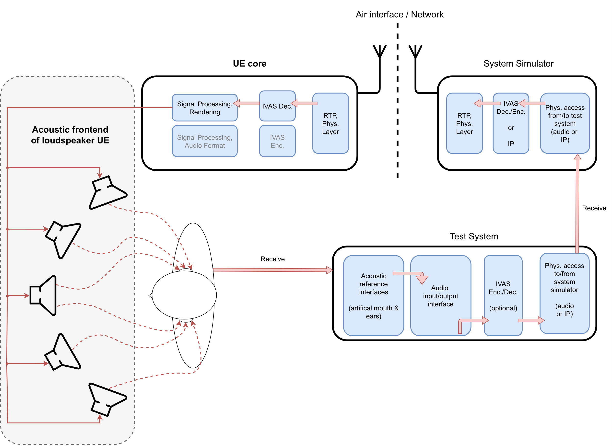
Figure 4: Loudspeaker hands-free UE and test equipment

Electrical interface (Send + Receive)
The test setup for electrical interface UE for send and receive directions is shown in Figure 5. It applies to all devices that do not provide integrated or associated equipment for capturing and/or reproduction of immersive audio. Note that the interface is not necessarily digital (Bluetooth, USB, or digital audio interfaces), it could also be an analogue jack plug, which provides up to two channels in receive and also send direction (see Recommendation ITU-T P.382 [7]). Optionally, the device might provide an additional input for head tracking data that can be used for rendering the receive direction (format/hardware interface for further study…?).
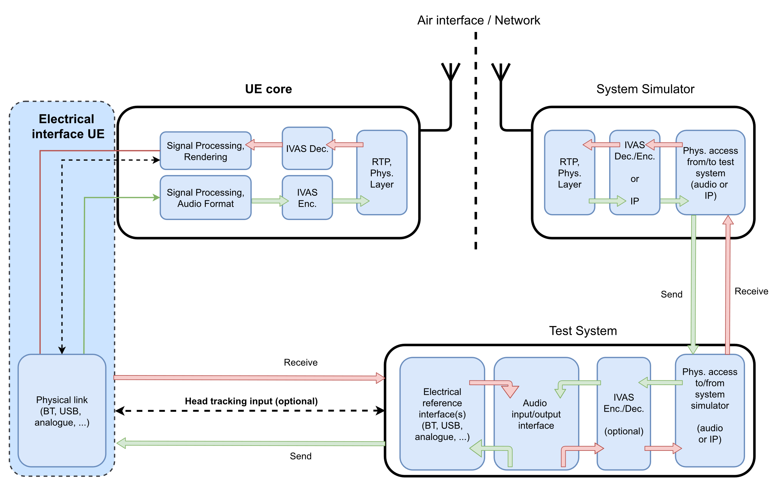
Figure 5: Electrical interface UE and test equipment
]

Test Conditions
[Editor’s note: Collect general test conditions in this clause, similar to TS 26.132 clause 6]
[

UE configuration
For testing the UE shall be configured for the relevant and/or envisioned use cases. During the tests potential internal development modes of the UE shall be disabled.
Ideally Ues should be test as is even if they have signal enhancement features. However, if performance issues are encountered and the UE allows to disable certain of these features like noise suppression, the tests should be repeated with these features disabled to document the possible cause of the problem.
[Editor’s note: Define IVAS codec operation mode(s) and bit rates to be used. Preferably such modes and bit rates should be used that have minimum impact on the acoustic tests.]

Test Equipment
[Editor’s note: Requirements on acoustic test equipment, system simulator, reference client, …]
]

Candidate sending side test methods and requirements
[
The following methods have been incorporated from [1]:

Sending frequency response

Sending frequency response of captured Ambisonics components
Definition:
Ratio of the sound pressure magnitude spectrum of the DUT for Ambisonics component ($m$, $l$): ${\hat{P}}_{l}^{m}\left(f\right)$ and a reference diffuse field sound pressure spectrum $P_{ref}(f)$ ( $=P_{0}^{0}\left(f\right)$ ). Letters $l$ and $m$ respectively denote Ambisonics degree and index. This means, for each Ambisonics component a sending frequency response is measured:
$G_{l}^{m}\left(f\right)=\frac{{\hat{P}}_{l}^{m}\left(f\right)}{P_{ref}(f)}$ .
Ideal characteristic:
The ideal send frequency response of the captured Ambisonics components would be flat, i.e. be frequency independent (for plane wave input).
How to formulate requirements:
One conceivable way to measure against requirements can be taken from TS 26.260. A decorrelated pink noise test stimulus is simultaneously played over all speakers of a periphonic array. The reference diffuse field sound pressure spectrum is obtained through recordings with a diffuse-field microphone positioned at the geometric centre of the periphonic array. The sound pressure magnitude spectrum of the DUT for Ambisonics component ($m$, $l$) is obtained through measuring with the DUT at the geometric centre and extracting and analysing that (B-format) component after coding, transmission and decoding as in 26.260 Figure 1.
The sensitivity/frequency response shall meet the ideal characteristics, within some tolerance.

Sending frequency response of captured Metadata-assisted Spatial Audio

Definition
Sending frequency response of MASA capture is defined as a ratio of the sound pressure magnitude spectrum of the DUT’s transport channels (k): Pkf and a reference diffuse field sound pressure spectrum Pref(f). Letter k denotes transport channel number. This means, for each MASA transport channel a sending frequency response is measured:
Gkf=PkfPref(f) .

Test conditions
Free-field propagation conditions
- The test environment shall contain a free-field volume, wherein free-field sound propagation conditions shall be observed.
- The free-field sound propagation conditions shall be observed down to a frequency of 200Hz.
[Test environment noise floor]
[Editor’s note: The test environment noise floor may not have to specified in this clause. Likely, a general clause for the whole specification is sufficient.]

Loudspeaker array
A loudspeaker array comprising L loudspeakers located at a set of predefined directions (θ_{i}, φ_{i}), i=1,...,L , from the geometric center of the loudspeaker array shall be used. The loudspeaker array can be realized with an arc loudspeaker array comprising the elevated positions and turntable.
[tbd]

Measurement for metadata-assisted spatial audio
Reference Spectrum measurement
Measurement is done as in TS 26.260 sub-clause 4.1.1.2.4.2 with the predefined loudspeaker positions and [pink noise] stimulus.

Estimated Spectrum
- The UE under test is connected to a test system composed of a 3GPP wireless system simulator and reference client with an IVAS session established with MASA EXT output. The codec shall be operated with metadata-assisted spatial audio input format at [512] kbit/s. The audio input format and bitrate shall be reported. The decoder/renderer option shall be MASA EXT.
b) The capture device under test is mounted in the free-field volume such that its geometric center coincides with the geometric center of free-field volume and the geometric center of the loudspeaker array.
Repeat steps c-d) for each loudspeaker position (θ_{i}, φ_{i}), i=1,...,L:
c) A pink noise signal is played over the loudspeaker. The noise signals shall be identical to the signals used for the reference spectrum measurement.
d) The response at the geometric center of the loudspeaker array pt is measured for each loudspeaker position.
e) The magnitude spectrum of the estimated sound pressure for each decoded MASA EXT transport channel k, Pkf, is calculated for the 1/12th octave intervals as given by the R40 series of preferred numbers in [6].

Calculation of send frequency response for metadata-assisted spatial audio
The send frequency response for metadata-assisted spatial audio, G_{k}(f), is calculated as Gkf=PkfPref(f) .

Sending directional response of captured Ambisonics componentss

Angular-dependent sensitivity
Definition:
Microphone angular-dependent sensitivity can be described by ${Sens}_{a}\left(θ,φ\right)$ (in Volt/Pascal or digital amplitude per Pascal), e.g., referring to the output voltage or digital level generated by a microphone for a given sound pressure at the microphone location for an incident plane wave from a certain direction $\left(θ,φ\right)$. Likewise, the angular-dependent sensitivity of the capture of each Ambisonics component ($m$, $l$) can be described as ${Sens}_{l}^{m}\left(θ,φ\right)$. As this sensitivity may also be frequency dependent, frequency is a further parameter:
${Sens}_{l}^{m}\left(θ,φ,f\right)$ .
Angular-dependent sensitivity of the capture of an Ambisonics component ($m$, $l$) can also be defined for multiple ($K$) incident plane waves from respective directions $\left(θ_{k},φ_{k}\right), k=1…K$. This yields:
${Sens}_{l}^{m}\left(Θ,Φ,f\right)$ with $Θ=(θ_{1},…,θ_{K})$ and $Φ=(φ_{1},…,φ_{K})$.

Of interest may be the cases $K=1$, $K=2$ and $K=N$. For $K=2$, the two directions should be 90 degrees apart (see [1-1]). For $K=N$, a reasonable setup could be where the directions would correspond to the Fliege positions of the considered Ambisonics order $N$.

Ideal characteristic:
The ideal angular-dependent sensitivity for the captured Ambisonics component ($m$, $l$) is obtained from the spherical harmonics equations. For simplicity, it is assumed that the spherical coordinate systems of the measurement room and the captured Ambisonics signals are aligned.
For the case $K=1$, we get
$${Sens}_{l}^{m}\left(θ,φ,f\right)={constant}_{1}∙Y_{l}^{m}\left(θ,φ\right)$$
with $Y_{l}^{m}\left(θ,φ\right)$ being the real valued spherical harmonics of the degree $m$ and index $l$ with $-m≤l≤m$.
Thus, if the reference client offers output of this Ambisonics component, it will in the ideal case and valid single plane-wave assumption (e.g., a distant-enough point source to approximate plane waves at the UE) follow the above relation. The ideal frequency response characteristic is flat. Care needs to be taken to apply the proper Ambisonics component ordering and normalization.
For any $K$, we get
$${Sens}_{l}^{m}\left(Θ,Φ,f\right)={constant}_{1}∙\sum_{k=1}^{K}{Y_{l}^{m}\left(θ_{k},φ_{k}\right)} .$$
Cases for K > 2 are not covered further.
How to formulate requirements:
The measurement for the simplest case of $K=1$ can be done according to the principles outlined above (under 2.1) using pink noise test stimuli. Unlike 2.1, only a single speaker at a time is used.
The angular-dependent sensitivity shall meet the ideal characteristics, within some tolerance.

[

Direction of arrival estimation under free-field propagation conditions

Definition
Direction of arrival (DOA) is defined as the spherical angle $(θ,φ)$ pointing towards the sound source. DOA is relative to the capture device position. This measurement compares the DOA estimation with the ground-truth DOA under free-field propagation conditions.
Note: The DOA estimation performance in reverberant environments may be different and is not covered by this test.

Test conditions
Free-field propagation conditions
- The test environment shall contain a free-field volume, wherein free-field sound propagation conditions shall be observed.
- The free-field sound propagation conditions shall be observed down to a frequency of 200Hz.
[Test environment noise floor]
[Editor’s note: The test environment noise floor may not have to specified in this clause. Likely, a general clause for the whole specification is sufficient.]
Loudspeaker array
A real or simulated loudspeaker array comprising L loudspeakers located at a set of predefined directions (θ_{i}, φ_{i}), i=1,...,L , from the geometric center of the loudspeaker array shall be used.

Measurement for Scene-based audio
For each loudspeaker position (θ_{i}, φ_{i}), i=1,...,L , the following procedure shall be used:
- The UE under test is connected to a test system composed of a 3GPP wireless system simulator and reference client with an IVAS session established with B-format output. The codec shall be operated with scene-based input format at [512] kbit/s. The audio input format and bitrate shall be reported. The decoder/renderer option shall be FOA.
- [TBD] test signal of [TBD s] length is played over the loudspeaker.
Editor’s note: The impact of codec on the test signal needs to be verified before performing the measurements.
c) The B-format scene-based audio format representation is captured.
d) The intensity parameter is calculated from the B-format capture $b=\left[\begin{aligned}\begin{matrix}b_{w} \\ b_{x} \\ b_{y}\end{matrix} \\ b_{z}\end{aligned}\right]$ using the equation:
$$i=R\left\{b_{w}{\left[\begin{matrix}b_{x} \\ b_{y} \\ b_{z}\end{matrix}\right]}^{*}\right\}.$$
NOTE: The intensity is calculated in frequency domain and per subframe. Further steps are thus performed with subframe accuracy.
e) The direction of arrival estimation $(θ_{est},φ_{est})$ is calculated based on the intensity parameter using the equations:
$φ_{est}=\frac{\arctan{\frac{i_{y}}{i_{x}}}}{π}⋅180°$,
$θ_{est}=\frac{\arctan{\frac{i_{z}}{\sqrt{i_{x}^{2}+i_{y}^{2}}}}}{π}⋅180°$,
Where the arctan function is assumed to be the computational variant “atan2” that solves the correct quadrant automatically
f) The estimated direction of arrival (θ_{est}, φ_{est}) is compared to the ground truth angle (θ_{i}, φ_{i}).
[Editor’s note: Potentially in several frequency bands and potentially time averaged. Weighting could be done similarly as in MASA case by estimating subframe energies and energy ratios.]

If the sending UE is properly implemented in terms of directionality, phase and scaling of Ambisonics components, the DOA metric is expected to correspond to the ground truth angle. The DOA angle calculated from the Ambisonics components from the UE capture system shall be within some tolerances w.r.t. the ground truth angle to the incident sound.

Measurement for Metadata-assisted spatial audio
For each loudspeaker position (θ_{i}, φ_{i}), i=1,...,L , the following procedure shall be used:
- The UE under test is connected to a test system composed of a 3GPP wireless system simulator and reference client with an IVAS session established with metadata-assisted spatial audio format output. The codec shall be operated with Metadata-assisted spatial audio input format at [512] kbit/s. The audio input format and bitrate shall be reported. The decoder/renderer option shall be MASA.
- [TBD] test signal of [TBD s] length is played over the loudspeaker.
Editor’s note: The impact of codec on the test signal needs to be verified before performing the measurements.
c) The Metadata-assisted spatial audio format representation is captured. The MASA representation includes estimated source angles and energy-related quantities per time frequency tiles, which are further analysed as follows.
d) The direct-to-total ratio times energy weighted azimuth and elevation angles (in radians) are mapped into Cartesian coordinate vectors $X$, $Y$ and $Z$ over all subframes and frequency bands:

$$X=\sum_{n}{\sum_{k}{(cos\left(φ_{nk}\right)⋅\cos\left(θ_{nk}\right)⋅{\text{direct-to-total energy ratio}}_{nk}⋅{energy}_{nk}),}}$$
$$Y=\sum_{n}{\sum_{k}{(\sin\left(φ_{nk}\right)⋅\cos\left(θ_{nk}\right)⋅{\text{direct-to-total energy ratio}}_{nk}⋅{energy}_{nk}),}}$$
$$Z=\sum_{n}{\sum_{k}{(\sin\left(θ_{nk}\right)⋅{\text{direct-to-total energy ratio}}_{nk}⋅{energy}_{nk}})}$$

where $n$ is the index of the frequency bands and $k$ is the index of the subframes.
[Editor’s note: Signal length [TBD] = $K⋅5ms$, where total number of subframes K = 1,2,…k,]
e) The direction of arrival estimation (θ_{est}, φ_{est}) is calculated based on the mapped Cartesian coordinate vectors using the equations:
$φ_{est}=\frac{\arctan{(\frac{Y}{X})}}{π}⋅180°$,
$θ_{est}=\frac{\arctan{\frac{Z}{\sqrt{X^{2}+Y^{2}}}}}{π}⋅180°$,
Where the arctan function is assumed to be the computational variant “atan2” that solves the correct quadrant automatically
f) The estimated direction of arrival $(θ_{est},φ_{est})$ is compared to the ground truth angle (θ_{i}, φ_{i}).
[Editor’s note: Potentially in several frequency bands and potentially time averaged.]

If the sending UE is properly implemented in terms of directionality and the energy ratio analysis for the MASA metadata, the DOA metric is expected to correspond to the ground truth angle. The DOA angle calculated from the MASA metadata from the UE capture system shall be within some tolerances w.r.t. the ground truth angle to the incident sound.

Comments for DOA test method design
Based on experimental evidence, the following points should be taken into an account:
- The DOA analysis based on analysing FOA and MASA signals were found to produce nearly equivalent results.
- Extreme angles should be handled accordingly. At the extreme angles, the absolute angle error can be very large, while the distance between the estimated sound source locations is small.
- (Mean) absolute angle error metric may not be the most applicable error calculation method. It should be examined whether e.g., spherical distance would be more suitable error metric
- Placement of the DUT is very critical for the test. It is suggested that the test should be performed multiple times, with replacement of the DUT between the measurements.
- Cone-of-confusion errors may occur in measurements of small devices with a limited number of microphones. These errors could be handled by e.g., limiting the measurement points or ignoring such errors if the number of errors is within acceptable limits.
- The applicability of the DOA test method for HOA capture is ffs.

]

[

Directivity test of FOA using virtual microphones

General
Definition:
A virtual microphone is created by a linear combination of the ambisonics components. As an example, for FOA, a cardioid, super-cardioid, figure-of-eight etc microphone can be constructed and pointed in an arbitrary direction, by adding or subtracting portions of the four FOA ambisonics components.
It is called a virtual microphone because its characteristics are manipulated without affecting the microphone itself. Compare with music production; the mix engineer can in post-production select where to point a microphone, and even construct an infinite number of virtual microphones pointing in various directions with various beam widths. A simplified variant of FOA capture is MS stereo recording using one omni and one figure-of-eight capsule, where the stereo width is decided in post-production by turning (usually two) virtual microphones’ mutual angle and setting their pickup pattern to taste. For ATIAS, this means the test system can steer an infinite number of virtual microphones anywhere and controlling the width of the pickup beam, without interacting with the UE that is “just” supplying ambisonics components to the test system.

Ideal characteristics
An ideal first-order directional microphone’s directional pickup in a plane can be described as:
$$f=p+\left(1-p\right)\cos{θ}$$
, where p =1 provides omni-directional, p=0.5 cardioid, p =0.37 super-cardioid, p =0.25 hyper-cardioid, p =0 bi-directional, etc.
This polar pattern can further be rotated, as illustrated below. The GIF illustrates adding portions of FOA components W, X and Y (“Pattern” corresponds to p above):

Figure 6 Illustration of beam and pattern steering (copied from [1-3])
With these simple means we are able to e.g. construct two simultaneous virtual microphones, one pointing at a sound source, the other pointing away from the sound source. This can be as simple as summing/subtracting the outputs from the reference decoder:
- Virtual mic A = W+Y
- Virtual mic B = W-Y

In the ideal case, if using two virtual back-to-back cardioids, one pointing towards a single sound source and one pointing away from it, only the first microphone shall produce an output signal.

How to formulate requirements:
Example: When a single sound source is placed at the positive Y direction in relation to the UE, the level of signal (W+Y) shall exceed the level of signal (W-Y) by at least X dB.
This test can be expanded to cover a variety of incidence angles. Or it can be expanded to rotate the virtual microphones while keep a single source constant.
The merit of using two virtual microphones (which are preferably implemented simultaneously), instead of only one, is that the testing is robust to dynamic range processing in the UE, thus spatial aspects can be robustly assessed with this method. This is achieved by the virtual microphones “pointing” at two or several incidence angles while the UE is subjected to only one source from one angle. A merit compared to [1-1], is that we avoid two simultaneous sound sources and two separable signals.
The method Is equally usable for ”OA, ’y defining appropriate linear combinations for the ambisonics components from the decoder.

Test conditions
Free-field propagation conditions
- The test environment shall contain a free-field volume, wherein free-field sound propagation conditions shall be observed.
- The free-field sound propagation conditions shall be observed down to a frequency of [200Hz].

[Test environment noise floor]
[Editor’s note: The test environment noise floor may not have to specified in this clause. Likely, a general clause for the whole specification is sufficient.]

Loudspeaker array
An array of coaxial loudspeakers is located at a set of predefined directions (θ_{i}, φ_{I}), i = 1,…,7, from the geometric center of the UE.

Table X: Location of loudspeakers generating stimuli in the acoustic chamber
I | θ_{i} [Ieg] | φ_{i} [deg]
1 | 0 | 30
2 | 0 | -30
3 | 0 | 0
4 | 0 | 135
5 | 0 | -135
6 | 0 | 90
7 | 0 | -90

Measurement based on decoded FOA signal
The following procedure shall be used:
- The UE under test is connected to a test system composed of a 3GPP wireless system simulator and reference client with an IVAS session established with FOA output. The encoder shall be operated with scene-based audio or metadata-assisted spatial audio input format at [512] kbit/s. The audio input format and bitrate shall be reported. The decoder/renderer option shall be FOA.
- A [tbd] test signal is played over a loudspeaker at position i.
Editor’s note: The impact of codec on the test signal needs to be verified before performing the measurements.
c) The output of each FOA output component (W, Y, Z, X) is captured.
d) Virtual microphone signals are deriver according to the Annex X.
e) The levels, averaged over the whole duration, are calculated for each deriver virtual microphone signal.
f) The level differences between each derived virtual microphone signals are calculated

Measurement based on decoded Multichannel signal
The following procedure shall be used:
- The UE under test is connected to a test system composed of a 3GPP wireless system simulator and reference client with an IVAS session established with 7.1+4 multichannel output. The encoder shall be operated with scene-based audio or metadata-assisted spatial audio input format at [512] kbit/s. The audio input format and bitrate shall be reported. The decoder/renderer option shall be 7.1+4 multichannel.
- A [tbd] test signal is played over a loudspeaker at position i.
Editor’s note: The impact of codec on the test signal needs to be verified before performing the measurements.
c) The output of each multichannel output channel (1, 2, …,12) is captured.
d) The levels, averaged over the whole duration, are calculated for each decoded output channel
e) The level differences between each decoded output channel are calculated

Annex X
Virtual microphones in horizontal plane for ϕi and ϕj directions are derived with the equations below:
Ai=p2W+1-pcosϕiX+sinϕiY,
Bj=p2W+1-pcosϕjX+sinϕjY,
where p =1 provides omni-directional, p=0.5 cardioid, p =0.37 super-cardioid, p =0.25 hyper-cardioid, p =0 bi-directional, etc.
[Editor’s note: θi corresponds to the loudspeaker position i, and θj to the other assessed directions. In practice θj could point towards other loudspeaker positions, or it can be rotated along the circle.]
For deriving virtual microphones with elevation and for hoa is ffs.

]

[
Editor’s note: the methods on sending spatial separation with two simultaneous sources and with multi-channel setup share the same basic principles and should be harmonized.
The following methods have been incorporated from [4]:

Scene-based audio spatial separation with two simultaneous acoustic sources in free-field propagation conditions and FOA decoding

Definition
The Scene-based audio sending spatial separation with two simultaneous acoustic sources measures the difference between the UE captured polar patterns of the Ambisonics B-format components and the expected ground-truth when the UE is subjected to two simultaneous acoustic sources at predefined directions, (θ_{i}, φ_{i}), i=1,...,L.

Test conditions
Free-field propagation conditions
- The test environment shall contain a free-field volume, wherein free-field sound propagation conditions shall be observed.
- The free-field sound propagation conditions shall be observed down to a frequency of 200Hz.

[Test environment noise floor]
[Editor’s note: The test environment noise floor may not have to specified in this clause. Likely, a general clause for the whole specification is sufficient.]
Loudspeaker array
An array of coaxial loudspeakers is located at a set of predefined directions (θ_{i}, φ_{i}), i=1,…,6, from the geometric center of the UE. The different locations may be realized using multiple loudspeakers or by rotation of at least two loudspeakers or by rotation of the UE.
The N=4 periphonic array can be augmented with these additional 5 positions (Y2 is already present).

In case the UE has motion compensation (automatic rotation of the captured soundfield depending on pose), physical rotation of the UE shall not be used to achieve the predefined directions and it shall be ensured that there is no misalignment of X, Y and Z axes due to the motion compensation.
[QCOM – Andre] Here again, the alignment with the periphonic array would be of help since the test lab would not have to worry about the issue above and no movement of the device would be required. See comments above.

[Editor’s note: this applies for general audio case. For communication HATS playback might be considered.]
The distance from the loudspeaker front baffle to the center of the UE shall be at least 1m and equal within ±[x]% for all loudspeakers. [Editor’s note: check if 1m is sufficient, considering the proximity effect at 200/275 Hz, which we would like to avoid as it biases the test result. This should go (later) into a separate clause]
The loudspeakers shall be equalized to a flat frequency response and equal sensitivity with the UE absent, using a [measurement microphone and diffuse-field equalization] placed at the UE position. The microphone shall point in the positive Z direction with its membrane in the XY plane.

Table X: Location of loudspeakers
Position | i | θ_{i} [deg] | φ_{i} [deg] | Comment
X₁ | 1 | 0 | 0 | 0 deg (frontal) incidence to the DUT, along the X-axis
X₂ | 2 | 0 | 180 | opposite to X₁, along the X-axis
Y₁ | 3 | 0 | -90 | -90 deg incidence to the DUT, along the Y-axis
Y₂ | 4 | 0 | 90 | opposite to Y1, along the Y-axis
Z₁ | 5 | 90 | 0 | “from the ceiling” incidence to the DUT, along the Z-axis
Z₂ | 6 | -90 | 0 | opposite to Z1, along the Z-axis

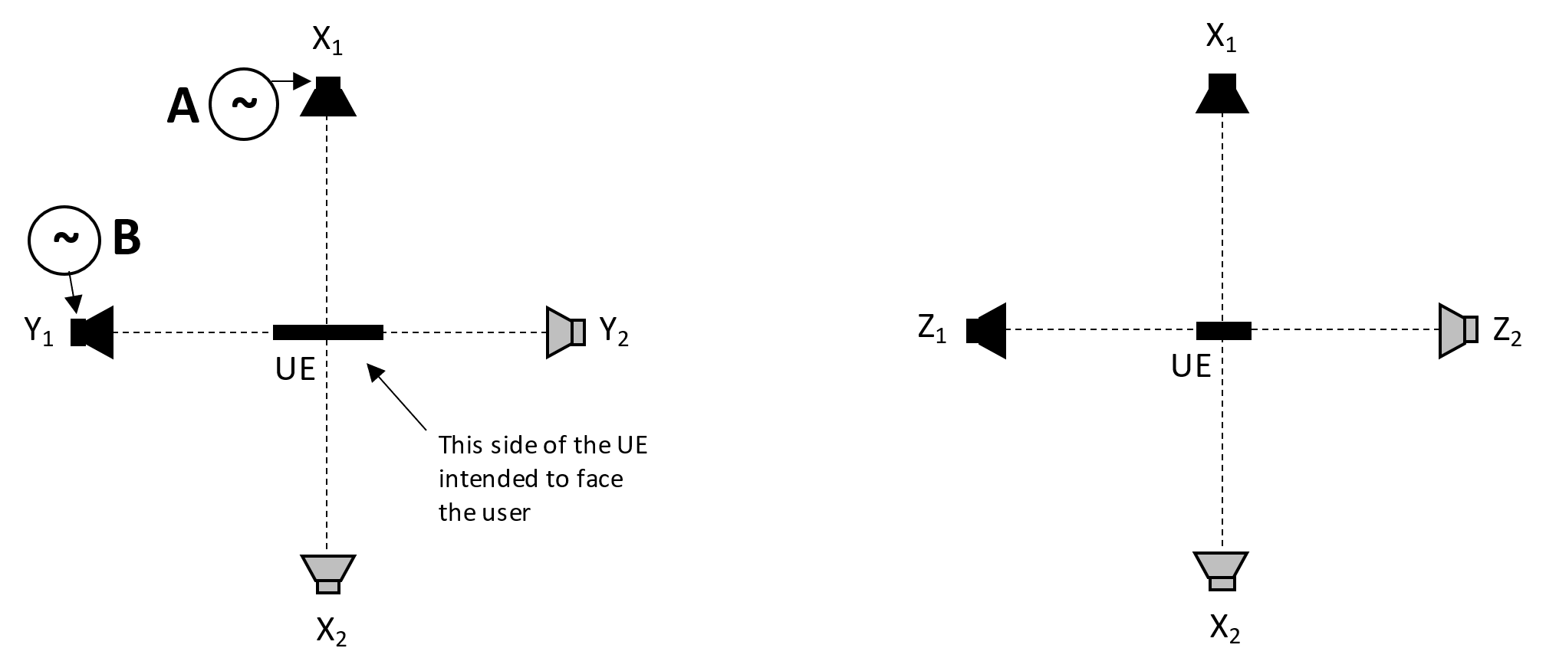
Figure 6 : Location of loudspeakers

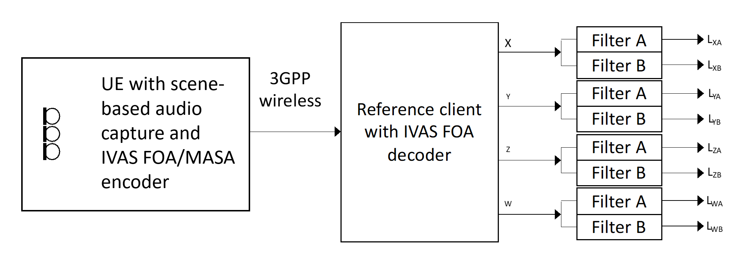
Figure 8: Example using FOA; The UE under test is connected to a test system composed of a 3GPP wireless system simulator and a reference client with B-format output and frequency-domain filters for analysis. For HOA, the same setup is used and the higher order ambisonics components at the receiver are ignored. For MASA input capture, IVAS MASA encoder is utilized
[Editor’s note: The actual subjective performance of the immersive capture after rendering using a high-quality reference should be considered. This applies to most test cases with unrealistic test signals and should be addressed in a general section.

Measurement
The following procedure shall be used:
- The UE under test is connected to a test system composed of a 3GPP wireless system simulator and reference client with an IVAS session established with B-format output. The codec shall be operated with scene-based audio or metadata-assisted spatial audio input format at [FFS] kbit/s. The audio input format and bitrate shall be reported. The decoder/renderer option shall be FOA.
- A modulated multi-tone test signal A is played over a loudspeaker at position X₁. Simultanously, a modulated multi-tone test signal B is played over a loudspeaker at position Y₁. See Annex X for a description of the multi-tone signals.
Editor’s note: The impact of codec on the test signal needs to be verified before performing the measurements.
c) The output of each ambisonics component (W, X, Y, Z) is captured. After an initial conditioning time of [5] seconds the remainder of the captured signal is converted to the frequency domain as described in Annex X. The signals are filtered by two different comb filters, filter A and filter B, with passbands corresponding to frequencies in signals A and B respectively. The filters are realized by including/excluding certain frequency bins as described in Annex X.
d) The levels after the filters, averaged over the whole duration, are calculated according to the Annex A.4.
e) The level metrics according to Table X are calculated.
Table X: Assessment of spatial separation
Simultaneous sources |  | Requirements on the B-format outputs of the reference decoder
Source A | Source B | Signal component A | Signal component B | Motivation
Position X₁ | Position Y₁ | L_{XA} – L_{YA} > [N] dB,  |L_{WA} – L_{XA}| < [M] dB | L_{YB} – L_{XB} > [N] dB,  |L_{WB} – L_{YB}| < [M] dB | Signal component A is ideally only seen in X and W, Signal component B is ideally only seen in Y and W
 |  | |L_{WA} – L_{WB}| < [P] dB |  | Signal component A in W equally strong as B in W
Position X₁ | Position Z₁ | L_{XA} – L_{ZA} > [N] dB,  |L_{WA} – L_{XA}| < [M] dB | L_{ZB} – L_{XB} > [N] dB,  |L_{WB} – L_{ZB}| < [M] dB | Signal component A is ideally only seen in X and W, Signal component B is ideally only seen in Z and W
 |  | |L_{WA} – L_{WB}| < [P] dB |  | Signal component A in W equally strong as B in W
Position X₂ | Position Y₂ | L_{XA} – L_{YA} > [N] dB,  |L_{WA} – L_{XA}| < N dB | L_{YB} – L_{XB} > [N] dB,  |L_{WB} – L_{YB}| < N dB | Signal component A is ideally only seen in X and W, Signal component B is ideally only seen in Y and W
 |  | |L_{WA} – L_{WB}| < [P] dB |  | Signal component A in W equally strong as B in W
Position X₂ | Position Z₂ | L_{XA} – L_{ZA} > [N] dB,  |L_{WA} – L_{XA}| < [M] dB | L_{ZB} – L_{XB} > [N] dB,  |L_{WB} – L_{ZB}| < [M] dB | Signal component A is ideally only seen in X and W, Signal component B is ideally only seen in Z and W
 |  | |L_{WA} – L_{WB}| < [P] dB |  | Signal component A in W equally strong as B in W
The test is repeated where signals A B are interchanged, to avoid a potential bias. The results from the two tests are averaged. The values M (maximum of difference to omni component), N (minimum of off-axis rejection) and P (maximum unbalance of omnidirectional capture) are TBD.
[Editor’s note: in case there will be different specifications for the test methods and the requirements, the table can be moved to the latter document, e.g. TS 26.261.]
[Editor’s note: ground-truth for this test to be clarified]

Annex A: Test signal and analysis for spatial separation with simultaneous acoustic sources

A.1 Test signal definition
The test signal shall be generated according to the ITU-P.501 [1] (subclause 7.2.4.1) and as provided in equation A.1.
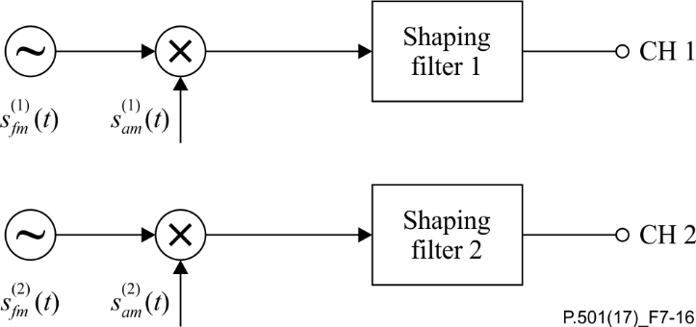
Figure 9: Two channel test signal generation for double-talk evaluations
based on AM-FM signals
$s_{fm}^{(1,2)}\left(t\right)= \sum_{n}{A^{(1,2)}(n)}⋅cos[2πf_{0}^{(1,2)}\left(n\right)⋅t+μ_{fm}^{(1,2)}\left(n\right)⋅\sin\left(2πf_{fm}^{(1,2)}⋅t\right)]{}$n = 1,2,... (A.1)
where $μ_{fm}^{(1,2)}\left(n\right)=\frac{{∆f}^{(1,2)}\left(n\right)}{f_{fm}^{(1,2)}}$
$$s_{am}^{(1,2)}\left(t\right)=[1+μ_{am}^{(1,2)}⋅\cos\left(2πf_{am}^{(1,2)}⋅t\right)]$$
In ITU-T P.501, the following parameters are defined in a frequency-independent manner: $f_{fm}^{(1,2)}=1 \text{Hz}$, $μ_{am}^{(1,2)}=\frac{2}{3}$and $f_{am}^{(1,2)}=3 \text{Hz}$. The center frequencies$f_{0}^{(1,2)}$ for test signal are defined in the Table A.1.
The frequency-dependent modulation bandwidth ${∆f}^{(1,2)}$ is determined as follows:
$${∆f}^{(1,2)}\left(f_{0}\right)=\min{(40.0, 0.0195033⋅f_{0}-0.230789)}$$
Table A.1: Centre frequencies and bandwidths (1/3rd octave bands)
Center Frequency [Hz] | Talker | Disable with MASA | Freq. Start [Hz] | Freq. Stop [Hz] | ${∆f}^{(1,2)}$ [Hz]
275 | A |  | 269 | 281 | [TBD (should essentially be Fstop – Fstart)]
346 | B | X | 339 | 354
436 | A | X | 427 | 446
550 | B |  | 538 | 562
693 | A | X | 678 | 707
873 | B | X | 855 | 890
1100 | A |  | 1078 | 1123
1386 | B |  | 1358 | 1414
1746 | A |  | 1711 | 1781
2200 | B |  | 2159 | 2241
2772 | A |  | 2731 | 2813
3492 | B |  | 3451 | 3533
4400 | A |  | 4359 | 4441
5543 | B |  | 5502 | 5585
6984 | A |  | 6943 | 7026
8800 | B |  | 8759 | 8841
11087 | A |  | 11047 | 11129
13969 | B |  | 13928 | 14011

[Editor’s note: Certain frequency components need to be disabled for MASA capture due to characteristics of that format. Disabling of the frequency components should be performed at the measurement stage, i.e., disabling the frequency components from the test signal.]

A.2 Shaping filter
Considering the spectra of programme material in general, and considering signal-to-noise ratio in the measurement, the frequency-dependent amplitude of each AM-FM-component is given by the decay d = 3 dB per octave.

$$20\log_{10}{A^{(1,2)}\left(n\right)}=-d⋅\log_{2}(f_{0}^{\left(1,2\right)}\left(n\right)/f_{c})$$

The shaping filter is illustrated in Figure A.2.
[TBD]
Figure A.2: Shaping filters for test signal
[Editor’s note: different shaping filters can be considered for general audio and communication scenarios]

A.3 Spectral mask
The spectral masks for the calculation of individual per-source / per-talker levels are defined as follows.
The signals are sampled at 48kHz sampling rate and transferred to the frequency domain using a [2^16] FFT, Hann window, [50%] overlap. Frequency bins are multiplied by 1 if they are within the passbands, and by 0 if they are outside.
The passbands of the masks are defined by the stimulus carrier frequencies and the frequency modulation ${∆f}^{\left(1,2\right)}$ plus a further widening by one frequency bin at each side, see Table A.1.
$$f_{lower}=f_{0}-{∆f}^{\left(1,2\right)}-{[1]∙∆f}_{bin}$$
$$f_{upper}=f_{0}+{∆f}^{\left(1,2\right)}+{[1]∙∆f}_{bin}$$
where ${∆f}_{bin}=48kHz/{[2}^{16}]$

A.4 Level calculations

The assessment of the signal separation of two simultaneously captured signals is done by calculating the mean level difference of captured frequency components between assessed channels. The mean level difference is calculated as follows:

- The level differences of captured frequency component pairs are calculated. Level of each captured frequency component $i=1,2….K$ is calculated individually over the mask width $±∆f_{i}$ for assessed channels:

$$L_{X_{i}}= 10⋅{\text{log}}_{10}(\sum_{n= f_{i}- ∆f_{i}}^{f_{i}+ ∆f_{i}}{X}\left[n\right]) \text{dB},$$

$$L_{Y_{i}}= 10⋅{\text{log}}_{10}(\sum_{n= f_{i}- ∆f_{i}}^{f_{i}+ ∆f_{i}}{Y}\left[n\right]) \text{dB}$$

where $X$ and $Y$ are the power spectrums of the X and Y channels, $f_{i}$ is the $i$th center frequency and $∆f_{i}$ is the $i$th bandwidth of the corresponding test signal component including the modulation bandwidth and frequency mask width.

- The level difference between two channels’ $i$th frequency components are calculated:

$$∆L_{i}=L_{ X_{i}}-L_{Y_{i}}$$

- Overall spatial separation is evaluated by calculating the average over all the frequency component pair level differences. The mean level difference N of the assessed channels is obtained by averaging level difference pairs over $K$ frequency component:

$$N=\frac{\sum_{i=1}^{K}{∆L_{i}}}{K}.$$

[Editor’s note: Channels X and Y are presented here as an example. Same calculations are done between all the assessed output channels with sufficient set of center frequencies, i.e., included center frequencies of the A and B signals.]

]

[
The following method(s) have been incorporated from [6]:

Spatial separation for multiple acoustic sources based on multichannel output

[

Test conditions
Free-field propagation conditions
- The test environment shall contain a free-field volume, wherein free-field sound propagation conditions shall be observed.
- The free-field sound propagation conditions shall be observed down to a frequency of [200Hz].

[Test environment noise floor]
[Editor’s note: The test environment noise floor may not have to specified in this clause. Likely, a general clause for the whole specification is sufficient.]

Loudspeaker array
An array of coaxial loudspeakers is located at a set of predefined directions (θ_{i}, φ_{I}), i = 1, …,8, from the geometric center of the UE. The different locations may be realized using multiple loudspeakers or by rotation of at least two loudspeakers or by rotation of the UE.
The distance from the loudspeaker front baffle to the center of the UE shall be at least [1m] and equal within ±[x]% for all loudspeakers.
The loudspeakers shall be equalized to a flat frequency response and equal sensitivity with the UE absent, using a [measurement microphone and diffuse-field equalization] placed at the UE position. The microphone shall point in the positive Z direction with its membrane in the XY plane.

Table X: Location of loudspeakers generating stimuli in the acoustic chamber, and configuration for the reference client rendereI
i | θ_{i} [Ieg] | φ_{i} [deg] | Comment
1 | 0 | 30 | Left, MC channel 1
2 | 0 | -30 | Right, MC channel 2
3 | 0 | 0 | Center, MC channel 3
4 | 0 | 135 | Left Surround, MC channel 5
5 | 0 | -135 | Right Surround, MC channel 6
6 | 0 | 90 | Left Side Surround, MC channel 7
7 | 0 | -90 | Right Side Surround, MC channel 8
8 | 90 | 0 | One height speaker is used in the acoustic test chamber.  The reference renderer in the reference client is configured with four height speaker signals in accordance with the IVAS default 7.1.4 configuration [reference to future IVAS specification], MC channels 9-12. These four signals are added in the time domain before further measurements.

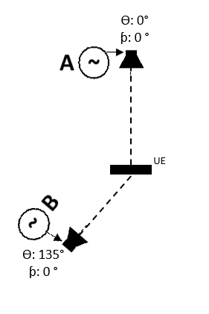
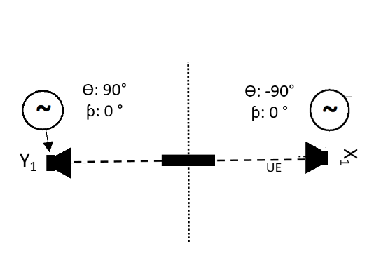

Figure X: Utilized loudspeaker position combinations

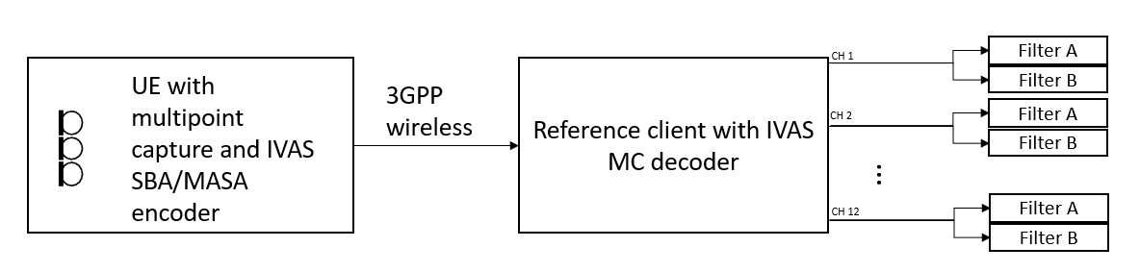
Figure X: Example using IVAS SBA or MASA; The UE under test is connected to a test system composed of a 3GPP wireless system simulator and a reference client with 7.1+4 multichannel output and frequency-domain filters for analysis.

Measurement
The following procedure shall be used:
- The UE under test is connected to a test system composed of a 3GPP wireless system simulator and reference client with an IVAS session established with 7.1+4 multichannel output. The encoder shall be operated with scene-based audio or metadata-assisted spatial audio input format at [512] kbit/s. The audio input format and bitrate shall be reported. The decoder/renderer option shall be 7.1+4 multichel.
- b) A modulated multi-tone test signal A is played over a loudspeaker at position i_{A}. Simultaneously, a modulated multi-tone test signal B is played over a loudspeaker at position i_{B}. See Annex A.1 for a description of the multi-tone signals.
Editor’s note: The impact of codec on the test signal needs to be verified before performing the measurements.
c) The output of each multichannel output channel (1, 2, …,12) is captured. After an initial conditioning time of [5] seconds the remainder of the captured signal is converted to the frequency domain as described in Annex X. The signals are filtered by two different comb filters, filter A and filter B, with passbands corresponding to frequencies in signals A and B respectively. The filters are realized by including/excluding certain frequency bins as described in Annex A.3.
d) The levels after the filters, averaged over the whole duration, are calculated by summing the power of the selected bins.
e) The level metrics according to Table X are calculated.

Table X Requirements on spatial separation of decoded multichannel output channels. Subscripts denotes the channel number of MC output and applied filtering.
Simultaneous sources |  | Requirements on the 7.1+4 Multichannel outputs of the reference decoder
Source A | Source B | Signal component A | Signal component B
Azi: 0°  Ele: 0° | Azi: 90°  Ele: 0° | L_{3A} – L_{7A} > [N_{A}] dB | L_{7B} – L_{3B} > [N_{B}] dB
Azi: -30°  Ele: 0° | Azi: 30°  Ele: 0° | L_{2A} – L_{1A} > [N_{A}] dB | L_{2B} – L_{1B} > [N_{B}] dB
Azi: -90°  Ele: 0° | Azi: 90°  Ele: 0° | L_{8A} – L_{7A} > [N_{A}] dB | L_{7B} – L_{8B} > [N_{B}] dB
Azi: 0°  Ele: 0° | Azi: 135°  Ele 0° | L_{3A} – L_{5A} > [N_{A}] dB | L_{5B} – L_{3B} > [N_{B}] dB
Azi: 0°  Ele: 0° | Azi: 0°  Ele: 90° | L_{3A} –L_{Ʃ9…12A} > [N_{A}] dB | L _{–9…12B} - L_{3B} > [N_{B}] dB

Editor’s note: It is expected that the threshold numbers will be set based on experiments with high-quality equipment in free-field propagation conditions with and without IVAS coding.
]
[
The following method(s) have been incorporated from [8]:

Test method for simultaneous multiple acoustic sources utilizing real speech
Editor’s note: This section may replace the section with artificial test signals; further inputs are needed.
The proposed test method utilizes similar setup as documented in ATIAS-1 permanent document sections 4.5 and 4.6 [3]. The main difference is with the test signal and the analysis metrics. In this section, the test method and the test signal are briefly explained.

Test setup
Test setup comprises two loudspeakers in an anechoic chamber. Loudspeakers should be placed such that the directions comply with two of loudspeaker positions in the multichannel loudspeaker setup or with FOA/HOA component directions.
In the figure below, the example setup of 7.1+4 multichannel capture and output is illustrated. For the sake of simplicity, only the horizontal layout of 7 horizontal loudspeakers is illustrated.
Reference speech signal $r_{1}$is the output signal of the loudspeaker 1 at azimuth angle of 0°, and reference speech signal $r_{2}$ is the output signal of the loudspeaker 2 at azimuth angle of 90°. Analysis signals $a_{1}$ and $a_{2}$ are then obtained from the decoded output e.g., from 7.1+4 multichannel signal’s channels 3 and 7, or X and Y components (channels 4 and 2) of FOA/HOA output, respectively.
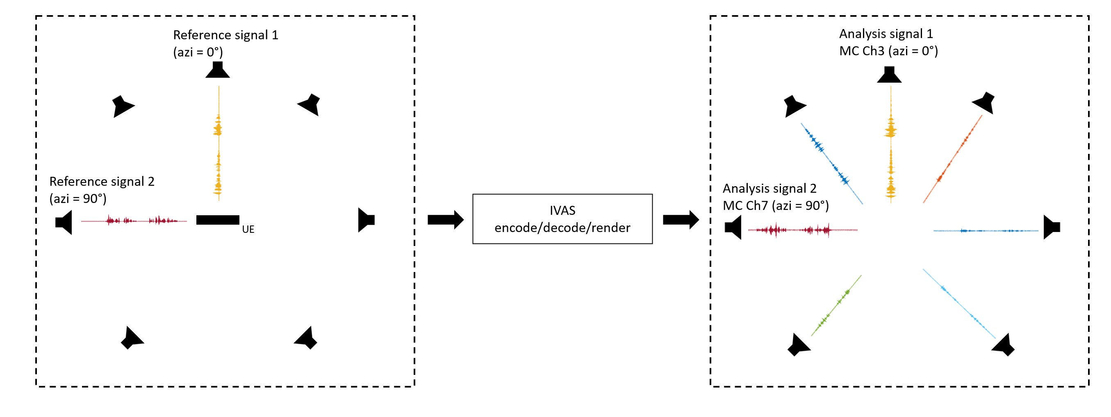
Figure 1 Test setup. Test signals are output from two different loudspeakers at the certain directions of multichannel output channels or FOA/HOA components. Acoustic capture is encoded and decoded with IVAS. Analysed signals are obtained from the decoded output channels of corresponding loudspeaker directions of the test setup. Possible cross-channel leakage is illustrated in the decoded output.

Test signal
The utilized test signals are two real speech signals, as given in the ITU-T recommendation P.501. The test can be made with two male, two female, or with mixed (one male, one female) talkers. In order to distinguish talkers accurately, the speech signals can be separated slightly in time domain, to obtain both single talk and double talk events. This can be achieved by adjusting the time difference of the signals in such a way, that the cross-correlation between speech signals is low within some adjustment window, e.g., 2 seconds time window. By adjusting the speakers to overlap only partly, the analysis can be made more robust, since also single talker scenarios can be evaluated in the same scene. Furthermore, in ITU-T recommendation P.501 section 7.3.5 speech signals for double-talk testing are specified. Whole test signal, or only part of it, could be applied for the test.

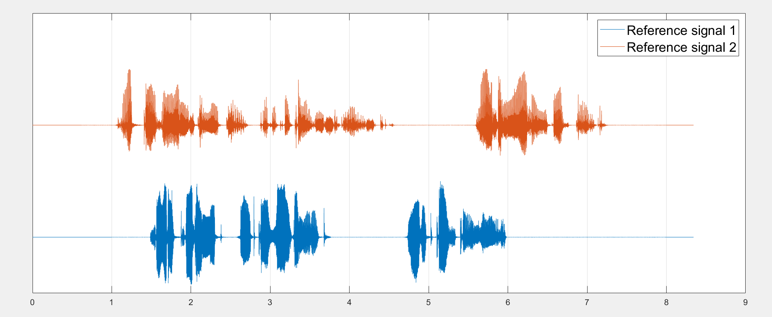
Figure 2 Visualized test signal comprising overlapping male and female speech.

Metrics
In this section, several alternative evaluation metrics for determining accuracy of double talk spatial capture are presented. For analysis, the properties between
- analysis signal $a_{1}$ (decoded MC/FOA output channel corresponding to the direction of r1),
- analysis signal $a_{2}$ (decoded MC/FOA output channel corresponding to the direction of r2),
- reference signal $r_{1}$ (output of loudspeaker 1) and
- reference signal $r_{2}$ (output of loudspeaker 2)
are compared. With an ideal capture system, analysis signal $a_{1}$should be similar to reference signal $r_{1}$, and analysis signal $a_{2}$ should be similar to reference signal $r_{2}$. Furthermore, similarity between analysis signal $a_{1}$ and reference signal $r_{2}$ should be low, as well as similarity between analysis signal$a_{2}$ and reference signal $r_{1}$.
Before the analysis, the captured and decoded analysis signals should be time aligned with the test signals. This can be done, e.g., via finding the maximum cross-correlation between mono summed analysis and reference signals with different time delays.

Cross-correlation ratio
Cross-correlation between analysis and reference signals are calculated to determine simple time-domain similarity. High cross-correlation between analysis signal $a_{1}$ and reference signal $r_{1}$ indicates, that the correct speech signal is coded mostly into the correct channel. Cross-correlation coefficient $\hat{R}$ between discrete signals $x$and $y$ at different time lags $k$ is defined as follows:
$$R_{xy}(k) = \left\{\begin{aligned}\sum_{n}^{N-k-1}{x_{n+k}∙y_{n}^{*}}, k ≥ 0 \\ R_{xy}^{*}(-k), k < 0\end{aligned}\right.$$

As the analysis signals and reference signals should be time aligned before the analysis, the cross-correlation values are calculated only for the time lag $k=0.$ Cross-correlation is then calculated between:
- Analysis signal $a_{1}$ and reference signal $r_{1}$, ${\hat{R}}_{a1r1}$
- Analysis signal $a_{1}$ and reference signal $r_{2}$, ${\hat{R}}_{a1r2}$
- Analysis signal $a_{2}$ and reference signal $r_{2}$, ${\hat{R}}_{a2r2}$
- Analysis signal $a_{2}$ and reference signal $r_{1}$, ${\hat{R}}_{a2r1}$

Plain cross-correlation values can be ambiguous and do not necessarily tell much about the performance. However, the ratio of absolute cross-correlation values between ${\hat{R}}_{a1r1}$ and ${\hat{R}}_{a1r2}$ indicates how much more similar analysis signal $a_{1}$ is with reference signal $r_{1}$ than with reference signal $r_{2}$:
$${CorrRat}_{1}= \frac{\left|R_{a1r1}\right|}{\left|R_{a1r2}\right|},$$
Similarly, the absolute ratio between ${\hat{R}}_{a2r2}$ and ${\hat{R}}_{a2r1}$ indicates how much more analysis signal $a_{2}$ correlates with the reference signal $r_{2}$ than with the reference signal $r_{1}$.
$${CorrRat}_{2}= \frac{\left|R_{a2r2}\right|}{\left|R_{a2r1}\right|}$$
High cross-correlation ratio implies that the analysis signal is more similar with the intended test signal, than with the other test signal, i.e., the signal from the correct direction is captured more accurately than the signal from the wrong direction.
Requirements for cross-correlation ratio can be formulated with a simple threshold value:
$${CorrRat}_{1}>\left[T\right],$$
$${CorrRat}_{2}> [T].$$

Coherence ratio
Coherence ratio is a similar metric as the cross-correlation ratio, but it is based on a frame-wise inter-channel coherence between analysis signals and reference signals. The inter-channel coherence value is a normalized similarity index between 0 and 1, where 1 means that the signals are coherent, although potentially with level differences, and value 0 means that the signals are incoherent. Inter-channel coherence between signals $x$and $y$ is defined as follows [4]:
$$C= \frac{\left|γ_{xy}\right|}{\sqrt{E_{x}∙E_{y}} },$$
where $γ_{xy} = E\left[X{∙Y}^{*}\right]$, $E_{x} =$ $E\left[{\left|X\right|}^{2}\right]$ and $E_{y} = E\left[{\left|Y\right|}^{2}\right]$. The expectation operation $E\left[∙\right]$ is typically implemented using a mean or a sum of the samples over a time–frequency area. $X(k,m)$ and $Y(k,m)$ are time-frequency representations of the signals $x$and $y$ with frequency band $k$ and frame index $m$.
As an example, the inter-channel coherence between analysis signal $a_{1}$ and reference signal $r_{1}$ is calculated as follows: Short-time Fourier transformations $A_{1}$ and $R_{1}$ are calculated. ICC is calculated for each frame $m.$
$$C_{a1r1}(m)= \frac{\left|γ_{a1r1}(m)\right|}{\sqrt{E_{a1}(m)∙E_{r1}(m)} } = \frac{\left|\sum_{k}{A_{1}(k,m)∙{R_{1}(k,m)}^{*}}\right|}{\sqrt{\sum_{k}{{\left|A_{1}(k,m)\right|}^{2}}∙\sum_{k}{{\left|R_{1}(k,m)\right|}^{2}}} }$$
Similarly, frame-wise inter-channel coherences are calculated between:
- Analysis signal $a_{1}$ and reference signal $r_{2}$ = $C_{a1r2}(m)$
- Analysis signal $a_{2}$ and reference signal $r_{2}$ = $C_{a2r2}(m)$
- Analysis signal $a_{2}$ and reference signal $r_{1}$ = $C_{a2r1}(m)$

From the calculated frame-wise inter-channel coherence values, the coherence ratios for each frame are calculated:
$${CohRat}_{1}(m)= \frac{C_{a1r1}(m)}{C_{a1r2}(m)}$$
The obtained coherence ratio indicates how much more coherent analysis signal $a_{1}$ is with reference signal $r_{1}$ than with reference signal $r_{2}$ within the frame $m$. The same ratio calculation is performed between the coherences of $C_{a2r2}(m)$ and $C_{a2r1}(m)$:
$${CohRat}_{2}(m)= \frac{C_{a2r2}(m)}{C_{a2r1}(m)}$$
The overall coherence ratio can be estimated by averaging over all the frames or only for the frames where the speech is estimated to be active. Active speech frames can be simply estimated with e.g., some threshold energy of the frame.
For coherence ratio, the requirements can also be formulated with a threshold value:
$${CohRat}_{1} > [P],$$
$${CohRat}_{2}> [P].$$

Level difference
In addition to the presented ratio metrics, simple frame-wise level difference can be utilized to approximate the energy content of the analysis signals with respect to the reference signals. In chapter 2, it was suggested that the acoustic scene contains both single talk and double talk events. For the level difference metrics this property can be utilized by calculating level differences for different acoustic scenarios.
At time instances when only one speaker is active, the level difference between the analysis signals should be high in favour of the analysis signal which represents the active talker direction. I.e., at the time instances when only the reference signal $r_{1}$ is active, the level of analysis signal $a_{1}$ should be significantly higher than the level of the analysis signal $a_{2}$ and vice versa when reference signal $r_{2}$ is only active. At the time instances when both reference signals $r_{1}$ and $r_{2}$ are simultaneously active, the levels of analysis signals $a_{1}$ and $a_{2}$ should be nearly equivalent in average.
Level differences can be calculated, e.g., from the same STFT as utilizing in coherence ratio calculations. Interchannel level difference per frame can be obtained by summing over the frame frequency bins and converting to a decibel scale:
$$L_{a1}(m) = 10\log_{10}(\sum_{k}{A_{1}(k,m)}),$$
$$L_{a2}(m) = 10\log_{10}(\sum_{k}{A_{2}(k,m)}),$$
As an example, reference signal $r_{1}$ and $r_{2}$ can be divided into a frames and active voiced frames can be estimated with e.g., a similar active frame detector as in coherence ratio analysis. Thus, the requirements could be:
Table 1 Requirements for level difference metric. Abbreviation VAD represents utilized active frame detector function.
Level difference metrics
Frames where r1 is active and r2 is inactive | $$VAD\left(r_{1}\left(m\right)\right)=1∧VAD\left(r_{2}\left(m\right)\right)=0$$ | $$L_{a1}(m)-L_{a2}(m) > [N] dB$$
Frames where r1 is inactive and r2 is active | $$VAD(r_{1}(m)) = 0 ∧ VAD(r_{2}(m)) = 1$$ | $$L_{a–}(m) - L_{a1}(m) > [N] dB$$
Frames where both r1 and r2 are active | $$VAD(r_{1}(m)) = 1 ∧ VAD(r_{2}(m)) = 1$$ | $$\left|L_{a1}(m)-L_{a2}(m)\right| < [M] dB$$

The overall level differences over the analysed frames can be then obtained by taking the average over the calculated frame-wise level differences.
]
[
The following method(s) have been incorporated from [5], [5-1]:

Spatial perception test for stereo UE in ATIAS

Definition
Central direction:
To create a central direction, interchannel time difference and interchannel level difference should small to avoid noticeable location shift.

Left\Right direction:
The left and right channels should have sufficient difference to make sound images located on the left or right. If the sound source comes from the left direction, the interchannel time difference>0 and\or interchannel level difference >0 in general and vice versa.

Test Conditions
Free-field propagation conditions
- The test environment shall contain a free-field volume, wherein free-field sound propagation conditions shall be observed.
- The free-field sound propagation conditions shall be observed down to a frequency of 200Hz

Test Configurations
Test signal：
Speech signal according to ITU-T Recommendation P.501 is used.
Editor’s Note: The influence of processing like echo cancel on stereo audio is still unclear. It should be careful about the differences caused by processing.

Sound source:
HAT and coaxial loudspeaker.
Editor’s Note: Since the UE is most used for speech service, and avoid phase different cause by x-way loudspeaker.

Setup for terminals
The setup is referred to TS 26.260 and TS 26.132[2-3]. Including the POI, reference point, etc.
Where the manufacturer gives conditions of use, these will apply for testing. If the manufacturer gives no other requirement, the DUT will be positioned according the reference usage of hand-held hands-free UE in TS 26.132 describing in the following block:
Measurement points:
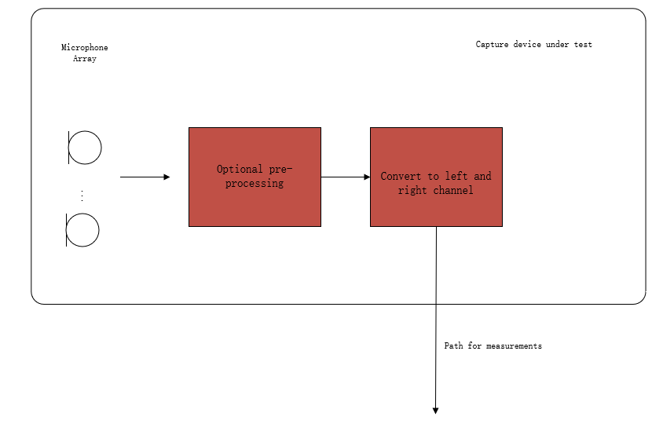
Figure 1: Audio capture block diagram for sending direction measurements
Editor’s Note: The test should represent what sound the user will get. Hence, the test operato’ doesn't need to calibrate the DUT. The result should include all the deviations between components in one device (like the sensitivity difference between a microphone array used in DUT) and deviations between different manufactured batches.

Measurement method
- The UE device under test is mounted in the free-field volume such that its reference point is on the axis of the sound source.
Repeat steps b-c) at -90, -30, 0, 30,90 degree :
- The sound source pointed directly toward the reference point of the DUT, measuring interchannel level difference and interchannel time difference.
- Change the angle between sound source and DUT.

Calculation of ILD and ITD
The calculation of ILD and ITD is referred to Chapter 5.3.

Sound image (SI)
Editor’s note : this subclause is under review, and there is also a proposal to define a requirement based on a 2D view (ITD, ILD)
- Stereo audio only need to consider the left ,center and right direction , Elevation and rear positioning are not essential for stereo. There for the measurement only carry out on 0,±30,±90.

Sound image indicates the perception location of the image. A sound image value less than zero indicates a position on the right side, while a value greater than zero signifies the left side. An sound image value of exactly zero represents the precise c
- enter.
- SI is a function of ITD and ILD as following:

$$SI=f\left(ILD,ITD\right)$$
Editor’s note : The specific formula is tbd.

Source azimuth[deg] | Requirement
-90 | ITD>-3ms^{*1}  SI<-[tbd]^{*2}
-30 | ITD>-3ms  and  SI<-[tbd]^{*3}
0 | -0.1ms< ITD<0.1ms  and  -1 dB< ILD<1 dB^{*4}
30 | ITD<3ms  and  SI>[tbd]
90 | ITD<3ms  SI>[tbd]
*1: The left and right channel will not be felt like two sound events.
*2: The sound from ±90 degree should have the sound image close to the edge.
*3: The sound from ±30 degree should have a clearly distinguish between the center positions.
*4: The sound from 0 degree should be precepted as center.
*5: The sound from left and right do not require the same performance, but should have the right direction

Editor’s note : The actual function needs to be defined. Tolerance masks of ILD and ITD also need to be considered.
]
[

Sending side audio performance assessment for Immersive Audio Systems in wind noise

The following methods have been incorporated from [2]:

Introduction
This test is applicable to UEs capturing immersive audio, including scene-based (e.g. First and Higher Order Ambisonics), binaural, channel-based (e.g. 7.1.4, 5.1, stereo), and object-based audio.

test conditions
- The test conditions should follow the Free-field propagation conditions and test environment noise floor described in TS 26.260[2-1].
- wind speed should be 0m/s.
- The size of free-field volume should be large enough to avoid influencing the wind.

Wind-generator:
ETSI TS 103 640[2-2] Annex A lists several turbulent wind generation considerations. Some most important requirements are listed here.
- The acoustic noise should be [TBD]dB less than the wind noise at effective frequency band.
- The airflow wide enough to cover the acoustic test equipment and DUT
- The device must keep the target wind speed stable during the test.
NOTE: this test method is used to measure the overload, the acoustic noise requirement of the device used to generate wind needn’t be so strictly as the requirement in ETSI TS 103 640[2-2] and IEC 60268-4[2-6].

Setup for terminals
The setup is referred to TS 26.260[2-1] and TS 26.132[2-3]. including the POI, reference point, etc.
Reference point:
Scene-based: geometric centre. [2-1]
Binaural: centre of the acoustic test equipment EEP-to-EEP axis.[2-2]
Object-based: geometric centre of all transducers.
Multichannel: geometric centre of all transducers.
Position:
When using handset UE, headset or hand-free terminal, the terminal should be placed on HATS, according to the corresponding standard or recommended position.
Handsets are given in ITU-T Recommendation P.64 Annex E.[2-5]
Headsets are given in ITU-T Recommendation P.340[2-4]

Measurement points [2-1]:
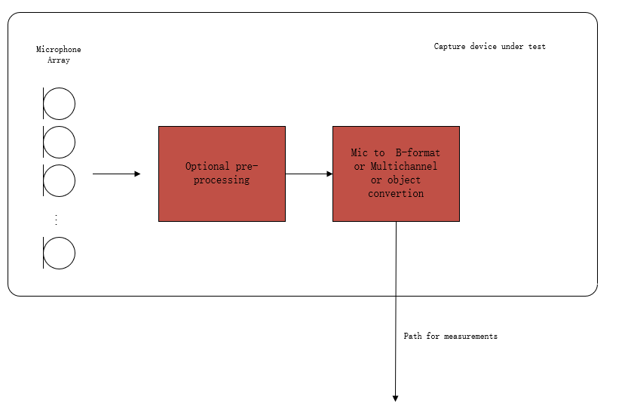
Figure 1: Audio capture block diagram for sending direction measurements
NOTE: The overload point wind speed is a limiting characteristic like the overload sound pressure. All the chann’ls won't affect each other Some processing may cause overload at some special condition, it has damage to communication and is inevitable in windy sensorics, hence the overload caused by processing is included in the result, so select the standard audio signal to measure, and each channel should be measured independently.

Definition
Overload point wind speed:
The maximum wind speed at which the distortion of the terminal does not exceed a specified limit(the value of the limit is TBD) for any possible direction of wind incidence and any channel the device outputted.

Distortion rate:
Since the clipping appears more frequently at higher wind speed, the probability of clipping appearing in the test signal can indicate distortion rate caused by wind.
So, the source suggests using the rate of clipped frames in all test frames as the distortion rate.
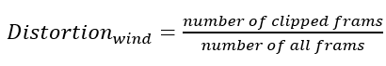
clipped frames:
The clipped frames will have any of the folharacterizesterises:
- reach the up limit of signal level (the value needs to test for the DUT)
- frequency range in high frequency is different from wind noise without clipped.

Wind noise measurement method with wind generator for sending direction.
- The UE device under test is mounted in the free-field volume such that its reference point is on the axis of the wind generator exit port and 30 cm from the exit port.
Repeat steps b-c) with an azimuth angular resolution of N degrees for every possible wind direction:
NOTE 2: Since limiting the wind direction in real usage scenarios is not suitable, the test should be implemented in every possible wind direction.
- The wind generator is the target wind speed on the DUT, and the airflow should cover the DUT.
- The output of the UE device is stored for offline analysis. The signal should be stored before the wind start and its duration time should larger than 60s.

Increasing the wind speed and repeating the test until the output signal is overloaded or reaches the expected wind speed.
NOTE 3: the wind speed should be selected carefully to avoid the overload damage caused by wind influence on the later test

Calculation of wind-resistant ability
The wind-resistant ability represents with the wind speed overload point, which means the terminal can work stable in all directions, and all channels with the wind sp’ed don't exceed the overload point.
The terminal, with several audio channels output, should be calculated by every channel.

The following conclusion has been incorporated from [3]:

Recommendations for wind noise simulations for terminal testing

- Wind noise simulations for terminal testing have to be carefully defined under the following constraints:
  - A minimum degree of laminar flow should be ensured by means of e.g., spatial wind speed accuracy, measured at multiple points.
  - A certain degree of reproducibility should be ensured across labs and/or different test equipment solutions.
  - The noise produced by the ventilator/generator should not exceed a certain threshold to minimize the impact on the actual measurements.
  - For employment in typical measurement rooms, a manageable generator size is required – which might limit the aforementioned constraints even further.
- There is currently no specification available or known to the group that uses or defines such a wind noise simulation.
- Possible test methods and performance requirements for ATIAS should be limited to certain form factors/types of terminals. Wind noise simulation for smaller devices is most likely more feasible and reproducible than for larger ones.
- If applicable, specification of a wind noise simulation, test methods and performance requirements should be verified by round robin tests.
]

Candidate receiving side test methods and requirements
[

Receiving loudness

General
TBD.

Requirements

The nominal value of Loudness Level in Receive (LLR) shall be [75] ± [3-4] phon for all UE types. In case a user controlled receive volume control is provided, for at least one setting of the control the LLR shall meet the nominal value.
When the control is set to maximum, the LLR shall not be louder than [89] phon. With the volume control set to the minimum position the LLR shall not be quieter than [52] phon and should not be quieter than [58] phon.’Editor's Note: Values calculated based on the RLR vs LLR equation above.
Performance requirements and objectives apply for source position of azimuth 0° and elevation 0° in the test signal and should also be evaluated for the source positions listed in Table 1.
Table 1: Additional source positions for loudness
Azimuth [°] | Elevation [°]
+90 | 0
-90 | 0
180 | 0
0 | +90
0 | -90

Test condons
1) The test signal to be used for the measurements shall be the British-English single talk sequence described in clause 7.3.2 of Recommendation ITU-T P.501 [xx], calibrated to an active speech level according to Recommendation ITU-T P.56 [xx] of [-26 dBov / TBD].’Editor's Note: The level calibration is a preparation for the following rendering step, so ASL in dBov is correct?
2) The source signal for the measurement is generated by virtually positioning the mono test signal at azimuth 0°, and elevation 0° and a distance of 1.0 m and then render it to the corresponding IVAS input format of the UE.’Editor's Note: Add better description / reference to IVAS command line tools?! (use ISM with metadata or HOA3?)
3) The source signal is calibrated to a [level/loudness] of [xx dB].’Editor's Note: How to define default levels for the source signals? See also loudness in send…
4) The UE is setup according to clause(s) [xx], the source signal is encoded by the reference client, and inserted at the POI to the UE.
5) The capture of the UE output is carried out via …
a) acoustical interface (headphones or loudspeakers): recording via diffuse-field equalized HATS.
b) electrical interface: recording via corresponding reference interface. [If the captured audio format is not stereo,] the default IVAS binaural renderer [xx] is used to generate a binaural signal.’Editor's Note 1: Assume that stereo == binaural and directly analyse it – or can/should it also be rendered to binaural?’Editor's Note 2: Add better description / reference to IVAS default renderer. We might need an additional factor to scale the renderer output to the acoustic domain (like e.g., 73 dB SPL == -21 dB Pa == -26 dBov apply +5 dB)?
6) The LLR in phon is calculated according to clause 8.3.3 of Recommendation ITU-T P.700 with the captured or rendered binaural signal.
7) The same binaural signal should be used to calculate Receive Loudness Rating (RLR) according to Recommendation ITU-T P.79 [xx] for comparison to 3GPP TSs 26.131 [9]/26.132 [10].
a) The inverse diffuse-field correction according to Recommendation ITU-T P.58 is applied on left and right channel of the recording to obtain the signal at DRP. Then DRP-to-ERP correction is applied.
b) The reference signal used for the RLR calculation is the original test signal specified in step 1), calibrated to -16 dBm0.
c) The RLR is calculated according to clause 8.2.3.2 of 3GPP TS 26.132.
Editor's Note: RLR may be calculated optionally from the same recording?
8) Steps 2-7 should be repeated for additional source positions as described in Table 1.

Receiving frequency characteristics

General
TBD.

Requirements
TBD.

Test conditions
The test conditions are the same as in TS 26.132, except for the codec-specifics stated below.
[

Receiving with binaural rendering: measurement for object-based audio
The following procedure shall be used:
- The UE under test is connected to a test system composed of a 3GPP wireless system simulator and reference client with an IVAS session established. The codec shall be operated with object-based input format at [512] kbit/s. The audio input format and bitrate shall be reported.
- For each object source position stated in Table X, the object metadata is set accordingly.
- The sensitivity/frequency characteristics are measured as described in TS 26.132, and are reported for the left and the right sides.

Table X: Object source positions for sensitivity/frequency characteristics
Source azimuth  $$[deg]$$ | Source elevation  $$[deg]$$ | Source distance  $$[m]$$
0 | 0 | ?
180 | 0 | ?
0 | 90 | ?
0 | -90 | ?
90 | 0 | ?
-90 (270) | 0 | ?

The sensitivity/frequency characteristics may in addition be measured and reported for other object positions.
[Editor’s note: Where it is possible to assign a certain distance to the object, a large value should be specified, to avoid corner cases with close distances]
]

Receiving with binaural rendering: inter-channel time difference

General
The inter-channel time difference is the delay between the left and the right binaural signals, resulting from the rendition of a decoded sound source from a certain position. The delay is measured electrically or acoustically.
Ideal characteristic:
To some extent, the ideal characteristics depend on the head-related transfer functions being used by the renderer, which may vary between UE:s. However, some generic statements can be made:
- Sounds from the median plane (azimuth=0, hence front/back/above/under) appear with no delay between the two channels
- Sounds from the left hemisphere are delayed in the right channel compared to the left, and vice versa. The head size which is associated with the head-related transfer functions used in the rendering will scale the magnitude of this delay, it is expected to be below 1ms.
- Simulated room reflections may be part of the rendering process. It is important that these do not misguide the measurement of the dominating inter-channel time difference

Requirements
[Editor’s note: It may be discussed what level of requirements that will be appropriate (shall/should/performance objectives, or no requirements with only UE characterization)]
The inter-channel time difference shall be as in Table X, when tested according the corresponding test procedure.
Table X: Inter-channel time difference ${ITD}_{left-right}$
Source azimuth  $$[deg]$$ | Source elevation  $$[deg]$$ | Source distance  $$[m]$$ | $${ITD}_{left-right}$$  $$[μs]$$
0 | 0 | ? | $$-15≤ITD≤15$$
180 | 0 | ? | $$-15≤ITD≤15$$
0 | 90 | ? | $$-15≤ITD≤15$$
0 | -90 | ? | $$-15≤ITD≤15$$
90 | 0 | ? | $$500≤ITD≤1000$$
-90 (270) | 0 | ? | $$-1000≤ITD≤-500$$

[Editor’s notes:
- The values in the table are suggested as a starting point, to illustrate the approach. They may be adjusted.
- Where it is possible to assign a certain distance to the object, a large value should be specified, to avoid corner cases with close distances.]

Test conditions
The UE is connected to a system simulator with a reference client. Signals from the UE are measured electrically on left/right headphone signals or acoustically using a pair of headphones and the microphones of a head- and torso simulator.
[Editor’s note: The generic test room conditions in terms of idle noise and reflections should suffice for this HATS measurement why nothing further is specified here.]

Measurement for object-based audio
The following procedure shall be used:
- The UE under test is connected to a test system composed of a 3GPP wireless system simulator and reference client with an IVAS session established. The codec shall be operated with object-based input format at [512] kbit/s. The audio input format and bitrate shall be reported. The left and right headphone/headset audio outputs from the UE are connected to the test system electrically, or acoustically using headphones and a ITU-T P.58 compliant head and torso simulator with associated left and right artificial ears. [Editor’s note: headtracking shall also be considered. Text TBD]
- The volume control is set to nominal [Editor’s note: it is expected that the generic clauses of this specification will state that the volume control, unless otherwise stated, is set to meet the nominal RLR=8 +-3dB for each ear. The sentence “The volume control is set to nominal” may then be superfluous.].
- The test signal is a CS-signal complying with ITU-T Recommendation P.501 using a PN-sequence with a length, T, of 4 096 points (for a 48 kHz sample rate test system). The duration of the complete test signal is as specified in ITU-T Recommendation P.501. [Editor’s note: this is the same signal as in TS 26.132 subclause 7.5.4] The level of the signal shall be -16 dBm0 at the POI.
Editor’s note: The impact of codec on the test signal needs to be verified before performing the measurements.
- For each simulated source position (θ_{i}, φ_{i}), i=1,...,L , the following procedure is repeated:
- The test signal is played to one object-based audio input of the reference client [the signal is proposed to be identical to TS 26.132 subclause 8.5.4]. For each sub-test, the source position metadata for the audio object is set according to a table in the requirements specification.

- The left and right headphone audio signals from the UE are captured electrically or acoustically, the capture method shall be reported. The analysis window shall include the PN-sequence part of the CSS signal. The correct positioning of the analysis window is accomplished by correcting for the delay of the test system and the particular UE, which is measured priorly.

- The transfer function between the left and the right channel is estimated [Editor’s note: details to be defined] and the inter-channel group delay is calculated from the phase response, as $τ_{g}(ω)=-\frac{dΦ(ω)}{dω}$, where $Φ$ is the phase and $ω$ is the angular frequency. The group delays for the different frequency bins are averaged from 200 to 2000Hz to obtain a single-figure inter-channel time difference.

- The inter-channel time difference ITD is compared to the requirements for the tested object audio source position.

Measurement for scene-based audio
The method is the same as for object-based audio except that the source position is not set by metadata to the reference client encoder but rather by presenting the encoder with a multi-component Ambisonics signal that represents a source from the particular incidence angle. The First-order ambisonics test signal $X$ for different source positions shall be as in the Table X. The applied signal $s$ is the same CS-signal as with object-based audio, and $-s$ is the phase inverted version of the signal $s$. [Details are TBD].
Table X: First-order ambisonics signals for different source positions
Source azimuth  $$[deg]$$ | Source elevation  $$[deg]$$ | FOA signal  $$X = [w, y, z, x]$$
0 | 0 | $$X = [s, 0, 0, s]$$
180 | 0 | $$X = [s, 0, 0, -s]$$
0 | 90 | $$X = [s, 0, s, 0]$$
0 | -90 | $$X = [s, 0, -s, 0]$$
90 | 0 | $$X = [s, s, 0, 0]$$
-90 (270) | 0 | $$X = [s, -s, 0, 0]$$

Measurement for metadata-assisted spatial audio
The method is the same as for object-based audio except format specific metadata is set. The applied descriptive metadata for every frame and the applied spatial metadata for every time-frequency tile shall be as in Table X and Table X, respectively. The test signal is the same CS-signal as with object-based audio.
Table X: Applied descriptive metadata
MASA descriptive metadata parameters | Assigned values for every metadata frame
Format descriptor | Default
Number of directions | 1 (bit value 0)
Number of channels | 1 or 2 (bit value 0 or 1), depending on the number of applied transport channels
Source format | Bit values 00 (Default/unknown)
Variable description | 12 bit zero-padding (Default/unknown)

Table X: Applied spatial metadata
MASA spatial metadata parameters | Assigned values for every time-frequency tile in all MASA metadata sub-frames
Spherical index | According to the tested azimuth and elevation
Direct-to-total ratio | 1.0
Spread coherence | 0.0
Diffuse-to-total ratio | 0.0
Surround coherence | 0.0
Remainder-to-total ratio | 0.0

Receiving with binaural rendering: source angle dependent band level difference

General
The source angle dependent band levels are the level pairs of the left and right audio signals in a certain frequency band, resulting from the rendition of a decoded source from a specific position. The levels are measured electrically or acoustically. The overall frequency response is removed from the analysis by assessing only differences (between different source angles and between left and right channels).
Ideal characteristic:
To some extent, the ideal characteristics depend on the head-related transfer functions being used. However, some generic statements can be made:
- Sounds from the median plane (front/back/above/under) appear with elevation-dependent spectral characteristics at high frequencies, depending on e.g. pinna geometries. [Editor’s note: it remains to be investigated across HRTF sets if there is a frequency band which is changing with angle in a consistent enough manner to allow imposing generic requirements. In any case, UE characterization is valuable to assess whether the rendering reacts to changes in source elevation.]
- Sounds from the left appear with considerable mid/high-frequency attenuation in the right ear, and for finite source distances, a slight level difference also for low frequencies. And vice versa for sources in the right hemisphere.
- If the level difference between left and right at low frequencies is considerable, the UE may be producing just left/right stereo without any binaural rendering. However, when measured acoustically, there has to be some allowance for headphone earphone sensitivity variation as well as variations due to leaks when positioned on HATS

Requirements
[Editor’s note: It may be discussed what level of requirements that will be appropriate (shall/should/performance objectives, or no requirements with only UE characterization).]
The levels in certain frequency bands are measured for left and right channels and for the specified source positions. For hard left and right source positions, the band levels are assessed in terms of the difference between the left and the right signals. For the median plane, the band level differences between positions are assessed.
Table X: Source angle dependent band levels
Sub-test | Frequency band  $$[Hz]$$ | Source azimuth  $$[deg]$$ | Source elevation  $$[deg]$$ | Source distance  $$[m]$$ | $$D_{left-right}$$  $$[dB]$$
A | $$TBD≤f≤TBD$$ | 0 | 0 | ? | No requirement
B |  | 180 | 0 | ?
C |  | 0 | 90 | ?
D |  | 0 | -90 | ?
E | $$TBD≤f≤TBD$$ | 90 | 0 | ? | X
F |  | -90 (270) | 0 | ? | -X
G | $$200≤f≤800$$ | 90 | 0 | [TBD, large] | $$-6≤D≤6$$
H |  | -90 (270) | 0 | [TBD, large] | $$-6≤D≤6$$

[Editor’s notes:
- The values in the table are suggested as a starting point, to illustrate the approach. They may be adjusted.
- Where it is possible to assign a certain distance to the object, a large value should be specified, to avoid corner cases with close distances]
Table X: Median plane band level differences for each channel
Sub-test | Requirement  $$[dB]$$
L_{A}-L_{B} | >Y_{AB}
L_{A}-L_{C} | >Y_{AC}
L_{A}-L_{D} | >Y_{AD}

Test conditions
The UE is connected to a system simulator with a reference client. Signals from the UE are measured electrically on left/right headphone signals or acoustically using a pair of headphones and the microphones of a head- and torso simulator. [Editor’s note: The generic test room conditions in terms of idle noise and reflections will suffice for the HATS measurements why nothing further is specified here.]

Measurement for object-based audio
The following procedure shall be used:
- The UE under test is connected to a test system composed of a 3GPP wireless system simulator and reference client with an IVAS session established. The codec shall be operated with object-based input format at [512] kbit/s. The audio input format and bitrate shall be reported. The left and right headphone/headset audio outputs from the UE are connected to the test system electrically, or acoustically using headphones and a ITU-T P.58 compliant head and torso simulator with associated left and right artificial ears. [Editor’s note: headtracking shall also be considered. Text TBD]
- The volume control is set to nominal [Editor’s note: it is expected that the generic clauses of this specification will state that the volume control, unless otherwise stated, is set to meet the nominal RLR=8 +-3dB for each ear. The sentence “The volume control is set to nominal” may then be superfluous.].
- The test signal is a CS-signal complying with ITU-T Recommendation P.501 using a PN-sequence with a length, T, of 4 096 points (for a 48 kHz sample rate test system). The duration of the complete test signal is as specified in ITU-T Recommendation P.501. [Editor’s note: this is the same signal as in TS 26.132 subclause 7.5.4] The level of the signal shall be -16 dBm0 at the POI.
Editor’s note: The impact of codec on the test signal needs to be verified before performing the measurements.
- For each simulated source position (θ_{i}, φ_{i}), i=1,...,L , the following procedure is repeated:
- The test signal is played to one object-based audio input of the refence client [the signal is proposed to be identical to TS 26.132 subclause 8.5.4]. For each sub-test, the source position metadata for the audio object is set according to a table in the requirements specification.
- The left and right headphone audio signals from the UE are captured electrically or acoustically, the capture method shall be reported. The analysis window shall include the PN-sequence part of the CSS signal. The correct positioning of the analysis window is accomplished by correcting for the delay of the test system and the particular UE, which is measured priorly.
- The left and right levels for the frequency band of interest is noted.

- Once all source angles are assessed, the inter-angle level differences as well as the inter-channel level differences are assessed according to the corresponding table in the requirements specification.

Measurement for scene-based audio
The method is the same as for object-based audio except that the source position is not set by metadata to the reference client encoder but rather by presenting the encoder with a multi-component Ambisonics signal that represents a source from the particular incidence angle (see sub-clause 5.3.5). [Editor’s note: Details are TBD, as well as text considering MASA].

Measurement for metadata-assisted spatial audio
The method is the same as for object-based audio except format specific metadata is set (see sub-clause 5.3.6).

Receiving with channel-based coding and loudspeaker rendering: channel order

General
This test may be renamed to “channel level” or “channel sensitivity”, since the channel order is checked by measuring levels, and levels may in any cases be of interest to characterize the UE.
Ideal characteristic:
The signal to each input channel is only observed at the corresponding output channel (muted in others).

Requirements
[TBD]

Test conditions
[TBD]

Measurement of channel order
The following procedure shall be used:
- The UE under test is connected to a test system composed of a 3GPP wireless system simulator and reference client with an IVAS session established. The codec shall be operated with a channel-based input format at [512] kbit/s. The audio input format and bitrate shall be reported.
- The UE renderer is set to the same channel-based format as the reference encoder.
- For each reference client input channel, a test signal [TBD] is presented and the levels at all output channels are measured.

[Editor’s note: Similar tests should be defined for other combinations, such as ambisonics coding with channel-based loudspeaker rendering.]

]

Annex: Proposed structure for TS 26.260
Editor’s note: This Annex defines the anticipated structure of TS 26.260 after implementation of ATIAS related CRs. Under the section headings, reference is made to the respective clauses in the main part of the Pdoc that hold the relevant contents that is intended to go into the TS. Along with that, the status of that contents is characterized. For portions that are identified as stable (dark green), unless already present in the TS, CRs will be created to introduce them in the TS. Portions that are not characterized as stable, actions are identified to complete them.

Example of proposed new structure in TS 26.260:
4 Objective Test Methodologies for Immersive Audio Systems
Status: Existing mature text in TS 26.260, with test methods for
- send frequency response and directional response for scene-based audio
- receive frequency response and sensitivity for scene-based audio
- receive motion-to-sound latency for dynamic binaural rendering
5 Objective Test Methodologies for Immersive Communication Systems (IVAS-based)
5.1 Test setups for terminals
Status: Pdoc clause 2.1 can be used
5.2 Test conditions
Status: Pdoc clause 3 can be used, but it lacks general test conditions and requriements on test equipment, reference client, etc. The text about enhancement features could be more clear.
5.3 [other general definitions?]
Status: not yet clear if this clause will be needed. Keep as placeholder for now.
5.4 Test methods in the sending direction
5.4.1 Stereo capture
Missing: Sending loudness ratings
[5.4.1.1 Spatial perception test for stereo audio capture]
Status: proposal in Pdoc clause 4.8. The title could be clarified (it is not a perceptual test per se). Considering the large variety of functional stereo arrays in commercial use, and the pass-through regime of IVAS stereo coding, it would be suitable to have ITD and ILD as chacaterization tests, rather than mandated requirements.
The test method applies to UE configurations Headset, Handheld, and Table-mounted.
[5.4.1.2 Wind noise test for stereo audio capture]
Note: The title above has some words removed from the title in the Pdoc
Status: proposal in Pdoc clause 4.9. It would be suitable to have wind noise as a characterization test, since wind generators differ in their characteristics, e.g. in terms of inherent turbulence. Some further work on the text is needed, and to finalize the definition of a clipped frame. Potentially other metrics could be considered, to capture poor quality in wind.
The test method applies to UE configurations Headset, Handheld, and Table-mounted.
5.4.2 Object-based audio capture
Missing: Sending loudness ratings
Status: No sending direction tests were defined for object-based audio (except wind noise, with the same text as for stereo). Proposed way forward:
Single object: test cases mono capture can be used
Multi-object: FFS
[5.4.2.1 Wind noise test for object-based audio capture]
It may be inconsistent to have wind noise test for single-object capture while there is no such test defined for mono capture (TS 26.132).
The test method applies to UE configurations Headset, Handheld, and Table-mounted.

5.4.3 Scene-based audio capture
Missing: Sending loudness rating
[5.4.3.1 Sending frequency response of captured Ambisonics components]
Status (proposal in Pdoc clause 4.1): Stable but unfinished text, needs detailing.
The test method applies to UE configurations Headset, Handheld, and Table-mounted.

[5.4.3.2 Sending directional response of captured Ambisonics components]
Status (proposal in Pdoc clause 4.2): Stable but infinished text, needs detailing.
The test method applies to UE configurations Headset, Handheld, and Table-mounted.

[5.4.3.3 Direction of arrival estimation under free-field propagation conditions]
Status (proposal in Pdoc clause 4.3): Stable text.
The test method applies to UE configurations Headset, Handheld, and Table-mounted.

[5.4.3.4 Directivity test of FOA using virtual microphones]
Status (proposal in Pdoc clause 4.4): Stable but unfinished text, needs detailing. The coverage of this test could be considered a subset (directionality) of what is covered by ‘spatial separation with two simultaneous acoustic sources’. Consider whether to mandate this test and leave the multisource tests for characterization.
The test method applies to UE configurations Headset, Handheld, and Table-mounted.

[5.4.3.5 Scene-based audio spatial separation with two simultaneous acoustic sources in free-field propagation conditions and FOA decoding]
Status (proposal in Pdoc clause 4.5): Stable text. Address editor’s notes. Test.
The test method applies to UE configurations Headset, Handheld, and Table-mounted.

[5.4.3.6 Spatial separation for multiple acoustic sources based on multichannel output]
Status (proposal in Pdoc clause 4.6 & 4.7): Stable text. Address editor’s notes, break out requirements/performance objectives. Test.
Consider which one of the two above should be mandated, or if both should be for characterization only. There is a stable-text proposal for speech-based testing in Pdoc clause 4.7. If assessments shows no considerable disadvantage with the speech-based testing, the above methods for spatial separation could be modified accordingly.
The test method applies to UE configurations Headset, Handheld, and Table-mounted.

5.4.4 Channel-based audio capture
Missing: Sending loudness ratings
5.4.4.1 …
Status: No proposals in the Pdoc. It is suggested to write a brief clause at least. Is the intention to specify sending channel-based audio only for electrical UE? Or also for acoustic capturing?

5.4.5 Metadata-assisted spatial audio capture
Missing: Sending loudness ratings
[5.4.3.1 Sending frequency response of captured Metadata-assisted spatial audio]
Status: Same principles could be considered as for scene-based audio (proposal in Pdoc clause 4.1), clarify how the audio is obtained from the reference decoder, needs detailing.
The test method applies to UE configurations Headset, Handheld, and Table-mounted.

[5.4.3.2 Sending directional response of captured Metadata-assisted spatial audio]
Status: Same principles could be considered as for scene-based audio (proposal in Pdoc clause 4.2), consider necessity, clarify how the audio is obtained from the reference decoder, needs detailing.
The test method applies to UE configurations Headset, Handheld, and Table-mounted.

[5.4.3.3 – 5.4.3.6]
Status: Essentially the same as for scene-based audio. Consider which one of the proposed multisource test method should be applied.

5.5 Test methods in the receiving direction

General note: the subclauses below for the receiving direction are (per the proposal in the Pdoc Annex) organized as:
- IVAS coding mode (configured for the IVAS encoder of the reference client)
  - Parameter to test
    - Acoustical frontends and electrical interface
However, it might be preferred to organize them more similar to the Pdoc main body:
- Parameter to test
  - IVAS coding mode (configured for the IVAS encoder of the reference client)
    - Acoustical frontends and electrical interface
If so, also the sending part should be reorganized in a similar way.

5.5.1 Stereo coding [consider skipping this for now, see also S4-231840]
[5.5.1.1 Receiving loudness]
Status (reuse of proposal in Pdoc clause 5.1): stable but unfinished text. Seems to be written for object-based coding -> adapt to the stereo coding; Specify if the same signal shall be fed to both channels of the stereo input of the reference IVAS encoder. Finalize for electrical interface.
[5.5.1.2 Receiving sensitivity/frequency characteristics]
Status (proposal in Pdoc clause 5.2): stable text. Address editor’s notes. Test.
5.5.2 Object-based audio coding
[5.5.2.1 Receiving loudness]
Status (proposal in Pdoc clause 5.1): stable text. Address editor’s notes, break out requirements. Finalize for electrical interface. Test.
[5.5.2.2 Receiving sensitivity/frequency characteristics]
Status (proposal in Pdoc clause 5.2): stable text for characterizing binaural rendering. Missing for other acoustical and electrical interfaces. Address editor’s notes. Test.
[5.5.2.3 Receiving with binaural rendering: inter-channel time difference]
Status (proposal in Pdoc clause 5.3): stable text. Address editor’s notes, break out requirements. Test.
[5.5.2.4 Receiving with binaural rendering: source angle dependent band level difference]
Status (proposal in Pdoc clause 5.4): stable text. Specify source distance. Address editor’s notes, break out requirements. Test.

5.5.3 Scene-based audio coding
[5.5.3.1 Receiving loudness]
Status (reuse of proposal in Pdoc clause 5.1): stable but unfinished text. Seems to be written for object-based coding -> adapt to scene-based coding; Specify how the stimulus shall be fed to the various ambisonics inputs of the reference IVAS encoder (same approach as in Pdoc clause 3.5.5 could be considered). Finalize for electrical interface.
[5.5.3.2 Receiving sensitivity/frequency characteristics]
Status (proposal in Pdoc clause 5.2): stable text for characterizing binaural rendering. Missing for other acoustical and electrical interfaces. Address editor’s notes. Test.
[5.5.3.3 Receiving with binaural rendering: inter-channel time difference]
Status (proposal in Pdoc clause 5.3): stable text. Address editor’s notes, break out requirements. Test.
[5.5.3.4 Receiving with binaural rendering: source angle dependent band level difference]
Status (proposal in Pdoc clause 5.4): stable text. Specify source distance. Address editor’s notes, break out requirements. Test.

5.5.4 Channel-based audio coding
Status: same as for stereo coding [consider skipping this for now, see also S4-231840], except:
[5.5.4.X Receiving with channel-based coding and loudspeaker rendering: channel order]
Status (proposal in Pdoc clause 5.5): stable text. Address test conditions, editor’s notes, break out requirements. Potentially introduce channel order tests for other coding modes. Test.

5.5.5 Metadata-assisted spatial audio coding
[5.5.5.1 Receiving loudness]
Status (reuse of proposal in Pdoc clause 5.1): stable but unfinished text. Seems to be written for object-based coding -> adapt to MASA; Specify how the stimulus and metadata shall be fed to the various MASA inputs of the reference IVAS encoder (same approach as in Pdoc clause 3.5.6 could be considered). Finalize for electrical interface.
[5.5.5.2 Receiving sensitivity/frequency characteristics]
Status (proposal in Pdoc clause 5.2): stable text for characterizing binaural rendering. Missing for other acoustical and electrical interfaces. Address editor’s notes. Test.
[5.5.5.3 Receiving with binaural rendering: inter-channel time difference]
Status (proposal in Pdoc clause 5.3): stable text. The metadata is clearly specifid. Clarify how the audio is applied to the reference encoder. Test.
[5.5.5.4 Receiving with binaural rendering: source angle dependent band level difference]
Status (proposal in Pdoc clause 5.4): stable text. The metadata is specified as in above. Specify source distance. Address editor’s notes, break out requirements. Test.

References
[1] S4-221449: On send side audio performance assessment for Immersive Audio Systems –additional metrics, Dolby Laboratories Inc.
[1-1] S4-220482: On ATIAS acoustic performance testing for FOA audio, Dolby Laboratories Inc.
[1-2] S4-191167: Description of the IVAS MASA C Reference Software, Nokia Corporation
[1-3] GIF image: https://commons.wikimedia.org/wiki/Category:Microphone_polar_patterns
[2] S4-221353: Proposal of wind noise test in ATIAS, Beijing Xiaomi Mobile Software
[2-1] 3GPP TS 26.260: " Objective test methodologies for the evaluation of immersive audio systems."
[2-2] ETSI TS 103 640 V1.2.1-Test Methods and Performance Requirements for Active Noise Cancellation Headsets and other Earphones
[2-3] 3GPP TS 26.132: " Speech and video telephony terminal acoustic test specification."
[2-4] ITU-T Recommendation P.340 (05/2000): "Transmission characteristics and speech quality parameters of hands-free terminals".
[2-5] ITU-T Recommendation P.64 (06/2019): "Determination of sensitivity/frequency characteristics of local telephone systems".
[2-6] IEC 60268-4: Sound system equipment - Part 4: Microphones
[3] S4-230035: Wind noise generation for terminals, HEAD acoustics
[4] S4-230259: Spatial audio capture – spatial separation for multiple acoustic sources based on FOA components, Dolby Laboratories Inc., Nokia Corporation, HEAD acoustics
[5] S4-230189: Add the spatial perception test for stereo UE in ATIAS, Xiaomi
[5-1] S4-231718: Updates of test for stereo UE in ATIAS Pdoc, Beijing Xiaomi Mobile Software Co., Ltd
[6] S4-230231: On spatial separation for multiple acoustic sources based on multichannel output, Nokia Corporation
[6-1] Recommendation ITU-T P.501, Test signals for use in telephony and other speech-based applications
[6-2] Tdoc S4-221297: IVAS Design Constraints (IVAS-4)
[7] S4-230232: On direction-of-arrival estimation for MASA input format, Nokia Corporation
[7-1] Tdoc S4-221449: On send side audio performance assessment for Immersive Audio Systems –additional metrics
[7-2] Tdoc S4-221297: IVAS Design Constraints (IVAS-4)
[8] Tdoc S4-231377: On multiple acoustic sources test with real speech
[9] TS 26.131: Terminal acoustic characteristics for telephony; Requirements
[10] TS 26.132: Speech and video telephony terminal acoustic test specification

Revision history

Date | Meeting | Subject/Comment | Old | New
2022-11-17 | SA4#121 | Initial version incorporating S4-221449 and S4-221353 | N/A | 0.1.0
2023-02-24 | SA4#122 | Agreed updates from SA4#122 | 0.1.0 | 0.2.0
2023-03-23 | Audio SWG post SA4#122 | Editorial updates | 0.2.0 | 0.2.1
2023-03-24 | Audio SWG post SA4#122 | Editorial updates | 0.2.1 | 0.2.2
2023-04-19 | SA4#123-e | Incorporation of Tdocs 543, 544, 545 | 0.2.2 | 0.3.0
2023-05-25 | SA4#124 | Consolidations of comments, updates based on Tdocs 910 and 911, re-arrangement of text in section 4.7 | 0.3.0 | 0.4.0
2023-08-21 | SA4#125 | Incorporation of various inputs received at meeting SA4#125 | 0.4.0 | 0.5.0
2023-11-13 | SA4#126 | Editor’s updates based on contribution S4aA230112 and comments received during post SA4#125 telco on ATIAS | 0.5.0 | 0.5.1
2023-11-15 | SA4#126 | Clean-up during Audio SWG session | 0.5.1 | 0.5.2
2023-11-15 | SA4#126 | Incorporation of S4-231718 (updates stereo test), S4-231931 (Loudness tests for ATIAS), S4-231934 (UE classification and test structure for ATIAS), Audio SWG agreed version + editorial updates | 0.5.2 | 0.6.0
2024-02-01 | SA4#127 | Incorporation of contents from Tdocs S4-240274, 277, 226 | 0.6.0 | 0.7.0

Stefan Bruhn, e-mail: stefan.bruhn@dolby.com
Depending on the defined format for the ambisonics, scaling factors may be applied to the X and Y components in this example

