3GPP TSG-SA3 Meeting #116 S3-242282
Jeju, South Korea, 20th - 24th May 2024

Source: Samsung

Title: New solution on secure IMS based avatar communication

Document for: Approval
Agenda Item: 5.2

1 Decision/action requested
SA3 is kindly requested to approve this contribution.

2 References
[1] 3GPP TR 33.790 Study on the security support for the Next Generation Real Time Communication services phase 2

3 Rationale
This contribution proposes a new solution on KI#2 in TR 33.790 [1].

4 Detailed proposal
*************** Start of 1st Change ****************

6.X Solution #X: Solution for secure IMS based avatar communication

6.X.1 Introduction
This solution addresses key issue #2: Security of IMS based Avatar Communication.
According to TR 23.700-77 [2], rendering of avatar meida can be performed by network, UE-A, or UE-B, which are called network centric IMS avatar call, UE-A centric IMS avatar call, and UE-B centric avatar call, respectively.
In this solution, only authorized entity from UE-A can access and retrieve the UE-A's avatar object which is stored in a data storage called Ditigal Asset Container (DAC). This solution proposes to use UE-A's attestation for the security procedure of IMS based avatar communication.
In this solution, it is assumed that DAC has UE-A's public key to verify the signature in UE-A's attestation, with UE-A's avatar object and avatar ID.
The avatar communication can be unidirectional or bidirectional. In this solution, only unidirectional avatar communication is described. When bidirectional avatar communication is used, UE-B also performs the operation same as UE-A described in the procedure.

6.X.2 Solution details
6.X.2.1 Network centric IMS avatar call flow
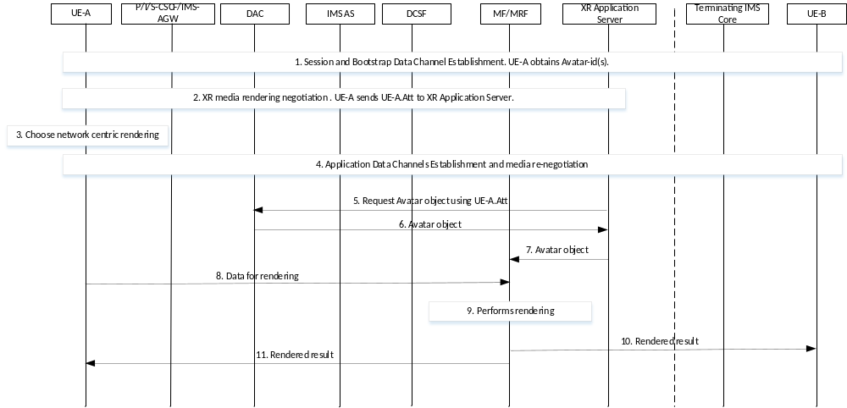
Figure 6.X.2.1-1 Network centric IMS avatar call flow
1. The UE-A initiates an IMS session and establishes audio and video session connections with the UE-B. The bootstrap channel is established for both the UE-A and UE-B. UE-A obtains UE-A's avatar id(s) in this step.

2. The UE-A performs the XR media rendering negotiation with the XR Application Server. The UE-A generates and sends UE-A's attestation to the XR Application Server. The UE-A's attestation consists of Avatar ID, identity of the XR AS, rendering option (i.e., network centric), expiration time, signature generated by using UE-A's private key, as described in clause 6.X.2.4 of this document.
3. The UE-A decides to use network centric rendering of an avatar object.
4. Application data channel is established between UE-A and IMS network, and media re-negotiation may be performed.
5. XR Application Server requests avatar object using UE-A's attestation.
6. After DAC retrieves UE-A’s public key based on avatar ID in UE-A’s attestation, DAC verifies the signature in UE-A's attestation using the UE-A's public key. If the verification is successful and the identity of XR AS in the UE-A's attestation is same as that of the XR Application Server which requested in step 5, the DAC responds with the UE-A's avatar object.
Editor’s Note: Whether the avatar object should be protected is FFS.
7. The XR Application Server sends the avatar object to MF/MRF and requests rendering of the avatar.
8. The UE-A sends data for the rendering (e.g., facial feature points).
9. The MF/MRF performs the rendering using the UE-A's avatar object and the data received from UE-A in step 8.
10. The rendered avatar media is sent as regular video media to UE-B.
11. The rendered avatar media is sent back to the UE-A as feedback.

6.X.2.2 UE-A centric IMS avatar call flow
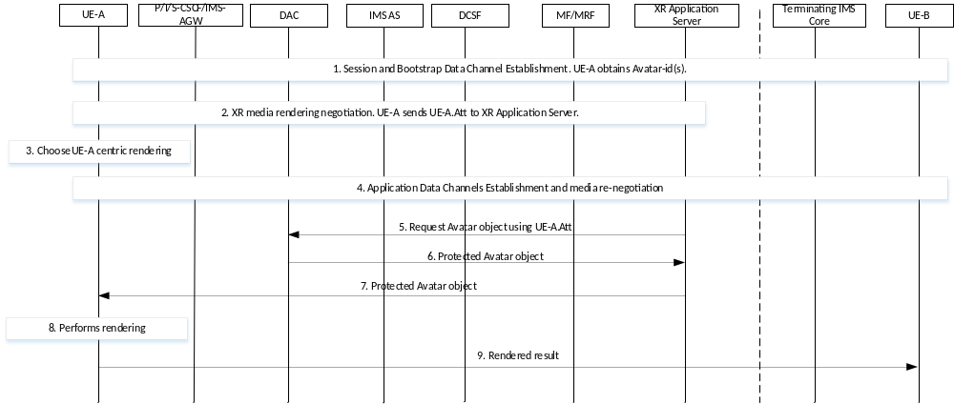
Figure 6.X.2.2-1 UE-A centric IMS avatar call flow
1. The UE-A initiates an IMS session and establishes audio and video session connections with the UE-B. The bootstrap channel is established for both the UE-A and UE-B. UE-A obtains UE-A's avatar id(s) in this step.

2. The UE-A performs the XR media rendering negotiation with the XR Application Server. The UE-A generates and sends UE-A's attestation to the XR Application Server. The UE-A's attestation consists of Avatar ID, identity of the XR AS, rendering option (i.e., UE-A centric), ephemeral public key of UE-A, expiration time, signature generated by using UE-A's private key, as described in clause 6.X.2.4 of this document.
3. The UE-A decides to use UE-A centric rendering of an avatar object.
4. Application data channel is established between UE-A and IMS network, and media re-negotiation may be performed.
5. XR Application Server requests avatar object using UE-A's attestation.
6. After DAC retrieves UE-A’s public key based on avatar ID in UE-A’s attestation, DAC verifies the signature in UE-A's attestation using the UE-A's public key. If the verification is successful and the identity of XR AS in the UE-A's attestation is same as that of the XR Application Server which requested in step 5, the DAC generates ephemeral public/private key pair and protects the UE-A's avatar object using the session key generated by ephemeral public key of UE-A included in the UE-A's attestation and ephemeral private key of DAC. The DAC responds with the protected UE-A's avatar object and ephemeral public key of the DAC.
7. The XR Application Server sends the protected avatar object and ephemeral public key of the DAC to UE-A, and requests rendering of the avatar.
8. The UE-A generates session key using the ephemeral public key of the DAC and the ephemeral private key of UE-A. UE-A verifies the protected avatar object using the session key and performs the rendering.
9. The rendered avatar media is sent as regular video media to UE-B.

6.X.2.3 UE-B centric IMS avatar call flow
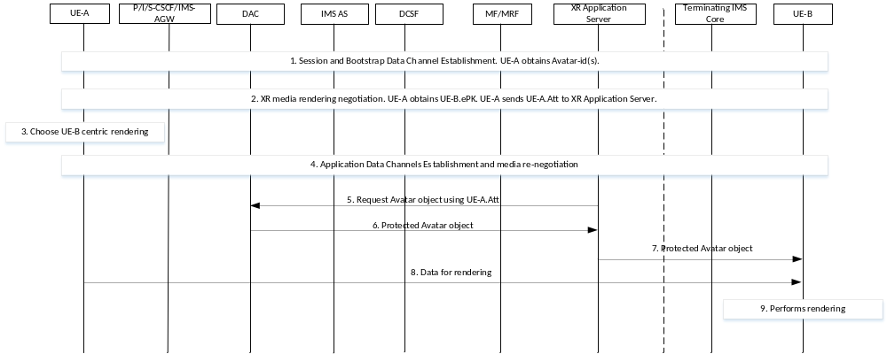
Figure 6.X.2.1-1 UE-B centric IMS avatar call flow
1. The UE-A initiates an IMS session and establishes audio and video session connections with the UE-B. The bootstrap channel is established for both the UE-A and UE-B. UE-A obtains UE-A's avatar id(s) in this step.

2. The UE-A performs the XR media rendering negotiation with the XR Application Server and UE-B. In this step, UE-A obtains UE-B's ephemeral public key. The UE-A generates and sends UE-A's attestation to the XR Application Server. The UE-A's attestation consists of Avatar ID, identity of XR AS, rendering option (i.e., UE-B centric), ephemeral public key of UE-B, expiration time, signature generated by using UE-A's private key, as described in clause 6.X.2.4 of this document.
2. The UE-A decides to use UE-B centric rendering of an avatar object.
4. Application data channel is established between UE-A and IMS network, and media re-negotiation may be performed.
5. XR Application Server requests avatar object using UE-A's attestation.
6. After DAC retrieves UE-A’s public key based on avatar ID in UE-A’s attestation, DAC verifies the signature in UE-A's attestation using the UE-A's public key. If the verification is successful and the identity of XR AS in the UE-A's atteststion is same as that of the XR Application Server, the DAC generates ephemeral public/private key pair and protects the UE-A's avatar object using the session key generated by ephemeral public key of UE-B included in the UE-A's attestation and ephemeral private key of DAC. The DAC responds with the protected UE-A's avatar object and ephemeral public key of the DAC.
7. The XR Application Server sends the protected avatar object and ephemeral public key of the DAC to UE-B, and requests rendering of the avatar.
8. The UE-A sends the data for rendering to UE-B.
9. The UE-B generates session key using the ephemeral public key of the DAC and the ephemeral private key of UE-B. UE-B verifies the protected avatar object using the session key and performs the rendering using the UE-A's avatar object and the data for rendering received from UE-A in step 8.
Editor’s Note: When DAC and XR AS are outside of IMS network, whether it is upto implentation is FFS.
Editor’s Note: The alignment with SA2 conclusions from TR 23.700-77 [2] is FFS.
Editor’s Note: The details of how the DAC/XR AS verifies the claimed avatar ID based on UE generated attestation are FFS.
Editor’s Note: The need for confidentiality protection of the avatar information transportation is FFS.
6.X.2.4 UE-A attestation
UE-A's attestation is generated by UE-A and it consists as follows:
Table 6.X.2.4-1 UE-A attestation
Parameter | Description
Avatar ID | REQUIRED. ID used to retrieve UE-A's avatar object.
Identity of XR AS | REQUIRED. The identifier of the XR Application Server that requests UE-A's avatar object to DAC.
Rendering option | REQUIRED. One of the followings: network centric, UE-A centric, or UE-B centric
Ephemeral public key of UE-A | OPTIONAL. This is included when the rendering option is UE-A centric. DAC uses ephemeral public key of UE-A and ephemeral private key of DAC to protect the UE-A's avatar object. The protected avatar object is sent to UE-A and it is end-to-end protected between DAC and UE-A.
Ephemeral public key of UE-B | OPTIONAL. This is included when the rendering option is UE-B centric. DAC uses ephemeral public key of UE-B and ephemeral private key of DAC to protect the UE-A's avatar object. The protected avatar object is sent to UE-B and it is end-to-end protected between DAC and UE-B.
Expiration time | REQUIRED. The expiration time of the UE-A attestation.
Signature | REQUIRED. Signature generated by UE-A using UE-A's public key and the parameters in the attestation.

6.X.3 Evaluation
TBD

