3GPP TSG-WG SA2 Meeting #162 S2-2405100
Changsha, China, April 15 – 19, 2024 (revision of S2-2403959)

Source: Tencent, Tencent Cloud
Title: New Solution for KI#8: Tethered traffic handling by reusing N5CW and trusted WLAN access
Document for: Approval
Agenda Item: 19.3
Work Item / Release: XRM_Ph2 / Rel-19
Abstract: This pCR proposes a new solution to support tethering for UE with tethered devices for XR and media services.

1. Introduction/Discussion
In TR 23.700-70, the following Key Issue is included:
In some XR services, the end point for those XRM service is not the UE but is the tethered device behind the UE, e.g. AR glasses tethering the cell phone. The traffic from tethered devices may require differentiated QoS handling.
This key issue aims at addressing the following points:
- Study whether and how to identify traffic flows from the tethered devices behind the UE from the uplink traffic (e.g. traffic from different tethered devices may be mapped to different QoS Flows to enable QoS differentiation).
NOTE: At the conclusion phase, it will be determined whether the solution is also applicable to 5G RG.
From the perspective of application scenarios for XR and cloud gaming, it is quite popular that XR and cloud gaming services may be running over a Wi-Fi device like a laptop or tablet while a 5G capable UE can be used as a tethering node to provide wide area access. Currently, quite many XR devices are WiFi or cable and tethering approach is a very practical way for 5G connectivity to serve the XR devices.
Therefore, we think that in XRM_Ph2, it is important to support tethering scenario considering both traffic identification and also QoS handling aspects.
This pCR propose a solution to reuse the N5CW access architecture as specified in 4.2.8.5 of TS 23.501 for tethering UE for XRM services. The proposal is submitted in Jan meeting i.e. S2-2400172 and not handled.
In such solution, the tethering UE implements the TWIF and TWAP function to the XRM device as N5CW device and uplink traffic are identified with this framework and these traffic can be differentiated from non-tethered traffic from the UE. The tether XRM traffic can share the PDU session with non-tethered XRM traffic and use different QoS flows or it may use another PDU session when needed.

2. Text Proposal
It is proposed to capture the following changes vs. TR 23.700-70.

* * * * First change * * * *

6.X Solution #X: Tethered traffic handling by reusing N5CW and trusted WLAN access

6.X.1 Key Issue mapping
Solutions | Key Issue #
 | <KI #1> | <KI#2> | <KI#3> | <KI#4> | <KI#5> | <KI#6> | <KI#7> | <KI#8> | <KI#9>
#1: PDU Set content ratio awareness at RAN | x
#2: Discarding of redundant PDUs (FEC) and reporting | x
#3: FEC mechanism and PSI based PDU Set QoS Handling Enhancement | x
#4: PDU Set FEC-based PDU Set QoS Handling | x
#5: PDU Set Handling and Information marking …for PSDB/PSER/PSIHI | x
#6: Enhanced Alternative QoS Profiles for PDU set based QoS handling | x
#7: Enhancing alternative QoS profile …PDU set QoS parameters | x
#8: Consistent PDU Set Handling between AF and 5GS | x |  |  | x
#9: PDU Set information identification for encrypted traffic |  | x |  | x
#10: PDU Set information identification based on MoQ |  | x
#11: RTP over QUIC based Encrypted Traffic …QoS flows mapping |  | x
#12: Obfuscated Metadata to Classify Payload in Encrypted Media Packets |  | x |  | x | x
#13: Multiple DSCP markings per QoS Flow |  |  | x
#14: Extending Packet Filter … within a single transport connection |  |  |  | x
#15: Traffic Detection and QoS mapping for XR and Media services |  |  |  | x
#16: AS based trigger of data boost handling with reflective QoS |  |  |  |  | x
#17: L4S in non-3GPP access networks |  |  |  |  |  | x
#18: PDU Set handling in wireline/wireless non-3GPP access |  |  |  |  |  |  | x
#19: Alternative PDU Set QoS parameters to support differentiated QoS handling and Exposure | x |  |  |  |  |  |  |  | x
#20: Nominal PSDB | x
#21: Enhancing PDU Set QoS Handling with Dynamic FEC Related Information Marking in GTP-U | x
#22: The handling UL PDU Set QoS parameters | x
#23: PDU set discard based on PDU sets correlation info from AS/AF | x
#24: PDU set identification ...fully encrypted using a tunneled connection over N6 |  | x
#25: Preconfigured N6 tunnelling and GTP-U header extension for ... PDU Set-related information |  | x
#26: PDU Set identification for end-to-end encrypted traffic |  | x
#27: Differentiated Handling for Transporting Encrypted XRM traffics Using Metadata over N6 |  | x | x | x
#28: QoS Flow Mapping Considering the PSI for Multiplexed Data Flows |  |  |  | x
#29: Support for multiplexed media traffic using RTP header inspection |  |  |  | x
#30: Support of dynamic change of traffic burst size |  |  |  |  | x
#X:Support of Handling of Tethered Devices by reusing N5CW and trusted WLAN access |  |  |  |  |  |  |  | X

* * * * Next change (all text new) * * * *

6.X.2 Description
For cloud gaming and XR services, tethering is very important to support the WiFi-capable devices into 5G network as shown in Figure 6.X-1.
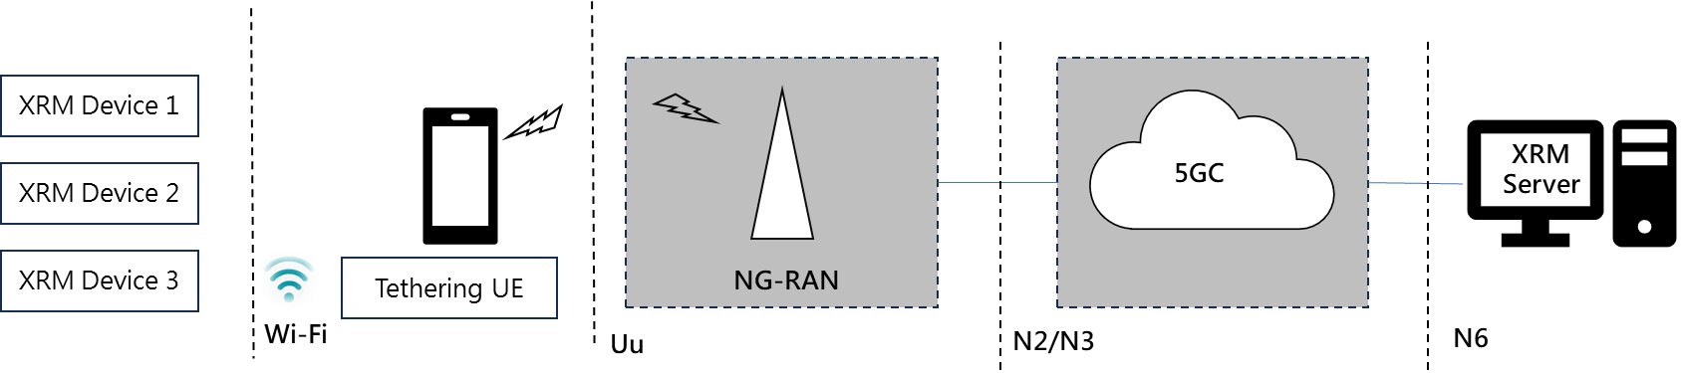
Figure 6.X-1 Scenario of Tethering for XR and Media Services
In this scenario, the tethering UE establish PDU session toward UPF using the NG-RAN and 5GC resources for both uplink and downlink directions.
In order to support the tethering scenario for non-5G capable XRM devices, this solution proposes to reuse the N5CW access mechanism which has been specified in 4.2.8.5 of TS 23.501. In Clause 4.2.8.5 of TS 23.501, access to 5GC from devices that do not support 5GC NAS over WLAN access has been specified as shown in Figure below.
Figure 6.X-2: Non-roaming and LBO Roaming Architecture for supporting 5GC access from N5CW devices (cited from TS 23.501)

6.X.3 Proposed architecture reusing N5CW access
This solution intends to reuse and extend the existing architecture specified in TS 23.501 as shown with the following functional assumptions as shown in Figure 6.X-3. The major impacts is that the tethering UE needs to implement the TWAP and TWIF function which has already been specified.

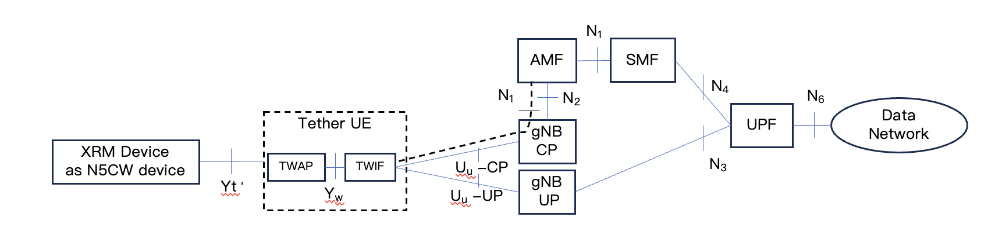
Figure 6.X-3 Proposed architecture reusing N5CW access

Referring to Figure 6.X-3, some assumptions related to XRM traffic handling of the proposed solution are listed as follows:

- Tether UE support authentication and make its WLAN access trusted by 5GC
- Reuse TWAP solution to support tethering e.g. on IP address allocation
- Yw interface becomes proprietary within Tether UE and N1 interface is terminated by TWIF within the tethering UE
- XRM traffic of XRM N5CW device from Yt’ interface is mapped to QoS flow of PDU session,Mapping of QoS parameters in Yt’ interface to Uu interface are carried out by the tethering UE e.g. by reusing the TWAP and TWIF functional modules.
- Uplink XRM traffic from N5CW device are identified by the TWAP/TWIF function within the UE, the tethered XRM traffic can be differentiated from the other non-tethered traffic between the UE and AF/AS. The tether XRM traffic can share the PDU session with non-tethered XRM traffic and use different QoS flows or it may use another PDU session when needed.

6.X.3 Procedures
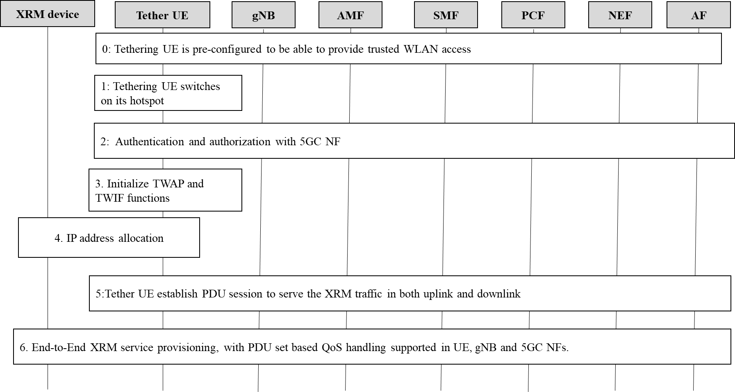
Figure 6.X-4 Procedure of Tethering for XR and Media Services reusing trusted WLAN access
- Tethering UE is pre-configured to be able to provide trusted WLAN access to XRM device
- Tethering UE switches on its hotspot
- Tethering UE carries out authentication and authorization with 5GC NF, and the hotspot WLAN access becomes trusted
- Tether UE initialize the TWAP and TWIF functions
- XRM device get IP address from Tether UE
- Tether UE establish PDU session to serve the XRM traffic in both uplink and downlink
- E2E XRM service provisioning with PDU set QoS handling supported, tethering UE need to support NAT function and IP address allocation for the N5CW devices which support XRM services, QoS mapping between N5CW access and 5GS QoS flow is supported by the tethering UE

6.X.4 Impacts on services, entities and interfaces
Tethering UE:
- Need to implements the TWAP and TWIF functions specified in 3GPP and identify the uplink XRM traffic and also performs QoS mapping between N5CW access and 5GS QoS flow
EN: The impacts of UE terminating N2/N3 interfaces to AMF and UPF need to be evaluated.
5GC:
- Need to support authentication and authorization to allow a tethering UE to provide trusted WLAN access, for this purpose, a subscription need to be configured in UDM per SIM of the tethering UE

* * * * End of changes * * * *

