SA WG2 Meeting #162 S2-2405192
15-19, April 2024, Changsha, P. R. China revision of S2-2404309
Source: OPPO, [China Mobile], Nokia, [Xiaomi], [Samsung]
Title: FS_UIA_ARC KI#4, New Sol: devices behind UE or 5G-RG
Document for: Approval
Agenda Item: 19.8
Work Item / Release: FS_UIA_ARC /Rel-19
Abstract of the contribution: This paper proposes a new solution for KI#4 of the FS_UIA_ARC.

1 Discussion
KI#4 of FS_UIA_ARC has been agreed and documented in TR 23.700-32, captured in the text box below. This contribution proposes a solution for KI#4 of FS_UIA_ARC.
This key issue will study whether and how 5GC identifies individual non-3GPP devices connecting behind a UE or 5G-RG and whether and how to provide policy control for the traffic associated with individual non-3GPP devices.
The use case that is associated with this key issue is the case where non-3GPP devices behind a UE or 5G-RG need to be identified.
The objective of this key issue is how an identifier is used by the network to control the traffic to/from UE or 5G-RG when the traffic is associated with the non-3GPP devices. This objective differs from existing support for AUN3 devices in TS 23.316 [7] because the objective is to enable the non-3GPP devices to be identified and to use only the subscription of the UE or 5G-RG to access the 5GC (i.e. the UE or 5G-RG should have to maintain only a NAS Context itself and not for each non-3GPP device).
Solutions to this key issue will address:
- whether and how the 5GC identifies individual non-3GPP devices connecting behind a UE or 5G-RG. (e.g. in order to charge the individual non-3GPP devices),
- whether and how to provide policy control for the traffic of individual non-3GPP devices connecting behind a UE or 5G-RG. Including whether and how to trigger policy control for the traffic of individual non-3GPP devices via PCF and NEF APIs, including whether and how to support concurrent services with differing QoS requirements launched by the different non-3GPP devices, and
- whether and how the operator can optionally restrict the number of simultaneously active User Identifiers per UE or 5G-RG.
NOTE 0: The User Identifiers in the above bullet means the identifiers of the devices behind gateway UE or 5G-RG.
NOTE 1: Changes to the layer 1 or layer 2 protocols of non-3GPP devices are not in scope of this study. It is assumed that the non-3GPP devices do not support 5G-AKA authentication procedures nor separate NAS connections with the 5GC for each non-3GPP device (e.g. like for AUN3 devices).
NOTE 2: Conclusions related to an 5G-RG should be shared with the Broadband Forum (BBF) and CableLabs.
NOTE 3: Solutions for Ethernet PDU Session should work in the presence of randomized MAC addresses.

2 Proposal
It is proposed to include the following changes in TR 23.700-32 V0.2.0.
* * * * Start of Changes * * * *

6.X Solution #X: Non-3GPP Devices Behind UE or 5G-RG support

6.X.1 Key Issue mapping

This is a solution for KI#4.

6.X.2 Description
The proposed solution addresses how 5GC identifies individual non-3GPP devices connecting behind a UE or 5G-RG (as depicted in Figure 6.X.2-1) and how to provide policy control for the traffic associated with individual non-3GPP devices. The mention of UE in subsequent sections needs to be considered as applicable for UE and 5G-RG.
The proposed solution meets the architecture assumptions specified in clause 4.1. In this solution, the following architecture principles apply.
Non-3GPP Device Behind UE/5G-RG (N3DBU) is a subscribed service, and a subscriber needs to coordinate with the operator to subscribe for N3DBU service. When a user subscribes for the N3DBU service, the N3DBU ID and associated subscription data may be allocated by the operator. N3DBU ID can be a unique identifier within the home PLMN. An N3DBU ID is only allowed to be actively used by one non-3GPP device at any time. During provisioning, the information related to the subscribed N3DBU IDs, such as the slice info, PDU session info, QoS settings, and/or a list of subscribed N3DBU ID, etc. is stored within the subscriber’s subscription data in UDR. Each N3DBU ID may be associated with pre-defined QoS, policy rules, and/or subscriber category identifiers (e.g., gold, silver, premium etc.).

Furthermore,

a Device Profile may be created and stored in UDR with relevant parameters provide by AF reusing External Parameter Provisioning procedures. Device Profile may consist of:
- N3DBU ID
- Device specific QoS/Policy Settings, etc.
Upon N3DBU-capable UE or 5G-RG registration with the 5GC, the list of subscribed N3DBU IDs is populated from the AMF to the UE or 5G-RG. Additionally, N3DBU IDs can be stored/updated/removed based on UDM decisions.
Upon connecting a non-3GPP device that is intended to be associated with an N3DBU ID to the UE or 5G-RG, the UE or 5G-RG should provide means to bind the connected non-3GPP devices with N3DBU ID. This binding process can be performed either manually by a user or automatically by the UE or 5G-RG with subscription to the N3DBU service.
NOTE 1: The binding process is implementation specific, not in scope of this study. For instance, subscribers could specify the binding by themselves through a GUI provided by the UE, which allow them to select the desired non-3GPP device to be bound with the N3DBU ID.
Alternatively, if the N3DBU ID is already associated with specific non-3GPP devices, identified by certain physical parameters or identifiers, the UE may automatically bind the non-3GPP device with the N3DBU ID upon its connection to the UE or 5G-RG.
The N3DBU-capable UEs/5G-RG may be provisioned with appropriate URSP rules to enable the non-3GPP devices to route the non-3GPP device traffic based on URSP rules.
N3DBU ID is introduced as one component of Traffic Descriptors (TDs). And N3DBU-capable 5G-RG or UE can recognize URSP rules including N3DBU ID.

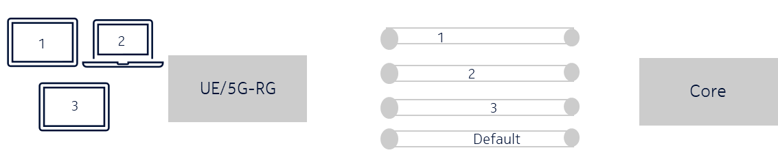
Figure 6.X.2-1: Representation of non-3GPP Device access

URSP rules should be provided to the 5G-RG or UE to indicate how to map N3DBU IDs to the parameters of the PDU Session, DNN, and S-NSSAI, used to carry the traffic of corresponding non-3GPP devices. It is possible that different N3DBU IDs in the TD may be provided with the same DNN/S-NSSAI parameters.

Differentiation of charging and QoS may be provided via PCC rules (for different service flows) related with dedicated PDU Sessions for non-3GPP devices.

6.X.3 Procedures

6.X.3.1 Identification
Figure 6.X.3.1-1 depicts high level procedures to show how 5GC identifies individual non-3GPP devices connecting behind a UE or 5G-RG.

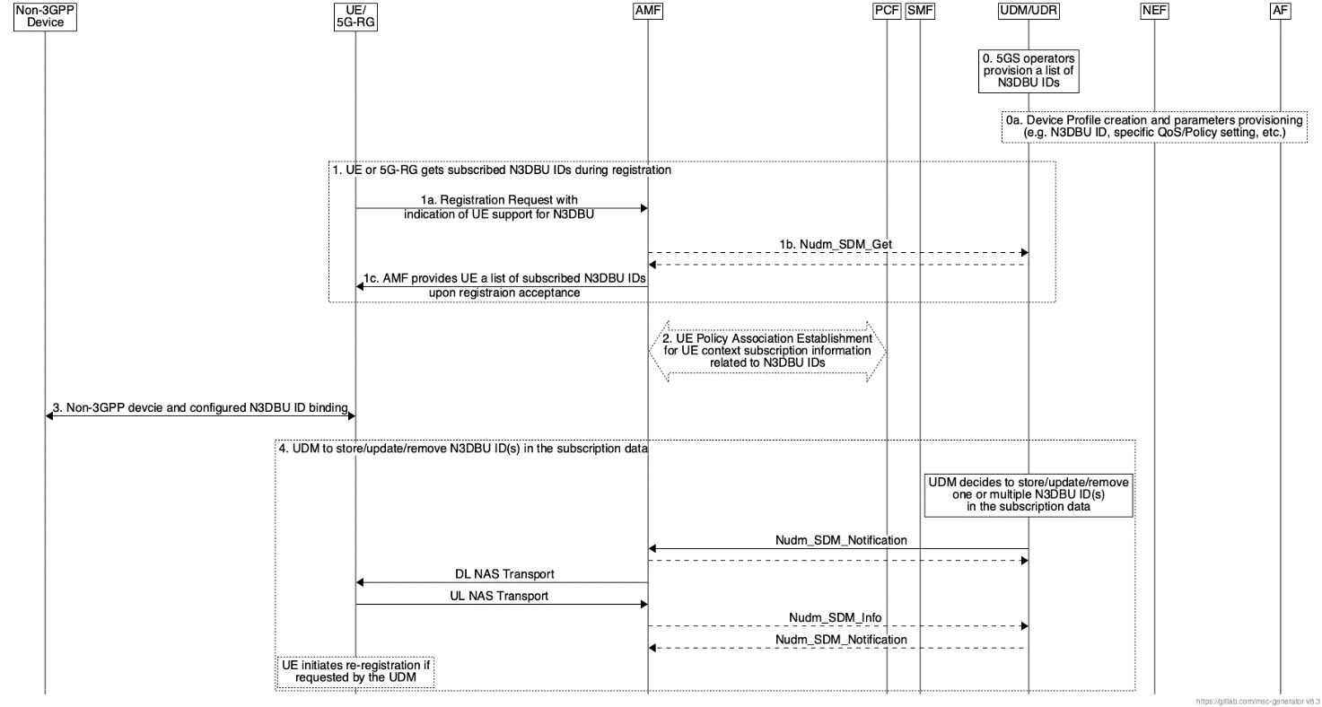
Figure 6.X.3.1-1: Identification of non-3GPP devices connecting behind a UE or 5G-RG
- The 5GS operators provision a list of N3DBU IDs.

Alternatively, in Step 0a, a Device Profile may be created for the device based on the request and parameters provided by AF directly or via NEF.

- In Steps 1a-1c, the UE or 5G-RG follows general registration procedures specified in clause 4.2.2.2.2 of TS 23.502, except for UEs/5G-RGs that indicate N3DBU ID support and are subscribed to N3DBU services, in which case the AMF may provide the UE with a list of subscribed N3DBU IDs.

UE may provide the UE Policy Container including UE capability of supporting Device User Identifiers.

AMF may retrieve the N3DBU IDs and their related subscription data using Nudm_SDM_Get service operation.

- AMF selects a PCF that supports N3DBU ID related policies. During the UE Policy Association Establishment/Modification procedure, the PCF includes the provisioned URSP rules that may consist of “N3DBU ID” TD described in Table 6.X.3.3-1.

- When a subscriber connects a non-3GPP device intended for association with a configured N3DBU ID to the UE or 5G-RG, the UE or 5G-RG is responsible for binding the connected non-3GPP device with the configured N3DBU ID.

The UE/5G-RG should maintain the associations between the configured N3DBU ID and the connected non-3GPP devices.

- UDM may decide to store/update/remove one or more N3DBU IDs associated with the UE/5G-RG's subscription. It may update information related to N3DBU IDs stored in UDR using Nudr_DM service operations.

Based on updates received from the UDM, the UE will store, update, or remove N3DBU IDs and their related configurations locally. Additionally, the PCF, AMF, and SMF will be informed to update their records with the latest N3DBU ID-related information.

6.X.3.2 Maximum Number of Simultaneously Active N3DBU ID
An operator may provision a maximum number of simultaneously active N3DBU IDs in the UE/5G-RG subscription data. As described in clause 6.X.2 and clause 6.X.3.1, the UE/5G-RG receives a list of subscribed N3DBU IDs and the allowed maximum number of simultaneously active N3DBU IDs upon Registration Accept. UE/5G-RG should enforce an N3DBU ID is only allowed to be actively used by one non-3GPP device at any time. If the limit of maximum simultaneously active N3DBU IDs is reached, the UE denies further non-3GPP device connections requesting N3DBU ID or route the traffic through the PDU Session that matches the default URSP rule based on the policy (to support backward compatibility).

6.X.3.3 Policy Aspects
To send PDU of a non-3GPP device associated with an N3DBU ID, the upper layers of the 5G-RG or UE require information on the PDU session (e.g., PDU address) via which to send the PDU of the non-3GPP device.
The mapping of local network resources and 5GC QoS is configured in the 5G-RG or UE. If N3QAI together with QoS rule information is provided, the 5G-RG or UE may reserve resources in the non-3GPP network behind the 5G-RG or UE.
N3DBU ID in the Traffic Descriptor of the URSP rule is matched against the N3DBU ID that the non-3GPP device is associated with. Table 6.X.3.3-1 provides a possible implementation of a new TD component “N3DBU ID” representing the non-3GPP device assigned.
Table 6.X.3.3-1: Enhanced UE Route Selection Policy Rule on top of 3GPP TS 23.503 Table 6.6.2.1-2
Information name | Description | Category | PCF permitted to modify in a UE context | Scope
Rule Precedence | Determines the order the URSP rule is enforced in the UE. | Mandatory  (NOTE 1) | Yes | UE context
Indication for reporting URSP rule enforcement | Determines the need for reporting the URSP rule enforcement in the UE.  (NOTE 10) | Optional | Yes | UE context
Traffic descriptor | This part defines the Traffic descriptor components for the URSP rule. | Mandatory  (NOTE 3)
Application descriptors | It consists of OSId and OSAppId(s) (NOTE 2, NOTE 8). | Optional | Yes | UE context
IP descriptors  (NOTE 6) | Destination IP 3 tuple(s) (IP address or IPv6 network prefix, port number, protocol ID of the protocol above IP) (NOTE 8, NOTE 12). | Optional | Yes | UE context
Domain descriptors | FQDN(s) or a regular expression which are used as a domain name matching criteria (NOTE 7, NOTE 8). | Optional | Yes | UE context
Non-IP descriptors  (NOTE 6) | Descriptor(s) for destination information of non-IP traffic (NOTE 8, NOTE 12). | Optional | Yes | UE context
DNN | This is matched against the DNN information provided by the application (NOTE 8). | Optional | Yes | UE context
Connection Capabilities | This is matched against the information provided by a UE application when it requests a network connection with certain capabilities (NOTE 4, NOTE 8) or traffic categories (NOTE 5). | Optional | Yes | UE context
PIN ID | Matched against a PIN ID for a specific PIN configured in the PEGC (NOTE 9). | Optional | Yes | UE context
Connectivity Group ID | Matched against a Connectivity Group ID for a specific Connectivity Group configured in the 5G-RG (NOTE 11). | Optional | Yes | UE context
N3DBU ID | This is matched against the non-3GPP Device user identifier representing the non-3gpp device assigned. (NOTE 13). | Optional | Yes | UE context
List of Route Selection Descriptors | A list of Route Selection Descriptors. The components of a Route Selection Descriptor are described in table 6.6.2.1-3. | Mandatory
NOTE 1: Rules in a URSP shall have different precedence values.
NOTE 2: The information is used to identify the Application(s) that is(are) running on the UE's OS. The OSId does not include an OS version number. The OSAppId does not include a version number for the application.
NOTE 3: At least one of the Traffic descriptor components shall be present.
NOTE 4: The format and some values of Connection Capabilities, e.g. "ims", "mms", "internet", etc. are defined in TS 24.526 [19]. More than one Connection Capabilities value can be provided.
NOTE 5: The format and values of Connection Capabilities Traffic Descriptor to match against standardized traffic categories are defined in TS 24.526 [19] according to the requirements in GSMA PRD NG.135 [39]. The reserved values of Connection Capabilities to match operator-specific traffic categories are specified in TS 24.526 [19]. Traffic categories requested by the UE application are independent from the UE's Operating System. Operator-specific traffic categories values are out of scope of 3GPP specifications. Details on how UE applications indicate traffic categories to the UE's Operating System are out of scope of 3GPP specifications.
NOTE 6: A URSP rule cannot contain the combination of the Traffic descriptor components IP descriptors and Non-IP descriptors.
NOTE 7: The match of this traffic descriptor does not require successful DNS resolution of the FQDN provided by the UE Application.
NOTE 8: Not applicable for PINE traffic.
NOTE 9: The PCF delivers traffic descriptor with PIN ID based on S-NSSAI/DNN as specified in clause 6.2.1.3. PIN ID only applies to traffic to/from PINEs. PIN ID and other traffic descriptor components are mutually exclusive, i.e. if PIN ID is included in a URSP rule, then no other traffic descriptor components are supported in the same URSP rule.
NOTE 10: A URSP rule can contain this indication only if the URSP rule includes a Connection Capabilities Traffic descriptor.
NOTE 11: Only applies to traffic to/from NAUN3 devices behind the 5G-RG (as defined in TS 23.316 [27]) and may only be combined with IP descriptors and/or non-IP descriptors in the same URSP rule.
NOTE 12: May also be applied for traffic from NAUN3 devices behind the 5G-RG (as defined in TS 23.316 [27]).
NOTE 13: To achieve unique policy, it is expected that the non-3GPP Device user identities are unique within PLMN.

When a URSP rule is determined to be applicable for a given N3DBU ID, the UE should select a Route Selection Descriptor within the URSP rule in the order of the Route Selectin Descriptor Precedence.
The UE/5G-RG may re-evaluate the URSP rules, to check if the change of the association of N3DBU ID to a PDU session is needed following the principles defined in TS 24.526.
Differentiation of charging and QoS may be provided via PCC rules (for different service flows) related with dedicated PDU Sessions for non-3GPP devices.
Figure 6.X.3.3-1 describes high-level procedures for N3DBU service operation.

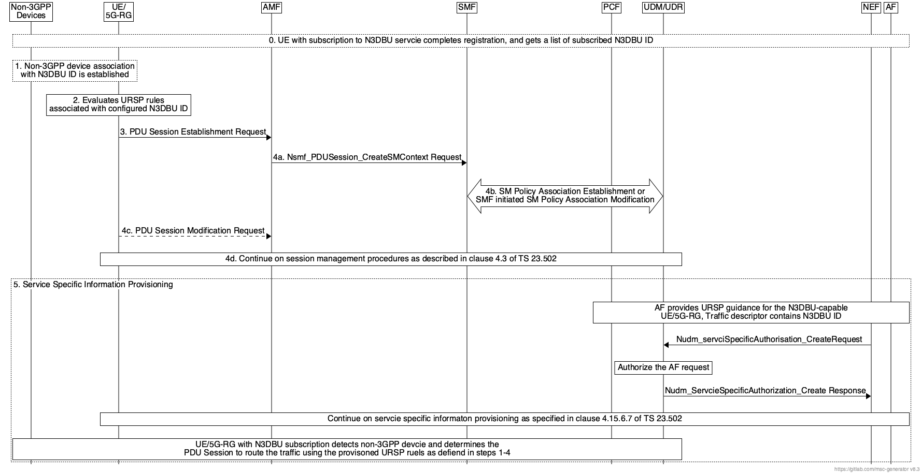
Figure 6.X.3.3-1: N3DBU Policy Aspects Procedures
- UE or 5G-RG with subscription to N3DBU service has completed registration and got a list of configured N3DBU IDs.

- For every newly detected non-3GPP device by N3DBU-capable UE or 5G-RG, the association between the target non-3GPP device and N3DBU ID is established.

- UE or 5G-RG evaluates the URSP rules associated with this N3DBU ID in the order of Rule Precedence and determines if the N3DBU ID is matching the Traffic Descriptor of any URSP rules.

- The UE or 5G-RG determines whether to establish a new PDU session or use one of the existing PDU session(s) based on the URSP rules , if any, or based on UE local configuration, as described in clause 4.2.2.3 of TS 24.526.

If UE/5G-RG determines to establish a new PDU session, it may include N3DBU ID in N1 SM container for Nsmf_PDUSession_CreateSMContext Request.

- In Steps 4a-4d, based on the N3DBU ID, SMF might retrieval/subscription for updates from N3DBU ID policy control subscription data from UDR.

If frame route is used, SMF get frame route info data from Framed Route information.

SMF may perform an SM policy Association Establishment procedure to establish an SM policy association with the PCF and get the default PCC rules for the PDU Session.

If each individual non-3GPP Device has an individual PDU Session with a corresponding DNN/S-NSSAI, PCF for the PDU Session based on these received parameters implements polices for the PDU Session as done currently by invoking the Nudr_DM_QueryRequest.

When one or several of the QoS parameters exchanged between the UE and the network associated with the N3DBU ID are modified, PDU Session Modification procedures will be applied.

Optionally, SMF may trigger Secondary authentication as specified in clause 4.3.2.3 of TS 23.502.

UE or 5G-RG then continue PDU Session procedures as described in clause 4.3 of TS 23.502.

- If a specific resource is required to be provisioned to support N3DBU service by using AF, e.g., to meet the non-3GPP device’s requested subscriber category, the procedure for clause 4.15.6.6 or clause 4.15.6.7a of TS 23.502 may be used.

The AF provides guidance for URSP generation to the 5GC. The AF uses a UE/5G-RG identifier (i.e., GPSI) as the target UE. The AF request contains DNN, S-NSSAI allocated to the N3DBU ID to meet the non-3GPP devices’ requested subscriber category. The NEF authorizes the request received from the AF and stores the information in the UDR as “Application Data” service specific subscription info sub date type.

The procedures specified in clause 4.15.6.7a of TS 23.502 may be used to authorize the AF request by the UDM.

6.X.4 Impacts on services, entities and interfaces
UE or 5G-RG
Support Registration Request with indication of N3DBU support
Handle N3DBU ID related URSP rules
AMF
UE Policy Association Establishment with UE context subscription information related to N3DBU IDs, optionally.
SMF
SM Policy Association Establishment or SMF initiated SM Policy Association Modification for N3DBU ID relate polices, optionally.
UDM
Make decision to store/update/remove N3DBU IDs in the subscription.
UDR
Store/update/remove N3DBU IDs in the subscription data.
PCF
Support of N3DBU ID related URSP rules.

NEF:
NEF receives Device User Identifier as part of Traffic Descriptor Components from the AF and communicate the same to the UDR.

* * * * End of Changes * * * *

