KI#6 – Way Forward - Clarify impact on 5G-RG [From SA2#161, S2-2402797 unhandled]

Discussion
In the case of wireline access, such as in cable access network, a dual-queue mechanism is used to separate queue-building traffic (non-L4S traffic) from non-queue-building traffic (L4S traffic). To correctly direct different traffic to the appropriate queues, classifiers associated with L4S DOCSIS Service Flows are used. For handling of UL traffic, 5G-RG is responsible for mapping the QoS rule(s) received in NAS to W-UP level QoS. In case of a 5G-CRG, QoS rules(s) are mapped to DOCSIS service flows, as indicated by the protocol stacks in the figures 1 and 2 below.
Fig. 1 Control Plane Protocol Stacks for W-5GAN
Fig. 2 User Plan Protocol Stacks for W-5GAN
TS 23.316 clause 6.3.1 states that –
- W-UP may support multiple W-UP resources per PDU session and associate different QoS profiles (QFIs) to different W-UP resources.
- W-UP supports access specific QoS parameters that can be mapped from 3GPP QoS parameters (e.g.5QI, RQI) received from the 5GC.
For 3GPP access, NG-RAN is responsible for scheduling and performing the mapping between QoS flows and DRBs for both UL and DL. Therefore, no explicit L4S indication is needed for the UE. But in the case of wireline access, W-AGF is responsible for performing the mapping between QoS flows and W-UP resources for DL, while the 5G-RG is responsible for scheduling and performing the mapping for UL.
To correctly map the L4S-enabled QoS Flow(s) to L4S-enabled W-UP resources (e.g. DOCSIS Service Flows), 5G-RG needs information from the SMF about which QoS Flow(s) are L4S enabled through NAS signaling. If the RG does not have this information from the 5GC, it could incorrectly map UL L4S traffic to non-L4S-enabled Service Flows based on QoS Rule(s) it received. Figures 3 and 4 show the 5G-CRG order of operations for an UL packet. If the 5G-RG is not aware of the dedicated L4S-enabled QoS Flow(s), as shown in Figure 3, it will determine a QFI that would map to a non-L4S Service Flow for the UL L4S traffic.
Additionally, the W-5GCAN could use different VLAN ids and/or DSCP values to differentiate between L4S traffic and non-L4S traffic. In this case, the 5G-RG would need to have information about L4S-enabled QoS flows to use the correct VLAN id and/or DSCP value when mapping to the W-UP resource.
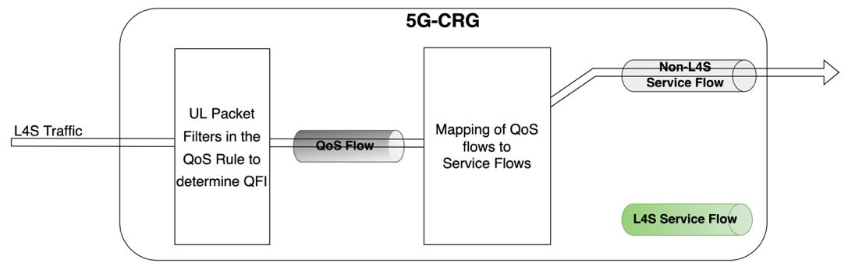
Fig. 3 Incorrect operation if 5G-RG is not aware about dedicated L4S-enabled QoS Flows
If the 5G-RG is aware about the dedicated L4S-enabled QoS Flow(s), as shows in Figure 4, it will first determine a QFI corresponding to a L4S-enabled QoS Flow for the UL L4S traffic, and then correctly map it to a L4S Service Flow.
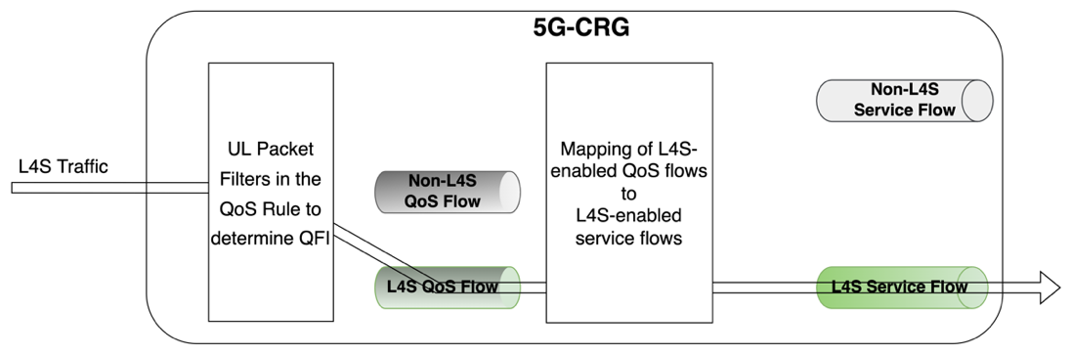
Fig. 4 Correct operation if 5G-RG is aware about dedicated L4S-enabled QoS Flows
Therefore, it is essential for 5G-RG to receive information about L4S-enabled QoS Flow(s) via NAS signaling.

Proposals
Proposal 1: Remove ENs in TR 23.700-70 clause 6.17.4.1 based on the procedures defined in clause 6.17.3.1.
Proposal 2: Agree on below principles –
ECN marking in | Supported by 5G-RG (N1 Signaling)
Wireline nodes | Mapping of 5G QoS to wireline QoS for UL
5G-RG | Indication of ECN marking for L4S

