SA WG2 Meeting #162 S2-2404988
Changsha, China, April 15 –19, 2024

Source: CableLabs, Charter Communications, Nokia, Tencent, Tencent Cloud, Lenovo, InterDigital
Title: KI#7: Solution#18 Update and Interim conclusions
Document for: Approval
Agenda Item: 19.3
Work Item / Release: FS_XRM_Ph2 / Rel-19
Abstract: This contribution proposes solution #18 update and interim conclusions for KI#7.

1. Description of Key Issue #7
The following is described in TR 23.700-70 v0.4.0:

5.7 Key Issue #7: Support for PDU Set in non-3GPP access.

5.7.1 Description
Support for PDU Set mechanisms are specified in TS 23.501 [2] clause 5.37.5. 5G system supports PDU Set based QoS handling in NG-RAN with the PSA UPF identifying PDUs that belong to PDU Sets based on Protocol Description for PDU Set identification and providing PDU Set Information to the RAN in the GTP-U header. Rel-18 5GS support for PDU Set based handling is limited to NG-RAN access. However, the interaction between the application and 5GS via non-3GPP access is also necessary to enhance efficiency and promote user experience. The user may be serviced by the 5GC via non-3GPP accesses such as trusted, untrusted, or wireline access, such as a device behind RG.
The objective of this Key Issue is to support PDU set based QoS Handling to non-3GPP access networks and the potential impacts of such extension on the non-3GPP access-specific intermediate nodes.
The following aspects should be studied:
- How PDU Set QoS Control mechanisms can be extended to non-3GPP access networks:
- Support PDU set QoS in untrusted/trusted access (e.g. N3IWF, TNGF).
- Support PDU set QoS in wireline access (e.g. W-AGF).
NOTE: It is limited to re-using existing control plane and user plane between 5GC and non-3GPP access networks. Additional parameters are not precluded to support non-3GPP nodes. Assumptions on W-AGF functionality are to be verified with BBF and CableLabs.

2. Proposal
This contribution proposes solution #18 update and conclusions for Key Issue #7 to be captured in TR 23.700-70.
Start of changes

6.18.2.2 Supporting PDU Set based QoS handling in non-3GPP access nodes
The PDU Set based QoS handling by the non-3GPP access nodes is determined by PDU Set QoS Parameters in the QoS profile of the QoS Flow and PDU Set Information provided by the PSA UPF.
For QoS Flows with PDU Set based QoS handling enabled, PDU Set QoS Parameters are determined by the PCF (based on information provided by AF and/or local configuration) and provided by SMF to the N3IWF, TNGF, W-AGF as part of the QoS profile. Alternatively, the SMF may be configured to support PDU Set based QoS handling without receiving PCC rules from PCF. When the N3IWF, TNGF, W-AGF receives N2 requests related to PDU Session resources, the N3IWF, TNGF, W-AGF maps the QoS profile(s) received from the 5GC to non-3GPP access level resources, e.g. W-UP level QoS for the fixed access.
The following PDU Set QoS Parameters are used to support PDU Set based QoS handling in the N3IWF, TNGF, W-AGF. At least one PDU Set QoS Parameter shall be sent to the N3IWF, TNGF, W-AGF to enable PDU Set based QoS handling.
1. PDU Set Delay Budget
The PDU Set Delay Budget (PSDB) defines an upper bound for the delay that a PDU Set may experience for the transfer between the UE/RG and the N6 termination point at the UPF, i.e. the duration between the reception time of the first PDU (at the N6 termination point for DL or the UE/RG for UL) and the time when all PDUs of a PDU Set have been successfully received (at the UE/RG for DL or N6 termination point for UL). PSDB applies to the DL PDU Set received by the PSA UPF over the N6 interface, and to the UL PDU Set sent by the UE/RG.
If the 5G-RG supports providing of the non-3GPP delay budget for a specific QoS flow, the 5G-RG may provide a non-3GPP delay budget to SMF by using the 5G-RG requested PDU Session Modification procedure. The SMF may compensate for this delay by adjusting the dynamic CN PSDB for the 3GPP network by the non-3GPP delay.

2. PDU Set Error Rate
The PDU Set Error Rate (PSER) defines an upper bound for the rate of PDU Sets that have been processed by the sender of a link layer protocol (e.g. W-UP or L-W-UP of a W-5GAN) but that are not successfully delivered by the corresponding receiver to the upper layer.
3. PDU Set Integrated Handling Indicator
The PDU Set Integrated Handling Information (PSIHI) indicates whether all PDUs of the PDU Set are needed for the usage of the PDU Set by the application layer in the receiver side.
The SMF may additionally signal Non-3GPP QoS Assistance Information (N3QAI) for each QoS flow to the 5G-RG. Based on the N3QAI together with QoS rule information, the 5G-RG may reserve resources in the non-3GPP network behind the 5G-RG. N3QAI may include the PDU Set QoS Parameters.
For the downlink direction, the PSA UPF identifies PDUs that belong to PDU Sets and determines the below PDU Set Information which it sends to the N3IWF, TNGF, W-AGF in the GTP-U header. The PDU Set Information comprises:
- PDU Set Sequence Number.
- Indication of End PDU of the PDU Set.
- PDU Sequence Number within a PDU Set.
- PDU Set Size in bytes.
- PDU Set Importance.
For the uplink direction, the UE/5G-RG may identify PDU Sets, and how this is done is left to UE implementation. The SMF may send Protocol Description associated with the QoS rule to the UE/5G-RG.

Next change

6.18.3 Procedures

6.18.3.1 Procedures in wireline 5G access network
Figure 6.18.3-1: High-level procedure of the solution for W-AGF and 5G-RG
1. Steps 1-2a specified in clause 7.3.1.1 of TS 23.316 [17].
2a. The N2 SM information carries information that the AMF shall forward to the W-AGF which includes: at least one PDU Set QoS parameter to activate PDU Set QoS handling for a given QoS flow.
The N1 SM container that the AMF shall provide to the 5G-RG may contains for each QoS Flow for which UL PDU Set based QoS handling needs to be enabled, Protocol Description for identifying the PDU Set.
2b. The AMF shall under request of the SMF send a N2 PDU Session Resource Setup Request message to W-AGF to establish the access resources for this PDU Session.
3. Based on the QoS flows and QoS parameters received in the previous step, W-AGF determines the corresponding PDU Set wireline QoS resource needed for the PDU session.
4. The W-AGF sets up the W-UP resources for the PDU session.
5. After all W-UP resources are established, the W-AGF shall forward to 5G-RG via the W-CP signaling connection the PDU Session Establishment Accept message (including the Protocol Description associated with the QoS Rule) received in step 2b.
6. The W-AGF shall send to AMF an N2 PDU Session Resource Setup Response including: the PDU Set Based Handling Support Indication in N2 SM information.
7. All steps specified after step 14 in clause 4.3.2.2.1 of TS 23.502 [3] are executed according to the PDU Session Establishment procedure over 3GPP access.
Similar procedures would be applicable for the 5G-RG connected to 5GC via NG-RAN.
Figure 6.18.3-2: High-level procedure of the solution for W-AGF and FN-RG
1. Steps 0-2a specified in clause 7.3.4 of TS 23.316 [17].
2a. The N2 SM information carries information that the AMF shall forward to the W-AGF which includes: at least one PDU Set QoS parameter to activate PDU Set QoS handling for a given QoS flow.
2b. The AMF shall under request of the SMF send a N2 PDU Session Resource Setup Request message to W-AGF to establish the access resources for this PDU Session.
3. Based on its own policies, configuration and based on the QoS flows, QoS parameters received in the previous step, the W-AGF shall determine what W-UP resources are needed for the PDU session.
The W-AGF may perform Access specific resource reservation with the AN, that is, it sets up the W-UP resources for the PDU session.
4. The W-AGF shall send to AMF an N2 PDU Session Resource Setup Response including: the PDU Set Based Handling Support Indication in N2 SM information.
5. All steps specified after step 13 in clause 4.3.2.2.1 of TS 23.502 [3] are executed according to the PDU Session Establishment procedure over 3GPP access.

6.18.3.2 Procedures in untrusted non-3GPP access
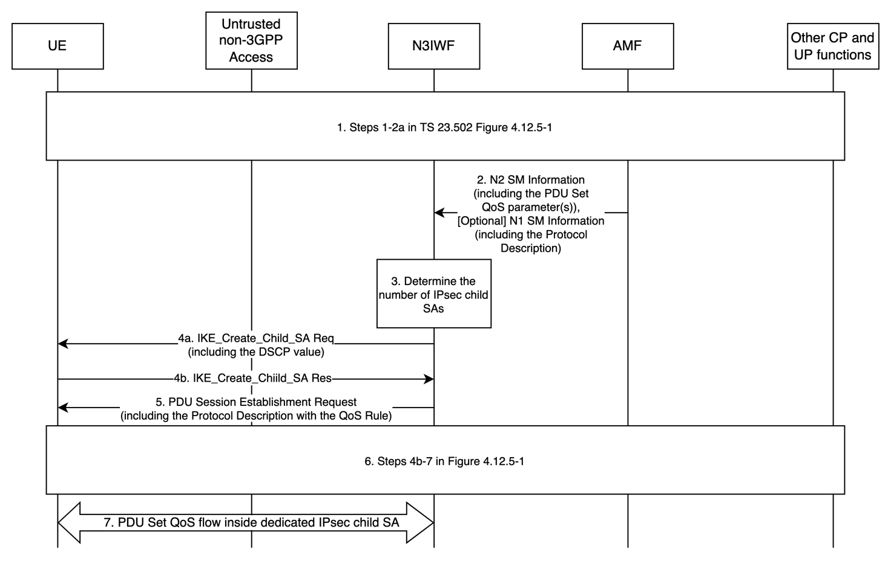
Figure 6.18.3.2-1: High-level procedure for untrusted non-3GPP access
- Steps 1-2a specified in clause 4.12.5 of TS 23.502 [3], with the difference that the N2 SM information carries information that the AMF shall forward to the N3IWF which includes: at least one PDU Set QoS parameter to activate PDU Set QoS handling for a given QoS flow.
The N1 SM container that the AMF shall provide to the UE may contains for each QoS Flow for which UL PDU Set based QoS handling needs to be enabled, Protocol Description for identifying the PDU Set.
- The AMF shall under request of the SMF send a N2 PDU Session Resource Setup Request message, which includes the PDU Set QoS parameter(s), to N3IWF to establish the non-3GPP access resources for this PDU Session.
- For PDU Set-enabled QoS Flow, N3IWF establishes a dedicated IPsec Child SA.
N3IWF may also determine the mapping of PDU Set Importance value(s) (or other type of PDU Set Information or PDU set QoS parameters) to DCSP value(s). Using PDU Set Importance as an example, the PDU Set Importance can be different for different PDU Sets within a QoS Flow. The mapping list of PDU set importance value(s) to DSCP value(s) includes at least one mapping (e.g., the mapping of PDU Set Importance value#1 and DSCP value#1, the mapping of PDU Set Importance value#2 and DSCP#2, etc.). More than one PDU Set Importance value may be mapped into one DSCP value.
- The N3IWF shall send to UE an IKE Create_Child_SA request which may include a DSCP value associated with the Child SA, based on operator policy. Besides, N3IWF may provide the mapping list of PDU Set Importance value(s) and DSCP instead of a DSCP value associated with the IPsec Child SA to the UE.

- If the UE accepts the new IPsec Child SA, the UE shall send an IKE Create_Child_SA response.
- After the IPsec Child SA is established, the N3IWF shall forward to UE via the signalling IPsec SA the PDU Session Establishment Accept message (including the Protocol Description associated with the QoS Rule) received in step 2.
- Steps 6-7 specified in clause 4.12.5 of TS 23.502 [3] are executed according to the PDU Session Establishment procedure via untrusted non-3GPP access.
- On the user-plane, PDUs belonging to PDU Set-enabled QoS flow are transferred over dedicated IPsec child SA. If a DSCP value is included, then the UE and the N3IWF shall mark all IP packets sent over this Child SA with this DSCP value. If the mapping list of PDU Set Importance value(s) and DSCP value is included, then UE and N3IWF shall mark all IP packets sent over this Child SA with the DSCP value based on the PDU Set Importance.

6.18.3.3 Procedures in trusted non-3GPP access
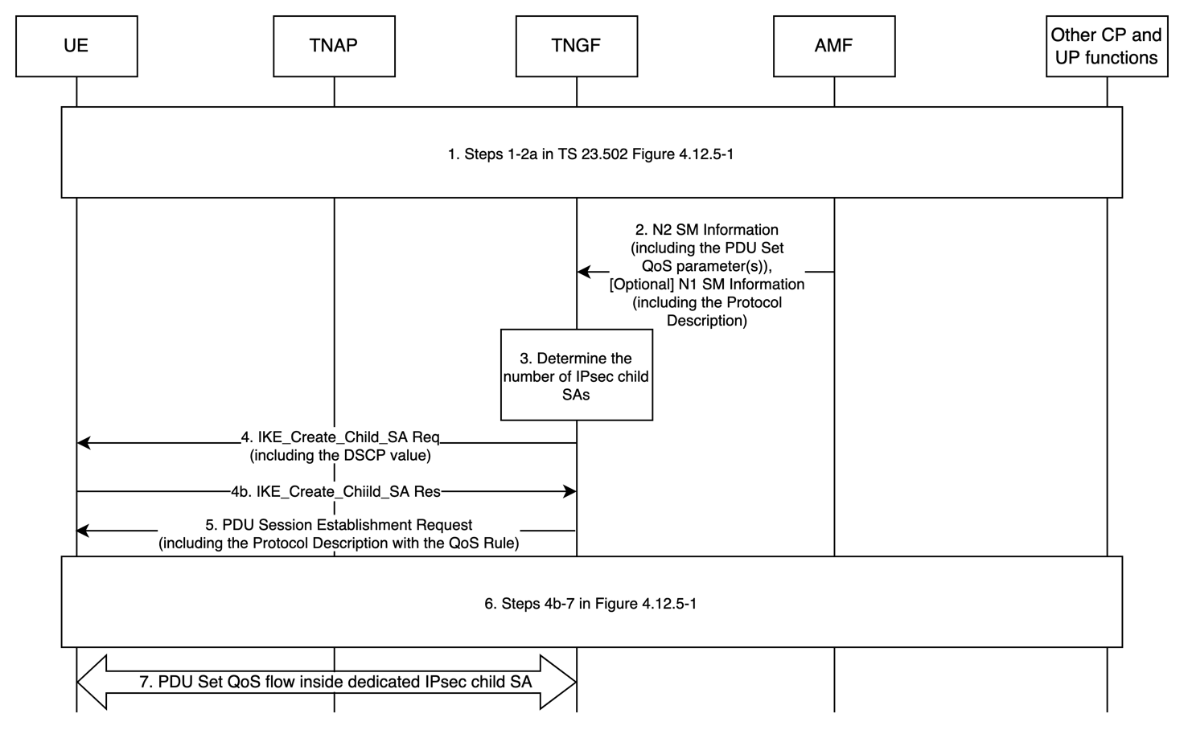
Figure 6.18.3.3-1: High-level procedure for trusted non-3GPP access
- Steps 1-2a specified in clause 4.12.5 with the modifications specified in clause 4.12a.5 of TS 23.502 [3], with the difference that the N2 SM information carries information that the AMF shall forward to the TNGF which includes: at least one PDU Set QoS parameter to activate PDU Set QoS handling for a given QoS flow.
The N1 SM container that the AMF shall provide to the UE may contains for each QoS Flow for which UL PDU Set based QoS handling needs to be enabled, Protocol Description for identifying the PDU Set.
- The AMF shall under request of the SMF send a N2 PDU Session Resource Setup Request message, which includes the PDU Set QoS parameter(s), to TNGF to establish the non-3GPP access resources for this PDU Session.
- For PDU Set-enabled QoS Flow, TNGF establishes a dedicated IPsec Child SA.
TNGF may also determine the mapping of PDU Set Importance value(s) (or other type of PDU Set Information or PDU set QoS parameters) to DSCP value(s).
- The TNGF shall send to UE an IKE Create_Child_SA request which may include a DSCP value associated with the Child SA, based on operator policy.
Besides, TNGF may provide the mapping list of PDU Set Importance value(s) and DSCP instead of a DSCP value associated with the IPsec Child SA to the UE.
- If the UE accepts the new IPsec Child SA, the UE shall send an IKE Create_Child_SA response.
- After the IPsec Child SA is established, the TNGF shall forward to UE via the signalling IPsec SA the PDU Session Establishment Accept message (including the Protocol Description associated with the QoS Rule) received in step 2.
- Steps 6-7 specified in clause 4.12.5 with the modifications specified in clause 4.12a.5 of TS 23.502 [3] are executed according to the PDU Session Establishment procedure via trusted non-3GPP access.
- On the user-plane, PDUs belonging to PDU Set-enabled QoS flow are transferred over dedicated IPsec child SA. If a DSCP value is included, then the UE and the TNGF shall mark all IP packets sent over this Child SA with this DSCP value. If the mapping list of PDU Set Importance value(s) and DSCP value is included, then UE and TNGF shall mark all IP packets sent over this Child SA with the DSCP value based on the PDU Set Importance.
Next change, all new text
8.X Conclusions for Key Issue #7
The following aspects are concluded as principles for the normative work:
- For wireline access –
  - W-AGF –
    - Uses the PDU Set QoS parameter(s) sent by SMF over N2 to determine W-UP resources.
    - Uses PDU Set Information received in the GTP-U header over N3 to identify PDU Sets.
  - 5G-RG –
    - 5G-RG may receive the UL Protocol Description associated with the QoS rule over N1 from SMF to identify PDU Sets.
    - How the 5G-RG may identify PDU Sets and determine W-UP resources to use is left up to 5G-RG implementation.
- For untrusted/trusted access –
  - N3IWF/TNGF –
    - Uses the PDU Set QoS parameter(s) sent by SMF over N2 to determine IPsec Child SAs.
    - Uses PDU Set Information received in the GTP-U header over N3 to identify PDU Sets.
    - Uses the PDU Set Importance received in the GTP-U header to determine the DSCP value for the IPsec Child SA.
  - UE –
    - UE may receive the UL Protocol Description associated with the QoS rule over N1 from SMF to identify PDU Sets.
    - How the UE may identify PDU Sets and determine IPsec Child SAs to use is left up to UE implementation.
    - UE may receive the mapping list of PDU Set Importance value(s) and DSCP associated with the IPsec Child SA and mark UL PDU with the DSCP value accordingly.
End of changes

