3GPP TSG-SA2 Meeting #162 S2-2405224
Changsha, Hunan Province, China, 15-19 April 2024 (revision of S2-2404992)

Source: Charter Communications, CATT
Title: New DualSteer solution for KIs 1.1, 1.2, 1.3 and 1.4
Document for: Approval
Agenda Item: 19.13
Work Item / Release: FS_MASSS / Rel-19
Abstract of the contribution: new solution to support DualSteer

1 Introduction
This contribution proposes a DualSteer solution for Subscription (KI #1.1), Registration (KI #1.2), Session Management (KI #1.3) and Policy Management (KI #1.4) aspects.

2 Proposal
It is proposed to agree the following changes in TR 23.700-54.

* * * * First Change * * * *

6.0 Mapping of Solutions to Key Issues
Table 6.0-1: Mapping of DualSteer Solutions to Key Issues
 | Key Issues for DualSteer
Solution# | Key Issue #1.1 | Key Issue #1.2 | Key Issue #1.3 | Key Issue #1.4
#X | X | X | X | X

Table 6.0-2: Mapping of ATSSS_Ph4 Solutions to Key Issues
 | Key Issues for ATSSS_Ph4
Solution# | Key Issue #2.1 | Key Issue #2.2
#2.1 | X
#2.2 |  | X
#2.3 | X
#2.4 | X
#2.5 | X
#2.6 |  | X
#2.7 |  | X
#2.8 |  | X

* * * * Second Change (all new text) * * * *

6.1.X Solution #X: DualSteer Solution on Subscription, Registration, Session Management and Policy Management

6.1.X.1 Description

6.1.X.1.1 General
Based on comparison of the ATSSS and DualSteer (DS) requirements, there are many similarities like possibility of data transfer over multiple accesses via traffic steering or switching to a PSA UPF in the H-PLMN, possibility of applying similar steering functions (e.g. MPQUIC, MPTCP, etc.) while some differences like DualSteer Device/UE requiring two subscriptions from the same operator. In order to address the DualSteer requirements, this solution makes use of the ATSSS framework as much as possible by enhancing the existing 3GPP functions and procedures related to subscription, registration, PDU session establishment, UE policy and session management policy.
Following subclauses capture the high-level solution principles.
Terminologies used in the solution descriptions and the procedures in following clauses are as follows:
- Two subscriptions from the same operator: Subscription_A (or SUPI_A) and Subscription_B (or SUPI_B)
- PLMNs that DualSteer Device/UE connects to: PLMN1 and PLMN2.
NOTE 1: DualSteer Device/UE connects to each PLMN using one of its subscriptions. In the solution descriptions SUPI_A registers to PLMN1, and SUPI_B registers to PLMN2.
NOTE 2: The solution principles have been described with the assumption that PLMN1 and PLMN2 are different PLMNs. However, same solution principles apply if PLMN1 and PLMN2 are same.
Solution principles can apply to the scenarios 1, 2 and 5 below (copied from the FS_MASSS SID (SP-240467)):

1. Two NR/5GC accesses in a single PLMN (HPLMN or VPLMN) with each access being NR TN or NR NTN;
2. Two NR/5GC accesses in two different PLMNs (including two VPLMNs or a VPLMN and the HPLMN) with each access being NR TN or NR NTN;
3. NR/5GC access and E-UTRA/EPC access in two different PLMNs (including two VPLMNs or a VPLMN and the HPLMN);
4. NR/5GC access and E-UTRA/EPC access in a single PLMN (HPLMN or VPLMN);
5. PNI-NPN (integrated with the HPLMN or integrated with the VPLMN) and PLMN access (TN/NTN plus TN or NTN). This scenario assumes only non-simultaneous transmission.

6.1.X.1.2 Architecture principles
Following diagrams depict sample architectural diagrams.
The PDU session established for each subscription (SUPI_A and SUPI_B) are anchored on the same SMF. Figure 6.1.X.1.2-1 is used as a sample architectural model describing the solution aspects and the registration and PDU session establishment procedures.

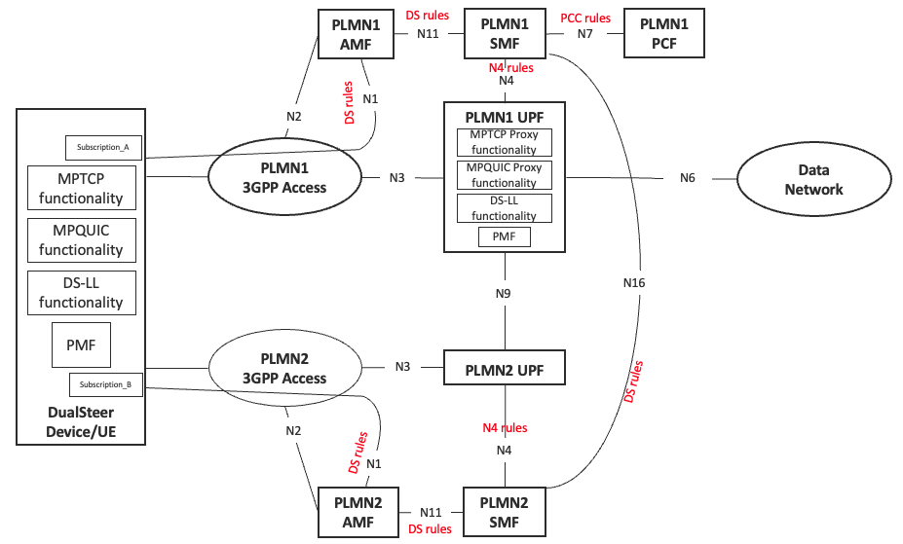
Figure 6.1.X.1.2-1: Sample DualSteer connectivity model: SUPI_A connects to PLMN1 as HPLMN, SUPI_B connects to PLMN2 as VPLMN

Figure 6.1.X.1.2-2 depicts a sample DualSteer Device/UE model supporting steering functionalities. This model is like the ATSSS steering functionalities specified in clause 5.32.6.1 of TS 23.501. DS-LL steering function is like ATSSS-LL. DS-HL steering functions are MPQUIC and MPTCP.
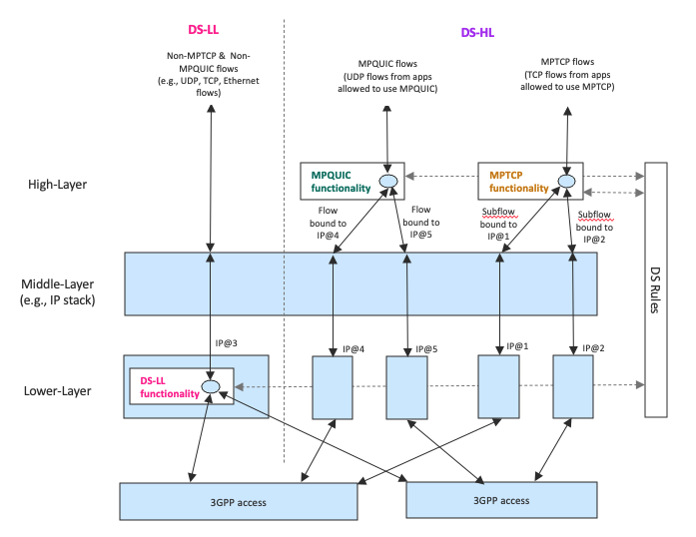
Figure 6.1.X.1.2-2: Steering functionalities in a sample DualSteer Device/UE model

6.1.X.1.3 Subscription Management aspects
Key solution aspects for subscription management are as follows:
- Two subscriptions from the same operator do not need to be explicitly linked in the UDM/UDR.
- The subscriptions can reside in different UDMs or in the same UDM.
- The URSP rules of each subscription/SUPI are maintained in the PCF/UDR separately, i.e., each SUPI has its own URSP rules.
- DualSteer rules (i.e., DS rules) for traffic steering and switching are similar to the ones specified for ATSSS rules in Rel-18 with the difference that the DS rules are applicable for two 3GPP access legs while the ATSSS rules are for one 3GPP access leg and one non-3GPP access leg. Therefore, the applicable ATSSS steering functions (i.e., MPQUIC, MPTCP, and ATSSS-LL by renaming as DS-LL) and applicable ATSSS steering modes (e.g., Active-Standby, Priority-Based) can be used in newly defined DualSteer rules. The PCC rules, which are used to derive the DualSteer rules, are maintained in the PCF/UDR.
- URSP rules of each SUPI in the PCF/UDR is enhanced with DualSteer components of the other SUPI(s) that can establish a DualSteer session. See Figure 6.1.X.1.3-1 below for the updated URSP rule structure with addition of DualSteer related components (highlighted in green) in the Route Selection Descriptor.
New components “DualSteer ID” and “Linked SUPI” are sent by the DualSteer Device/UE in the PDU Session Establishment message and UL NAS Transport message containing the PDU Session Establishment message. The AMF considers these fields as indicators that the PDU session is for DualSteer. The AMF also uses the Linked SUPI to query the UDM of the Linked SUPI to get the H-SMF ID and H-PCF ID in use for the PDU session of the Linked SUPI if already activated (see also subclause 6.1.X.1.5).
Table 6.1.X.1.3-1: New URSP Route Selection Descriptor with DualSteer related components
(from subclause 6.6.2.1 of TS 23.503)
Information name | Description | Category | PCF permitted to modify in URSP | Scope
Route Selection Descriptor Precedence | Determines the order in which the Route Selection Descriptors are to be applied. | Mandatory  (NOTE 1) | Yes | UE context
Route selection components | This part defines the route selection components | Mandatory  (NOTE 2)
SSC Mode Selection | One single value of SSC mode.  (NOTE 5) | Optional | Yes | UE context
Network Slice Selection | Either a single value or a list of values of S-NSSAI(s). | Optional  (NOTE 3) | Yes | UE context
DNN Selection | Either a single value or a list of values of DNN(s). | Optional | Yes | UE context
PDU Session Type Selection | One single value of PDU Session Type | Conditional  (NOTE 8) | Yes | UE context
Non-Seamless Offload indication | Indicates if the traffic of the matching application is to be offloaded to non-3GPP access outside of a PDU Session. | Optional  (NOTE 4)  (NOTE 10) | Yes | UE context
ProSe Layer-3 UE-to-Network Relay Offload indication | Indicates if the traffic of the matching application is to be sent via a ProSe Layer-3 UE-to-Network Relay outside of a PDU session. | Optional  (NOTE 4)  (NOTE 10) | Yes | UE context
ProSe Multi-path Preference | Indicates if the traffic of the matching application is preferred to be sent via a PDU Session over the Uu reference point and a ProSe Layer-3 UE-to-Network Relay outside of a PDU session. | Optional  (NOTE 9)  (NOTE 10) | Yes | UE context
Access Type preference | Indicates the preferred Access Type (3GPP or non-3GPP or Multi-Access or DualSteer) when the UE establishes a PDU Session for the matching application. | Optional | Yes | UE context
PDU Session Pair ID | An indication shared by redundant PDU Sessions as described in clause 5.33.2.1 of TS 23.501 [2]. | Optional  (NOTE 10) | Yes | UE context
RSN | The RSN as described in clause 5.33.2.1 of TS 23.501 [2]. | Optional  (NOTE 10) | Yes | UE context
DualSteer ID | An identifier for the UE to establish a PDU Session with DualSteer associated with the SUPI indicated in the Linked SUPI component.  DualSteer ID needs to match the URSP rule of the SUPI indicated in the Linked SUPI component. | Optional  (NOTE 10)  (NOTE X) | Yes | UE context
Linked SUPI | Indicates the SUPI of the other subscription that the PDU session with DualSteer to be established. | Optional  (NOTE 10)  (NOTE X) | Yes | UE context
Route Selection Validation Criteria  (NOTE 6, NOTE 7) | This part defines the Route Validation Criteria components | Optional
Time Window | The time window when the matching traffic is allowed. The RSD is not considered to be valid if the current time is not in the time window. | Optional | Yes | UE context
Location Criteria | The UE location where the matching traffic is allowed. The RSD rule is not considered to be valid if the UE location does not match the location criteria. | Optional | Yes | UE context
NOTE 1: Every Route Selection Descriptor in the list shall have a different precedence value.
NOTE 2: At least one of the route selection components shall be present.
NOTE 3: When the Subscription Information contains only one S-NSSAI in UDR, the PCF needs not provision the UE with S-NSSAI in the Network Slice Selection information. The "match all" URSP rule has one S-NSSAI at most.
NOTE 4: If this indication is present in a Route Selection Descriptor, no other components shall be included in the Route Selection Descriptor.
NOTE 5: The SSC Mode 3 shall only be used when the PDU Session Type is IP.
NOTE 6: The Route Selection Descriptor is not considered valid unless all the provided Validation Criteria are met.
NOTE 7: To support VPLMN specific URSP rules, Location Criteria in the Route Selection Descriptor may contain VPLMN-specific values.
NOTE 8: This component shall be present when the Route Selection Component does neither include the "Non-Seamless Offload indication" nor "ProSe Layer-3 UE-to-Network Relay Offload indication".
NOTE 9: If this indication is present in a Route Selection Descriptor, ProSe Layer-3 UE-to-Network Relay Offload indication shall not be included in the Route Selection Descriptor.
NOTE 10: This indication is not applicable for PIN.
NOTE X: For an Access Type preference of DualSteer, both DualSteer ID and Linked SUPI components shall be present.

Editor’s Note: Whether there are potential issues of sending Linked SUPI to the UE as part of URSP rule will be coordinated with SA3.
Sample URSP rules for SUPI_A and SUPI_B for Traffic Descriptors of X and Y are as follows. Note that for the same traffic descriptor type, the DualSteer IDs in the URSP rules for SUPI_A and SUPI_B match. For example, for the Traffic descriptor of X, same DualSteer ID of 1 is assigned; and similarly for the Traffic descriptor of Y, same DualSteer ID of 2 is assigned.
It is the operator’s responsibility to have matching URSP configuration for each SUPI like in the example below.
Table 6.1.X.1.3-2: Sample settings of DualSteer related components in the URSP rules for SUPI_A and SUPI_B
URSP rules in the DS Device/UE  for SUPI_A | URSP rules in the DS Device/UE  for SUPI_B
URSP rule id: a  Traffic descriptor: X  Route Selection Descriptor:  DualSteer ID: 1  Linked SUPI: SUPI_B | URSP rule id: c  Traffic descriptor: X  Route Selection Descriptor:  DualSteer ID: 1  Linked SUPI: SUPI_A
URSP rule id: b  Traffic descriptor: Y  Route Selection Descriptor:  DualSteer ID: 2  Linked SUPI: SUPI_B | URSP rule id: d  Traffic descriptor: Y  Route Selection Descriptor:  DualSteer ID: 2  Linked SUPI: SUPI_A

6.1.X.1.4 Registration aspects
Key solution aspects when the DualSteer Device/UE registers to a PLMN using one of its active subscriptions:
- Registration Request message: The DualSteer Device/UE indicates to the AMF its capabilities to support for DualSteer and simultaneous/non-simultaneous data transfer.
NOTE: How the UE decides to register to a second 3GPP access network and how the UE selects this 3GPP access network is assumed to be addressed by other solutions.
- Registration Accept message: The AMF indicates to the Device/UE whether the network supports DualSteer. This indication will allow the Device/UE whether it can perform PDU Session Establishment procedures for DualSteer.
- UE Policy association signalling:
- The AMF passes on the capability indication to support for DualSteer and simultaneous/non-simultaneous data transfer of DualSteer Device/UE to the PCF.
- The PCF makes use of the DualSteer capability information to derive the URSP rules with the DualSteer related components and deliver it to the DualSteer Device/UE.

6.1.X.1.5 PDU Session establishment aspects
Key solution aspects when the DualSteer Device/UE establishes PDU sessions for DualSteer over PLMN1 and PLMN2 using SUPI_A and SUPI_B, respectively.
- For a new application data, the DualSteer Device/UE checks the URSP rules of the SUPI (e.g., SUPI_A), and if it finds a matching URSP rule, it initiates a PDU Session establishment procedure.
NOTE 1: The PDU session establishment for each SUPI should be initiated in sequential order. In other words, upon successful establishment of the PDU session for SUPI_A, the DualSteer Device/UE initiates the PDU Session establishment procedure for the other SUPI (e.g., SUPI_B). Sequential activation will help the AMF to select the same H-SMF for the PDU sessions as described below.
NOTE 2: When the URSP rules for each SUPI in a DualSteer Device/UE are used to trigger the PDU session establishments for each SUPI is left to the DualSteer Device/UE implementation. Such activation could also be any time based on certain trigger such as Route Selection Validation Criteria in the URSP rules without requiring any application data trigger.
- The PDU Session Establishment Request message and the UL NAS Transport message carrying the PDU Session Establishment Request message:
- Each message carries PDU Session ID, DualSteer ID, Linked SUPI, and the PDU Session ID of the Linked SUPI (if already established).
NOTE 3: The solution does not require that the PDU Session IDs assigned by the Device/UE for each SUPI are the same, but same PDU Session ID can be used.
Editor’s Note: Whether there are potential issues of sending Linked SUPI to in the PDU session establishment request signalling will be coordinated with SA3.
- PDU Session Establishment Request message: 5GSM Capability IE includes the DualSteer capabilities including supported steering functions (MPTCP, MPQUIC, DS-LL), supported steering modes (e.g., Active-Standby, etc.), and support for simultaneous or non-simultaneous data transfer.
- AMF selects an H-SMF (and V-SMF in case of Home-Routed PDU session) supporting DualSteer.
- If the PDU Session ID of the Linked SUPI IE is included in the UL NAS Transport message, the AMF queries the UDM of the Linked SUPI to receive the UE context in SMF Data of the Linked SUPI. The AMF matches the received UE context information with the PDU Session ID of the Linked SUPI to identify the H-SMF ID and PCF ID to be used for the PDU Session.
- AMF sends to the selected H-SMF (or V-SMF) the Nsmf_PDUSession_CreateSMContext Request message with PDU Session ID, DualSteer ID, Linked SUPI, the PDU Session ID of the Linked SUPI (if received from the Device/UE) and PDU Session Establishment Request.
If the PCF ID (i.e., H-PCF ID) used by the Linked SUPI’s PDU session is identified by the AMF, it is also included.
- H-SMF retrieves the SM subscription data in the UDM to check whether DualSteer is allowed for the SUPI.
- H-SMF performs SM Policy Association Establishment with the H-PCF by including DualSteer Capabilities of the SUPI. In response message from the H-PCF provides the PCC rules including the DualSteer related ones.
- H-SMF establishes/modifies the N4 Session with the selected H-UPF (PSA UPF) by including the N4 rules with DualSteer related ones. Common N4 session for SUPI_A and SUPI_B is established between H-SMF and PSA-UPF.
- H-SMF sends the PDU Session Establishment Accept message with the DS Rules via the AMF (and V-SMF).
- Same IP address/prefix (e.g., IP@3 in Figure 6.1.X.1.2-2) is allocated to the DualSteer Device/UE.

6.1.X.1.6 Policy aspects
- The enhancements to the URSP rules are described in subclause 6.1.X.1.3.
- DualSteer rules (i.e., DS rules) for traffic steering and switching are similar to the ones specified for ATSSS rules in Rel-18 with the difference that the DS rules are applicable for two 3GPP access legs while the ATSSS rules are for one 3GPP access leg and one non-3GPP access leg. Therefore, the applicable ATSSS steering functions (i.e., MPQUIC, MPTCP, and ATSSS-LL by renaming as DS-LL) and applicable ATSSS steering modes (e.g., Active-Standby, Priority-Based) can be used in newly defined DualSteer rules.
Editor’s Note: Whether any enhancements to the DS rules is needed to identify each 3GPP access leg by the UE is FFS.

6.1.X.2 Procedures

6.1.X.2.1 General
Following subclauses has the registration and the PDU Session establishment signalling flows based on the sample DualSteer connectivity model depicted in Figure 6.1.X.1.2-1 and the solution descriptions in clause 6.1.X.1.
The signalling flows depicts only the key messages with key/new information elements (marked in red) compared to the existing signalling flows.

6.1.X.2.2 Registration procedure
Figure 6.1.X.2.2-1 depicts the registration signalling flow of SUPI_A to PLMN1, where PLMN1 is HPLMN for SUPI_A.
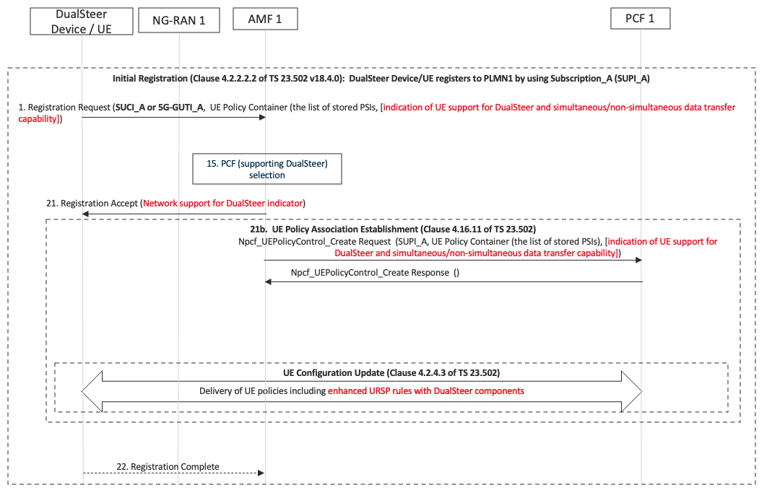
Figure 6.1.X.2.2-1: Registration in PLMN1 with SUPI_A.
PLMN1 is HPLMN for SUPI_A.
1. The DualSteer Device/UE indicates to the AMF its capabilities to support for DualSteer and simultaneous/non-simultaneous data transfer in Registration Request message.
15. The AMF selects a PCF supporting DualSteer.
21. The AMF indicates to the Device/UE in Registration Accept message whether the network supports DualSteer. This indication means that the Device/UE may initiate PDU Session Establishment procedure for DualSteer.
21b. The AMF initiates UE Policy association establishment procedure. The AMF passes on the capability indication for support of DualSteer and simultaneous/non-simultaneous data transfer of DualSteer Device/UE to the PCF. The PCF makes use of the DualSteer capability information to derive the URSP rules with the DualSteer related components and deliver it to the DualSteer Device/UE, if the Device/UE does not have the up-to-date URSP rules.

Figure 6.1.X.2.2-2 depicts the registration signalling flow of SUPI_B to PLMN2, where PLMN2 is VPLMN and PLMN1 is HPLMN.
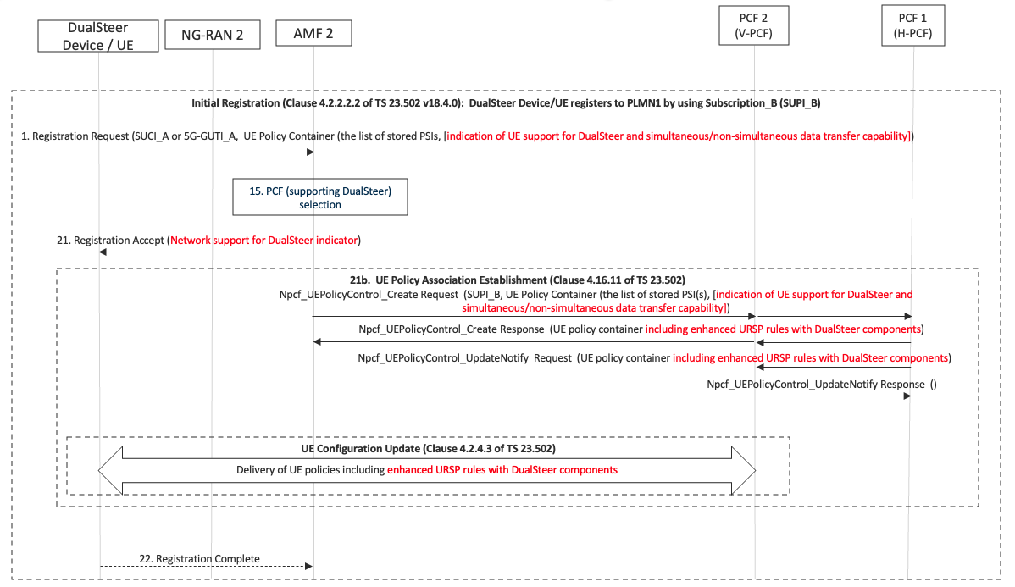
Figure 6.1.X.2.2-2: Registration in PLMN2 with SUPI_B.
PLMN2 is VPLMN and PLMN1 is HPLMN for SUPI_B.
The signalling flow in Figure 6.1.X.2.2-2 is similar to Figure 6.1.X.2.2-1 except AMF2 (V-AMF) communication with PCF1 (H-PCF) takes place via PCF2 (V-PCF).

6.1.X.2.3 PDU Session Establishment procedure
Figure 6.1.X.2.3-1 depicts the PDU Session Establishment signalling flow of SUPI_A to PLMN1, where PLMN1 is HPLMN for SUPI_A. Based on the URSP rules of SUPI_A, the Linked SUPI is SUPI_B.
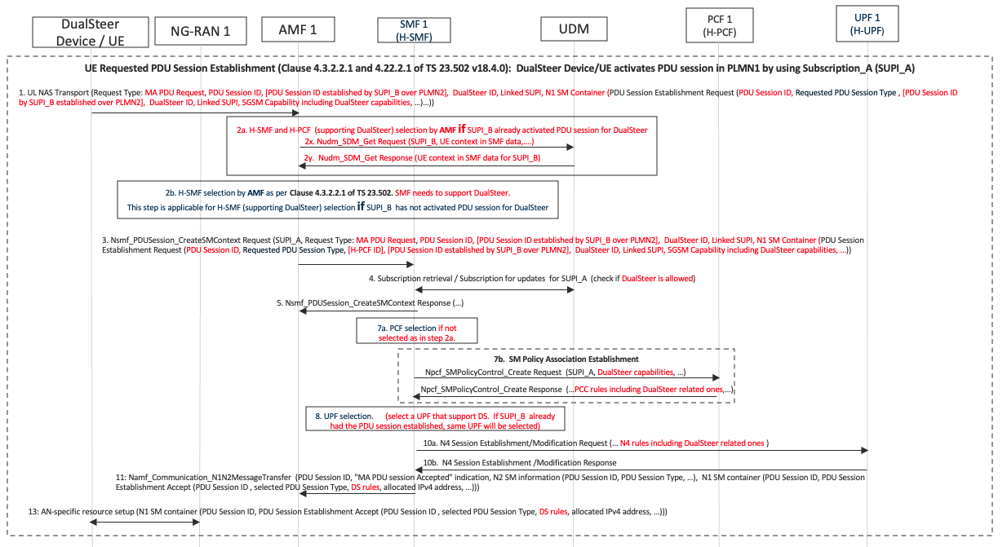
Figure 6.1.X.2.3-1: PDU Session Establishment in PLMN1 with SUPI_A.
PLMN1 is HPLMN for SUPI_A. Linked SUPI = SUPI_B
1. Based on finding a matching URSP rule, the DualSteer Device/UE initiates an PDU session establishment using SUPI_A. In the PDU Session Establishment Request and the UL NAS Transport message carrying the PDU Session Establishment Request, the Device/UE includes the PDU Session ID (for SUPI_A), DualSteer ID, Linked SUPI (which is SUPI_B), and the PDU Session ID of the Linked SUPI (if SUPI_B already established the PDU session in PLMN2). The DualSteer ID and Linked SUPI are derived from the URSP rules of SUPI_A.
PDU Session Establishment Request message includes 5GSM Capability IE. 5GSM Capabilities IE include the DualSteer capabilities including supported steering functions (MPTCP, MPQUIC, DS-LL), supported steering modes (e.g., Active-Standby, etc.), and support for simultaneous or non-simultaneous data transfer.
The PDU Session IDs assigned by the Device/UE for each SUPI are not required to be the same, but same PDU Session ID can also be used.
2a. If SUPI_B (which is the Linked SUPI) has a PDU session already established and the corresponding PDU Session ID is included in the PDU Session ID of the Linked SUPI in UL NAS Transport message, the AMF queries the UDM of the Linked SUPI to receive the UE context in SMF Data of the Linked SUPI. The AMF matches the received UE context information with the PDU Session ID of the Linked SUPI to identify the H-SMF ID and the PCF ID to be used for the PDU Session.
2b. If the PDU Session ID of the Linked SUPI is not included in the UL NAS Transport message, the AMF selects an SMF (H-SMF) supporting DualSteer.
3. The AMF sends to the selected SMF (H-SMF) the Nsmf_PDUSession_CreateSMContext Request message with PDU Session ID, DualSteer ID, Linked SUPI, the PDU Session ID of the Linked SUPI (if received from the Device/UE) and PDU Session Establishment Request.
If the PCF ID (i.e., H-PCF ID) used by the Linked SUPI’s PDU session is identified by the AMF in step 2a, it is also included.
4. The H-SMF retrieves the SM subscription data of SUPI_A in the UDM to check whether DualSteer is allowed for SUPI_A.
7a. The H-SMF selects a PCF supporting DualSteer if the PCF ID was not identified by the AMF in step 2a and not included in the message sent to the SMF in step 3.
7b. The H-SMF performs the SM Policy association establishment with the H-PCF by including DualSteer capabilities of SUPI_A. In the response message from the H-PCF, the PCC rules including the DualSteer related ones are provided.
Editor's note: Further description on how to handle a single SM policy association related to two SUPIs, is FFS.
8. The H-SMF selects a UPF. If the PDU session for SUPI_B is already established, the H-SMF selects the same UPF.
10a. The H-SMF establishes the N4 Session with the UPF. It includes the N4 rules with the DualSteer related ones.
11. The H-SMF sends to the AMF Namf_Communication_N1N2MessageTransfer message including the PDU Session Establishment Accept message which includes the DS (DualSteer) rules.
13. The RAN sends the PDU Session Establishment Accept message which includes the DS (DualSteer) rules.

Figure 6.1.X.2.3-2 depicts the PDU Session Establishment signalling flow of SUPI_B to PLMN2, where PLMN2 is VPLMN for SUPI_B. Based on the URSP rules of SUPI_B, the Linked SUPI is SUPI_A.
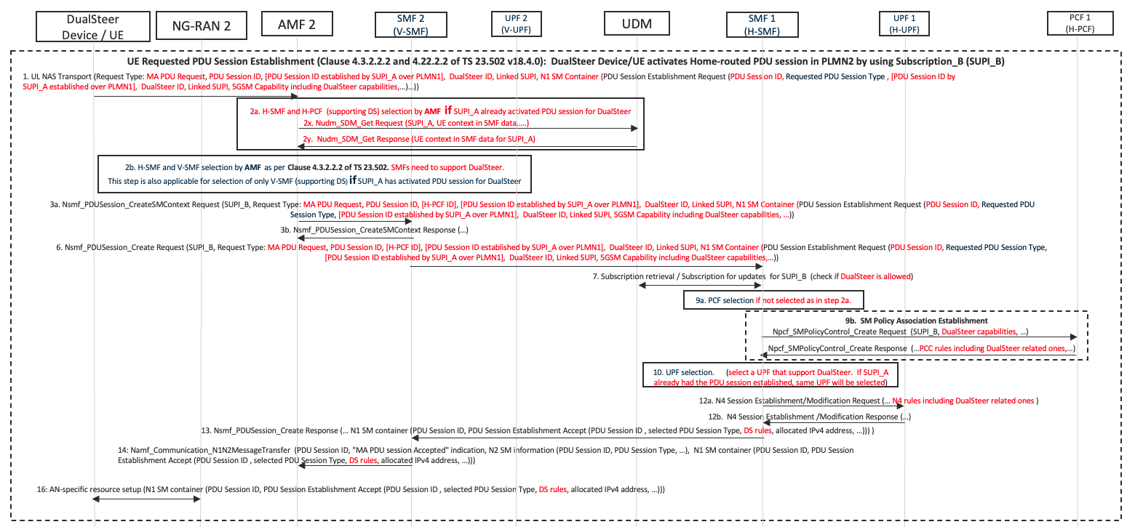
Figure 6.1.X.2.3-2: PDU Session Establishment in PLMN2 with SUPI_B.
PLMN2 is VPLMN and PLMN1 is HPLMN for SUPI_B. Linked SUPI = SUPI_A
The signalling flow in Figure 6.1.X.2.3-2 is similar to Figure 6.1.X.3.2-1 except AMF2 (V-AMF) communication with SMF1 (H-SMF) takes place via SMF2 (V-SMF)
1. Based on finding a matching URSP rule, the DualSteer Device/UE initiates an PDU session establishment using SUPI_B. In the PDU Session Establishment Request and the UL NAS Transport message carrying the PDU Session Establishment Request, the Device/UE includes the PDU Session ID (for SUPI_B), DualSteer ID, Linked SUPI (which is SUPI_A), and the PDU Session ID of the Linked SUPI (if SUPI_A already established the PDU session in PLMN1). The DualSteer ID and Linked SUPI are derived from the URSP rules of SUPI_B.
PDU Session Establishment Request message includes 5GSM Capability IE. 5GSM Capabilities IE include the DualSteer capabilities including supported steering functions (MPTCP, MPQUIC, DS-LL), supported steering modes (e.g., Active-Standby, etc.), and support for simultaneous or non-simultaneous data transfer.
The PDU Session IDs assigned by the Device/UE for each SUPI are not required to be the same, but same PDU Session ID can also be used.
2a. If SUPI_A (which is the Linked SUPI) has a PDU session already established and the corresponding PDU Session ID is included in the PDU Session ID of the Linked SUPI in UL NAS Transport message, the AMF queries the UDM of the Linked SUPI to receive the UE context in SMF Data of the Linked SUPI. The AMF matches the received UE context information with the PDU Session ID of the Linked SUPI to identify the H-SMF ID and the PCF ID to be used for the PDU Session.
2b. If the PDU Session ID of the Linked SUPI is not included in the UL NAS Transport message, the AMF selects an H-SMF and a V-SMF supporting DualSteer.
If the PDU Session ID of the Linked SUPI is included in the UL NAS Transport message, the AMF selects an only V-SMF supporting DualSteer.
3a. The AMF sends to the selected V-SMF (H-SMF) the Nsmf_PDUSession_CreateSMContext Request message with PDU Session ID, DualSteer ID, Linked SUPI, the PDU Session ID of the Linked SUPI (if received from the Device/UE) and PDU Session Establishment Request.
If the PCF ID (i.e., H-PCF ID) used by the Linked SUPI’s PDU session is identified by the AMF in step 2a, it is also included.
6. The V-SMF sends to the H-SMF the Nsmf_PDUSession_Create Request message with PDU Session ID, DualSteer ID, Linked SUPI, the PDU Session ID of the Linked SUPI (if received from the Device/UE) and PDU Session Establishment Request.
7. The H-SMF retrieves the SM subscription data of SUPI_B in the UDM to check whether DualSteer is allowed for SUPI_B.
9a. The H-SMF selects a PCF supporting DualSteer, if the PCF ID was not identified by the AMF in step 2a and not included in the message sent to the SMF in step 3a and 6.
9b. The H-SMF performs the SM Policy association establishment with the H-PCF by including DualSteer Capabilities of SUPI_B. In the response message from the H-PCF, the PCC rules including the DualSteer related ones are provided.
Editor's note: Further description on how to handle a single SM policy association related to two SUPIs, is FFS.
10. The H-SMF selects a UPF. If the PDU session for SUPI_A already established, the H-SMF selects the same UPF.
12a. The H-SMF establishes the N4 Session with the UPF. It includes the N4 rules with the DualSteer related ones.
13. The H-SMF sends to the V-SMF the Nsmf_PDUSession_Create Response message including the PDU Session Establishment Accept message which includes the DS (DualSteer) rules. Same UE IP address, which was allocated for the PDU Session for SUPI_A, is allocated,
14. The V-SMF sends to the AMF the Namf_Communication_N1N2MessageTransfer message including the PDU Session Establishment Accept message which includes the DS (DualSteer) rules.
16. The RAN sends the PDU Session Establishment Accept message which includes the DS (DualSteer) rules

6.1.X.3 Impacts on services, entities and interfaces
UE
- handle URSP rules with DS components
- indicates to the AMF its capabilities to support for DualSteer and simultaneous/non-simultaneous data transfer in Registration Request message.
- support sending additional IEs in the PDU Session Establishment Request such as PDU Session ID established by SUPI, DualSteer ID, Linked SUPI, & DualSteer capabilities.
AMF
- indicates to the Device/UE in Registration Accept message whether the network supports DualSteer. This indication means that the Device/UE may initiate PDU Session Establishment procedure for DualSteer.
- passes on the capability indication to support for DualSteer and simultaneous/non-simultaneous data transfer of DualSteer Device/UE to the PCF
- support additional IEs in the PDU Session Establishment Request such as PDU Session ID established by SUPI, DualSteer ID, Linked SUPI, & DualSteer capabilities
- support Nudm_SDM_Get messaging for retrieving UE context in SMF data of a SUPI (already activated PDU session) for selecting same H-SMF & H-PCF for the second SUPI.
- selecting SMFs supporting DualSteer.
- adding the selected PCF ID in Nsmf_PDUSession_CreateSMContext and Nsmf_PDUSession_Create messages

PCF
- enhanced URSP rules with DualSteer specific components
- V-PCF to send the DualSteer capability information to the H-PCF
- makes use of the DualSteer capability information to derive the URSP rules with the DualSteer related component
- handle SM policy association related to two SUPIs, support of SM Policy Association Establishment (i.e., Npcf_SMPolicyControl_Create Request/Response messaging) receiving with DualSteer capabilities and replying with PCC rules including DualSteer related ones.
SMF
- support additional IEs in Nsmf_PDUSession_CreateSMContext and Nsmf_PDUSession_Create messages such as PDU Session ID established by SUPI, DualSteer ID, Linked SUPI, & DualSteer capabilities
- selecting UPF that supports DualSteer
- handle N4 rules specific to DualSteer including support for providing two SUPIs to UPF
UDM
- SM Subscription update for DualSteer
UPF
- handle N4 rules specific to DualSteer including support for handling two SUPIs received from the SMF for the NN4 session.

* * * * End of Changes * * * *

