3GPP TSG-SA WG2#161 S2-2405228
April 15th – 19th, 2024, Changsha, China (was S2-2404153, S2-2402912)

Source: Apple
Title: Registration and Mobility Management for DualSteer
Document for: Discussion/Approval
Agenda Item: 19.13
Work Item / Release: FS_MASSS / Rel-19
Abstract of the contribution: this contribution proposes a solution for registration and mobility management aspects for DualSteer.

1. Introduction
This contribution proposes a solution for Registration and Mobility Management aspects for DualSteer.

2. Text proposal
It is proposed to agree the following changes vs. TR 23.700-54 v0.2.0:

>>>>BEGINNING OF CHANGES <<<<

6.0 Mapping of Solutions to Key Issues
Table 6.0-1: Mapping of DualSteer Solutions to Key Issues
 | Key Issues for DualSteer
Solution# | <Key Issue #1.1> | <Key Issue #1.2>
X | X | X

>>>>NEXT CHANGE<<<<

6.1.X Solution #X: DualSteer Registration and Mobility Management

6.1.X.1 Description
This is a solution for Registration and Mobility Management aspects for a DualSteer device to support traffic steering and switching when the DualSteer device can perform either non-simultaneous or simultaneous data transmission over the two networks.
DualSteer device supports traffic steering and switching of user data (for different services) across two 3GPP access networks. DualSteer device has two subscriptions/SUPIs, sharing one subscription profile from the same operator and correspondingly it has two PEIs/IMEIs. The two subscriptions/SUPIs of the DualSteer device are registered to two 3GPP access networks and thereafter the DualSteer device performs steering or switching of services across those two access networks.
DualSteer device can perform either non-simultaneous or simultaneous data transmission over the two networks. There is no difference from the UE or network perspective in how the DualSteer Device registers with the network whether it can simultaneously transmit data over two networks or not.
Since the DualSteer device registers over two 3GPP access networks and can have data transfer ongoing over these two access networks at same time, the DualSteer device can be paged on either of these two accesses.
On the network side a DualSteer device appears as two distinct UEs irrespective of whether it can transmit simultaneously over two networks or not. DualSteer device registers with 3GPP access network separately for each of the two accesses it supports. The network needs to identify the two SUPIs/UEs associated with a DualSteer device during registration and also identify that the DualSteer device is registering on which access network. The network needs to identify that the second registration is for the same DualSteer device and hence the UE context created during first registration needs to be maintained.

6.1.X.2 Procedures

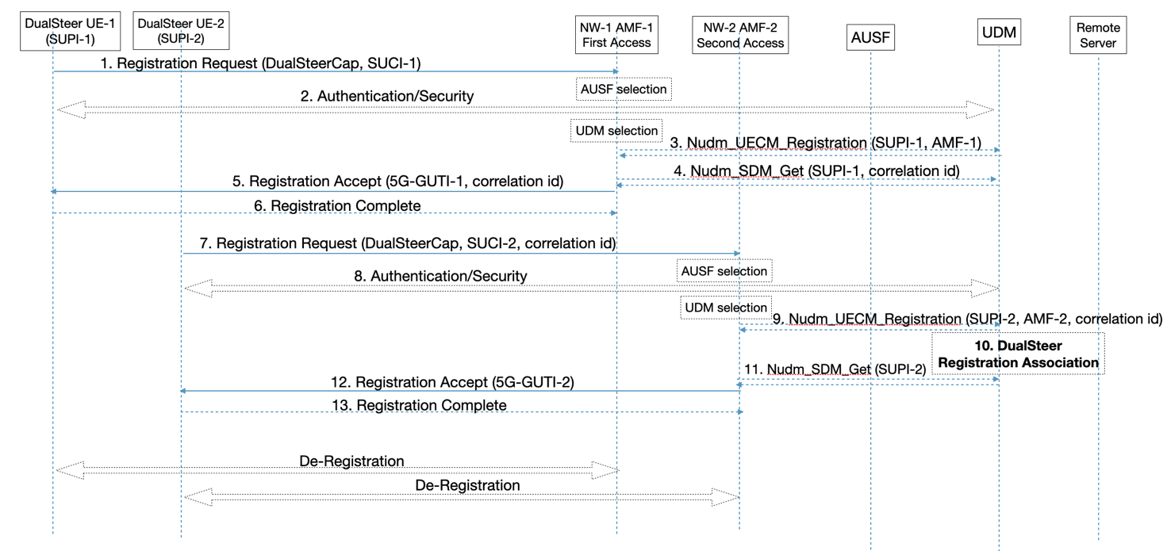
Figure 6.1.X.2-1: Registration, Paging and De-registration for a DualSteer Device

6.1.X.2.1 DualSteer Registration
The DualSteer registration performs the following steps:
1. The DualSteer device registers with UE-1 on first 3GPP access it supports by sending Registration Request message using SUCI-1 with NW-1 and AMF-1. The UE-1 indicates its capability to support DualSteer functionality as part of the 5GS registration procedure.
2. Authentication and Security procedures for UE-1 with SUPI-1 to activate integrity protection and NAS security.
3-4. The AMF-1 registers with the UDM using Nudm_UECM_Registration for the first access. If the device has appropriate subscription and credentials, the UDM allocates a correlation id for the SUPI-1 and returns it to AMF-1 with the subscription data in the Nudm_SDM_Get response. The AMF-1 verifies that the device supports DualSteer subscription. If the device has appropriate subscription and credentials, the AMF-1 creates the context for UE-1 corresponding to first 3GPP access.
5-6. The AMF-1 sends a Registration Accept message, including the 5G-GUTI-1 corresponding to this registration and the correlation id, notifying the UE-1 that network supports DualSteer and that device has DualSteer subscription. If the device does not have DualSteer subscription, the network may register the UE-1 for single access only and indicate so appropriately.
7. After registering for the first access network the DualSteer device registers with UE-2 on second 3GPP access it supports using SUCI-2 with NW-2 and AMF-2 by sending the Registration Request message. The UE-2 may register with same AMF-1 (when using first 3GPP access) or a different AMF-2 depending on deployment configuration and whether the second access network belongs to the same or different PLMN. The UE-2 indicates its capability to support DualSteer functionality as part of the registration procedure. The UE-2 also includes the correlation id from registration to NW-1 in this registration request, so as to allow the UDM to tie the two DualSteer registrations together.
8. Authentication and Security procedures for UE-2 with SUPI-2 to activate integrity protection and NAS security.
9-11. The AMF-2 registers with the UDM using Nudm_UECM_Registration for the second access using SUPI-2 and AMF-2. The AMF-2 also includes the correlation id. The UDM retrieves the UE-2 subscription and associates the two DualSteer registrations and activates DualSteer registration for the DualSteer device. The AMF-2 retrieves the subscription data from the UDM using Nudm_SDM_Get and verifies that the device supports DualSteer subscription. If the device has appropriate subscription and credentials, the AMF-2 creates the context for this UE-2 in the network corresponding to second 3GPP access.
12-13. The AMF-2 sends a Registration Accept message, including the 5G-GUTI-2 corresponding to this registration, notifying the UE-2 that network supports DualSteer and that device has DualSteer subscription and that DualSteer registration has been activated. If the device does not have DualSteer subscription, the network may register the UE-2 for single access only and indicate so appropriately.

6.1.X.2.2 DualSteer Registration Update
The DualSteer device may receive MT data over any of the access network. If the DualSteer device loses coverage and is only accessible over NW-2, then the UE-2 can send a Service Request message or a Mobility and Registration Update (MRU) message to update DualSteer device registration over the second access network and indicate that the DualSteer Device is now reachable only over second access network.

6.1.X.2.3 DualSteer De-Registration
The deregistration for UE-1 or UE-2 can be initiated either by the respective UE or the network. The UE or network may de-register either of the access in any order. If one of the access network is de-registered, the UE ceases to operate as a DualSteer UE and the registration for the remaining access that is registered operates similar to that for UE with single access registration.

6.1.X.2.4 DualSteer Subscription
The DualSteer device has two subscriptions/SUPIs, sharing one subscription profile from same operator. The two SUPIs/UEs can register to two 3GPP access networks belonging to the same PLMN, or between two different PLMNs, or between one PLMN and one PLMN-integrated NPN, over same or different RAT, which can use terrestrial and/or satellite access. The subscription for a DualSteer device is enhanced to include two SUPIs along with status information that indicates whether DualSteer registration has been activated or not.

6.1.X.3 Impacts on services, entities and interfaces
UE
- Register to two 3GPP access networks separately, one after the other. Indication of capability to support DualSteer functionality in the Registration procedure. Include the correlation id from registration to first access network, in the registration for second access network.
AMF
- Recognize based on UE capability that this is a DualSteer device and treat the DualSteer device as two separate UEs. Create and update the UE context for each subscription/SUPI separately during registration.

UDM
- Support for two subscriptions/SUPIs, sharing one subscription profile from same operator. Allocate a correlation id, associate the two separate registrations from a DualSteer device and maintain the overall DualSteer registration status.
- During AMF relocation, notify the corresponding AMF to update the UE context for its corresponding subscription/SUPI, even though both the SUPIs belong to the same DualSteer device.
Editor’s Note: Further impacts to UE, AMF, and other entities such as PCF, SMF etc. may be added when describing session management and policy aspects.

>>>>END OF CHANGES<<<<

