SA WG2 Meeting #162 S2-2404398
Changsha, China, 15th Apr 2024 - 19th Apr 2024
Source: Xiaomi, Huawei
Title: new solution for KI#1 support monitoring the performance of AI model
Document for: Approval
Agenda Item: 19.15
Work Item / Release: FS_AIML_CN/ Rel-19
Abstract of the contribution: This paper proposes a new solution for key issue#1 to support for monitoring the performance of the AI model by reusing the PRU (Positioning Reference Unit) in LCS service.

1 Discussion
This solution is trying to resolve the following key issue.

5.2.1 Key Issue #1: Enhancements to LCS to support Direct AI/ML based Positioning
This key issue aims to provide solutions for whether and how to consider enhancements to support AI/ML based Positioning for Cases 2b, 3b as defined in TR 38.843 [6], which will investigate the following aspects:
- Study whether and how an AI/ML model for Direct AI/ML positioning (i.e. case 2b/3b) is handled:
- Which entity trains the model for Direct AI/ML positioning and if the entity that train the model and the consumer are different, how the Model consumer gets the trained AI/ML model;
- How the Model consumer uses the trained model to perform inference and/or derive UE position;
- Define procedures for data collection with objective to train AI/ML models for Direct AI/ML positioning.
- Whether and how to support Direct AI/ML positioning with additional 5GC enhancements.
- How to monitor model performance for ML models used for Direct AI/ML based positioning.
NOTE 1: UE data collection, model delivery and transfer to the UE and model identification/management are not within the scope of this key issue.
NOTE 2: What data to be collected for the model training/model inference/model performance monitoring for LMF-sided model needs to be coordinated with RAN WGs.
NOTE 3: Any potential impacts for case1/2a/3a in TR 38.843 [6], are out of the scope and any potential alignment work will be based on the possible requirements defined by RAN WGs considering the conclusions in TR 38.843 [6].

2 Proposal
It is proposed to include the following changes in TR 23.700-84 V0.2.0.
* * * * Start of Changes * * * *

6.X Solution #X: new solution for KI#1 support monitoring the performance of AI model

6.X.1 Key Issue mapping
Solutions
 | <Key Issue #1> | <Key Issue #2> | <Key Issue #3> | <Key Issue #4>
Solution x | X

6.X.2 Description
This solution resolves the how to monitor and evaluate the performance of an AI/ML models in Key Issue #1 Enhancements to LCS to support Direct AI/ML based Positioning. PRU (Positioning Reference Unit) defined for LCS service is reused to support LMF to monitor and evaluate the performance of an AI/ML model.
In this solution the architecture assumption as shown in Figure 6.X.2-1 is to reuse the NWDAF architecture for AIML model training entity that also collects data for the training. LMF (may be co-located with NWDAF) is the entity to perform AIML model inference and to monitor the performance of the AIML model. There are following assumptions:
- NWDAF is the entity for training the AI/ML Model for Direct AI/ML positioning.
- NWDAF is the entity for data collecting with objective to train the AI/ML Model for Direct AI/ML positioning.
- PRU known location and associated PRU location measurement(s) from LMF are used for AI/ML model training.
- LMF is the entity for AI/ML Model inference to compute the final UE location.
- LMF is the entity to monitor and evaluate the performance of an AI/ML model
NOTE: Whether the LMF is a standalone NF or co-located with NWDAF can be determined during conclusion phase.
In this solution, it is also assumed that the monitoring and evaluating the performance of an AL/ML mode is executed in purpose on dedicated UEs (e.g., PRU), not for all the UEs. For example, operator can monitor the performance of an AM/ML model by comparing two or more sets of locations of one specific UE (e.g., PRU) to determine whether performance of the AI/ML model is good or not. The location of the specific UE can be obtained via AI/ML model, GPS, or other positioning methods provided by network.
If the performance of an AM/ML is lower than one preconfigured condition, LMF may stop or change the AI/ML model, or request NWDAF to train or update the AL/ML mode, or to use other positioning methods based on the operator policy.
Figure 6.X.2-1 architecture assumption for supporting Direct AI/ML based Positioning

6.X.3 Procedures

6.X.3.1 Performance of AI/ML model monitoring based on PRU

Figure 6.X.3.1-1 performance of AI/ML model monitoring based on PRU
1, AMF receives LCS service request from UE (i.e., MO-LR), or from LCS Client (i.e., MT-LR), or AMF itself.
2-3 AMF selects a LMF that supporting AI based positioning and sends Location request to LMF that determines to select AI/ML model based positioning method to compute the final UE location. The LMF may subscribe/request AI/ML model from NWDAF, and the procedure of the NWDAF collecting data and training the AI/ML model is detailed in clause 6.X.3.2.
4a, PRU/UE, or/and gNB reports the measurements data to LMF for computing the final UE location.
4b, PRU/UE also reports the known location information to LMF. The PRU/UE can obtain its known location information by e.g., GPS, or other positioning way.
5a, LMF performs AI model inference to compute the final UE location based on the collected measurement data from PRU/UE, or/and gNB.
5b, LMF monitors and evaluates the performance of the AI model by comparing the calculated PRU/UE’s location and the known location of PRU/UE, to determine whether the performance of AI/ML model is still good, or needs to drop the AI/ML model to change the positioning method to compute the final UE location.
Optionally, LMF may trigger to request the AI/ML training entity to train/update the AI model.
6, LMF sends the final UE location to AMF
7, AMF sends the UE location to LCS consumers, e.g., UE, LCS client, etc.

6.X.3.2 Procedure of PRU information collection for AI/ML model training
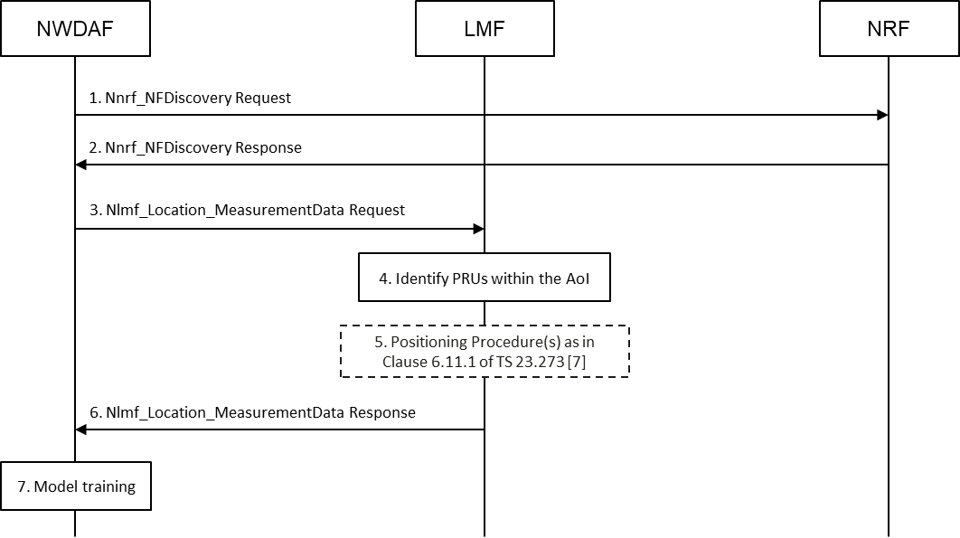
Figure 6.X.3.2-1: Procedure of PRU information collection for AI/ML model training
1. NWDAF invoke an Nnrf_NFDiscovery Request service operation to an NRF. The service operation includes a PRU existence indication and an AoI.
2. The NRF selects one or more PRU serving LMFs based on the PRU existence indication and the AoI received in step 1 and sends an Nnrf_NFDiscovery Response to the NWDAF. The service operation includes the profiles of the PRU serving LMFs selected by the NRF.
3. The NWDAF sends a measurement data request to each PRU serving LMF, that includes the AoI and a PRU indication, which indicates to obtain the PRU information.
4. The PRU serving LMF identifies PRUs within the AoI based on the AoI and a PRU indication received in step 3.
5. The PRU serving LMF uses the procedures defined in clause 6.11.1 of TS 23.273 [7] to obtain the location measurements of the PRUs.
NOTE: It is up to RAN WGs to determine what location measurement(s) is needed and how to obtain the location measurement(s) from UE/RAN by the LMF.
6. The PRU serving LMF sends a measurement data response to the NWDAF, that includes the PRU known location and associated PRU location measurement(s).
7. The NWDAF performs model training based on the PRU known location and associated PRU location measurement(s).

6.X.4 Impacts on services, entities and interfaces
Editor's note: It is FFS to capture impacts on existing 3GPP nodes and functional elements.
NWDAF:
- Support to discover the PRU serving LMFs, and request the PRU known location and associated PRU location measurement(s) directly from the PRU serving LMFs.
LMF:
- Support for AI/ML Model inference to compute the final UE location
- Support for monitoring and evaluating the performance of the AI/ML model
- Support to identify PRUs within an AoI based on the request from NWDAF.
- Support to send the PRU known location and associated PRU location measurement(s) to the NWDAF.
AMF:
- Enhance to select the LMF that supporting AI based positioning, based on the request or location policy, etc.
UDM:
- Support Direct AI/ML based Positioning service in UE subscription data.

* * * * End of Changes * * * *

