3GPP TSG-WG SA2 Meeting #162 S2-2404906
April 15 - 19, 2024, Changsha, China (Revision of S2-24xxx)
Source: Samsung
Title: KI#1: New solution for mobility support between CAG and CSG cells
Document for: Approval
Agenda Item: 19.12
Work Item / Release: FS_5G_Femto /Rel-19
Abstract of the contribution: This contribution proposes a new solution for KI#1.

Discussion
In clause 5.1 of TR 23.700-45, the Key Issue #1 for support of UE mobility between CAG cell of 5G Femto and CSG cell is agreed as one of key issues for Rel-19 FS_5G_Femto study:
This key issue investigates any needed enhancements to support the UE moving between CAG cell of 5G Femto and CSG cell.
The KI should cover:
- The mobility scenarios to be studied for the UE move (e.g. CSG cell to CAG cell of 5G Femto).
- Whether and how control signalling procedures are enhanced to support the mobility scenarios.
NOTE 1: This Key Issue assumes that the existing CAG concept defined for PNI-NPN is re-used for access control when a UE wants to access a 5G Femto cell without impacts to PNI-NPN.
NOTE 2: This Key Issue expects that solutions avoid impacts on EPC (e.g., MME), E-UTRAN and NG-RAN.
Editor's note: It is FFS if idle mode mobility scenario needs to be considered.

This contribution proposes a new solution for the KI #1.

Proposal
It is proposed to adopt the following changes into TR 23.700-45.

*** Start of the change ***

6.0 Mapping of Solutions to Key Issues
Table 6.0-1: Mapping of Solutions to Key Issues and Use Cases

 | Key Issues
Solutions | <Key Issue #1> | <Key Issue #2>
#1
#X | x

*** Next change (all new text) ***

6.X Solution #X: Solution for mobility between CAG and CSG cells

6.X.1 Description
The solution aims to address the issues described in KI#1 to support mobility between a CAG cell of 5G Femto and a CSG cell of HeNB/EPC.
The solutions assumes the followings:
- The existing CAG concept defined for PNI-NPN is re-used for access control when a UE wants to access a 5G Femto cell without impacts to PNI-NPN.
- Impacts on EPC, E-UTRAN and NG-RAN should be avoided.
- UE subscription information includes allowed CAG and CSG list for the UE
- UE includes the CAG ID broadcast by a target CAG cell of a 5G Femto gNB, in the measurement report to the source HeNB to avoid impact on the UE
A UE is provisioned with the allowed CAG and CSG list for access to CAG cells of a 5G Femto gNB and CSG cells of a 4G HeNB, respectively. If the UE finds a CAG cell of a 5G Femto while communicating through a CSG cell attached to the EPC, it may sends a CAG ID for the corresponding CAG cell of the 5G Femto to the source HeNB. The CAG ID is forwarded to the AMF via MME transparently, to check allowed CAG list by the AMF based on the UE subscription data from the UDM.

6.X.2 Procedures
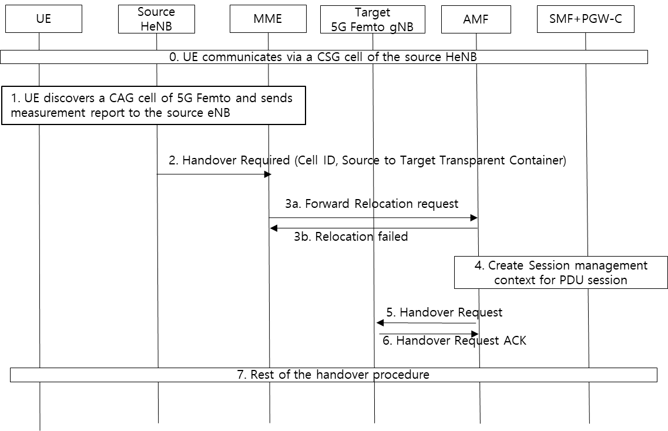
Figure 6.x.2-1 Procedures for UE mobility from CSG cell to CAG cell

0. It is assumed that UE has been provisioned with the allowed CAG and CSG list for access to CAG cells of 4G HeNBs and CSG cells of 5G Femto gNBs. The UE is currently attached to a CSG cell and EPC and set up a PDN connection(s).
- The UE discovers an available CAG cell of 5G Femto and reports to the source HeNB. Based on the control of the source HeNB, the UE may sends the measurement report to the source HeNB which may include a CAG ID corresponding to a CAG cell of a 5G Femto.
- The source eNB may send Handover Required message to the MME. The message includes the CAG ID of the CAG cell of the 5G Femto in the Source to Target Transparent Container IE.
- The MME forwards the handover request to the AMF.
- The AMF selects the SMF+PGW-C and requests to create Session Management context for UE’s PDU session(s).
- The AMF forwards the handover request to the target 5G Femto gNB.
- The gNB sends acknowledges message to the AMF that includes the CAG ID received from the source HeNB. The AMF checks if the CAG ID can be acceptable for the UE based on the UE subscription data, operator policies, etc. Otherwise, the AMF rejects the handover request from the MME and requests the removal of UE context from SMF and gNB.
- If the CAG can be allowed for the UE, the rest of the interworking handover procedures will proceed.
The same procedure may be applied for the case that the UE moves from 5GS to the EPS, i.e., from CAG cells to CSG cells.

6.X.3 Impacts on services, entities and interfaces
UE:
- No impact
AMF:
- Check CAG list that recieves in the Forward Relocation Request message
HeNB:
- Forwards the CAG ID of a 5G Femto cell in the source to target transparent container

*** End of the change ***

