SA WG2 Meeting #171 S2-2508711r01
13 – 17 Oct, 2025, Wuhan , CN (Revision of S2-2508129)
Source: Samsung (Penholder), AT&T, OPPO
Title: [WT#2] 6G Migration Paths
Document for: Approval
Agenda Item: 20.6.2
Work Item / Release: FS_6G_ARC/Rel-20
Abstract of the contribution: This contribution lists all possible 6G migration paths and considers feasible paths.

1. Justifications
Editor's Note: This justification section is not included in the TR; it is intended solely to justify the scope of the proposed WT.
The existing description of WT#2 as in the agreed SID titled as “Study on Architecture for 6G System” [SP-250806] is described as follows:

WT#2: Study migration and interworking, including
- How to support migration to 6GS
- How to support interworking with 5GS
- Whether and how to support interworking with EPS
- How to support interworking between 6GS and 4G/5G NTN/satellite access that use EPS/5GS.

NOTE 2: Interworking with 2G/3G are not considered in this study. Interworking between 6GS and 5GS is assumed to work even if the UE has previously registered in 2G, 3G or 4G.
NOTE 3: The detailed migration study scope will be coordinated and aligned with RAN.

Observation 1: The 1st bullet, Migration Path / Deployment Scenarios is the most important and the other bullets are dependent on the 1st bullet.
Proposal 1: Hence, Migration Paths / Deployment Scenarios should be discussed first for WT#2.

Observation 2: 5G Rel-15 introduced too many network architecture options. 5 options (2, 3, 4, 5, 7) are standardized, but only 2 options (2, 3) are deployed. SA deployments are delayed due to the existing NSA operation.
Proposal 2: In 6G, it is proposed to consider Standalone architecture only from day one.

Migration/Architecture Options for 6G include MRSS (5G+6G spectrum sharing) and 6G-6G carrier aggregation, as described in the following figure.

Observation 3: Whether MRSS is applied or not, the interfaces in CN sides or the interfaces in UE sides are the same, as shown in the following figures: (a) MRSS is applied, (b) MRSS is not applied.

Proposal 3: In SA2 discussion, we should not discriminate Migration Paths / Deployment Scenarios whether MRSS is applied or not.

During Pre-SA2#171 CC, it is proposed to proceed with the following terminology.
- 6G CN: in this study, it refers to the core network for the 6G system.
NOTE: Whether 6G CN can be considered as evolution of 5GC or as a new Core Network will be determined during the study.

Observation 4: 6G CN may or may not include 5GC.

Proposal 4: It is proposed to discuss Migration Paths / Deployment Scenarios considering both options.

Observation 5: The candidate migration paths are like the following (Current Deployment: 5G SA and/or NSA, Intermediate Deployment: 5G SA and/or NSA and 6G SA, Final Deployment: 6G SA). Considering bullet 3 in WT#2, whether and how to support interworking with EPS, Path 2 and Path 4 need more discussions.

Proposal 5: It is proposed to add Path 1 and others to the Annex of the TR 23.801-01 as candidate migration paths.

2. Merging status
The following contributions are considered to the WT#2: Migration and Interworking for SA2#171 meeting.

- | Study on Architecture for 6G System (FS_6G_ARC) - WT#2 | - | Docs:=2
S2-2508711 | 23.801-01: Migration Paths | Samsung, AT&T, OPPO | Discussion of Migration Paths with the following NOTE  - NOTE: Whether 6G CN can be considered as evolution of 5GC or as a new Core Network will be determined during WT#1 study.  The summary is like the following:  - Represent 6G CN as a gradually-shaded box that may share the whole or part of 5GC.  - Path 1: 5G SA to 6G SA via 5G SA and 6G SA interworking.  - Path 2: 5G NSA to 6G SA via 5G NSA and 6G SA interworking.  - Path 3: 5G NSA to 6G SA via 5G SA and 6G SA interworking.  - Path 4: 5G NSA and 5G SA into 6G SA to 6G SA via 5G SA, NSA and 6G SA interworking.
S2-2508796 | 23.801-01: [WT#2] 6G Migration Paths | [Samsung, AT&T] NTT DOCOMO | Discussion of Migration Paths with the following Assumption.  - The 6G CN consists of (possibly re-designed or enhanced) 5GC NFs and 6G-level NFs necessary e.g. for AI, sensing, data framework, computing, etc, as discussed in the other WTs in this study.  The summary is like the following:  - Represent 6G CN as a solid-lined box that includes the whole of 5GC.  - Path 1: 5G SA to 6G SA via 5G SA and 6G SA interworking.  - Path 2: 5G NSA to 6G SA via 5G NSA and 6G SA interworking.  - Remove Path 3.  - Path 4-1: 5G NSA and 5G SA to 6G SA via 5G NSA and 6G SA interworking, and then via 5G SA and 6G SA interworking.

This contribution gives proposals for 6G Migration Paths based on S2-2508129.

**** First Change ****

3.3 Abbreviations
For the purposes of the present document, the abbreviations given in TR 21.905 [1] and the following apply. An abbreviation defined in the present document takes precedence over the definition of the same abbreviation, if any, in TR 21.905 [1].

MRSS Multi-RAT Spectrum Sharing

**** Second Change (all new) ****

Annex A.X Work Task #2 6G Migration Paths

This clause describes potential migration paths to 6G standalone system.
Editor’s note: This clause may be undated for further coordination with RAN WGs.
NOTE: Whether 6G CN can be considered as evolution of 5GC or as a new Core Network will be determined during WT#1 study. (S2-2508711)
RAN study on 6G Scenarios and Requirement in TR 38.914 [x] has agreed that the 6G RAN shall support Multi-RAT Spectrum Sharing (MRSS) between 6GR and NR. This is illustrated in the following figure:

Figure A.X-1: 6G final deployment with MRSS between 6GR and NR

Whether MRSS is applied or not, the interfaces in CN side or in UE side are the same, therefore the figures in the Annex X do not show MRSS, although it may be present.

A.X.1 6G Migration Path 1, from 5G SA into 6G SA
This migration describes the case when 5G standalone deployment migrates into 6G standalone via 5G standalone and 6G standalone interworking with or without MRSS. The 6G CN consists of (possibly re-designed or enhanced) 5GC NFs and 6G-level NFs necessary e.g. for AI, sensing, data framework, computing, etc, as discussed in the other WTs in this study.
6G Migration Path 1 includes the following steps as described in Figure A.X.1-1 or in Figure A.X.1-2.
Figure A.X.1-1: 6G Migration Path 1, from 5G SA into 6G SA (Representation 1)
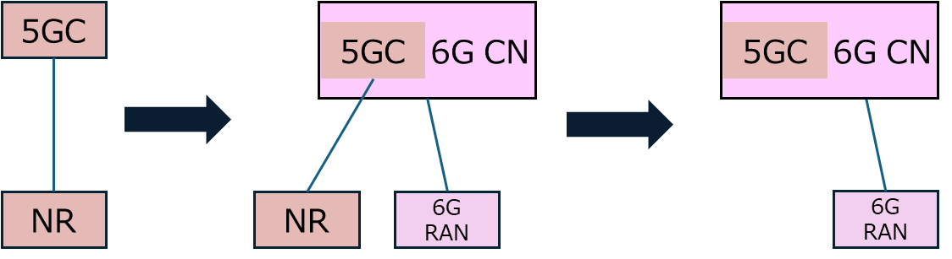
Figure A.X.1-2: 6G Migration Path 1, from 5G SA into 6G SA (Representation 2)

1. Current deployment: 5G SA
2. Intermediate deployment: 5G SA and 6G SA coexist with or without MRSS. 6G RAN spectrum can be re-farmed, a new band with MRSS, or new FR3 introduction, and can be used with MRSS.

3. Final deployment: 6G SA

A.X.1.2 6G Migration Path 2, from 5G NSA into 6G SA
This migration describes the case when 5G non-standalone deployment migrates into 6G standalone via 5G non-standalone and 6G standalone interworking with or without MRSS.
6G Migration Path 1 includes the following steps as described in Figure A.X.2-1 or in Figure A.X.2-2.
Figure A.X.2-1: 6G Migration Path 2, from 5G NSA into 6G SA (Representation 1)
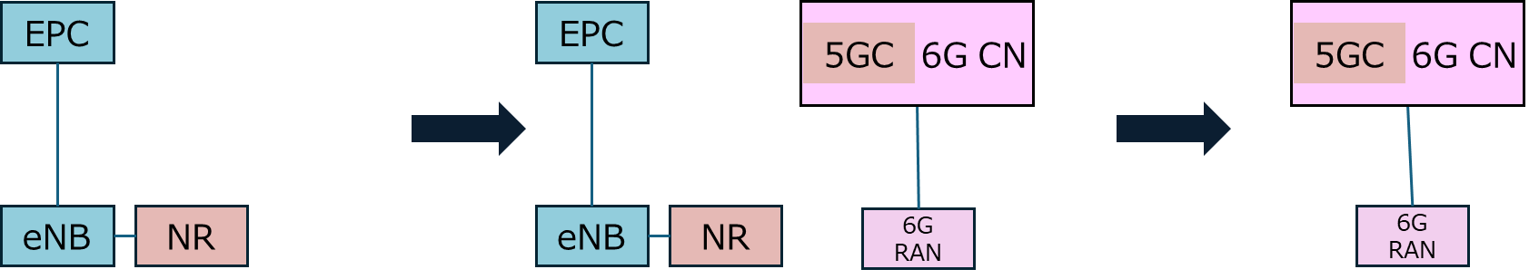
Figure A.X.2-2: 6G Migration Path 2, from 5G NSA into 6G SA (Representation 2)

1. Current deployment: 5G NSA
2. Intermediate deployment: 5G NSA and 6G SA coexist with or without MRSS. Radio spectrum used by 6G RAN can be re-farmed, a new band with MRSS, or new FR3 introduction, and can be used with MRSS.
3. Final deployment: 6G SA

This migration path requires 6GS and EPS interworking.
Editor’s note: Further discussions are needed regarding whether to support interworking with EPS. (S2-2508711)

A.X.3 6G Migration Path 3, from 5G NSA into 6G SA via 5G SA (S2-2508711)
This migration describes the case when 5G non-standalone deployment migrates into 6G standalone via 5G standalone and via 5G standalone and 6G standalone interworking with or without MRSS.
6G Migration Path 3 includes the following steps as described in Figure A.X.3-1.
Figure A.X.3-1: 6G Migration Path 3, from 5G NSA into 6G SA via 5G SA

1. Current deployment: 5G NSA
2. Intermediate deployment: 5G SA and 6G SA coexist with or without MRSS. Spectrum used by 6G RAN can be re-farmed, a new band with MRSS, or new FR3 introduction, and can be used with MRSS.
3. Final deployment: 6G SA

NOTE 1: This migration path does not assume Path 2 is needed.
NOTE 2: This migration path is similar to Path 1 in terms of intermediate deployment.

A.X.4 6G Migration Path 4, from 5G NSA and 5G SA into 6G SA
This migration describes the case when 5G non-standalone and 5G standalone deployments migrate into 6G standalone via 5G non-standalone and 5G standalone and 6G standalone interworking with or without MRSS.
6G Migration Path 4 includes the following steps as described in Figure A.X.4-1 or in Figure A.X.4-2.
Figure A.X.4-1: 6G Migration Path 4, from 5G NSA and 5G SA into 6G SA (Representation 1)
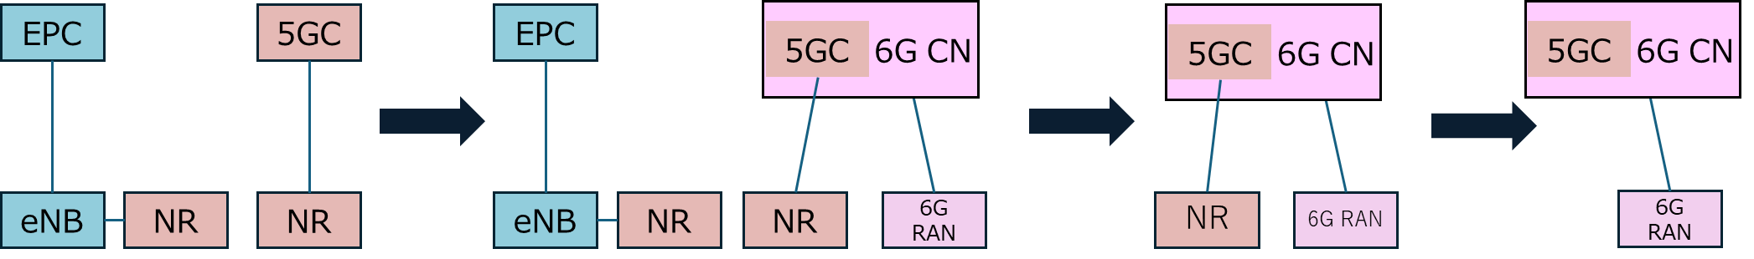
Figure A.X.4-2: 6G Migration Path 4, from 5G NSA and 5G SA into 6G SA (Representation 2)

1. Current deployment: 5G NSA and 5G SA
2. Intermediate deployment: 5G NSA and 5G SA and 6G SA coexist with or without MRSS. 6G RAN spectrum can be re-farmed, a new band with MRSS, or new FR3 introduction, and can be used with MRSS.
3. Intermediate deployment 2: 5G SA and 6G SA coexist with or without MRSS. 6G RAN spectrum can be re-farmed, a new band with MRSS, or new FR3 introduction, and can be used with MRSS. (S2-2508796)
3. Final deployment: 6G SA

This migration path requires 6GS and EPS interworking.
Editor’s note: Further discussions are needed regarding whether to support interworking with EPS. (S2-2508711)

**** End of Changes ****

