SA WG2 Meeting #162 S2-2405011
(Revision of S2-2404779)
Changsha, China, 15-19 April 2024

Source: Sateliot, Novamint
Title: KI#2, Sol#15: Update to address ENs
Document for: Approval
Agenda Item: 19.1
Work Item / Release: FS_5GSAT_ARCH_Ph3 / Rel-19
Abstract: This contribution proposes to resolve ENs of solution 15 in TR 23.700-29v0.4.0.

Discussion
For:
Editor's note: This clause will describe the solution principles and architecture assumptions for corresponding key issue(s). (Sub) clause(s) may be added to capture details.
Editor's note: This clause captures impacts on existing 3GPP nodes and functional elements.
Above ENs are part of the initial template of the document. Content provided is already aligned with the indications given. We propose to remove these ENs.

For:
Editor’s note: It is FFS whether there is a more efficient way for handling the subscription-based service restrictions.
An description of how to handle subscription-based service restrictions more efficiently has been introduced. In particular, as proposed by other solutions (e.g., solution #12 and #13), it’s been mentioned the possibility to fetch
both authentication information and subscription data for S&F operation (i.e., steps 7a/7b and 16a/16b in Figure 6.15.2.2-1) before the UE gets authenticated. In this way, possible subscription-based service restrictions could be taken into consideration before performing the attach.
With the above introduced clarifications, we propose to remove the EN.

For:
Editor’s note: It is FFS whether and, in case, how the Control Plane CIoT EPS Optimisation data transfer procedure needs to be extended to handle S&F service parameters such as quotas, priorities and retention/validity periods.
A possible approach for extending the CP CIoT Optimization data transfer procedure with new IEs to handle S&F quotas, priorities and informing of expected delivery time has been delineated, along with some minor refinements of the text to accommodate these changes.
With respect to the enforcement of any retention/validity period of the data buffered within the C-SGN-SAT, it’s been mentioned that this can be left to implementation or be further considered during the normative phase.
Based on the above, we propose to remove the EN.

Proposal
It is proposed to agree below proposed changes to 23.700-29.

* * * Start of change * * * *

6.15 Solution #15: S&F solution for multi-satellite IoT NTN

6.15.1 Description

The description of the solution principles and architecture assumptions for the proposed solution are conducted taking as a reference architecture the Optimized EPS architecture option for CIoT as specified in TS 23.401 [5]. The consideration of such architecture is mainly motivated for the sake of clarity in the presentation and does not intend to introduce any restriction or constraint to the general architectures defined in TS 23.401 [5] and TS 23.682 [7].
The Optimised EPS architecture option for CIoT is reproduced in Figure 6.15.1-1 and Figure 6.15.1-2 for, respectively, non-roaming and roaming scenarios.
Figure 6.15.1-1: Optimised EPS architecture option for CIoT - Non-roaming architecture (Source: Figure L.2-1 in TS 23.401 [5])
Figure 6.15.1-2: Optimised EPS architecture option for CIoT - Roaming architecture (Source: Figure L.3-1 in TS 23.401 [5])
In the Optimised EPS architecture option for CIoT, the C-SGN (CIoT Serving Gateway Node) is a combined node EPC implementation option that includes the three main EPC entities, i.e. MME, S-GW and P-GW, with no limitation in terms of functionality. Accordingly, the external interfaces of the C-SGN node are those of the respective combined EPC entities towards other entities.
Based on the representation of the Optimized EPS architecture option for CIoT, Figure 6.15.1-3 shows a potential distribution/split of the core network (CN) functions between the satellite and the ground. Such distribution/split is based on the following principles:
- The set of CN functions on board the satellite can be a subset of the C-SGN functions, with no need for 3GPP to specify the specific split and interfaces between the subset of the C-SGN functions on board the satellite (referred to as C-SGN-SAT in Figure 6.15.1-3) and the remaining subset of the C-SGN functions deployed on ground (referred to as C-SGN-GND in Figure 6.15.1-3). Accordingly, the interface between C-SGN-SAT and C-SGN-GND, referred to as S&F interface in Figure 6.15.1-3, could remain implementation dependent.
- The minimum subset of CN functions that should necessarily form part of the C-SGN-SAT would be the MME functions needed to (1) handle the S1 interface with the onboard eNB and (2) the MME functions needed to terminate NAS protocol signalling from/to UEs via the onboard eNB.
Under such architectural approach, standardization efforts could be focused on the impact that the support of S&F Satellite operation could have, if any, on existing interfaces, i.e.: Uu, NAS protocols, S1, S8/SGi, T6a/T7/T8, S6a and SGd.
Figure 6.15.1-3: Proposed distribution of CN functions between the satellite and the ground for S&F Satellite operation, considering the Optimized EPS architecture option for CIoT as a baseline
Moreover, as discussed in SA2#159, it is important that the S&F Satellite operation mode can properly support multi-satellite deployment scenarios by allowing a UE to be potentially served by multiple satellites, i.e. not restricting the S&F operation for a UE to a single satellite within the constellation. Multi-satellite support is indeed considered critical to be able to reduce the latencies in data transfer delivery, given that the revisit time of a single satellite may be around 12h or longer for typical orbits (see R2-2107453).
In this respect, the same principles previously established for the distribution/split between the C-SGN-SAT and C-SGN-GND can be directly extended to the multi-satellite case, as represented in Fig. 6.15.1-4. Consequently, specifics of the multi-satellite scenario, such as how to handle UE/MME context synchronisation between multiple C-SGN-SAT entities and other challenges, can be kept implementation dependent, given that multiple and diverging solutions may exist depending on particular constellation and network configurations.
Figure 6.15.1-4: Proposed distribution of CN functions between the satellites and the ground for S&F Satellite operation, considering the Optimized EPS architecture option for CIoT as a baseline, in a multi-satellite deployment scenario
In light of the above considerations, the proposed solution for S&F Satellite operation support relies on the following principles and architecture assumptions:
1) The split of CN functions between the satellite and ground is achieved by means of splitting the C-SGN functions between a C-SGN-SAT and a C-SGN-GND, so that termination end-points for S1 and NAS protocols remain on the satellite as part of the CN-SGN-SAT and termination end-points for SGd, S6a, S8/SGi and T6a/T6ai remain on the ground as part of the CN-SGN-GND.
2) The split between C-SGN-SAT and C-SGN-GND is also applicable to a multi-satellite scenario, where a single instance of C-SGN-GND on ground could interact with multiple instances of C-SGN-SAT on board the satellites.
3) The interface between the C-SGN-SAT and C-SGN-GND entities could be left to vendor implementation, given that multiple and diverging solutions may exist depending on particular constellation and network configurations.
4) Within this architecture approach, standardization efforts could be focused on the impact that the support of S&F Satellite operation could have, if any, on existing interfaces, i.e.: Uu, NAS protocols, S1, S8/SGi, T6a/T7/T8, S6a and SGd.

6.15.2 Procedures
Based on the architecture depicted in Figure 6.15.1-4 and giving special relevance to the following architecture assumption "Impacts to UE, network functions and entities are minimised. To the extent possible, existing procedures and functionality is reused", this section describes high-level procedures and information flows for:
- The EPS to inform UEs if the network is operating in S&F Satellite operation mode or not.
- Carrying out system procedures between the UE and EPS that may not be completed during a single satellite pass due to S&F Satellite operation but can be realized over several satellite passes (e.g. such as the initial attach procedure in a roaming scenario).
- User data transfer in S&F Satellite operation mode.

6.15.2.1 Advertising capabilities and activation of S&F Satellite operation
A E-UTRAN cell with satellite access for Cellular IoT (CIoT) should be able to inform a UE of:
- Whether the satellite cell is being operated in S&F Satellite operation mode or in normal/default mode.
- Whether there is any service restriction/limitation, or alternatively which services/options are available, while the cell is in S&F Satellite operation mode (e.g. service availability could be restricted to support of only CP CIoT EPS Optimization services during S&F Satellite operation mode)
The advertisement of such information shall prevent UEs from requesting service access or triggering some procedures that might not be supported during the S&F Satellite operation mode. Moreover, the awareness of whether a satellite cell is operated in S&F or normal/default mode could also be considered by the UE for:
- Selection of the proper application layer profile/behaviour (e.g. preventing the usage of IoT applications using TCP as transport layer during S&F operation mode and instead relying on applications that use UDP transport, NIDD or SMS).
- Network selection (e.g. a UE may choose not to select a given PLMN operated in S&F mode if other PLMNs operated in normal mode are available).
It is also important to consider that a satellite cell may be switching between S&F Satellite operation mode and normal/default mode (i.e. a given satellite may not be operating all the time under a single mode). For instance, at geographical areas where the satellite cannot be connected to ground network via a feeder link, the satellite can use S&F Satellite operation mode to give minimum service. However, in areas that the same satellite can be connected to the ground network simultaneously, the satellite cell operation may remain in S&F Satellite operation mode or switch to normal mode, subject to network operator's policies.
As a potential solution approach, the following options can be considered for informing UEs of whether S&F Satellite operation is available/activated or not in a satellite cell:
- Option#1. S&F Satellite operation is advertised via system information broadcasting (SIB).
- Option#2. S&F Satellite operation is advertised via dedicated NAS messaging.
Whether only one or both options are necessary to provide complementary information should be further assessed (e.g. SIB can be used to signal only whether the cell is operated in S&F mode or not, while and NAS messaging can be used to provide further information on service limitation and/or supported S&F capabilities).

6.15.2.2 NAS procedures spanning several satellite passes
In a satellite cell operating in S&F Satellite operation mode, if a UE initiates a signalling procedure during a satellite pass (e.g. E-UTRAN Initial Attach procedure) and the procedure cannot be completed within the duration of the pass because some information is missing in the serving satellite (e.g. E-UTRAN Authentication Vectors, AVs, are not available within the satellite and should be retrieved from an HSS on the ground), the initiated procedure should be terminated/suspended with a proper rejection cause and an indication about when/how the UE may re-attempt/resume the procedure (e.g. the initial attach procedure may be rejected with a cause like "procedure suspended due to S&F operation" and an indication such as "re-try in 'X' minutes" could be given for the UE to retry during the next pass of the same or a different satellite where E-UTRAN AVs could have been already uploaded into the satellite to be able to complete the procedure).
Moreover, in a multi-satellite constellation, it should be possible to initiate/suspend a procedure in a given satellite and resume/terminate it in another satellite of the same PLMN in order to benefit from reduced latencies (i.e. the UE does not have to wait for a pass of the same satellite to be able to resume/terminate the procedure).
In this context, extensions/components that might be considered in a potential solution are:
- Means for the UE to indicate to the network that it supports S&F (e.g. a UE network capability flag to signal that S&F is supported on the UE side).
- New reject causes and (backoff) timers for terminating/suspending the NAS procedures and assisting the UE on subsequent re-attempts in the same or other satellite cells of the same PLMN.
- Means for the network to communicate to the UE in which satellites user data transfer is allowed after a valid network registration (e.g. list of satellite IDs for which the registration is valid).
An illustration of how this sort of extensions/components can be used is given in Figure 6.15.2.2-1 for the case of a E-UTRAN initial attach procedure. Without loss of generality, the description of the procedure considers the involvement of three different satellites (SAT#i, SAT#j, SAT#k) to highlight the facts that (1) the execution of the attach procedure can be initiated in one satellite and completed in another and that, after the attach completion, (2) user data transmission should be possible via any of the three satellites. Moreover, in this example, it is assumed that the HSS with the subscription information (including the E-UTRAN AVs needed for completing the attach procedure) is on the ground, as it could be the case of a roaming scenario.
The procedure described in Figure 6.15.2.2-1 assumes the following sequence of contacts (i.e. satellite passes) between the UE, satellites and ground:
Table 6.15.2.2-1
Contacts | UE | SAT#i | SAT#j | SAT#k | GROUND
Contact#1 | X | X
Contact#2 | X |  | X
Contact#3 |  | X |  |  | X
Contact#4 |  |  |  | X | X
Contact#5 | X |  |  | X
Contact#6 |  |  |  | X | X
Contact#7 |  |  | X |  | X
Contact#8 | X | X
Contact#9 | X |  | X

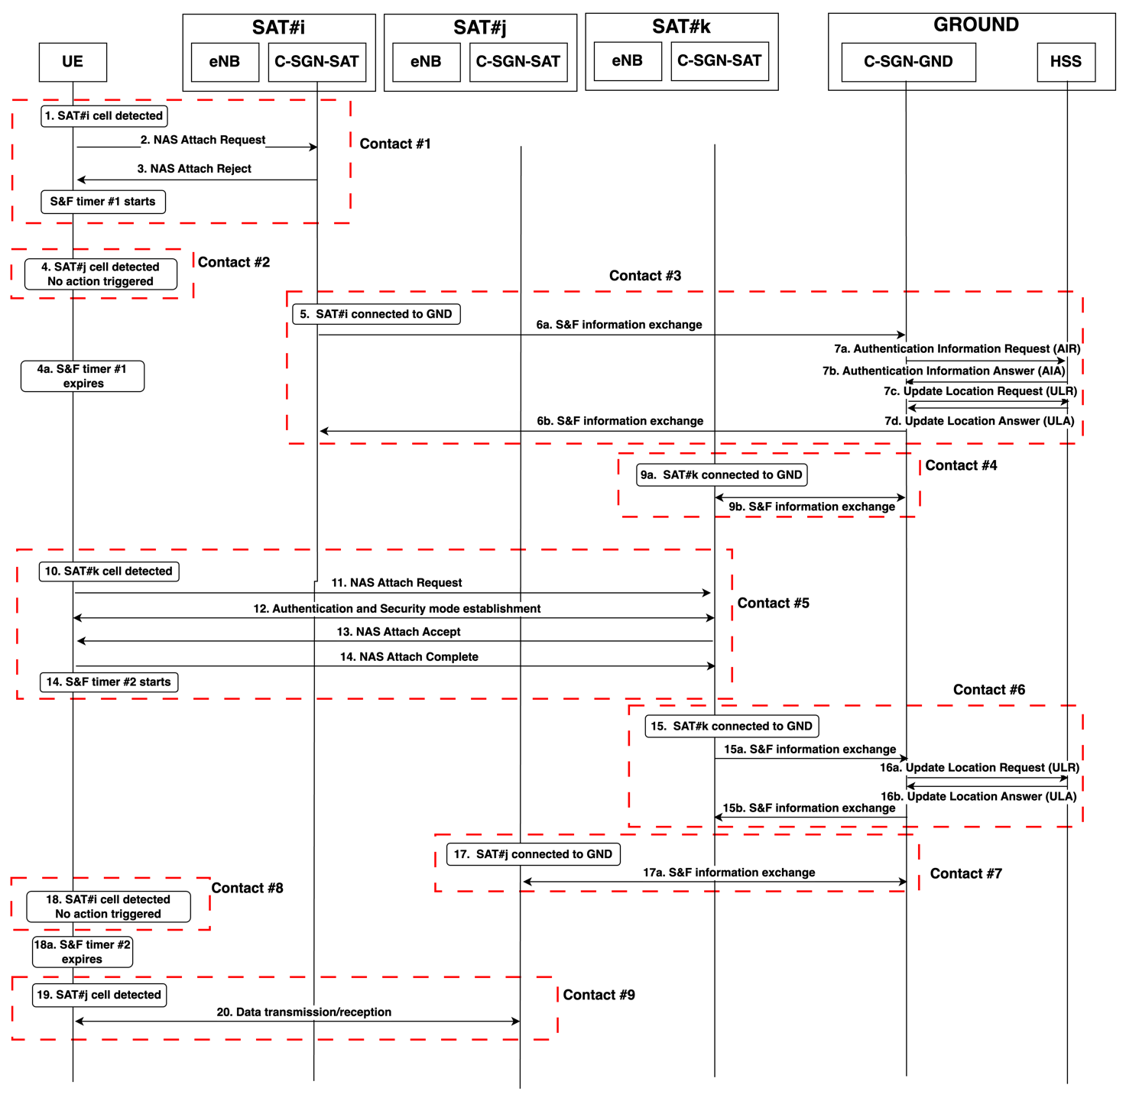

Figure 6.15.2.2-1: Illustration of E-UTRAN Initial Attach procedure under S&F Satellite operation in a multi-satellite deployment and roaming scenario (i.e. HSS on ground)
0. As a starting point it is assumed that the UE is switched on and needs to register with the network. It is assumed that the (terrestrial) home PLMN of the UE is not found and the UE starts the search for a cell of a satellite PLMN.
1. SAT#i comes within the communication range of the UE. The satellite cell is detected by the UE. The UE acquires, among others, the PLMN and the TLEs of multiple satellites of the constellation (SIB32). The UE also learns from SIB31 or SIB32 that the satellite cell is operating in S&F Satellite mode.
2. The UE triggers the initial attach procedure. Within the Attach request, the UE network capabilities incorporate an 'S&F feature supported' flag, signalling the device's ability to handle S&F operations.
3. SAT#i rejects the initial attach procedure due to the absence of subscription data on board the satellite, such as E-UTRAN Authentication Vector (AV), and the lack of a currently active feeder link to the ground network for subscription data retrieval during this satellite pass. If the UE has signalled support for S&F (e.g. Rel-19 UE), the SAT#i issues an ATTACH REJECT message with:
- A new reject cause (S&F rejection cause in Figure 6.15.2.2-1) to indicate that the attach procedure needs to be suspended.
- A timer (backoff) value (S&F Timer#1 in Figure 6.15.2.2-1) to indicate to the UE when the UE can re-attempt the initial attach procedure. During the duration of this timer value, the UE should not to initiate a new attach attempt with any satellite cell operating in S&F mode within the same PLMN.
NOTE 1: This timer may not prevent the UE to re-attempt the initial attach in a satellite cell of the same PLMN not operating in S&F mode.
NOTE 2: A list of potential satellite cells or satellite identifiers may also be provided along with the attach response message to restrict the resumption of the procedure to a subset of the satellites of the constellation.
If the UE has not signalled that it supports S&F (e.g. case of a pre-Rel-19 UE), another reject cause can be used (e.g. congestion) to force the UE to retry in a next satellite pass. This option is up to network implementation.
Internally in the SAT#i, the initial attach attempt of the UE is recorded/saved so that SAT#i will try to retrieve the missing information to complete the attach as soon as the connectivity with the ground network is available.
4. SAT#j comes within the communication range of the UE. Like SAT#i in step 03, SAT#j is assumed to be in S&F operation mode and have no subscription information on board either (e.g. E-UTRAN AVs) to be able to resume/complete the attach registration with the UE. The satellite cell is detected. The UE identifies that this satellite cell belongs to the same PLMN as the cell where it previously attempted the initial attach (step 03). The UE learns that SAT#j satellite cell is operating in S&F mode. In this situation, the UE does not trigger an attach attempt because SAT#j operates in S&F mode and the timer value (S&F Timer#1) has not yet expired.
4a. "S&F Timer#1" expires on the UE. From this point on, the UE knows that the initial attach procedure can be re-attempted in any upcoming satellite cell of the PLMN.
5. SAT#i gets connected to the ground network via the feeder link.
6. C-SGN-SAT of SAT#i and C-SGN-GND exchange information on the initial attach attempt detected by SAT#i in step 03.
7. C-SGN-GND interacts over S6a interface with the HSS of the home PLMN of the UE requesting the initial attach. The IMSI of the UE is used to execute the Authentication Information Retrieval (AIR) procedure. At this point, the C-SGN-GND could also trigger an Update Location Request (ULR) procedure to pre-fetch the necessary subscription data to be able to complete the attach procedure in a next satellite pass.
C-SGN-GND obtains the subscriber information from the HSS, including the E-UTRAN AVs.
8. E-UTRAN AVs are uploaded to C-SGN-SAT in SAT#i.
9. SAT#k gets connected to the ground network via the feeder link. Assumption is that SAT#k is expected to fly over the area where the UE that attempted the attach is located. E-UTRAN AVs for that subscriber/UE are also uploaded to the C-SGN-SAT of SAT#k.
10. SAT#k comes within the communication range of the UE.
11. The satellite cell is detected by the UE. The UE re-tries the initial attach procedure in SAT#k given that the "S&F Timer#1" value is already expired.
12. Authentication and security setup steps can be now completed successfully, given that SAT#k has the necessary information about the UE/IMSI.
13. Network attach is accepted. A new UE/MME context is created. As part of the NAS attach accept, a timer value ("S&F Timer#2" in Figure 6.15.2.2-1) is provided to the UE to indicate a proper time when the UE can attempt user data transmission/reception in any satellite. This timer value is needed to prevent the UE from trying to start data transfer in a next satellite before the network has been able to complete the update of the HSS (location update procedure) on the ground and the new established UE/MME context has been propagated/synchronised in other satellites of the constellation (FFS if the service gap control could be reused for this same purpose).
14. The UE sends the NAS attach complete and sets the timer.
15. SAT#k gets connected to the ground network via the feeder link. The C-SGN-GND learns about the new UE/MME context created in SAT#k.
16. C-SGN-GND triggers a location procedure over S6a with the HSS of the home PLMN of the UE that completed the attach so that the HSS gets updated about the registration. With the registration finalized, the system has successfully retrieved all subscriber-related information from the HSS of the home PLMN.
17. SAT#j gets connected to the ground network via the feeder link. The new UE/MME context is uploaded into SAT#j.
NOTE 3: If pre-fetching of subscription data was performed in previous Step 7c/d and the subscriber-related information retrieved from the HSS in Step 16 indicates that the UE is not allowed to be served in the location where the Attach was requested, the C-SGN-SAT on SAT#j initiates UE detach during the subsequent contact with the UE.

18. SAT#i comes within the communication range of the UE. The UE may detect the satellite cell. However, the UE does not trigger any user data transmission because the timer value (S&F Timer#2) provided in step 13 has not yet expired.
18a. S&F Timer#2 expires on UE. From this point on, the UE assumes that the registration is valid in the network (e.g. the network has already managed to distribute the newly created UE/MME context to the several satellites) and that user data transmission/reception can be attempted in any upcoming satellite cell of the PLMN.
19. SAT#j comes within the communication range of the UE.
20. User data transmission can be performed in SAT#j

6.15.2.3 Data transfer in S&F Satellite operation mode
Following successful registration with the satellite PLMN and establishment of a valid UE/MME context across all or a subset of the satellites of the constellation, data transfer can take place between the UE and any of those satellites when in reach of the UE.
Without preventing other approaches, this scenario considers the use of Control Plane CIoT EPS Optimisation as the baseline protocol for data transfer between the UE and satellite cells operating in S&F Satellite operation mode.
Data transfer under Control Plane CIoT EPS Optimisation relies on an exchange of ESM DATA TRANSPORT messages between the UE and the MME, encapsulating user data within the User Data Container Information Element (IE), as defined in TS 24.301 [17]. Furthermore, the protocol allows for the exchange of ESM STATUS messages between the UE and MME to report specific error conditions upon the reception of ESM protocol data.
On this basis, a solution approach to enable data transfer in S&F mode involves augmenting the existing Control Plane CIoT EPS Optimisation with
new IEs in the ESM DATA TRANSPORT messages and/or new causes in the ESM STATUS messages to handle S&F data transfer aspects such as S&F data quotas, delivery priority levels and providing information on expected delivery times (some further details on these aspects are given below as part of the description of the steps in Fig. 6.15.2.3-1).

From a service perspective, such a data transfer mechanism could be conceived as an extension of the "Control Plane CIoT EPS Optimisation" for when the satellite cell is in S&F mode, which could be referred to as "Control Plane CIoT EPS Optimisation with S&F extensions". Alternatively, a new data transfer service associated with S&F Satellite operation could be defined, potentially termed "S&F CP data transfer".
An illustration of the data transfer mechanism is depicted in Figure 6.15.2.3-1 for the Mobile Originated (MO) case. For the Mobile Terminated (MT) case, the same approach applies, with the only difference being the trigger of the paging procedure by the CN-SGN-SAT when the UE is expected to be in reach from the flying satellite.
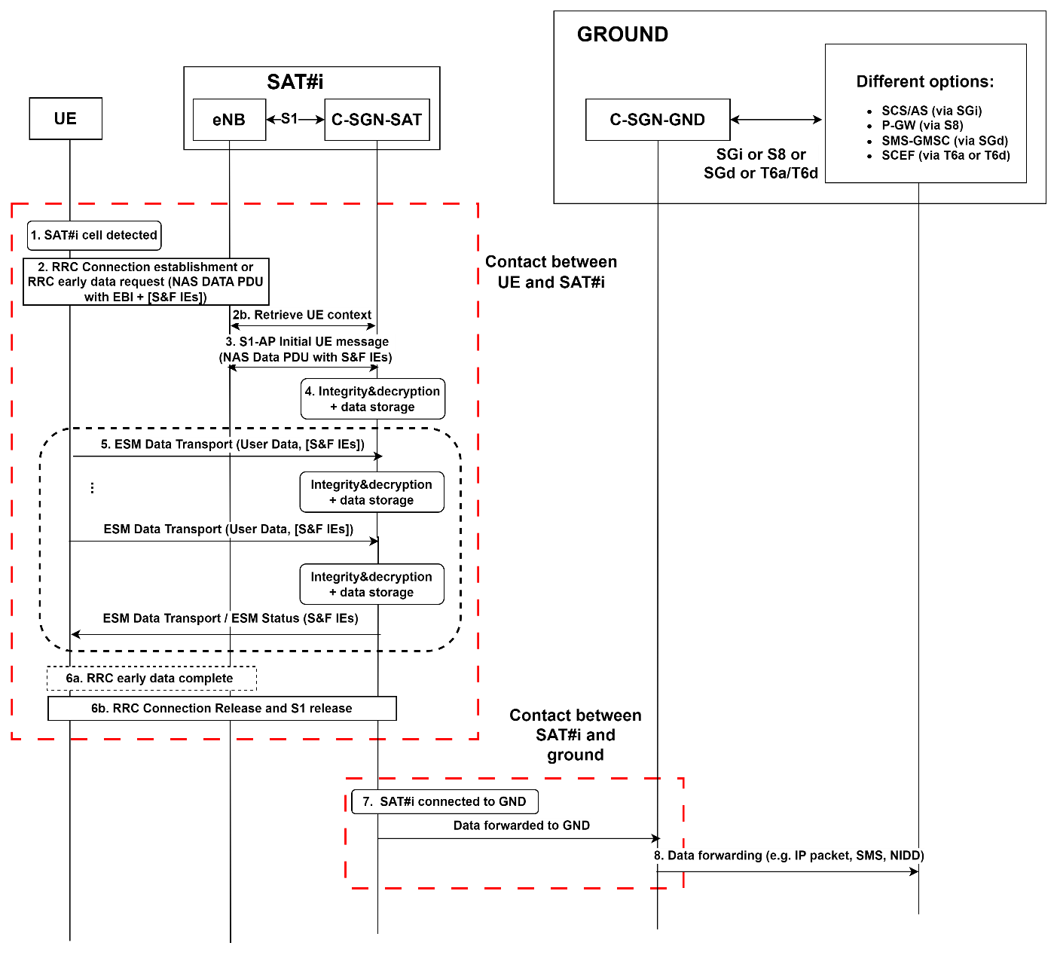
Figure 6.15.2.3-1: MO user data transfer
0. As a starting point it is assumed that:
- The UE is already registered in the satellite network.
- The UE has previously acquired long-term ephemeris (TLEs) during past contacts with satellites (from SIB32).
- New data originating at the application layer is ready to be transferred.
- The UE is capable of estimating the timing of its next contact with a forthcoming satellite (SAT#i) that has a valid UE/MME context to interact with the UE.
1. SAT#i comes within the communication range of the UE. The UE detects the satellite cell and verifies that S&F Satellite mode is supported. The UE triggers the "Control Plane CIoT EPS Optimisation with S&F extensions" (or "S&F CP data transfer") procedure:
- The UE either establishes an RRC connection or sends an RRCEarlyDataRequest message, as defined in TS 36.300 [13], which includes an integrity-protected NAS PDU. The NAS PDU carries the EPS Bearer ID and encrypted Uplink Data.
- The UE may also indicate in a NAS Release Assistance Information in the NAS PDU whether no further Uplink or Downlink Data transmissions are expected, or only a single Downlink data transmission (e.g. Acknowledgement or response to Uplink data) subsequent to this Uplink Data transmission is expected.
- The UE may also include in the NAS PDU any needed S&F IEs (e.g. a new IE to ask for data storage allowance).
2a. The eNodeB, based on configuration, may retrieve the EPS negotiated QoS profile from the MME, if not previously retrieved. The eNodeB may retrieve additional parameters (e.g. UE Radio Capabilities).
3. The NAS PDU sent in step 02 is relayed to the MME by the eNodeB using a S1-AP Initial UE message. If the RRCEarlyDataRequest message was received in step 02, the eNodeB includes the "EDT Session" indication in the S1-AP Initial UE message.
4. The C-GCN-SAT checks the integrity of the incoming NAS PDU, decrypts the encapsulated data and stores it.
5. Additional user data may be exchanged using the ESM data transport mechanism as defined in TS 24.301 [17]. Data is stored in the satellite. The ESM data transport messages now may include specific S&F Information Elements (IEs) to manage S&F data quotas (e.g. notification on data storage allowance or status messages forcing the release of the data transfer procedure when the quota is reached) or inform about expected S&F delivery time. For instance, similarly to how the Release Assistance Information (RAI) IE in ESM data transfer is used to inform the network on further uplink and downlink data transmission expectations, a new IE or an extension of the RAI IE could be defined to handle S&F data transfer and used to e.g. provide information to the UE on whether further data transmission is allowed or quota limitations have been reached. A new IE could also be defined to indicate the priority of S&F data, out of a few priority levels (e.g. low, medium, high) and another IE could be defined for the network to inform, possible upon demand, of the expected delivery time for the data being buffered (e.g. time left for the data to be delivered to the ground network).
6. To complete the data transfer, RRC connection and S1 release is triggered. Alternatively, RRC Early Data Complete is sent if the data transfer procedure was initiated using an RRCEarlyDataRequest message.
7. SAT#i gets connected to the ground network via the feeder link. The satellite forwards the stored user data to the C-SGN-GND.
8. Downloaded user data is forwarded to the destination via proper interfaces.
The way to enforce retention/validity periods (e.g. discard the data after retention/validity period expiration) for the data buffered within the C-SGN-SAT can be left to implementation or further considered during the normative phase.

6.15.3 Impacts to Services, Entities and Interfaces

No impacts foreseen in terms of defining new entities or interfaces for the EPS architecture.
However, the following extensions would be needed to support S&F Satellite operation in a multi-satellite constellation scenario:
1) For the network to advertise the support of S&F capabilities and/or activation of S&F satellite operation mode:
a) New IEs in SIB (e.g. SIB31 or SIB32); and/or
b) New IEs in NAS messaging.
2) For the UE to advertise the support of S&F capabilities:
a) A UE network capability flag indicating S&F support.
3) For NAS procedures spanning several satellite passes and potentially different satellites:
a) New reject causes and backoff timers for terminating/suspending NAS procedures and assisting the UE on how to proceed with subsequent re-attempts in future passes of the same or different satellite cells.
b) New IEs for the network to inform the UE of the satellites in which user data transfer is allowed after completing network registration (e.g. list of satellite identifiers for which the registration is valid).
4) For user data transfer, the Control Plane CIoT EPS Optimisation data transfer procedure could be extended with
new IEs in the ESM DATA TRANSPORT messages and/or new causes in the ESM STATUS messages to handle S&F data transfer aspects such as S&F data quotas, delivery priority levels and providing information on expected delivery times.

5) In addition, the following extensions could be also needed for a end-to-end solution:
a) Subscription parameters related to S&F satellite operation in the HSS and option to pre-fetch the necessary data for S&F operation before UE authentication.
b) Awareness of the S&F satellite operation to the SCS/AS entities via T8 procedures.

* * * End of change * * * *

