SA WG2 Meeting #170 S2-2507309
Goteborg, Sweden, 25 - 29 Aug, 2025

Title: KI#2, New Sol: Authorization Information Provisioning/Update by AF
Source: Toyota Motor Corporation, BUPT
Document for: Approval
Agenda Item: 20.2.1
Abstract: An authorization information provisioning/update mechanism initiated by AF for FS_Sensing_ARC is proposed.

1. Introduction
This pCR proposes a solution for Key issue#2 authorization and revocation to support sensing service. The key issue includes the question of when and how to provision and update the authorization information. This solution introduces an authorization information provisioning and update mechanism performed by trusted AFs. These AFs are capable of generating and updating the authorization information associated with sensing areas and request the Sensing Data Management (SDM) function to perform the corresponding create and update of the sensing authorization settings for the sensing areas, in order to enable subsequent authorization of sensing services.

2. Text Proposal
It is proposed to capture the following changes in TR 23.700-14.

* * * * First change * * * *

6 Solutions

6.0 Mapping of Solutions to Key Issues
Table 6.0-1: Mapping of Solutions to Key Issues
 | Key Issues
Solutions | 1 | 2 | 3 | 4 | 5 | 6
X |  | X

* * * * Second change (All Text New) * * * *

6.X Solution #X: Authorization Information Provisioning/Update by AF

6.X.0 High-level solution Principles
The solution is based on the following general principles to support sensing service:
- A new function, the SDM, is introduced to store sensing authorization information (e.g. the authorization information of sensing areas.). The SDM may be co-located with the Sensing Function or with the Sensing Gateway Function.
- A trusted AF can send an provisioning/update request of sensing authorization information to the SDM.

6.X.1 Description
Authorization of the sensing service can be specifically supported by sensing authorization profile, which is managed by the SDM. The authorization profile of the sensing area specifies the authorization information applicable to the area. Based on the authorization information, a sensing request can be evaluated whether to be permitted.
This solution primarily focuses on how to provisioning and update authorization information for sensing areas which can be performed by a trusted AF, such as a server of the operator, or a governmental authority, or a management server responsible for the sensing area. The AF that provides or updates the authorization information is not the AF that requests the sensing service.

6.X.2 Authorization Information Provisioning/Update Initiated by trusted AF
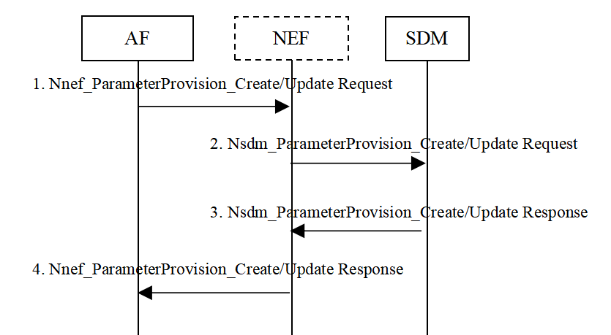
Figure 6.X.4-2: Authorization information provisioning/update Initiated by trusted AF.
- Optionally, the AF sends Nnef_ParameterProvision_Create/Update Request to the NEF, which is enhanced to support the provisioning of information for sensing areas by external parties. The message may include the sensing area information, the sensing authorization information and AF Identifier. NEF checks whether the AF is allowed to perform the service operation by checking requestor's identifier (i.e. AF Identifier).
- If the AF is authorized by the NEF to provide sensing authorization information, the NEF shall send a Nsdm_ParameterProvision_Create/Update request to the SDM to provision or update the authorization profile of the corresponding sensing area. The message carries the sensing area information along with the sensing authorization modification instructions which is defined for modifying the authorization information in the SDM. If the AF is not authorised to provision or update the sensing authorization profile, the NEF shall return the reason for failure in the response of Step 4.
- The SDM sends Nsdm_ParameterProvision_Create/Update Response to NEF. If the procedure failed, the cause value indicates the reason.
- The NEF sends Nnef_ParameterProvision_Create/Update Response to AF. If the procedure failed, the cause value indicates the reason.

Editor’s note: Support of authorization information provisioning and update by other NFs in the network is FFS.

6.X.3 Impacts on services, entities and interfaces
NEF:
- Support to send the sensing authorization information update request received from the AF to the SDM.
- Support permission check for AF to perform authorization information provisioning/update.
SDM:
- Support the storage and update of authorization information.

* * * * End of changes * * * *

