3GPP TSG-SA WG1 Meeting #111 S1-253183r1
25-29 August 2025, Goteborg, Sweden (revision of S1-25xxxx)

Source: China Unicom, ZTE, CATT, China Telecom
New use case title: Network sharing on radio access network with sensing capability
Draft TS/TR: 3GPP TR 22.870
Agenda item: 8.1.2
Document for: Approval
Contact: Qun Wei, weiqun5@chinaunicom.cn
Qian Song, songq10@chinaunicom.cn
Jinjian Qiao, qiaojj91@chinaunicom.cn

Abstract: This pCR provides a new use case on network sharing of 6G about sensing scenario based on last meeting discussion.
1. Introduction
The 6G SID skeleton has been agreed in the 3GPP SA1#107 and it contains system and operational aspects section under which support of network sharing can be introduced. The last SA1 meeting approved the basic sharing and event triggered network sharing requirements. This pCR provides general considerations on network sharing on radio access network with sensing capability.
2. Reason for Change
Discuss the possibility of sharing radio access network with sensing capability on 6G.
3. Proposal
It is proposed to agree the following changes to 3GPP TR 22.870.

* * * First Change (New use case)* * *

5 System and Operational Aspects
Editor's Note: "System and Operational Aspects" facilitates system and network operation features that underpin overall operation, covering aspects that apply across use cases and services, and those that relate to network operations. These aspects include, for example: migration scenarios, interworking with earlier 3GPP systems, interworking with non-3GPP system, roaming and interconnection, network simplification, network sharing, security, privacy, resilience, sustainability and energy efficiency, device diversity, support of legacy services

5.x Network sharing on radio access network with sensing capability

5.x.1 Description
Given the multitude of use cases for services, some operators, based on their business model, may deploy one or more network capabilities (e.g., data processing capability, computing capability, or sensing data collection capability) in some areas to serve their services, but not in all areas. However, through multi-operator sharing collaboration, the service coverage of specific network capability can be expanded, for instance, this could be used to provide positioning and velocity sensing services for drones, smart transportation and refrigerated transport. This particularly occurs in rural areas, in long-distance logistics and in traffic management, for example, in order to reduce the cost of deployments.

5.x.2 Pre-conditions
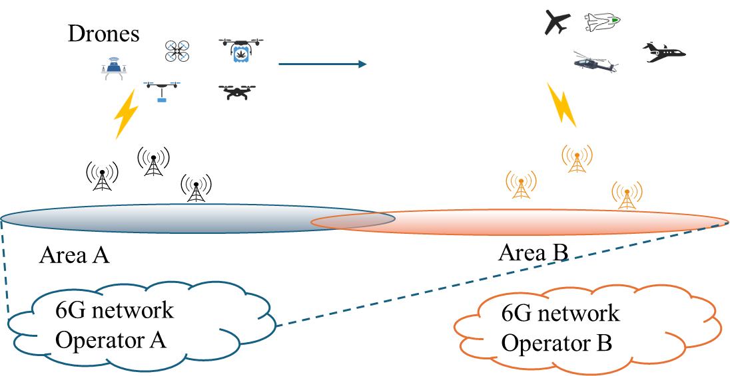
Fig. 5.x.2-1: OP#A provides sensing service for logistics UAV tracking in area A plus B
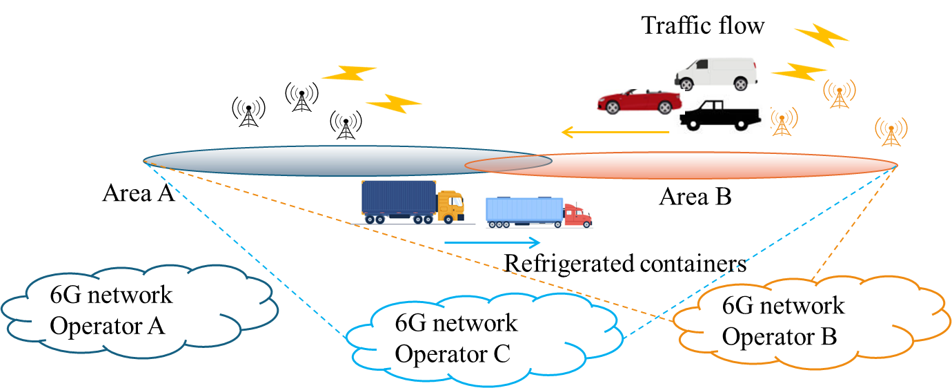
Fig. 5.x.2-2: OP#B and OP#C provides sensing service for traffic flow and refrigerated transport tracking
in area A plus B
For point-to-point delivery by logistics UAVs from area A to area B, the sensing service can provide logistics customers with real-time positioning and velocity data assistance through operator sensing capability based on the operator’s policy (e.g., via non-3GPP, 3GPP or hybrid sensing methods).
Mobile Network Operator #A (OP#A) can provide sensing service by deploying radio access network with sensing capability (e.g., RAN node as sensing transmitter/sensing receiver) in area A. The coverage of sensing service in OP #A is area A.
Mobile Network Operator #B (OP#B) can provide sensing service by deploying radio access network with sensing capability in area B. The coverage of sensing service in OP #B is area B.
To expand the sensing service coverage for OP#A and OP#B, operators A and B have the sensing network sharing agreement. This will extend their sensing service coverage to area A plus area B, as well as the overlapping coverage area of area A and B through sharing the radio access network with sensing capability.
Mobile Network Operator #C (OP#C) doesn’t deploy the radio access network which has the sensing capability but wants to provide its own sensing service. OP#C can have the sensing network sharing agreement with Operators A and B to share the radio access network with sensing capability of the OP#A and OP#B.

5.x.3 Service flows
1. Depending on customer service and regulatory requirements, OP#A provides sensing service for logistics UAV tracking for collection of sensing data related to UAV using the radio access network with sensing capability (e.g., UAV’ position, velocity and environment related data), when the UAV enters the sensing area A.
2. When the UAV enters sensing area B, based on sensing network sharing agreement between operators, the OP#A can use the shared radio access network with sensing capability to collect the sensing data which satisfy the service requirement of OP#A’s customer (e.g. logistics UAV tracking) as figure 5.x.2-1, while these collected data will not be used by other operators. Logistics customers do not need to be aware of which radio access network with sensing capability are used to provide the sensing service.
3. Similarly, OP#B can provide sensing service for smart transportation for collection of sensing data related to motor vehicle using the shared radio access network with sensing capability (e.g., traffic speed and environment related data) in the sensing area B as figure 5.x.2-2. When the cars enter the sensing area A, based on sensing network sharing agreement between operators, OP#B can use the shared radio access network with sensing capability to collect the sensing data which satisfy the service requirement of OP#B’s customer (e.g. smart transportation), while these collected data will not be used by other operators.
4. Similarly, OP#C which doesn’t deploy the radio access network with sensing capability, can use the shared radio access network with sensing capability of OP#A/#B to collect sensing data and satisfy the service requirement of OP#C’s customer (e.g. refrigerated transport) as figure 5.x.2-2.
5. When drones, motor vehicles and refrigerated containers move across the overlapping coverage areas of Areas A and B, the sensing service transmitters and receivers can be located in a shared or non-shared radio access network with sensing capability, or a mix of both.

5.x.4 Post-conditions
OP#A can provide sensing services for logistics UAV customers in the area A plus area B.
OP#B can provide sensing services for smart transportation customers in the area A plus area B.
OP#C can provide sensing services to refrigerated transport customers in the area A plus area B.

5.x.5 Existing features partly or fully covering the use case functionality
TS 22.261 [14] clause 3 includes the definition for NG-RAN sharing and Participating Operator.
NG-RAN Sharing: the sharing of NG-RAN among a number of operators.
Participating Operator: as defined in 3GPP TS 22.101 [58].
The definition of Participating Operator in 3GPP TS 22.101 is as follows:
Participating Operator: Authorized operator that is using Shared NG-RAN, Shared E-UTRAN, Shared GERAN or UTRAN resources provided by a Hosting RAN Operator.
TS 22.137 [6] clause 4.3 and clause 3 introduces that operator can provide sensing service by deploying RAN node with sensing capability (e.g., RAN node as sensing transmitter/sensing receiver)
The introduction of sensing capabilities can enable tracking of people and objects in the environment, including people not carrying UEs. Thus, additional considerations are needed to protect their rights to privacy.
Sensing receiver: a sensing receiver is an entity that receives the sensing signal which the sensing service will use in its operation. A sensing receiver is part of a RAN node or a UE. A Sensing receiver can be located in the same or different entity as the Sensing transmitter.
Sensing transmitter: a sensing transmitter is the entity that sends out the sensing signal which the sensing service will use in its operation. A Sensing transmitter is part of a RAN node or a UE. A Sensing transmitter can be located in the same or different entity as the Sensing receiver.

5.x.6 Potential New Requirements
[PR-5.x.6-1] Subject to regulatory requirements or operator policy, the 6G network shall support sharing of radio access network with sensing capability among operators.
[PR-5.x.6-2] Subject to regulatory requirements or operator policy, the 6G network shall support participating operator to provide sensing service via shared radio access network with sensing capability.
NOTE 1: It is assumed operators can have sharing agreement for radio access network with sensing capability in the specific sensing area.
[PR-5.x.6-3] The 6G network shall provide a mean to protect sensing data security and data privacy when sharing radio access network with sensing capability among operators.
NOTE 2: It may need additional consideration when UE is involved in sensing operation.

* * * End of changes * * *

