TSG-RAN Working Group 4 (Radio) meeting #119 R4-2607726
Dalian, China, 18th to 22nd May 2026

Source: Ericsson (Moderator)
Title: Way-Forward for NR_BS_RF_Ph2
Agenda item: 7.2.1
Document for: Approval

Introduction
Based on the discussions related to thread [119][345] NR_BS_RF_Ph2 this way-forward contribution was created to captured agreements and provide guidance for coming meetings.
Topic summary and ad-hoc meeting summary is captured in [1, 2].

Way-forward

  - Enhancement of co-location requirements

    - Coupling loss evaluation

Agreement:
- Simulated coupling loss values for A-to-A and A-to-SA are collected this meeting in template agreed last meeting (the two tables below).
- Use tables as baseline for data collection next meeting.
- Aim to finalize data collection in August RAN4 meeting.

Table 2.1.1-1: Simulated coupling loss for 10 cm side-by-side separation
Frequency regions | 3.5 GHz | 4.9 GHz | 7.0 GHz
3.5 GHz | R4-2606667 (Huawei)  A-to-SA:  95%@CDF 51.3 dB, 99%@CDF 50.3 dB  A-to-A:  95%@CDF 51.1 dB, 99%@CDF 47.7 dB | R4-2607033 (Ericsson)  A-to-SA:  95%@CDF 38 dB, 99%@CDF 32 dB  A-to-A:  95%@CDF 40 dB, 99%@CDF 36 dB | R4-2606667 (Huawei)  A-to-SA:  95%@CDF 59.3 dB, 99%@CDF 58.6 dB  A-to-A:  95%@CDF 64.1 dB, 99%@CDF 61.3 dB
3.5 GHz | R4-2607033 (Ericsson)  A-to-SA:  95%@CDF 48 dB, 99%@CDF 45 dB  A-to-A:  95%@CDF 54 dB, 99%@CDF 52 dB |  | R4-2607033 (Ericsson)  A-to-SA:  95%@CDF 56 dB, 99%@CDF 50 dB  A-to-A:  95%@CDF 52 dB, 99%@CDF 44 dB
4.9 GHz | R4-2607033 (Ericsson)  A-to-SA:  95%@CDF 40 dB, 99%@CDF 36 dB  A-to-A:  95%@CDF 38 dB, 99%@CDF 32 dB | R4-2606667 (Huawei)  A-to-SA:  95%@CDF 51.5 dB, 99%@CDF 50 dB  A-to-A:  95%@CDF 51.3 dB, 99%@CDF 46.8 dB | R4-2606667 (Huawei)  A-to-SA:  95%@CDF 53.3 dB, 99%@CDF 52.7 dB  A-to-A:  95%@CDF 60.3 dB, 99%@CDF 58.1 dB
4.9 GHz |  | R4-2607033 (Ericsson)  A-to-SA:  95%@CDF 50 dB, 99%@CDF 46 dB  A-to-A:  95%@CDF 56 dB, 99%@CDF 52 dB | R4-2607033 (Ericsson)  A-to-SA:  95%@CDF 56 dB, 99%@CDF 50 dB  A-to-A:  95%@CDF 52 dB, 99%@CDF 50 dB
7.0 GHz | R4-2607033 (Ericsson)  A-to-SA:  95%@CDF 52 dB, 99%@CDF 44 dB  A-to-A:  95%@CDF 58 dB, 99%@CDF 52 dB | R4-2607033 (Ericsson)  A-to-SA:  95%@CDF 52 dB, 99%@CDF 48 dB  A-to-A:  95%@CDF 48 dB, 99%@CDF 42 dB | R4-2606667 (Huawei)  A-to-SA:  95%@CDF 60.3 dB, 99%@CDF 58.3 dB  A-to-A:  95%@CDF 62.8 dB, 99%@CDF 57.2 dB
7.0 GHz |  |  | R4-2607033 (Ericsson)  A-to-SA:  95%@CDF 60 dB, 99%@CDF 56 dB  A-to-A:  95%@CDF 66 dB, 99%@CDF 62 dB

Table 2.1.1-2: Simulated coupling loss for 50 cm side-by-side separation
Frequency regions | 3.5 GHz | 4.9 GHz | 7.0 GHz
3.5 GHz | R4-2607033 (Ericsson)  A-to-SA:  95%@CDF 54 dB, 99%@CDF 50 dB  A-to-A:  95%@CDF 60 dB, 99%@CDF 56 dB | R4-2607033 (Ericsson)  A-to-SA:  95%@CDF 44 dB, 99%@CDF 38 dB  A-to-A:  95%@CDF 44 dB, 99%@CDF 42 dB | R4-2607033 (Ericsson)  A-to-SA:  95%@CDF 60 dB, 99%@CDF 56 dB  A-to-A:  95%@CDF 58 dB, 99%@CDF 52 dB
4.9 GHz | R4-2607033 (Ericsson)  A-to-SA:  95%@CDF 44 dB, 99%@CDF 40 dB  A-to-A:  95%@CDF 44 dB, 99%@CDF 38 dB | R4-2607033 (Ericsson)  A-to-SA:  95%@CDF 56 dB, 99%@CDF 52 dB  A-to-A:  95%@CDF 61 dB, 99%@CDF 58 dB | R4-2607033 (Ericsson)  A-to-SA:  95%@CDF 54 dB, 99%@CDF 50 dB  A-to-A:  95%@CDF 56 dB, 99%@CDF 52 dB
7.0 GHz | R4-2607033 (Ericsson)  A-to-SA:  95%@CDF 60 dB, 99%@CDF 54 dB  A-to-A:  95%@CDF 60 dB, 99%@CDF 56 dB | R4-2607033 (Ericsson)  A-to-SA:  95%@CDF 54 dB, 99%@CDF 50 dB  A-to-A:  95%@CDF 54 dB, 99%@CDF 50 dB | R4-2607033 (Ericsson)  A-to-SA:  95%@CDF 64 dB, 99%@CDF 60 dB  A-to-A:  95%@CDF 70 dB, 99%@CDF 68 dB

2.2.2 Collection of measurement results

Agreement:
- Use table below as baseline for data collection next meeting.
- Add missing coupling loss input with reference to tdoc no and company name.
- Encourage input from other companies.
- Aim to finalize data collection in August RAN4 meeting.

Table 2.2.2-1: Measured coupling loss
Frequency regions | 3.5 GHz | 4.9 GHz | 7.0 GHz
3.5 GHz | R4-2606667 (Huawei)  A-to-SA: 41.4 dB  A-to-A: 46 dB
4.9 GHz |  | R4-2606667 (Huawei)  A-to-SA: 50.6 dB  A-to-A: 53.5 dB
7.0 GHz

    - Correlation factor assumption

Agreement:
- For TDD OFF power the leakage produced by the aggressor BS during TX OFF period into victim BS during RX period is considered. The wideband noise produced by the aggressor BS is typically generated by AWGN produced by PAs, hence correlation would be 0%.
- Further study impact due to harmonics with respect to spurious emissions. The correlation factor is expected to be within the range 0 to 1.

    - Improvements of CLRA/CLTA concept

Agreement:
- Further work on definition of CLTA loss. Clarify what losses is included, e.g. transmission loss, dissipative loss, miss-match loss, etc.)
- How to capture CLTA loss in specification:
  - Option 1: Specify maximum loss
  - Option 2: Further study possibility to characterize the CLTA loss/gain and apply to test.

Agreement:
- For next meeting encourage companies to come with more detailed improvements of CLTA description (TS 38 141-2, Table 4.12.2.2-1) including issues such as length/beamwidth and in-band/out-of-band.

    - Alternative test antennas

Agreement:
- Further explore possibilities to describe requirements based on field-strength levels which would allow for any antenna type to be used during conformance testing.
- Aim to establish details needed for alternative test antenna to be used during conformance testing.

  - SBFD BS to SBFD BS adjacent channel coexistence

2.3.1 In-band blocking calibration

Agreement:
- Merge all calibration data into common Excel document.
- Some deviations have been identified between companies.
- Further discuss calibration results with the goal to better align at next meeting.

The calibration results provided to this meeting is captured in figure below.
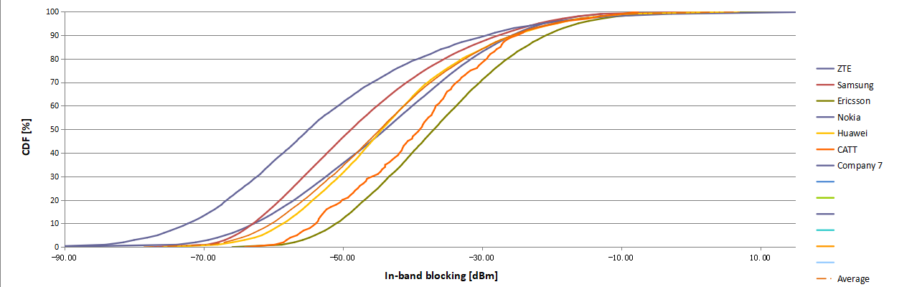

2.3.2 In-band blocking model

Agreement:
- Use the blocking model in TR 38.858, Annex E.2.3 as baseline and offset according to blocking simulation result
- FFS impact due to insertion loss
- For 7 GHz use F₁=6 dB, FFS F₂.

2.3.3 ACLR/ACS modelling approach

Agreement:
- Use scaling factors as described in Rel-18 in TR 38.858, Annex E.2.3.2.
- In TR 38.748 capture technical background and considered co-existence scenario.

2.3.4 Co-location modelling aspects

Agreement:
- For 0% grid shift case (co-location), propose to postpone the discussion until coupling loss evaluation in section 2.2.1 is complete.
- Encourage companies to provide inter-sector coupling loss.

References
[1] R4-2607232, “Topic summary for [119][345] NR_BS_RF_Ph2”, Moderator (Ericsson)
[2] R4-2607714, “Ad-hoc summary for [119][345] NR_BS_RF_Ph2”, Moderator (Ericsson)

