3GPP TSG-RAN WG4 Meeting #116 R4-2511329
Bengaluru, India, 25 – 29th August 2025

Source: BT
Title: TP for TR 38.753 Annex A Channel Measurements
Agenda item: 7.12.3
Document for: Endorsement
- Introduction
In RAN4#113 work split for TR 38.753 was agreed [1]. In this contribution we provide draft TP for TR 38.753 Annex A Channel Measurements. This revision fixes identified formatting issues only.
- Text Proposal

<Start of Change 1>

Annex A (informative):
Channel Measurements
During SCM channel measurements have been provided to demonstrate properties of sample MIMO channels from operational networks. This section summarises contributed material, observations and conclusions.
For ease of reference, Table A.1 below lists and summarizes some contributions to the study, and relevant channel properties reported.
Table A-1: Summary of provided measurement results
Tdoc number | Channel properties reported | Observations
R4-2402277, Sec. 2.5 | Singular value distributions of measured 4x4 MIMO channels | Variability in the quality of spatial layers observed.
R4-2411557 | Long-term stability of singular values, cross-polarisation discrimination | Variations in channel eigenmodes characterised, long-term stability consistent with expected behaviour in a measurement scenario is observed.
R4-2415673 | Power delay profile | The power delay profiles from reflections of the transmitted reference signals exhibit stability across time (~250ms in this specific measurement sample) for static scenarios
R4-2419338 | Angle of Arrival | MIMO radio channels for stationary UE in typical deployments exhibit multiple long-term stable spatial directions of arrivals
R4-2501745 | Eigenmodes for 32x4 channels from commercial deployments; Angular spread | In typical MIMO deployments, dominant eigenmodes remain within a narrow high-gain range, while weaker eigenmodes are more spread out, leading to performance disparities among codewords
R4-2504431 | PMI statistics for sample measured 32x4 channels | The UE's preference for a specific PMI subset is observed in measured MIMO channels from typical deployments

A.1 Measurement Configurations
Results were provided based on two sets of measurement campaigns for:
- a 4-port transmitter and a 4-port receiver system, and
- a 4-port transmitter and a 32-port receiver.

A.1.1 Measurement campaign A: a 4-port transmitter and a 4-port receiver system
The MIMO channel measurements were conducted using a typical commercial MIMO deployment using a base station with 4 transceiver ports and user equipment with 4 ports. Measurements were conducted in a 15MHz channel at 2162.2MHz centre frequency, over several locations in a campus-type environment shown in Figure A.1.1-1. Reported samples were collected in static positions during office hours, with some movement of people and vehicles in the coverage sector, yet not in the immediate vicinity of the measurement setup.
The output of the measurements were complex channel gains per transmitter and receiver port pair (the H matrices), including all system gains and losses. Noise power was estimated at the receiving equipment, while the transmitter power setting was 15 dBm per resource element (15 kHz subcarrier spacing).

A.1.2 Measurement campaign B: a 4-port transmitter and a 32-port receiver
Uplink sounding reference signals (SRS) were used for evaluation of respective MIMO channel between a typical commercial MIMO base station and a UE. Measurements were conducted using a 40MHz channel in n78 band (3680 – 3720 MHz) in four locations A to D shown in Figure A.1.2-1. The output of the measurements were complex channel gains per transmitter and receiver port pair (the H matrices), including all system gains and losses. Noise power was estimated at the receiving equipment, while the transmitter power setting was 15 dBm per resource element (15 kHz subcarrier spacing).
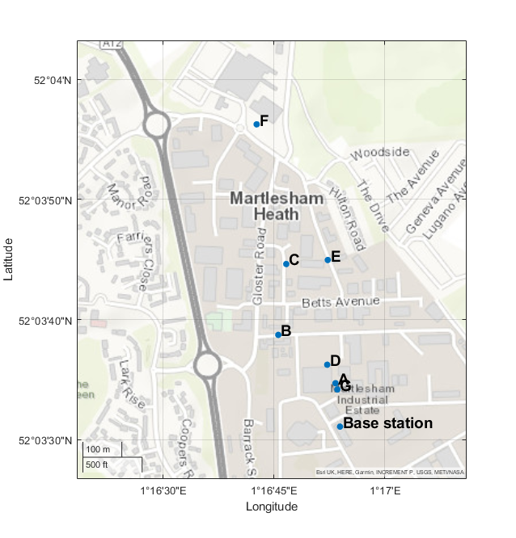
Figure A.1.1-1: Measurement point locations for the sample MIMO channels from a typical 4T4R base station for measurement campaign A.
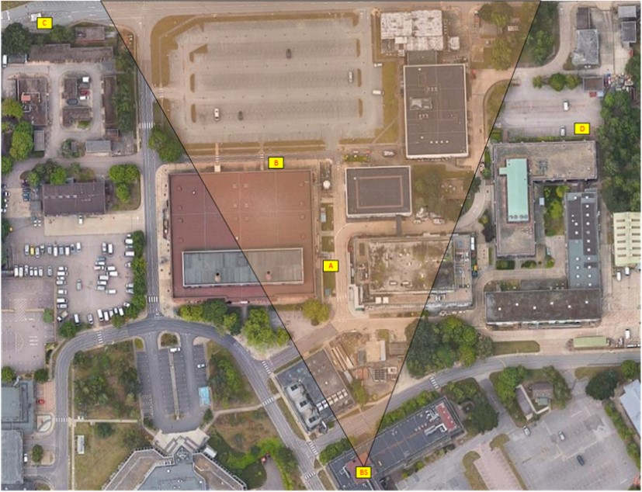
Figure A.1.2-1: Measurement point locations for the sample MIMO channels measurement campaign B.

A.2 Measurement Results
Analysis of sample MIMO channel measurements was provided covering following channel properties:
- Channel Eigenmodes
- Power Angular Distribution
- Time Coherence
- Frequency Coherence
- PMI Preference

A.2.1 Channel Eigenmodes
Histograms in Figure A.2.1-1 illustrate the distribution of singular values of measured MIMO channels in locations B and D, in conditions outlined in Section A.1.1.
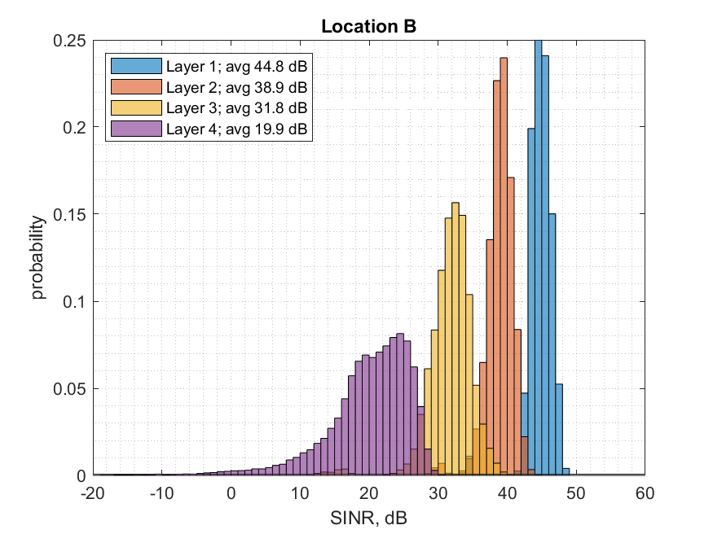 | 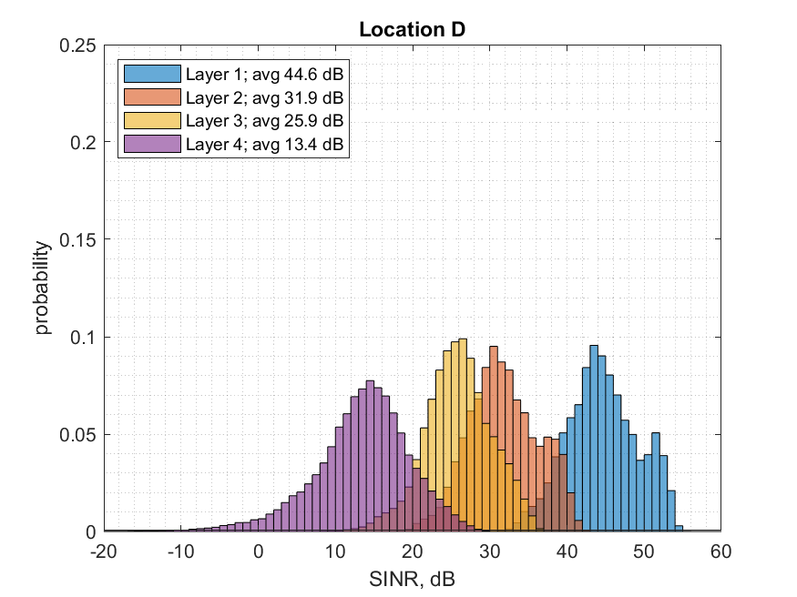
Figure A.2.1-1: Measurement campaign A. Histograms of the SINR assuming SVD precoding and combining for measurement locations with a strong line of sight (B), and for non-line-of-sight position (D)

Table A.2.1-1 Average eigenmode gains relative to the strongest spatial preference per measurement location
Location | Average gain relative strongest eigenmode, dB
 | Eigenmode 2 | Eigenmode 3 | Eigenmode 4
A | -4.85 | -20.70 | -33.18
B | -5.84 | -12.94 | -24.38
C | -7.48 | -15.71 | -27.86
D | -12.74 | -18.65 | -30.67
E | -7.92 | -14.89 | -24.89
F | -7.84 | -15.17 | -27.00
G | -7.91 | -18.58 | -31.92
Average | -7.80 | -16.66 | -28.56

Empirical CDFs of eigenmodes for Measurement campaign B are provided in Figure A.2.1-2.
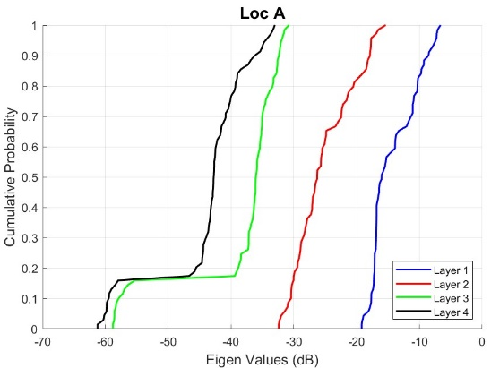 | 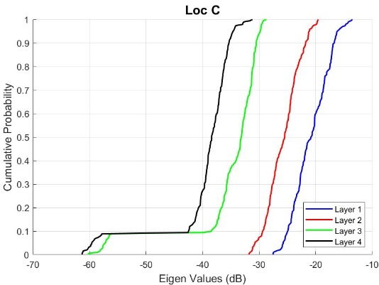
Figure A.2.1-2: Empirical CDF of Eigen Modes for Locations A and C.
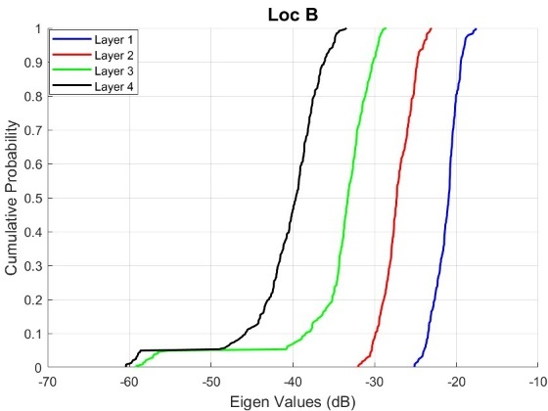 | 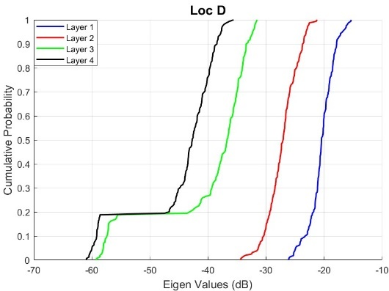
Figure A.2.1-3 Empirical CDF of Eigen Modes for Locations B and D.

A.2.2 Spatial Properties
Spatial properties were analysed based on measurement campaign B.
Angle of Arrival stability
Figure A.2.2-1 and Figure A.2.2-2 illustrate the estimated AoAs over time. In this analysis, the focus was on exploring whether MIMO channels in typical field deployments have long-term stable spatial preferences. Presence of three dominant arrivals was assumed and a simple implementation of MUSIC algorithm was applied to measured MIMO channel matrices.
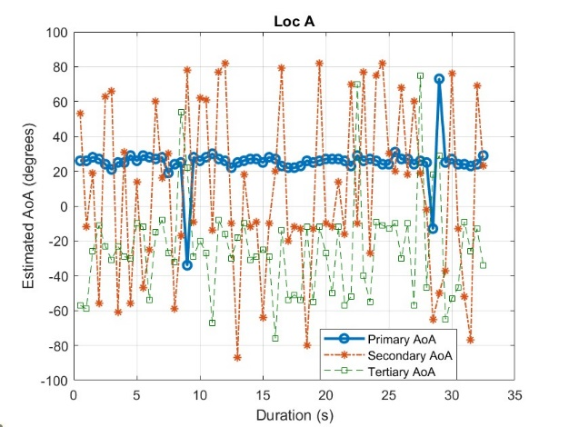 | 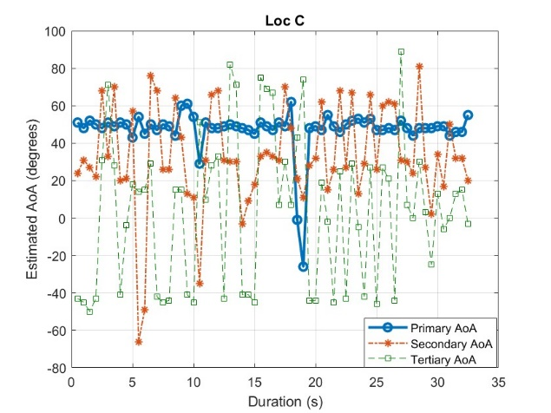
Figure A.2.2-1: Three primary AoAs for SRS from UE in Locations A and C.
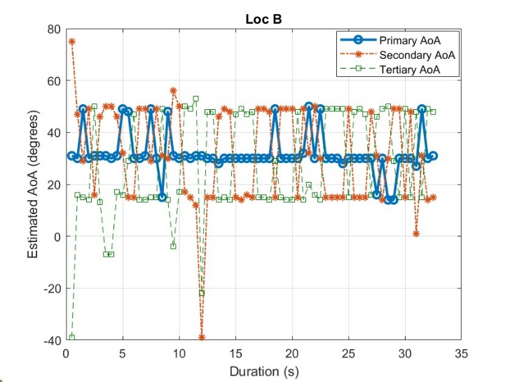 |  | 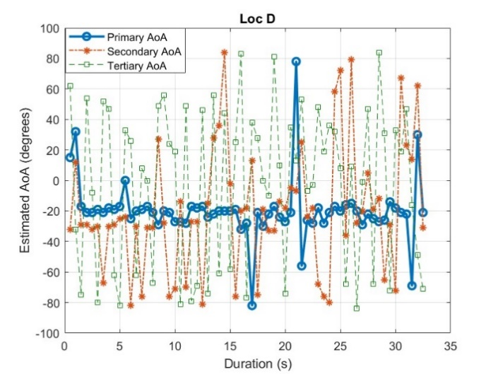
Figure A.2.2-2: Three primary AoAs for SRS from UE in Location B and D.

Angular Spread in MIMO channels
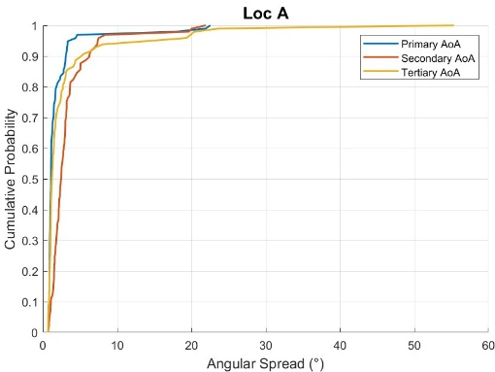 | 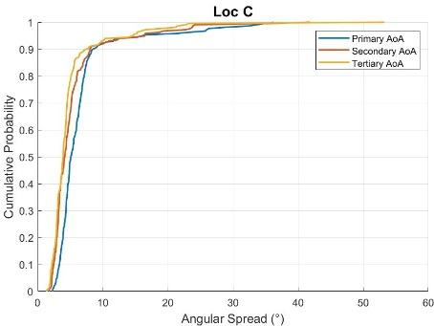
Figure A.2.2-3: Empirical CDF of Angular Spread for Locations A and C

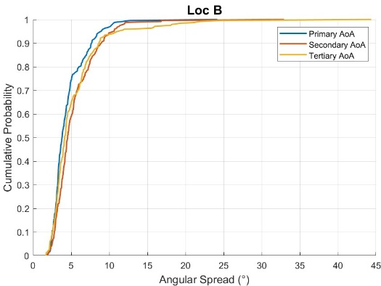 | 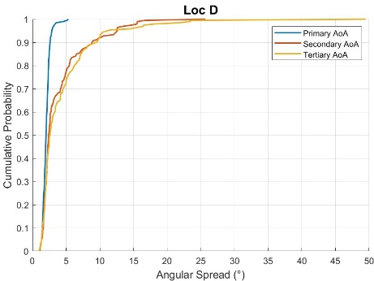
Figure A.2.2-4. Empirical CDF of Angular Spread for Locations B and D.
The empirical CDF of angular spread has been computed for 4 different locations, as shown in Figure A.2.2-3 and Figure A.2.2-4, to analyze spatial clustering characteristics. The Angles of Arrival (AoAs) were estimated using the MUSIC algorithm, identifying three dominant AoAs per location. The empirical CDF of angular spread is then computed separately around each of these AoAs. The analysis is conducted in the azimuth domain, where correlations are derived from the horizontal spatial relationships between antenna elements. To enhance statistical robustness, each estimate combines 25 consecutive SRS receptions, representing an observation period of 500 ms. This approach ensures a reliable representation of angular spread variations across different locations.
The analysis of angular spread CDFs around primary, secondary and tertiary AoAs suggests the presence of different types of spatial clusters in the MIMO channel environement. Primary clusters, characterized by a narrow angular spread, are crucial for high-SNR transmissions, while diffuse clusters with a broader angular spread enable higher-rank MIMO transmission. This presence of distinct spatial clusters indicates a spatial preference in MIMO channels, which is more acurately captured by CDL models.

Time Correlation Analysis
The time correlation across SRS transmissions is computed over the full duration of the dataset by evaluating the similarity between channel snapshots separated by forward time lags of up to 2 seconds. The general time correlation function $R(Δt)$ is given by the normalized inner product between channel vectors separated by a time lag $Δt$, averaged over all valid time indices:
$$R\left(Δt\right) =\frac{E\{h(t)h*(t + Δt)\}}{\sqrt{E\{h(t)h*(t )\}}\sqrt{E\{h(t + Δt)h*(t + Δt)\}}},$$
where $h(t)$ is the vectorized channel at time $t$, and $Δt=Δ T_{SRS}$ with $T_{SRS}=20 ms$ and $Δ∈\{0,1,2,…,100\}$. The expectation E[⋅] is approximated by a sample average across all antenna pairs and frequency realizations.
At each time lag $Δt$, the correlation is calculated between the channel at time $t$ and $t+Δt$. The results from all valid time indices $t$ for which both channel snapshots ($t and Δt$) are available are then averaged to obtain the average time correlation function $\overline{R}\left(Δt\right)$ . The coherence time $T_{c}$ is defined as the minimum time lag (in seconds) at which the average magnitude of the time correlation function drops below a specified threshold $γ:$
$$T_{c}=\min\left\{Δt \right| \overline{R}\left(Δt\right)|≤γ\}.$$

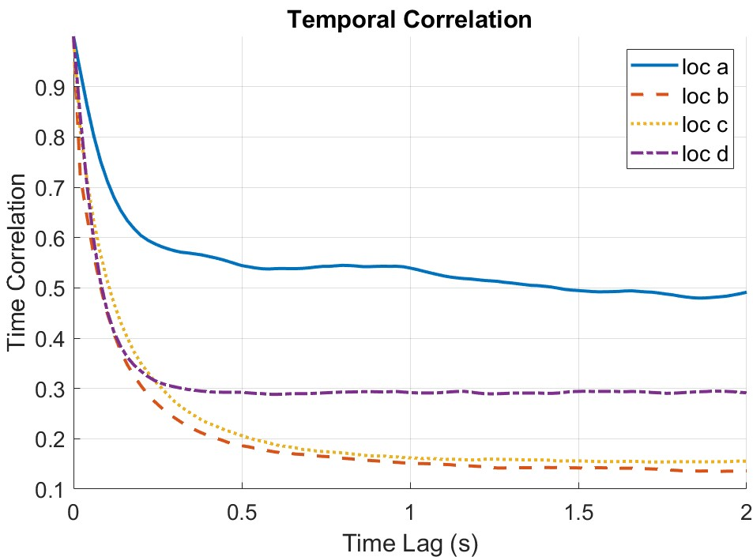
Figure A.2.2-5: Average Time Correlation Across Four Locations Highlighting Time Lag (s).

Table A.2.2-1: Temporal Channel Metrics: Coherence Time and Doppler Spread (γ=0.5).
 | Coherence Time, $T_{c}$ [s] | Doppler Spread$, f_{D}≈\frac{1}{2T_{c }}$, [Hz]
Location A | 1.44 | 0.3472
Location B | 0.1 | 5
Location C | 0.12 | 4.166
Location D | 0.1 | 5

Figure A.2.2-5 shows the average time correlation as a function of time lag for four different measurement locations (A–D). Location A displays the most temporally stable channel, with correlation remaining above 0.5 for lags approaching 2 seconds, indicating low Doppler spread and minimal channel variation over time. In contrast, Locations B and D exhibit steep correlation decay within the first 0.1 seconds, consistent with higher Doppler spread and more dynamic propagation environments, potentially due to complex scattering. Location C shows slightly slower decay than B and D but still indicates a fast-varying channel.

Frequency Correlation Analysis
To evaluate the frequency selectivity of the wireless channel, frequency correlation function (FCF) was computed across subcarriers and extract the corresponding coherence bandwidth. The normalized frequency correlation function is calculated as:
$$R_{f}(Δf)=\frac{E[h\left(f\right)⋅h{\left(f+Δf\right)}^{*}]}{\sqrt{E\left[{\left|h\left(f\right)\right|}^{2}\right]⋅E\left[{\left|h\left(f+Δf\right)\right|}^{2}\right]}}$$
where $h(f)$ is the channel frequency response at subband $f$. The expectation $E[⋅]$ is approximated by a sample average across all antenna pairs and time realizations, and $Δf$ is the frequency lag in subbands. The coherence bandwidth $f_{c}$is then defined as the frequency lag corresponding to $Δf$ at which the average magnitude of the FCF falls below a certain threshold $γ$:
$f_{c}=\min\left\{Δf \right| {|R}_{f}\left(Δf\right)|≤γ\}$.

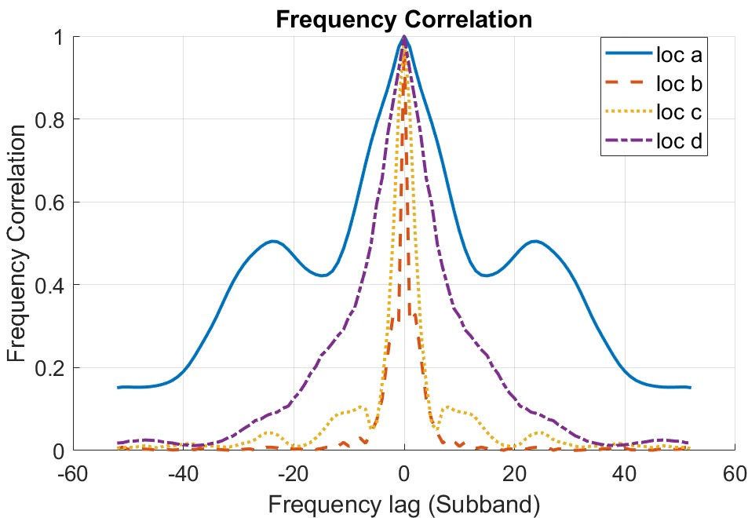
Figure A.2.2-6: Average Frequency Correlation Across Four Locations Highlighting Frequency Lag.

Table A.2.2-2: Channel Metrics: Coherence Bandwidth and Delay Spread (γ=0.5, subcarrier spacing= 30 KHz, 1 Subband = 2 PRBs).
 | Coherence bandwidth, $f_{c}$ [Hz] | Delay Spread$, T_{D}≈\frac{1}{2{ πf}_{c }}$, [ns]
Location A | 7.92 MHz | 20.1
Location B | 720 KHz | 221
Location C | 2.16 MHz | 73.7
Location D | 4.32 MHz | 36.8

Figure A.2.2-6 represents the frequency correlation functions computed across four measurement locations (A–D), plotted as a function of frequency lag in subbands. The results highlight distinct frequency selectivity characteristics, with location A exhibiting the slowest decorrelation across frequency, indicative of a flat (frequency-nonselective) channel. In contrast, locations B and C display a faster decorrelation, likely due to multipath delay spread or scattering richness. Location D exhibits intermediate behaviour with moderate correlation decay.
Table A.2.2-2 summarizes the estimated coherence bandwidths and corresponding delay spreads at a threshold of 0.5. The coherence bandwidth is determined as the minimum positive frequency lag at which the frequency correlation magnitude falls below the threshold. The delay spread is then estimated using the relation T_D≈1/(2πf_c ). These results underscore the spatial variability in frequency-domain characteristics.
PMI statistics
Figure A.2.2-7 presents the PMI statistics for four locations. This analysis aims to determine if there is a spatial preference experienced by a UE, as indicated by the PMI values in a channel state information (CSI) report. We input the time samples of the channel matrix from the first subband (captured by the SRS) into an in-house simulator. The simulator processes each H matrix to generate an NR 3GPP Release-15 Type-1 report. From this report, we extract the port-to-beam mapping (represented by PMI1) and the beam-to-layer mapping (represented by PMI2). The actual precoder for the PDSCH is the product of PMI1 and PMI2.
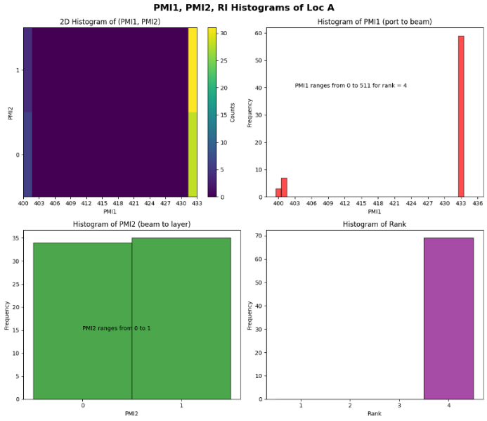 | 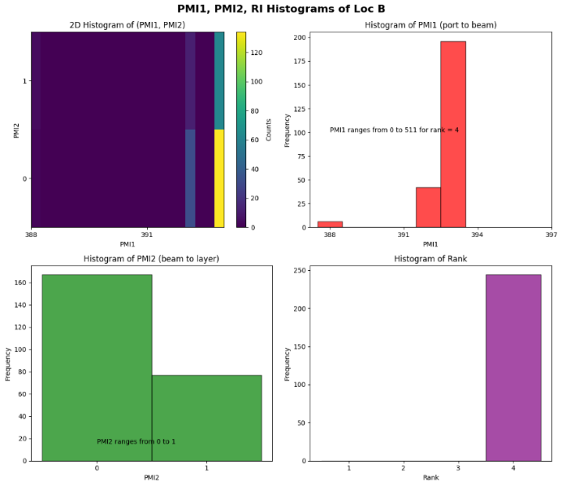
a) | b)
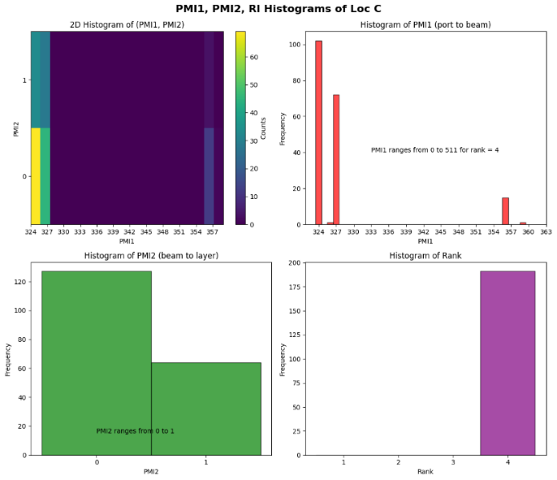 | 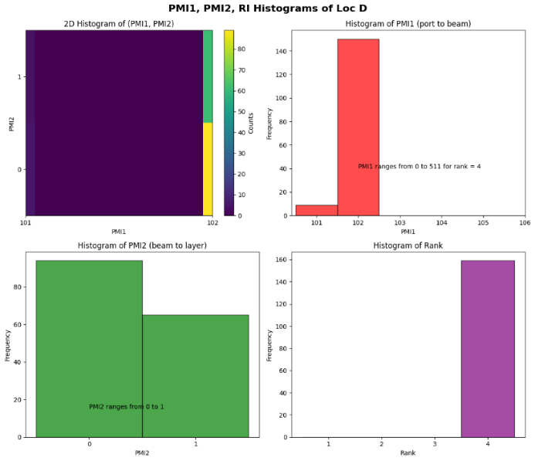
c) | d)
Figure A.2.2-7: PMI Statistics Across Four Locations Highlighting Spatial Preferences in UE
The results indicate that the UE prefers the highest rank (rank 4) for transmission among the PMI hypotheses {1,2,3,4}. For a rank of 4, there are 512 possible PMI1 hypotheses and two corresponding PMI2 hypotheses for each PMI1. The histograms reveal that the UE reports a subset of PMI1s, with one particular PMI being reported significantly more frequently than others. This suggests a spatial preference consistent with the PMI statistics shown in Figure 17 of [R4-2418043]. Furthermore, this observation is consistent with the Angle of Arrival (AoA) analysis detailed in [R4-2419338], where the primary AoA remained constant over time.

<End of Change 1>

