3GPP TSG-RAN WG4 Meeting #116 R4-2512558
Bangalore, India, August 25th – August 29th, 2025

Source: [MediaTek, Huawei,] BT
Title: pCR on TR 38.753 Section 6.3 Channel Properties
Agenda item: 7.12.2
Document for: Endorsement

- Introduction
During RAN4#116 the introduction of Section 6.3 to TR 38.753 was agreed. This contribution provides corresponding text proposal.
- Text Proposal

<Start of Change 1>

6.3 Channel Properties
Spatial channel properties were analysed qualitatively across TDL and CDL models in reference to provided field measurements, including angular distribution in Tx and Rx directions (stability and diversity) and spatial layer properties. Measurement results provided to this study are included in Annex A.

6.3.1 CDL
Following observations can be drawn:
- The spatial properties of TR 38.753 CDLC match well to measured typical deployment MIMO characteristics.
- For CDL models, both spatial and temporal properties are drawn from a common ray-based framework that resembles physical environments.
- CDL (link level) models are based on the same paradigm that is extensively used for system-level simulations by RAN1.
- Each tabulated CDL model corresponds to a single possible physical environment example with static long-term spatial properties.
- In this study item, RAN4 contributors had to spend considerable effort to clarify and align the understanding of the many practical details of CDL models.

6.3.1.1 Spatial properties
Estimated direction of arrivals (DoAs) from field measurements demonstrate a limited number of stable directions (environment properties).
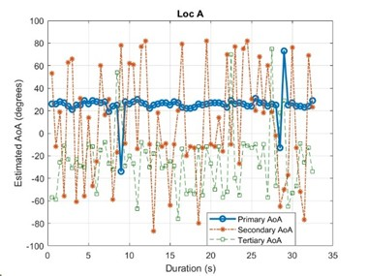 | 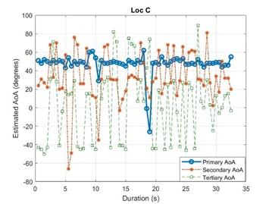
Figure 6.3.1.1-1: Three primary AoAs for SRS from UE in Locations A and C using MUSIC algorithm.
DoAs of the TR 38.753 based CDLC channel provide a limited number of mid-term stable directions (clusters), that slowly fade in and out over time (or rather with RE distance).
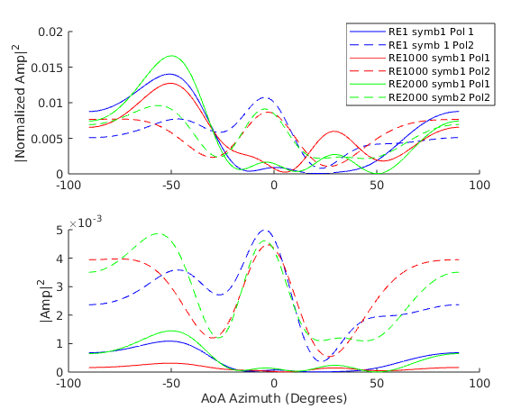 | 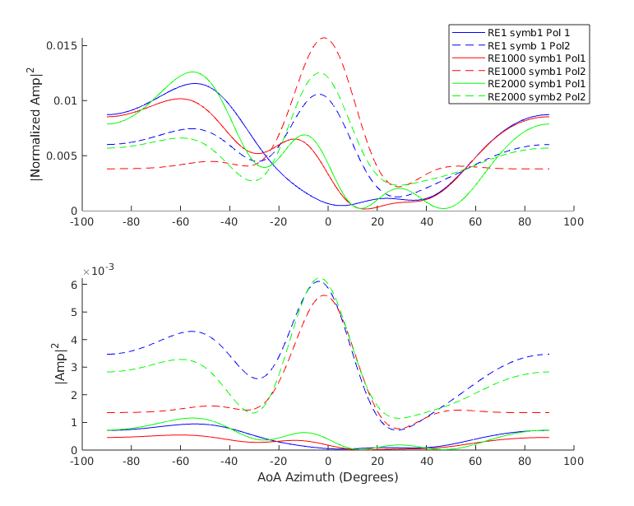
Slot 20 | Slot 1002
Figure 6.3.1.1-2: TR 38.753 based CDLC Uma Bartlett DoA analysis vs. relative “RE distance” (x-axis is DoA):
4x1 Xpol ULA assumption.
DoAs of the TR 38.753 based CDLC channel, we observe a limited number of mid-term stable directions (clusters), that slowly fade in and out over time (or rather with RE distance).
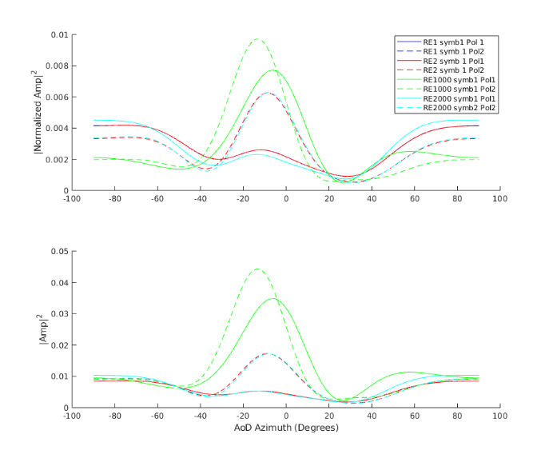 | 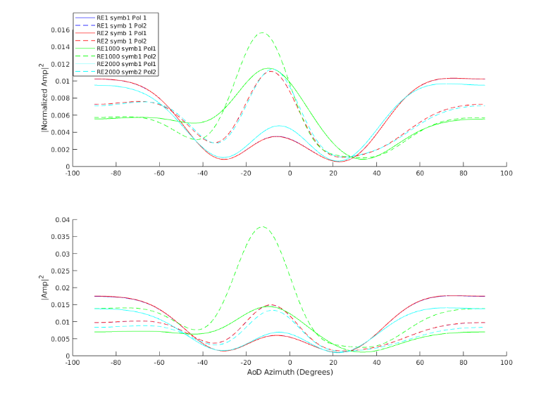
Slot 1 | Slot 100
Figure 6.3.1.1-3: TR 38.827 based CDLC Uma Bartlett DoA analysis vs. relative “RE distance” (x-axis is DoA):
4x1 Xpol ULA assumption.

6.3.1.2 SINR distributions
Per layer post-EQ SINR of each MIMO layer measured after the application of a baseband receiver/equalizer on the channel facing receive ports has been evaluated for CDL and TDL models in reference to measurements from field deployments. Post-EQ processed SINR distributions from field measurements, demonstrate that each spatial layer exhibits individual loss in a realistic deployment [R4-2402277, R4-2411557].
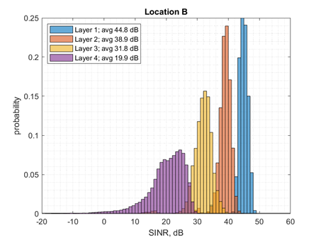 | 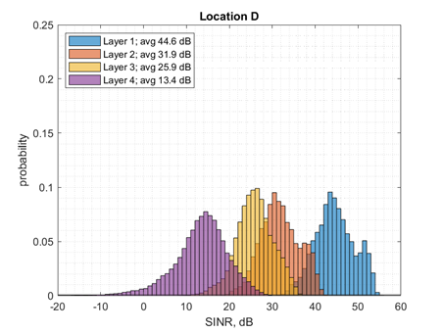
Figure 6.3.1.2-1: Histograms of the per layer SINR assuming SVD precoding and combining for measurement locations with a strong line of sight (B), and for non-line of sight position (D).
The post-EQ SINR distributions are derived with both random and fixed TypeI precoding and assuming MMSE-IRC receivers [R4-2509395]. The PDSCH post-EQ SINR profiles, when using TDL channel models do not match measurements. SDM processing does not impact performance, when using TDL channel models. CDL both shows typical post-EQ SINR profiles and typical deployment spatial components.
TDLC low | TDLC Med | 38.753 CDLC
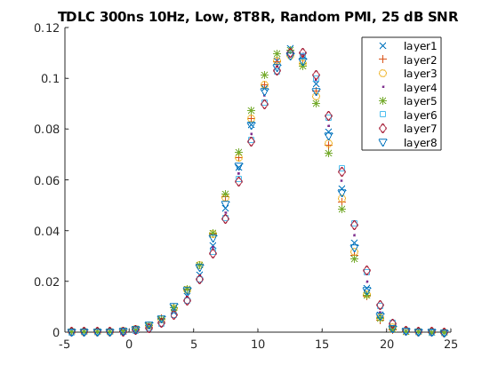 | 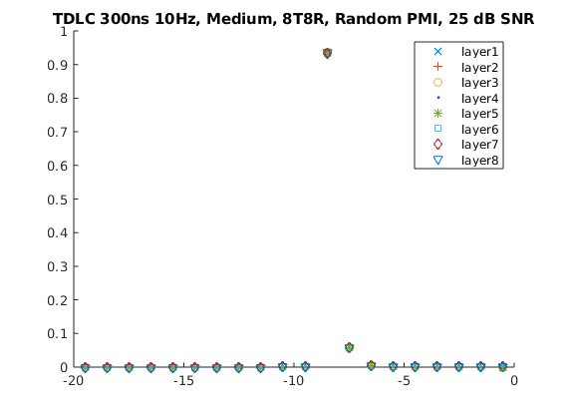 | 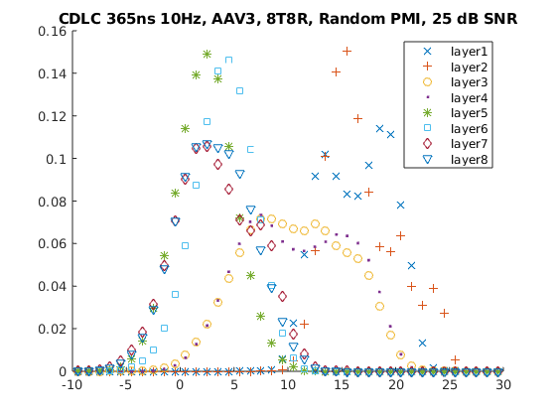
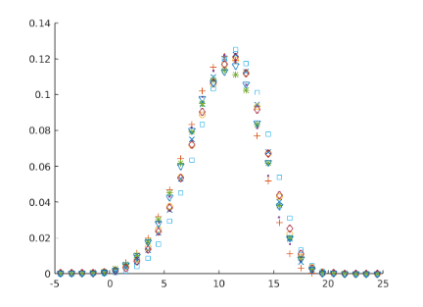 | 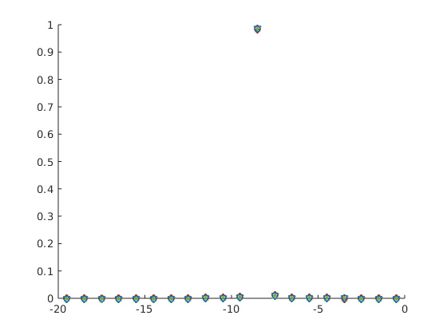 | 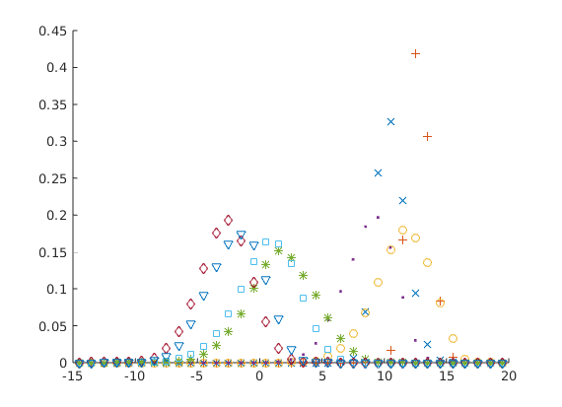
Figure 6.3.1.2-2: Post-EQ SINR distributions for channel candidates under random (top row) and fixed (bottom row) precoding.

6.3.2 TDL
Following observations can be drawn:
- Spatial properties of legacy channel models do not match the measured typical deployment MIMO characteristics
- The PDSCH post-EQ SINR profiles, when using TDL channel models do not match measurements. SDM processing does not impact performance, when using TDL channel models.
- TDL channel models are very simple and extensively used in RAN4 demodulation and CSI testing.
- Multi-cluster TDL models builds on top of the well-known and well-aligned legacy TDL models, and should therefore be easy to take into use by RAN4.
- Legacy TDL correlation models introduce strong spatial selectivity so that higher transmission ranks are either infeasible or require unreasonably high SNR or low MCS.
- The multi-cluster TDL model breaks the spatial limitations of the underlying spatially correlated legacy TDL model so that higher ranks can be supported.
- The multi-cluster TDL model does not alter the Doppler spread or the frequency selectivity of the underlying legacy TDL model.
- The multi-cluster TDL model can be configured by a handful of beam-steering parameters to match various desired test cases and features.

6.3.2.1 Spatial properties
Looking at the DoAs of a 3GPP (low correlation) TDL channel, the large-scale spatial preference of the per RE channels is seen to fully decorrelate after about 2.5ms (5 slots in our simulation); it could be argued that this already occurs after only 1ms
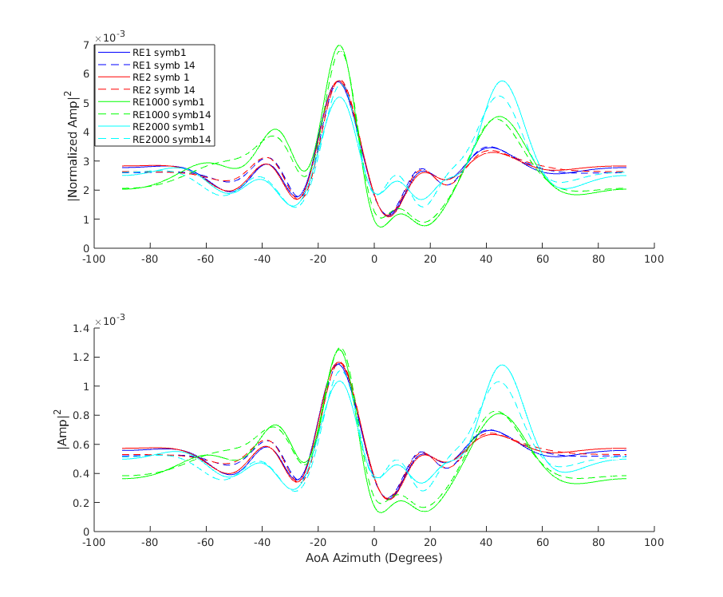 | 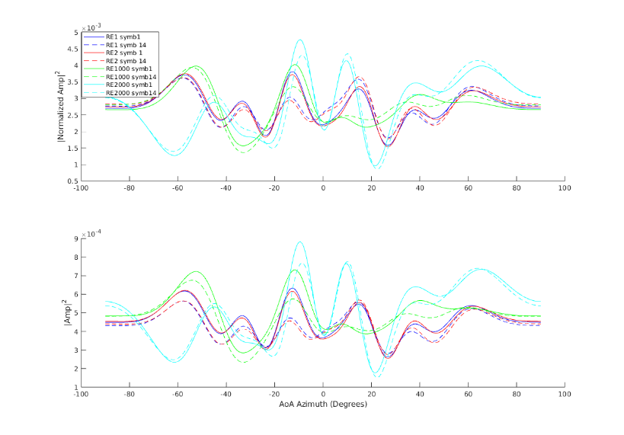
Slot 1 | Slot 5
Figure 6.3.2.1-1: TDLC300-100 (low) Bartlett DoA analysis vs. relative “RE distance”:
DoAs of a 3GPP TDLC300-100 MedA channel, we can directly see the limitation to broadside spatial preference, which remains unchanged indefinitely.
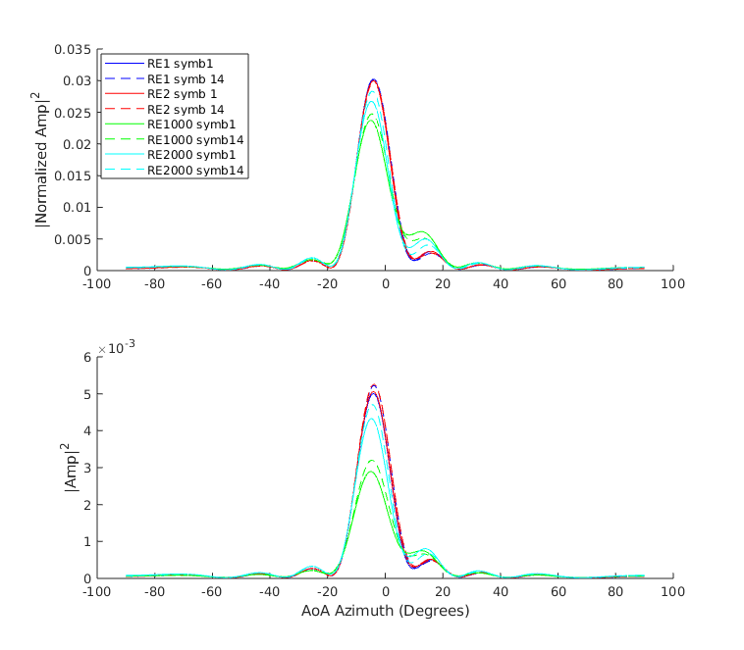 | 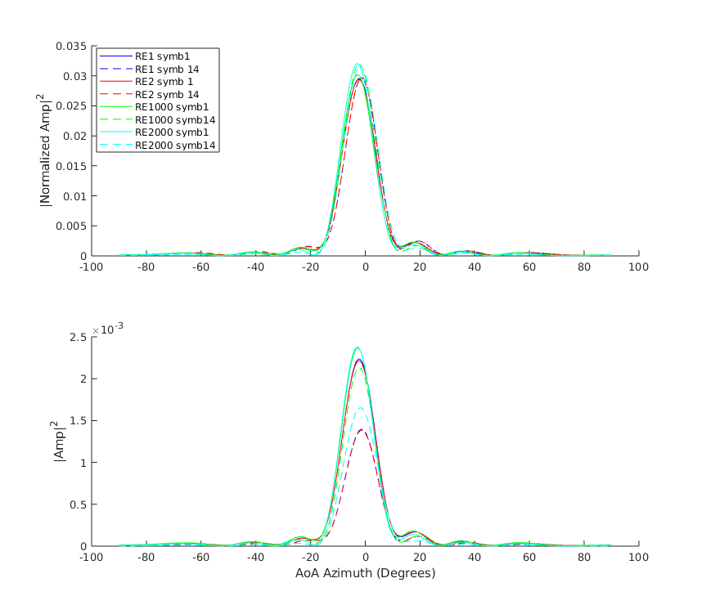
Slot 1 | Slot 5
Figure 6.3.2.1-2: TDLC300-100 (MedA) Bartlett DoA analysis vs. relative “RE distance”:

<End of Change 1>

References
- tbc.

