3GPP TSG RAN WG4 Meeting #116 R4-2512667
Bangalore, India, August 25th – 29th , 2025

Title: TP to TR 38.774 on transmitted signal quality (clause 7.2.4) for LP-WUS
Agenda Item: 7.28.2
Source: CATT, Ericsson
Document for: Discussion

1 Introduction
This contribution provides an initial version on Clause 7.2.4 for transmit signal quality based on the completed RAN1 LP-WUS signal design and the outcome of the corresponding RAN4 discussions.

2 Text proposal
< Start of change>

7.2.4 Transmitted signal quality

7.2.4.1 Transmitted signal generation for LP-WUS
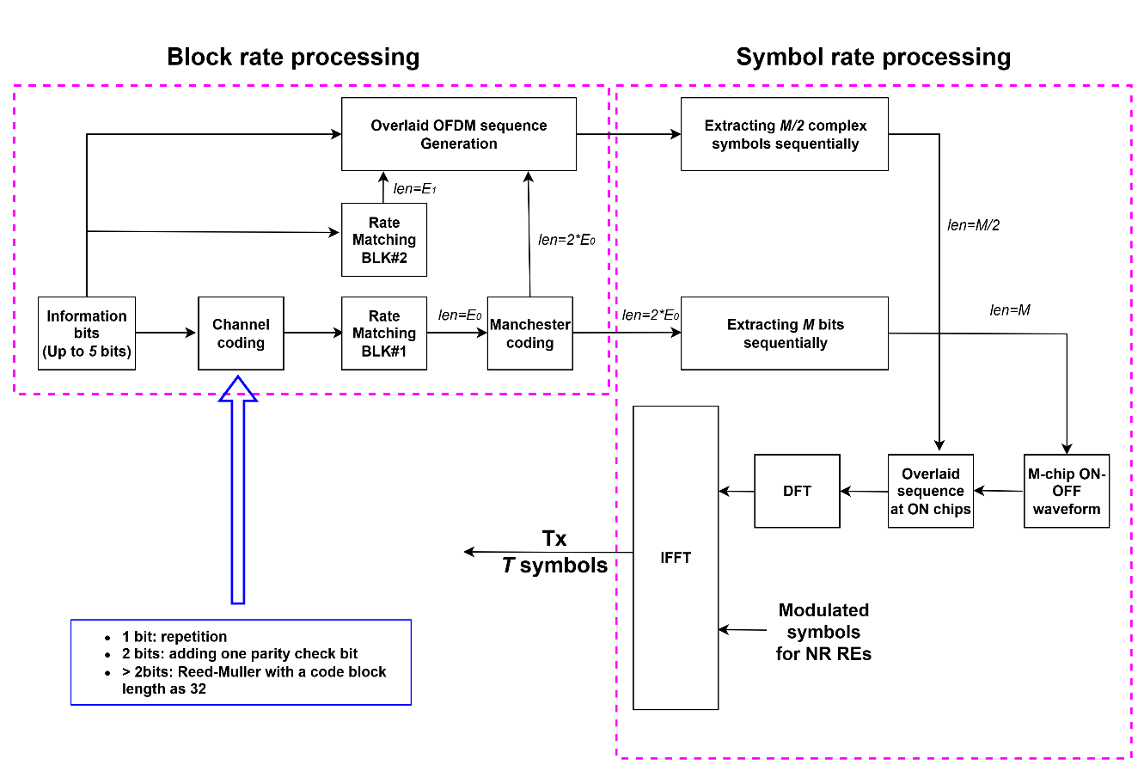
Fig. 7.2.4.1-1, Transmitted signal generation for LP-WUS
Figure 7.2.4.1-1 illustrates the LP-WUS signal generation process based on the completed RAN1 signal design. Up to 5 information bits are channel coded, followed by rate matching of the coded bits as the first bit block. The output is then Manchester coded, doubling the bit length as 2*E₀, where
- $E_{0}=\frac{N_{OS}∙M}{2}$
- $N_{OS}$ is the number of OFDM symbols allocated for the information bits configured by higher layer
- $M$ is the chip rate which means the number of ON-OFF chips per OFDM symbol.
In parallel, there is also another path directly from information bits to generate a corresponding overlaid OFDM sequence according to the outputs of both Manchester coding and the rate matching for the second bit block if present, and the generated overlaid OFDM sequence is to be overlaid on ON-chips after ON-OFF waveform generation. Both paths are performed on a per-block basis. With the overlaid OFDM sequency, an OFDM-based receiver can decode the information bits earlier than the final OFDM symbol corresponding to the information bits. Whereas a symbol-rate processing comes afterward, where for OOK-4 with M chips, all bits are grouped into M-bit tuples with each tuple associated with one OFDM symbol, and for each tuple an ON-OFF waveform is generated and then M ON-chips are replaced with M complex symbols sequentially extracted from the overlaid OFDM sequence. After the replacement, the waveform is transmitted in one symbol via a DFT module, and then the output is multiplexed across N sub-carriers with other NR modulated symbols followed by an IFFT operation to generate a time-domain signal for transmission.

7.2.4.2 EVM

The simulation results on the WUR performance degradation due to the EVM impairment from different companies are listed in Table 7.2.4.2-1.
Table 7.2.4.2-1: The WUR performance degradation with different EVM of LP-WUS
Companies | LP-WUS EVM | OOK WUR degradation (dB) | OFDM WUR degradation (dB)
Ericsson | 12,5% (16QAM) | 0.6 | 0.6
 | 8% (64QAM) | Minor (< 0.2) | Minor (< 0.2)
Nokia | 30% | Minor (< 0.2) | Minor (< 0.2)
ZTE | 20% | Minor (< 0.2) | Minor (< 0.2)

NR RF requirements for LP-WUS operation in the present release are specified assuming that LP-WUS signal transmitting signal quality is assured in NR BS with NR signal transmission.

<End of change>

