3GPP TSG-RAN WG4 Meeting #116 R4-25XXXXX

Bengaluru, India, 25th-29th Aug., 2025

Source: ZTE Corporation, Sanechips

Title: TP to TR 38.774 on other Rx requirements (Clause 7.1.9)

Agenda Item: 7.24.2

Document for: Approval

Introduction
In this contribution, we provided a text proposal for TR 38.774 on Clause 7.1.9 on other Rx requirements for LP-WUR based on the WF and contributions in last meeting [1][2][3][4].

Reference
- R4-2507936 WF for [115][136] NR_LPWUS_UERF, Vivo, RAN4#115, St. Julian’s, Malta, May 2025.
- R4-2505519 Further consideration on UE RF other Rx requirements for Rel-19 LP-WUS, Huawei, RAN4#115, St. Julian’s, Malta, May 2025.
- R4-2506116 Other RX requirements for LP-WUR, Nokia, RAN4#115, St. Julian’s, Malta, May 2025.
- R4-2506316 Discussion on receiver characteristics for LP-WUR, ZTE, RAN4#115, St. Julian’s, Malta, May 2025.

Text Proposal
<Start of Text Proposal>

7.1.9 Other Rx requirements
For other Rx requirements for LP-WUR, only spurious emissions is defined for LP-WUR because this is a regularity requirement.
The spurious emissions power is the power of emissions generated or amplified in a receiver that appear at the UE antenna connector. For receiver, the emissions at the antenna connector usually come from the reverse LO leakage. As illustrated in Figure 7.1.9-1 marked with the green line, the LO leakage ends at the antenna or antenna connector. The main LO frequency will dominate in-band spurious emissions, and the harmonic will dominate out-of-band spurious emissions. In a design with potential low isolation from LO to RF input, an LNA is required to attenuate the in-band spurious, and a band pass filter is required to ensure that out-of-band spurious is suppressed. Since the emissions could be considered as kind of regulatory requirements, the same levels for MR should also be defined for LR. Namely, the spurious emissions as specified in clause 7.9 in TS38.101-1 still applies.
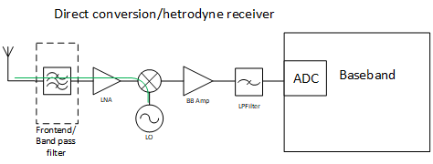
Figure 7.1.9-1 Illustration of a DC receiver

<End of Text Proposal>

