**3GPP TSG-RAN WG4 Meeting # 116 R4-25XXXXX**

**Bengaluru, India,** **25th -29th August, 2025**

**Agenda item:** 7.22.1

**Source:** Moderator (Huawei)

**Title:** Adhoc minutes for [116][135] A-IoT_BSCW

**Document for:** Information

# Introduction

**Discuss the following topics in adhoc session:**

Issue 1-1: Modulation quality

Issue 1-2: ACLR

Issue 1-3: OBUE

Issue 2-2: SNR value

Issue 2-4: ACS

Issue 2-6: General intermodulation

Issue 2-7: Narrowband intermodulation

Issue 3-2: Phase noise

Issue 3-4: CW channel bandwidth

# Topic #1: A-IoT BS TX

### Issue 1-1: Modulation quality

* Online agreement:
  + **Parameters:**

Discuss whether to agree with or revise the parameter definitions:

* + - An is measured peak high level for the nth chip, in units of V/m or A/m
    - Bn is either a pre-determined value in percentage of An or based on measured peak low level for the nth chip, in units of V/m or A/m
    - Anavg is the measured average high level for the nth chip during 1/2 duration above 90%An, in units of V/m or A/m
    - Bnavg is the measured average low level for the nth chip during 1/2 duration below 10%An, in units of V/m or A/m
  + **Modulation Depth:**
    - For each chip, Modulation depth =(Anavg-Bnavg)/Anavg
    - (Anavg–Bnavg)/Anavg>=80%
  + **RF Envelope Ripple**
    - **Option 1**

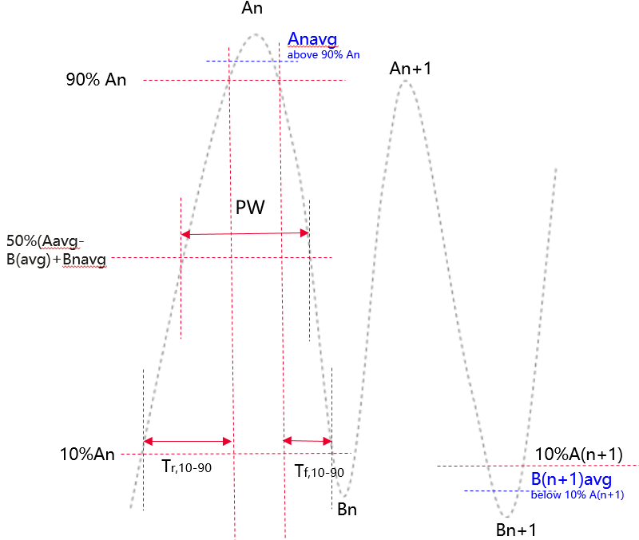

* + - * Ripple_high (%) = ((An − Anavg) / (Anag-Bnavg)) × 100% <=±15%
      * Ripple_low (%) = ((Bn − Bnavg) / (Anavg-Bnavg)) × 100%<=±15%
      * Note: SIP is included for the ripple requirement
  + **RF Envelope Rise/Fall Time:**
    - RF Envelop Rise Time: The time from 0.1 ×(Anavg-Bnavg) +Bnavg to 0.9 ×(Anavg-Bnavg)+Bnavg Tr,10-90 <=0.66Tc
    - RF Envelop Fall Time: The time from 0.9 ×(Anavg-Bnavg) +Bnavg to 0.1 ×(Anavg-Bnavg)+Bnavg Tf,10-90 <=0.66Tc
  + **RF Pulsewidth:** 
    - The pulse width is the time between two points on the pulse where the signal reaches 50% of (Anavg-Bnavg)+Bnavg, PW <=1.3 Tc

Offline Agreement：

* + - * Ripple_high (%) = ((An − Anavg) / (Anag-Bnavg)) × 100% <=±15%
      * Ripple_low (%) = ((Bn − Bnavg) / (Anavg-Bnavg)) × 100%<=±15%
      * Note：captured that in WF check whether modification is allowed up to implementation

Adhoc ：

* + - Bn definition
      * Option 1： Bn is pre-determined value in percentage of An
      * Option 2： Bn based on measured peak low level for the nth chip, in units of V/m or A/m
  + **RF Pulsewidth:** 
    - Option 1：The pulse width is the time between two points on the pulse where the signal reaches 50% of (Anavg-Bnavg)+Bnavg, PW <=1.3 Tc
    - Option 2：to be discussed in future.
* Table3: A-IoT BS RF envelope parameters

|  |  |  |  |  |
| --- | --- | --- | --- | --- |
| **R2D Chip duration：Tc** | **Parameter** | **Symbol** | **Value** | **Units** |
| $$Tc=\frac{{10}^{3}}{M*15}(us)$$ M∈ {2,6,12,24} | Modulation Depth | (A–B)/A | 80 | % |
| RF Envelope Ripple | Ripple_high  Ripple_low | <=±15 | % |
| RF Envelop Rise Time | Tr,10-90 | <=0.66Tc | µs |
| RF Envelop Fall Time | Tf,10-90 | <=0.66Tc | µs |
| RF Pulsewidth | PW | Option 1:<=1.3 Tc  Option 2: to be discussed in future | µs |

### Issue 1-2: ACLR

* Recommended WF
  + Option 1:100kHz offset, 35/40dB
  + Option 2: 100kHz offset, 40/45dB

Adhoc:

Check with ZTE on option 2 before Thurs.

### Issue 1-3: OBUE

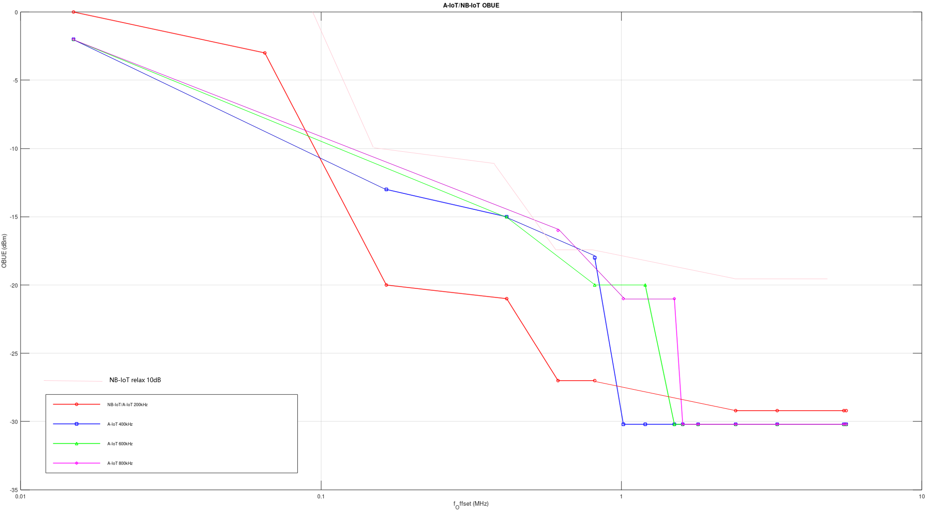

Adhoc:

* + Option 1:100kHz offset, 35/40dB
  + Option 2: 100kHz offset, 40/45dB
    - A-IoT OBUE compared with NB-IoT

|  |  |  |  |  |  |  |  |  |  |  |  |  |  |  |  |  |  |  |
| --- | --- | --- | --- | --- | --- | --- | --- | --- | --- | --- | --- | --- | --- | --- | --- | --- | --- | --- |
| f-offset(kHz) | 0.015 | 0.065 | 0.165 | 0.415 | 0.615 | 0.815 | 1.015 | 1.2 | 1.5 | 1.6 |  | 1.8 |  | 2.4 |  | 3.3 | 5.5 | 5.6 |
| NB-IoT/AIoT 200k | 0 | -3 | -20 |  | -21 |  | -27 |  | -27 |  |  |  |  |  |  | -29.2 | -29.2 | -29.2 |
| A-IoT 400k | -2 |  |  | -13 |  | -15 |  |  |  | -18 | -30.2 |  |  |  |  |  |  |  |
| A-IoT 600k | -2 |  |  |  | -15 |  |  | -20 |  |  |  | -20 | -30.2 |  |  |  |  |  |
| A-IoT 800k | -2 |  |  |  |  | -16 |  |  |  | -21 |  |  |  | -21 | -30.2 |  |  |  |

* + **For A-IoT micro BS with 200 kHz R2D CBW**,
  + Option 1： reuses the operating band unwanted emissions requirements of standalone NB-IoT Medium Range BS for A-IoT micro BS.
* Table 6.6.3.2H-1: Standalone NB-IoT medium range BS operating band unwanted emission limits, BS maximum output power 31 < Prated,c ≤ 38 dBm

|  |  |  |  |
| --- | --- | --- | --- |
| Frequency offset of measurement filter ‑3dB point, Δf | Frequency offset of measurement filter centre frequency, f_offset | Minimum requirement (Note 1, 2, 3) | Measurement bandwidth (Note 8) |
| 0 MHz ≤ Δf < 0.05 MHz  (Note 1) | 0.015 MHz ≤ f_offset < 0.065 MHz |  | 30 kHz |
| 0.05 MHz ≤ Δf < 0.15 MHz | 0.065 MHz ≤ f_offset < 0.165 MHz |  | 30 kHz |
| 0.15 MHz ≤ Δf < 0.6 MHz  (Note 1) | 0.015MHz ≤ f_offset < 0.615MHz |  | 30 kHz |
| 0.6 MHz ≤ Δf < 1 MHz | 0.615MHz ≤ f_offset < 1.015MHz |  | 30 kHz |
| (Note 6) | 1.015MHz ≤ f_offset < 1.5 MHz | Prated,c - 65 dB | 30 kHz |
| 1 MHz ≤ Δf ≤ 2.8 MHz | 1.5 MHz ≤ f_offset < 3.3 MHz | Prated,c - 52 dB | 1 MHz |
| 2.8 MHz ≤ Δf ≤ 5 MHz | 3.3 MHz ≤ f_offset < 5.5 MHz | min(Prated,c - 52 dB, -15dBm) | 1 MHz |
| 5 MHz ≤ Δf ≤ Δfmax | 5.5 MHz ≤ f_offset < f_offsetmax | Prated,c - 56 dB | 1 MHz |
| NOTE 1: The limits in this table only apply for operation with a standalone NB-IoT carrier adjacent to the Base Station RF Bandwidth edge.  NOTE 2: For BS supporting non-contiguous spectrum operation within any operating band the minimum requirement within sub-block gaps is calculated as a cumulative sum of contributions from adjacent sub blocks on each side of the sub block gap, where the contribution from the far-end sub-block shall be scaled according to the measurement bandwidth of the near-end sub-block.  NOTE 3: For BS supporting multi-band operation with Inter RF Bandwidth gap < 20MHz the minimum requirement within the Inter RF Bandwidth gaps is calculated as a cumulative sum of contributions from adjacent sub-blocks or RF Bandwidth on each side of the Inter RF Bandwidth gap, where the contribution from the far-end sub-block or RF Bandwidth shall be scaled according to the measurement bandwidth of the near-end sub-block or RF Bandwidth. | | | |

* For standalone NB-IoT medium range BS (maximum output power Prated,c ≤ 31 dBm), emissions shall not exceed the maximum levels specified in Tables 6.6.3.2H-2.
* Table 6.6.3.2H-2: Standalone NB-IoT medium range BS operating band unwanted emission limits, BS maximum output power Prated,c ≤ 31 dBm

|  |  |  |  |
| --- | --- | --- | --- |
| Frequency offset of measurement filter ‑3dB point, Δf | Frequency offset of measurement filter centre frequency, f_offset | Minimum requirement (Note 1, 2, 3, 4) | Measurement bandwidth (Note 8) |
| 0 MHz ≤ Δf < 0.05 MHz  (Note 1) | 0.015 MHz ≤ f_offset < 0.065 MHz |  | 30 kHz |
| 0.05 MHz ≤ Δf < 0.15 MHz | 0.065 MHz ≤ f_offset < 0.165 MHz |  | 30 kHz |
| 0.15 MHz ≤ Δf < 0.6 MHz  (Note 1) | 0.015MHz ≤ f_offset < 0.615MHz |  | 30 kHz |
| 0.6 MHz ≤ Δf < 1 MHz | 0.615MHz ≤ f_offset < 1.015MHz |  | 30 kHz |
| (Note 6) | 1.015MHz ≤ f_offset < 1.5 MHz | -34 dBm | 30 kHz |
| 1 MHz ≤ Δf ≤ 5 MHz | 1.5 MHz ≤ f_offset < 5.5 MHz | -21 dBm | 1 MHz |
| 5 MHz ≤ Δf ≤ Δfmax | 5.5 MHz ≤ f_offset < f_offsetmax | -25 dBm | 1 MHz |
| NOTE 1: The limits in this table only apply for operation with a NB-IoT carrier adjacent to the Base Station RF Bandwidth edge.  NOTE 2: For BS supporting non-contiguous spectrum operation within any operating band the minimum requirement within sub-block gaps is calculated as a cumulative sum of contributions from adjacent sub blocks on each side of the sub block gap, where the contribution from the far-end sub-block shall be scaled according to the measurement bandwidth of the near-end sub-block.  NOTE 3: For BS supporting multi-band operation with Inter RF Bandwidth gap < 20MHz the minimum requirement within the Inter RF Bandwidth gaps is calculated as a cumulative sum of contributions from adjacent sub-blocks or RF Bandwidth on each side of the Inter RF Bandwidth gap, where the contribution from the far-end sub-block or RF Bandwidth shall be scaled according to the measurement bandwidth of the near-end sub-block or RF Bandwidth.  NOTE 4: In case the carrier adjacent to the RF bandwidth edge is a NB-IoT carrier, the value of X = PNB-IoTcarrier – 31, where PNB-IoTcarrier is the power level of the NB-IoT carrier adjacent to the RF bandwidth edge. In other cases, X = 0. | | | |

* + Option 2：corrsponding relax with ACLR
* Table 6.6.3.2H-1: Standalone NB-IoT medium range BS operating band unwanted emission limits, BS maximum output power 31 < Prated,c ≤ 38 dBm

|  |  |  |  |  |  |  |  |
| --- | --- | --- | --- | --- | --- | --- | --- |
| Frequency offset of measurement filter ‑3dB point, Δf | | Frequency offset of measurement filter centre frequency, f_offset | | Minimum requirement (Note 1, 2, 3)  （with ACLR 40/50） | ACLR 40/45dB（onging） | ACLR  35/40dB（ongoing） | Measurement bandwidth (Note 8) |
| 0 MHz ≤ Δf < 0.05 MHz  (Note 1) | | 0.015 MHz ≤ f_offset < 0.065 MHz | |  | +x | +x+5 | 30 kHz |
| 0.05 MHz ≤ Δf < 0.15 MHz | | 0.065 MHz ≤ f_offset < 0.165 MHz | |  | +x | +x+5 | 30 kHz |
| 0.15 MHz ≤ Δf < 0.6 MHz  (Note 1) | | 0.015MHz ≤ f_offset < 0.615MHz | |  |  | +x+5 | 30 kHz |
| 0.6 MHz ≤ Δf < 1 MHz | | 0.615MHz ≤ f_offset < 1.015MHz | |  | +x | +x+5 | 30 kHz |
| (Note 6) | | 1.015MHz ≤ f_offset < 1.5 MHz | | Prated,c - 65 dB | Prated,c - 65 dB+x | Prated,c - 65 dB+x+5 | 30 kHz |
| 1 MHz ≤ Δf ≤ 2.8 MHz | | 1.5 MHz ≤ f_offset < 3.3 MHz | | Prated,c - 52 dB | Prated,c - 52 dB+x | Prated,c - 52 dB+x+5 | 1 MHz |
| 2.8 MHz ≤ Δf ≤ 5 MHz | | 3.3 MHz ≤ f_offset < 5.5 MHz | | min(Prated,c - 52 dB, -15dBm) | min(Prated,c - 52 dB, -15dBm) +x | min(Prated,c - 52 dB, -15dBm) +x+5 | 1 MHz |
| 5 MHz ≤ Δf ≤ Δfmax | | 5.5 MHz ≤ f_offset < f_offsetmax | | Prated,c - 56 dB | Prated,c - 56 dB | Prated,c - 56 dB | 1 MHz |
|  |  | | NOTE 1: The limits in this table only apply for operation with a standalone NB-IoT carrier adjacent to the Base Station RF Bandwidth edge.  NOTE 2: For BS supporting non-contiguous spectrum operation within any operating band the minimum requirement within sub-block gaps is calculated as a cumulative sum of contributions from adjacent sub blocks on each side of the sub block gap, where the contribution from the far-end sub-block shall be scaled according to the measurement bandwidth of the near-end sub-block.  NOTE 3: For BS supporting multi-band operation with Inter RF Bandwidth gap < 20MHz the minimum requirement within the Inter RF Bandwidth gaps is calculated as a cumulative sum of contributions from adjacent sub-blocks or RF Bandwidth on each side of the Inter RF Bandwidth gap, where the contribution from the far-end sub-block or RF Bandwidth shall be scaled according to the measurement bandwidth of the near-end sub-block or RF Bandwidth. | | | | |

* For standalone NB-IoT medium range BS (maximum output power Prated,c ≤ 31 dBm), emissions shall not exceed the maximum levels specified in Tables
* Table: A-IoT medium range BS operating band unwanted emission limits, BS maximum output power Prated,c ≤ 31 dBm

|  |  |  |  |  |  |  |  |
| --- | --- | --- | --- | --- | --- | --- | --- |
| Frequency offset of measurement filter ‑3dB point, Δf | | Frequency offset of measurement filter centre frequency, f_offset | | Minimum requirement (Note 1, 2, 3, 4) | ACLR 40/45dB（ongoing） | ACLR  35/40dB（onging） | Measurement bandwidth (Note 8) |
| 0 MHz ≤ Δf < 0.05 MHz  (Note 1) | | 0.015 MHz ≤ f_offset < 0.065 MHz | |  | +x |  | 30 kHz |
| 0.05 MHz ≤ Δf < 0.15 MHz | | 0.065 MHz ≤ f_offset < 0.165 MHz | |  |  |  | 30 kHz |
| 0.15 MHz ≤ Δf < 0.6 MHz  (Note 1) | | 0.015MHz ≤ f_offset < 0.615MHz | |  |  |  | 30 kHz |
| 0.6 MHz ≤ Δf < 1 MHz | | 0.615MHz ≤ f_offset < 1.015MHz | |  | +x | +x+5 | 30 kHz |
| (Note 6) | | 1.015MHz ≤ f_offset < 1.5 MHz | | -34 dBm | -34 dBm+x | -34 dBm+x | 30 kHz |
| 1 MHz ≤ Δf ≤ 5 MHz | | 1.5 MHz ≤ f_offset < 5.5 MHz | | -21 dBm | -21 dBm+x | -21 dBm+x | 1 MHz |
| 5 MHz ≤ Δf ≤ Δfmax | | 5.5 MHz ≤ f_offset < f_offsetmax | | -25 dBm | -25 dBm | -25 dBm | 1 MHz |
|  |  | | NOTE 1: The limits in this table only apply for operation with a NB-IoT carrier adjacent to the Base Station RF Bandwidth edge.  NOTE 2: For BS supporting non-contiguous spectrum operation within any operating band the minimum requirement within sub-block gaps is calculated as a cumulative sum of contributions from adjacent sub blocks on each side of the sub block gap, where the contribution from the far-end sub-block shall be scaled according to the measurement bandwidth of the near-end sub-block.  NOTE 3: For BS supporting multi-band operation with Inter RF Bandwidth gap < 20MHz the minimum requirement within the Inter RF Bandwidth gaps is calculated as a cumulative sum of contributions from adjacent sub-blocks or RF Bandwidth on each side of the Inter RF Bandwidth gap, where the contribution from the far-end sub-block or RF Bandwidth shall be scaled according to the measurement bandwidth of the near-end sub-block or RF Bandwidth.  NOTE 4: In case the carrier adjacent to the RF bandwidth edge is a NB-IoT carrier, the value of X = PNB-IoTcarrier – 31, where PNB-IoTcarrier is the power level of the NB-IoT carrier adjacent to the RF bandwidth edge. In other cases, X = 0. | | | | |

For A-IoT micro BS with 400/600/800kHz R2D CBW, use the operating band unwanted emissions requirements in Table 7 and 8. (R4-2509883，Huawei)

Table1 A-IoT medium range BS operating band unwanted emission limits, BS maximum output power 31 < Prated,c ≤ 38 dBm , for 400/600/800kHz R2D CBW

|  |  |  |  |  |  |
| --- | --- | --- | --- | --- | --- |
| **R2D CBW** | **Frequency offset of measurement filter ‑3dB point, Δf** | **Frequency offset of measurement filter centre frequency, f_offset** | **Minimum requirement (Note 1, 2)**  (**ACLR 40/45dB)** | **If ACLR 35/40dB** | **Measurement bandwidth (Note 8)** |
| 400kHz | 0 MHz ≤ Δf < 0.4 MHz | 0.015 MHz ≤ f_offset < 0.415 MHz | Prated,c -40dB - $\frac{11}{0.4}$ ($\frac{f_offset}{MHz}$- 0.015) dB | Prated,c -35dB - $\frac{11}{0.4}$ ($\frac{f_offset}{MHz}$- 0.015) dB | 30 kHz |
| 0.4 MHz ≤ Δf < 0.8 MHz | 0.415 MHz ≤ f_offset < 0.815 MHz | Prated,c - 51dB- $\frac{5}{0.4}$ ($\frac{f_offset}{MHz}$-0.415) dB | Prated,c - 46dB- $\frac{5}{0.4}$ ($\frac{f_offset}{MHz}$-0.415) dB | 30 kHz |
| 0.8 MHz ≤ Δf < 1.6 MHz | 0.815 MHz ≤ f_offset < 1.6 MHz | Prated,c - 56dB | Prated,c - 51dB | 30 kHz |
| 1.6 MHz ≤ Δf < Δfmax | 1.6 MHz ≤ f_offset < f_offsetmax | -25dBm | -25dBm | 100kHz |
| 600kHz | 0 MHz ≤ Δf < 0.6 MHz | 0.015 MHz ≤ f_offset < 0.615 MHz | Prated,c – 40dB - $\frac{13}{0.6}$ ($\frac{f_offset}{MHz}$-0.015) dB | Prated,c – 35dB - $\frac{13}{0.6}$ ($\frac{f_offset}{MHz}$-0.015) dB | 30 kHz |
| 0.6 MHz ≤ Δf < 1.2 MHz | 0.615 MHz ≤ f_offset < 1.2 MHz | Prated,c – 53dB - $\frac{5}{0.6}$ ($\frac{f_offset}{MHz}$-0.615) dB | Prated,c – 48dB - $\frac{5}{0.6}$ ($\frac{f_offset}{MHz}$-0.615) dB | 30 kHz |
| 1.2 MHz ≤ Δf < 1.8 MHz | 1.2 MHz ≤ f_offset < 1.8 MHz | Prated,c - 58dB | Prated,c - 53dB | 30 kHz |
| 1.8 MHz ≤ Δf < Δfmax | 1.8 MHz ≤ f_offset < f_offsetmax | -25dBm | -25dBm | 100K |
| 800kHz | 0 MHz ≤ Δf < 0.8 MHz | 0.015 MHz ≤ f_offset < 0.815 MHz | Prated,c – 40dB- $\frac{14}{0.8}$ ($\frac{f_offset}{MHz}$-0.015) dB | Prated,c – 35dB- $\frac{14}{0.8}$ ($\frac{f_offset}{MHz}$-0.015) dB | 30 kHz |
| 0.8 MHz ≤ Δf < 1.6 MHz | 0.815 MHz ≤ f_offset < 1.6 MHz | Prated,c – 54dB- $\frac{5}{0.8}$ ($\frac{f_offset}{MHz}$-0.815) dB | Prated,c – 49dB- $\frac{5}{0.8}$ ($\frac{f_offset}{MHz}$-0.815) dB | 30 kHz |
| 1.6 MHz ≤ Δf < 2.4 MHz | 1.6 MHz ≤ f_offset < 2.4 MHz | Prated,c - 59dB | Prated,c - 54dB | 30 kHz |
| 2.4 MHz ≤ Δf < Δfmax | 2.4 MHz ≤ f_offset < f_offsetmax | -25dBm | -25dBm | 100K |

Table 2 A-IoT medium range BS operating band unwanted emission limits, BS maximum output power Prated,c ≤ 31 dBm , for 400/600/800kHz R2D CBW

|  |  |  |  |  |  |
| --- | --- | --- | --- | --- | --- |
| **R2D CBW** | **Frequency offset of measurement filter ‑3dB point, Δf** | **Frequency offset of measurement filter centre frequency, f_offset** | **（new）Minimum requirement (Note 1, 2)** （note：this is revised from proposal in paper R4-2509883 to correct some error）  **ACLR 40/45dB** | **If ACLR 35/40dB** | **Measurement bandwidth (Note 8)** |
| 400kHz | 0 MHz ≤ Δf < 0.4 MHz | 0.015 MHz ≤ f_offset < 0.415 MHz | -9dBm - $\frac{11}{0.4}$ ($\frac{f_offset}{MHz}$- 0.015) dB | -4dBm - $\frac{11}{0.4}$ ($\frac{f_offset}{MHz}$- 0.015) dB | 30 kHz |
| 0.4 MHz ≤ Δf < 0.8 MHz | 0.415 MHz ≤ f_offset < 0.815 MHz | -20dBm- $\frac{5}{0.4}$ ($\frac{f_offset}{MHz}$-0.415) dB | -15dBm- $\frac{5}{0.4}$ ($\frac{f_offset}{MHz}$-0.415) dB | 30 kHz |
| 0.8 MHz ≤ Δf < 1.6 MHz | 0.815 MHz ≤ f_offset < 1.6 MHz | -25dBm | -20dBm | 30 kHz |
| 1.6 MHz ≤ Δf < Δfmax | 1.6 MHz ≤ f_offset < f_offsetmax | -25dBm | -25dBm | 100kHz |
| 600kHz | 0 MHz ≤ Δf < 0.6 MHz | 0.015 MHz ≤ f_offset < 0.615 MHz | -9dBm - $\frac{13}{0.6}$ ($\frac{f_offset}{MHz}$-0.015) dB | -5dBm - $\frac{13}{0.6}$ ($\frac{f_offset}{MHz}$-0.015) dB | 30 kHz |
| 0.6 MHz ≤ Δf < 1.2 MHz | 0.615 MHz ≤ f_offset < 1.2 MHz | -22dBm - $\frac{5}{0.6}$ ($\frac{f_offset}{MHz}$-0.615) dB | -17dBm - $\frac{5}{0.6}$ ($\frac{f_offset}{MHz}$-0.615) dB | 30 kHz |
| 1.2 MHz ≤ Δf < 1.8 MHz | 1.2 MHz ≤ f_offset < 1.8 MHz | -27dBm | -22dBm | 30 kHz |
| 1.8 MHz ≤ Δf < Δfmax | 1.8 MHz ≤ f_offset < f_offsetmax | -25dBm | -25dBm | 100K |
| 800kHz | 0 MHz ≤ Δf < 0.8 MHz | 0.015 MHz ≤ f_offset < 0.815 MHz | -9dBm - $\frac{14}{0.8}$ ($\frac{f_offset}{MHz}$-0.015) dB | -5dBm - $\frac{14}{0.8}$ ($\frac{f_offset}{MHz}$-0.015) dB | 30 kHz |
| 0.8 MHz ≤ Δf < 1.6 MHz | 0.815 MHz ≤ f_offset < 1.6 MHz | -23dBm - $\frac{5}{0.8}$ ($\frac{f_offset}{MHz}$-0.815) dB | -18dBm - $\frac{5}{0.8}$ ($\frac{f_offset}{MHz}$-0.815) dB | 30 kHz |
| 1.6 MHz ≤ Δf < 2.4 MHz | 1.6 MHz ≤ f_offset < 2.4 MHz | -28dBm | -23dBm | 30 kHz |
| 2.4 MHz ≤ Δf < Δfmax | 2.4 MHz ≤ f_offset < f_offsetmax | -25dBm | -25dBm | 100K |

# Topic #2: A-IoT BS RX

### Issue 2-2: SNR value

Adhoc agreement:

Agree the average [-5dB] SNR for BPSK

Adhoc :Check with ZTE before Thurs，whether can be down selected

Option 1:If OOK ON level as reference，OOK sensitivity is X+6dB；

Option 2:If OOK Average level as reference，OOK sensitivity is X+3dB

### Sensitivity

offline

Add a note： the refsens is not included IRC CW phase noise cancellation capability.

### Issue 2-4: ACS

Agreement on line:

Specify ACS requirement for A-IOT BS with one of the following options

* + Option 1: Modify the ACS of NB-IoT standalone MR BS
    - no need to consider the 7.5kHz misalignment
    - Interfering signal mean power [-47~-60]dBm or ACS is relaxed to [20-30dB].
  + Option 2: Reuse the ACS of NB-IoT standalone MR BS for 200kHz. The ACS for other CBW can be scaled accordingly

Adhoc:

ZTE： option 1 is ok with 200kHz D2R；need further check with 3.52MHz D2R

* Table 15: Adjacent channel selectivity for A-IoT Medium Range BS

|  |  |  |  |  |
| --- | --- | --- | --- | --- |
| A-IoT  channel bandwidth of the lowest/highest carrier received [kHz] | Wanted signal mean power [dBm] | Interfering signal mean power [dBm] | Interfering signal centre frequency offset to the lower/upper Base Station RF Bandwidth edge or sub-block edge inside a sub-block gap [kHz] | Type of interfering signal |
| 200 | PREFSENS + 6dB (Note) | -53 | ±100 | 5 MHz DFT-s-OFDM NR signal, 15 kHz SCS, 1 RB |
| 3520 | PREFSENS + 6dB (Note) | -53 | ±100 | 3 MHz DFT-s-OFDM NR signal |
| Note: PREFSENS depends on the sub-carrier spacing as specified in Table X | | | | |

### Issue 2-6: General intermodulation

Adhoc agreement :

No need.

### Issue 2-7: Narrowband intermodulation

ZTE：difficult to calculate all the frequency combination which fall into R2D bandwidth，can go with define two kind of D2R BW（200kHz and 3.52MHz）

Ericsson: similar view as ZTE, can be defined.

Adhoc agreement:

for narrow band IMD requirements, the interference level is suggested as -53dBm. Other parameters reuse the same value as NB IoT system.

Table 7.5.1-1c: Narrowband blocking requirement for NB-IoT standalone

|  |  |  |  |  |
| --- | --- | --- | --- | --- |
|  | NB-IoT  channel bandwidth of the lowest/highest carrier received [kHz] | Wanted signal mean power [dBm] | Interfering signal mean power [dBm] | Type of interfering signal |
| Medium Range BS | 200 | PREFSENS + 6dB (Note 3) | -53 | See Table 7.5.1-2a |
|  | 3520 | PREFSENS + 6 dB (Note 3) | -53 |  |
| Note 1: PREFSENS depends on the sub-carrier spacing as specified in Table | | | | |

Table 7.5.1-2a: Interfering signal for Narrowband blocking requirement for NB-IoT standalone operation BS

|  |  |  |
| --- | --- | --- |
| NB-IoT  channel bandwidth of the lowest/highest carrier received [kHz] | Interfering RB centre frequency offset to the lower/upper Base Station RF Bandwdith edge or sub-block edge inside a sub-block gap [kHz] | Type of interfering signal |
| 200 | ±(240 +m*180),  m=0, 1, 2, 3, 4, 9, 14 | 3 MHz E-UTRA signal, 1 RB* |
| 3520 | ±(240 +m*180),  m=0, 1, 2, 3, 4, 9, 14 | 3 MHz E-UTRA signal, 1 RB* |
| Note*: Interfering signal consisting of one resource block is positioned at the stated offset, the channel bandwidth of the interfering signal is located adjacently to the lower/upper Base Station RF Bandwidth edge. | | |

# Topic #3: CW

### Issue 3-2: Phase noise

Adhoc

Ericsson： Ericsson also has proposal for phase noise.

ZTE: Ericsson ‘s proposal is based on simulation, a little too challenge.

QC: if based on implementation, too loose may be

Check later

The limit of phase noise can be defined as -30 dBm/7.5kHz at 120kHz offset from the center frequency of CW; [x] dBm/[?]kHz at 7.5kHz offset

**Table 1 Phase noise requirement for the CW node**

|  |  |
| --- | --- |
| **Frequency distance toward the CW centre** | **Phase noise (dBc/Hz)** |
| **7.5kHz** | **[-97]** |
| **120kHz** | **-102** |

### Issue 3-4: CW channel bandwidth

* Recommended WF
  + No definition of channel bandwidth for CW is needed.

Adhoc:

Check later with CATT