**3GPP TSG-RAN4 Meeting #116  *rev* R4-2509884**

**Bengaluru, India,** **25th -29th August, 2025**

Source: Huawei, HiSilicon,[Ericsson, ZTE]

Title: draft TP to TS38194 on Transmitted signal quality

Agenda Item: 7.22.3.1

Document for: Approval

# Text Proposal

<Start of Change>

## 6.4 Transmitted signal quality

### 6.4.1 Frequency error

.6.4.1.1 General

The requirements in clause 6.4.1 apply to the *transmitter ON period*.

Frequency error is the measure of the difference between the actual BS transmit frequency and the assigned frequency. The same source shall be used for RF frequency and data clock generation.

For *BS type 1-C* this requirement shall be applied at the *antenna connector* supporting transmission in the *operating band*.

6.4.1.2 Minimum requirement for *BS type 1-C*

For *BS type 1-C*, the modulated carrier frequency of each NR carrier configured by the BS shall be accurate to within the accuracy range given in table 6.4.1.2-1 observed over 1 ms.

**Table 6.5.1.2-1: Frequency error minimum requirement**

|  |  |
| --- | --- |
| **BS class** | **Accuracy** |
| Medium Range BS | ±0.1 ppm |

### 6.4.2 Modulation quality

Based on TS38.291, R2D signal includes SIP (Start indicator part), CAP (Clock acquisition part), PRDCH, the R2D postamble and padding if needed.

~~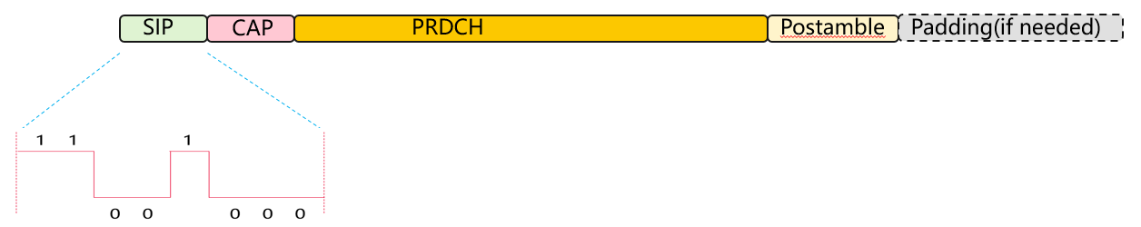~~

Figure 1 R2D signal composition

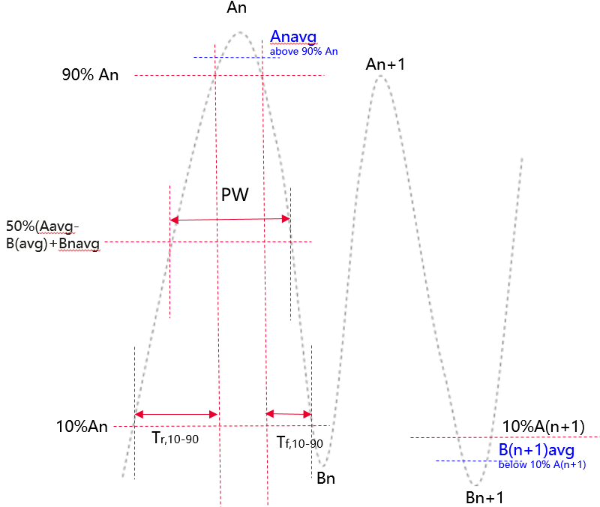

Figure3 R2D signal diagram

An is measured peak high level for the nth chip, in units of V/m or A/m

Bn is measured peak low level for the nth chip, in units of V/m or A/m

Anavg is the measured average high level for the nth chip during1/2 duration above 90%An, in units of V/m or A/m

Bnavg is the measured average low level for the nth chip during 1/2 duration below 10%An, in units of V/m or A/m

Modulation depth:

Modulation depth is defined with equation below and modulation depth for OOK chip 0/1 shall meet the requirements in Table 6.4.2-1.

Modulation depth =(Anavg-Bnavg)/Anavg

The envelope of electric filed strength for OOK chip 0 RF pulse shall comply the timing mask in Figure 6.4.2-1 and meet the requirements in Table 6.4.2-1. The envelope of electric filed strength for OOK Bit 0 shall decrease monotonically from 90% to less than 10 % of initial value Einitial during t1. The envelope of electric filed strength for OOK Bit 0 shall increase monotonically from 10% to less than 90 % of its initial value Einitial during t3. The initial value Einitial is defined as the field strength difference between Anavg and Bnavg.

RF Envelop Rise Time:

The Tr,10-90 measures the rise of the OOK bit 0 pulse and starts when envelop rises to 10% level of the initial value Einitial and ends when the envelop rises to 90% of the initial value Einitial.

RF Envelop Fall Time:

The Tf,10-90 measures the fall time of the OOK chip 0 pulse and starts when envelop falls to 90% level of the initial value Einitial and ends when the envelop falls to 10% of the initial value Einitial.

Tf,10-90 starts when the envelop drops to the 90% level of the initial value Einitial and ends when envelop rise to 10% level of the initial value Einitial.

Ripple:

Ripple_high (%) = ((An − Anavg) / (Anag-Bnavg)) × 100%

Ripple_low (%) = ((Bn − Bnavg) / (Anavg-Bnavg)) × 100%

In case of an overshoot or undershoot the field shall remain within +/- Ripple_high % of Einitial for OOK chip 1 and +/-Ripple_low % of Einitial for OOK chip 0.

Pulsewidth

The PW measures the time between envelop falling edge at 50% of the initial value Einitial and envelop rinsing edge at 50% of the initial value Einitial.

Table 3: A-IoT BS RF envelope parameters



* Table 6.4.2-1: A-IoT BS RF envelope parameters

|  |  |  |  |  |
| --- | --- | --- | --- | --- |
| **R2D Chip duration：Tc** | **Parameter** | **Symbol** | **Value** | **Units** |
| M∈ {2,6,12,24} | Modulation Depth | (A–B)/A | 80 | % |
| RF Envelope Ripple | Ripple_high  Ripple_low | <=±15 | % |
| RF Envelop Rise Time | Tr,10-90 | <=0.66Tc | µs |
| RF Envelop Fall Time | Tf,10-90 | <=0.66Tc | µs |
| RF Pulsewidth | PW | <=1.3 Tc | µs |



Figure 6.4.2-1:Timing mask for OOK chip 0 pulse

<End of Change>

# References

[1]RP-243326, New Work Item: Solutions for Ambient IoT (Internet of Things) in NR, RAN1 Vice-chair (Huawei), RAN#106 Dec.,2024