**3GPP TSG-RAN4 Meeting #116  *rev* R4-2509884**

**Bengaluru, India,** **25th -29th August, 2025**

Source: Huawei, HiSilicon

Title: draft TP to TS38194 on Transmitted signal quality

Agenda Item: 7.22.3.1

Document for: Approval

# Text Proposal

<Start of Change>

## 6.4 Transmitted signal quality

### 6.4.1 Frequency error

.6.4.1.1 General

The requirements in clause 6.4.1 apply to the *transmitter ON period*.

Frequency error is the measure of the difference between the actual BS transmit frequency and the assigned frequency. The same source shall be used for RF frequency and data clock generation.

For *BS type 1-C* this requirement shall be applied at the *antenna connector* supporting transmission in the *operating band*.

6.4.1.2 Minimum requirement for *BS type 1-C*

For *BS type 1-C*, the modulated carrier frequency of each NR carrier configured by the BS shall be accurate to within the accuracy range given in table 6.4.1.2-1 observed over 1 ms.

**Table 6.5.1.2-1: Frequency error minimum requirement**

|  |  |
| --- | --- |
| **BS class** | **Accuracy** |
| Medium Range BS | ±0.1 ppm |

### 6.4.2 Modulation quality

Based on TS38.291, R2D signal includes SIP (Start indicator part), CAP (Clock acquisition part), PRDCH, the R2D postamble and padding if needed. Agreement in [5] is that SIP（start indicator part） of R-TAS（R2D timing acquisition signal） is adopted with 2 OFDM symbol duration, i.e. ON-OFF-ON-OFF with a ratio of 2:2:1:3. The R-TAS SIP consists of $N_{\text{SIP}}=8$ bits denoted $S_{0},S_{1},S_{2}, S_{3},S_{4},S_{5},S_{6},S_{7}=1, 1, 0, 0, 1, 0, 0, 0$ As shown in Figure 1.

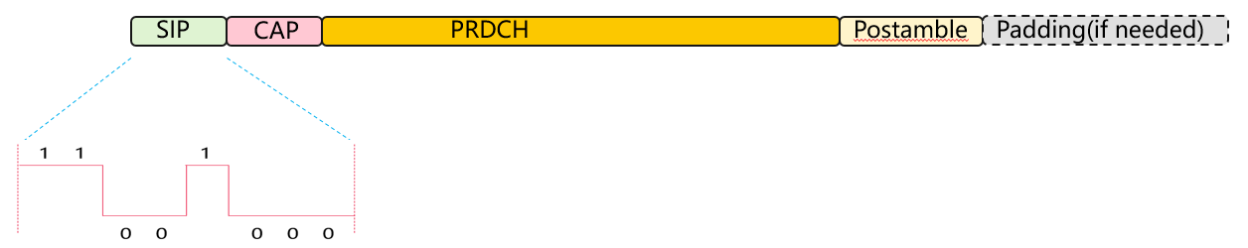

Figure 1 R2D signal composition

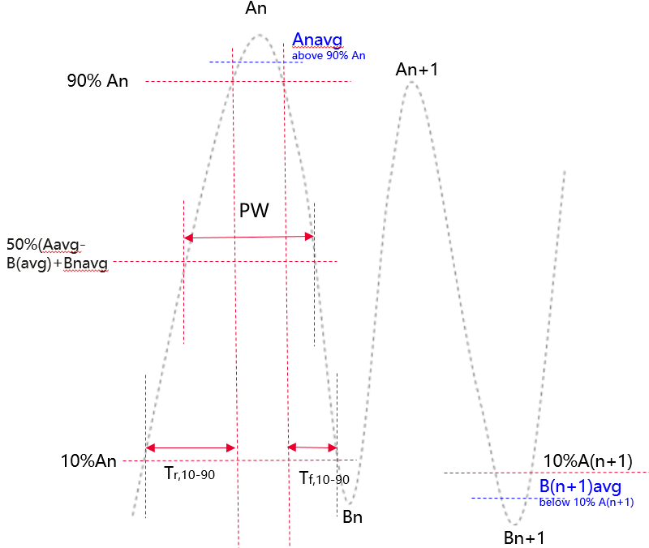

Figure3 R2D signal diagram

An is measured peak high level for the nth chip, in units of V/m or A/m

Bn is either a pre-determined value in percentage of An or based on measured peak low level for the nth chip, in units of V/m or A/m

Anavg is the measured average high level for the nth chip during1/2 duration above 90%An, in units of V/m or A/m

Bnavg is the measured average low level for the nth chip during 1/2 duration below 10%An, in units of V/m or A/m

Ripple:

Ripple_high (%) = ((An − Anavg) / (Anag-Bnavg)) × 100%

Ripple_low (%) = ((Bn − Bnavg) / (Anavg-Bnavg)) × 100%

Modulation depth:

For each chip, Modulation depth =(Anavg-Bnavg)/Anavg

RF Envelop Rise Time:

The time from 0.1 ×(Anavg-Bnavg) +Bnavg to 0.9 ×(Anavg-Bnavg)+Bnavg

RF Envelop Fall Time:

The time from 0.9 ×(Anavg-Bnavg) +Bnavg to 0.1 ×(Anavg-Bnavg)+Bnavg

Pulsewidth

The pulse width is the time between two points on the pulse where the signal reaches 50% of (Anavg-Bnavg)+Bnavg

the RF envelope requirements can be defined as Table 3.

Table 3: A-IoT BS RF envelope parameters



* Table3: A-IoT BS RF envelope parameters

|  |  |  |  |  |
| --- | --- | --- | --- | --- |
| **R2D Chip duration：Tc** | **Parameter** | **Symbol** | **Value** | **Units** |
| M∈ {2,6,12,24} | Modulation Depth | (A–B)/A | 80 | % |
| RF Envelope Ripple | Ripple_high  Ripple_low | <=±15 | % |
| RF Envelop Rise Time | Tr,10-90 | <=0.66Tc | µs |
| RF Envelop Fall Time | Tf,10-90 | <=0.66Tc | µs |
| RF Pulsewidth | PW | Option 1:<=1.3 Tc  Option 2: to be discussed in future | µs |

<End of Change>

# References

[1]RP-243326, New Work Item: Solutions for Ambient IoT (Internet of Things) in NR, RAN1 Vice-chair (Huawei), RAN#106 Dec.,2024