3GPP TSG-RAN4 Meeting #116 R4-2509721
Bengaluru, India, Aug.25th – 29th, 2025

Source: CMCC

Title: TP for TR 38.191 section 8.3 device positioning guidelines

Agenda Item: 7.22.5

Document for: Approval

Introduction
This TP will focus on section 5.3 Channel bandwidth and 5.4 Channel Arrangement.

Reference
[1]

Text Proposal
----- Start of TP -----

---Start of changes---

8.3 Device positioning guidelines

8.3.1 Free space
For Free space configuration, the centre of the reference coordinate system shall be aligned with the geometric centre of the DUT in order to minimize the offset between antenna arrays integrated at any position of the device and the centre of the quiet zone.
Table 8.3.1-1: Device positioning for Free space

Test condition | DUT  orientation | Diagram
Free space  DUT | α = 0º;  β = -90º;  γ = 0º | 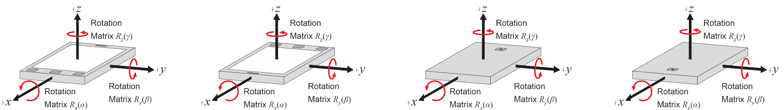
For Ambient IoT device, if the device has a rectangular shape, the DUT orientation in Table 8.3.1-1 is applied. The front and back side of device is based on device declaration. Otherwise, the device positioning is based on device declaration.

