3GPP TSG-RAN WG4 Meeting # 116 R4-2511797
Bengaluru, India, Aug. 25 – 29, 2025

Agenda item: 7.17.1
Source: vivo, NTU, Nokia, Ericsson, Qualcomm, Xiaomi, Huawei, Hisilicon, Mediatek, OPPO, APPLE, Rohde & Schwarz, CATT, Samsung, Intel, ZTE Corporation, Sanechips, CAICT
Title: WF on updated simulation assumption for AI based beam management
Document for: Approval

Introduction
In this contribution, the simulation assumption for AI/ML based BM case-1 is further updated based on [1]. Companies are encouraged to provide simulation results to evaluate the impact of the measurement error based on the performance metrics in section 5.

Simulation assumptions for baseband error
Link level simulation (LLS) assumptions and System level simulation (SLS) assumptionsfor evaluation of measurement error on AI/ML based BM case-1 performance are defined in Table 1-7.
Table 1 Baseline Link Level Simulation assumptions for AI/ML in beam management evaluations
Parameter | Value
Carrier frequency | 30GHz
Subcarrier spacing | 120kHz
Channel model | Case 1: NLOS channel  - Baseline:  - TDL-C, DS=100ns  - Optional:  - CDL-C, DS=100ns
 | Case 2: AWGN channel
BS antenna configurations | - Option 1:  - One panel: (M, N, P, Mg, Ng) = (4, 8, 2, 1, 1), (dV, dH) = (0.5, 0.5) λ as baseline.  - Number of Tx beams is 32  - Option 2:  - Number of TX beams: 1  - Baseband errors are independent for each TX beam
BS antenna element radiation pattern | Option1: Table 2  Option 2: N/A
BS antenna height and antenna array down-tilt angle, if needed (Option 1 above) | Option1: 25m, 110°  Option 2: N/A
Beamforming characteristic of the BS pattern | Use same assumption for System-level simulation assumption defined Table 6
UE antenna configurations | Option 1: Panel structure: (M, N, P) = (1, 4, 2),  - 2 panels (left, right) with (Mg, Ng) = (1, 2) as baseline  - 1 panel as optional  Number of Rx beams is up to UE  Option 2: 2 Rx
UE antenna element radiation pattern | Option 1: Table 3  Option 2: N/A
UE moving speed | 3km/h
Reference signal | SSB or CSI-RS
DRX | No
Number of samples in L1 averaging | Baseline:  - 1 sample  Optional:  - 3 samples  - 5 samples
Note 1: TXRU weights mapping for BS and UE is up to company.
Table 2 BS antenna radiation pattern
Parameter | Values
Antenna element vertical radiation pattern (dB)
Antenna element horizontal radiation pattern (dB)
Combining method for 3D antenna element pattern (dB)
Maximum directional gain of an antenna element G_{E,max} | 8dBi
Table 3 UE antenna radiation pattern model
Parameter | Values
Antenna element radiation pattern in dim (dB)
Antenna element radiation pattern in dim (dB)
Combining method for 3D antenna element pattern (dB)
Maximum directional gain of an antenna element G_{E,max} | 5dBi
Note: are in local coordinate system.
Table 4 Cell-specific parameters
Parameter | Unit | Value
PBCH and DMRS power offset with respect to NR-PSS and NR-SSS | dB | 0
Data and control PSD relative to NR-PSS and NR-SSS | dB | 0
SSB periodicity | ms | 20
SSB bandwidth | RB | 20
SSB SCS | kHz | 120
RB Utilization | % | 100
Data Modulation | - | QPSK
CP Length | - | Normal
Frequency Offset relative to UE frequency reference | Hz | 0
Relative Delay of 1st Path (synchronous) | µs | 0
SNR | dB | -3  Note: Simulation with other SNR levels are not precluded, e.g., for determining the SNR for ideal measurement.
Note: When analog beamforming is used in LLS, SNR value of above row represents the post beamforming SNR of the strongest Tx-Rx beam pair.
For other Tx-Rx beam pairs, there are two options.
Option 1: Apply error distribution from the post beamforming SNR of the strongest Tx-Rx beam pair to all Tx-Rx beam pair’s measurements in the SLS
Option 2: Generate error distribution separately for each individual Tx-Rx beam pair’s SNRs and apply to the corresponding Tx-Rx beam pair measurement in the SLS.

When analog beamforming is not used in LLS,
Apply error distribution based on the SNR of above row to the strongest Tx-Rx beam pair’s measurements in the SLS
Option 1: Apply error distribution from the SNR of above row to all Tx-Rx beam pairs’ measurements in the SLS
Option 2: Generate error distribution separately for each individual Tx-Rx beam pairs’ SNR values and apply to the corresponding Tx-Rx beam pair measurements in the SLS. SNR of the strongest Tx-Rx beam pair can be fixed or not fixed.

Table 5 CSI-RS configuration parameters
Parameter | Value
CSI-RS bandwidth | 48 PRBs;
CSI-RS SCS | 120 kHz
Periodicity | 5 ms (optional); 40 ms
CSI-RS configuration:  <X,D,N,CDM>, where:  X=number of CSI-RS ports,  D=density [RE/RB/port],  N=number of OFDM symbols in the same slot | <32,1,4,FD-CDM2>
Table 6 Beamforming characteristic of the BS pattern for System-Level simulation assumption in narrow-to-narrow scenario
Parameter | Value
Beam pattern legend for Set A and Set B | 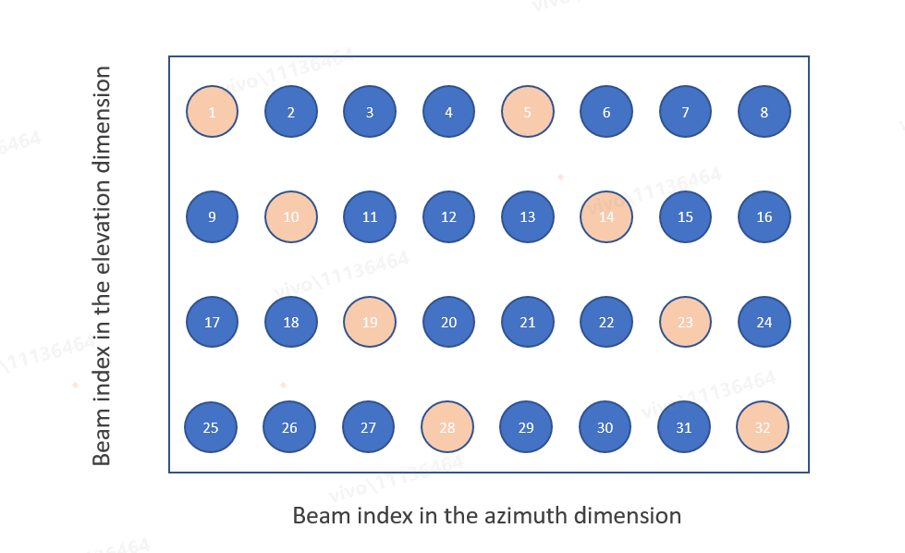
Azimuth and elevation angle ranges | 32 beams with grid of 4 elevation angles from (100°to 150°) and 8 azimuth angles from (-60°to 60°)  Note: here the 0 degree in Elevation refers to +Z axis
AoDs of Set A and Set B (°) | - Set A:  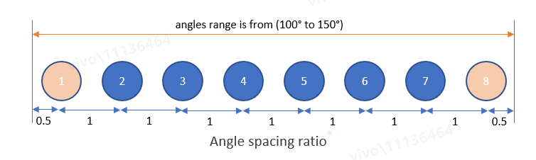  - 4 elevation DFT beams: [106.25, 118.75, 131.25, 143.75]  - 8 azimuth DFT beams: [-52.5, -37.5, -22.5, -7.5, 7.5, 22.5, 37.5, 52.5]  - Set B [(azimuth, elevation)]:  - [(-52.5, 143.75), (-37.5, 131.25), (-22.5, 118.75), (-7.5, 106.25), (7.5, 143.75), (22.5, 131.25), (37.5, 118.75), (52.5, 106.25)

Table 7 Beamforming characteristic of the BS pattern for System-Level simulation assumption in wide -to-narrow scenario
Parameter | Value
AoDs of Set A and Set B (°) | Set A (CSI-RS):  - 4 elevation DFT beams: [106.25, 118.75, 131.25, 143.75]  - 8 azimuth DFT beams: [-52.5, -37.5, -22.5, -7.5, 7.5, 22.5, 37.5, 52.5]  Set B (SSB):  - 2 elevation DFT beams: [112.5, 137.5]  - 4 azimuth DFT beams: [-45, -15, 15, 45]  Companies can use a subset of antenna elements to generate wider DFT beams for SSB. One of the options to generate setB beams is shown below. Other options to generate setB beams are not precluded.
BS Antenna Configuration and number of beams | For setA determination:  Use the setup from 38.843 Table 6.3.1-1  Antenna setup and port layouts at gNB: (4, 8, 2, 1, 1, 1, 1), (dV, dH) = (0.5, 0.5) λ  Number of CSI-RS beams: 32  For setB determination:  Use a subset of antenna elements, e.g., below.  Antenna setup and port layouts at gNB: (2, 4, 2, 1, 1, 1, 1), (dV, dH) = (0.5, 0.5) λ  Number of SSB beams: 8  Other options to generate setB beams are not precluded.

For the case of wide-to-narrow spatial beam prediction (SSB to CSI-RS), the simulation assumption in Table 7 can be the reference for the simulation assumption.

Simulation assumptions for RF error
The impact of RF errors should be considered. Following assumptions can be used to generate RF errors.
- Truncated Gaussian distribution under ±4.5 dB RF error (${μ=0, σ}^{2}$=4.5) is used
  - Each TX beam are Independent
  - 2Rx chains with independent RF error per chain (same distribution for each chain)

Reference model
For better alignment of the performance between companies, it would be better to perform simulations based on a reference model. The model description in Fig. 1 is an example of reference model for BM-case 1 performance evaluation, while it is not the intention to preclude other reference models.
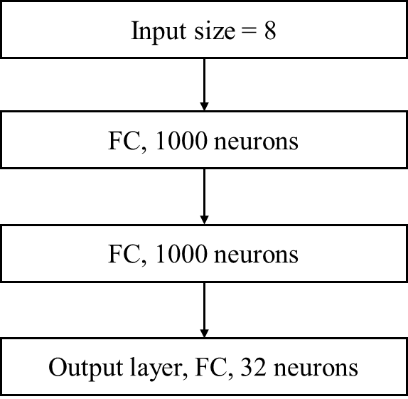
Fig. 1 Reference model description

Performance metrics
At least the following performance characteristics are to be provided
KPI 1: Beam prediction accuracy
- The successful rate for the correct prediction which is considered as maximum ground truth RSRP among top-K predicted beams is larger than the ground truth RSRP of the strongest genie-aided beam – x dB, where K=1,2,3,4,5, X= 0, 1, 2, 3dB
KPI 2: Absolute RSRP accuracy
- 90%-tile L1-RSRP difference between the predicted L1-RSRP of the 1st / 3rd / 5th strongest predicted beam(s) and the ground truth L1-RSRP of the same beams

Note 1: the ‘ground truth’ underlined refers to:
- Ideal value without consideration of measurement error (for Case 1 defined in clause 6)
- Measurement result with consideration of measurement error (for Case 3 defined in clause 6)
Note 2:
90%-tile L1-RSRP difference = max (abs (95%-tile L1-RSRP), abs (5%-tile L1-RSRP))

Simulation procedures
We provide the following procedures for companies to perform simulations to evaluate the impact of measurement error in both of following scenarios of BM prediction:
- Scenario 1: spatial domain prediction with 32 beams in Set A, Set B is subset of Set A and contains 8 beams for measurement.
- Scenario 2: Spatial domain prediction with 32 CSI-RS beams in Set A and 8 SSB beams in Set B
The simulated cases include:
- Case 1: No error will be considered in training dataset, model input during inference and ground-truth.

- Case 3: Error will be considered in training dataset, model input during inference and ground-truth.

For Case 1, the simulation procedure includes:
- Companies to generate ideal L1-RSRP dataset from the SLS assumption defined in Table 6 (for scenario 1), Table 7 (for scenario 2) and TR 38.843 Table 6.3.1-1.
- Use subset samples of the ideal dataset generated from the 1st step for training models.
- Filter UEs in the other subset samples of the ideal dataset (none overlap samples with the subset dataset in 2nd step) which SNR> -3dB (use this SNR range as the starting point) to derive the ideal dataset for inference
Note: UE distribution is 100% outdoor
- Use the ideal dataset for inference and to evaluate the performance metric assuming that the ground truth is without the measurement error

For Case 3, the simulation procedures include:
- Companies to generate ideal L1-RSRP dataset from the SLS assumption defined in Table 6 (for scenario 1), Table 7 (for scenario 2) and TR 38.843 Table 6.3.1-1.
- Use subset samples of the ideal dataset generated from the 1st step with added measurement error for training models (The same Alt of error as selected in Step 6).
- Filter UEs in the other subset samples of the ideal dataset (none overlap samples with the subset dataset in 2nd step) which SNR> -3dB (use this SNR range as the starting point) to derive the ideal dataset for inference.
Note: UE distribution is 100% outdoor
- Use the LLS simulation assumptions defined in Table 1-5 to generate L1-RSRP difference as the baseband errors.
- Use the Simulation assumptions for RF error defined in Clause 3 to generate RF errors.
- Add the measurement errors generated from LLS into the ideal SLS dataset to derive the dataset with measurement errors. The measurement errors will be:
  - Alt 1: Only baseband errors are included
  - Alt 2: Only RF errors are included
  - Alt 3: Both baseband errors and RF errors are included
- Use the dataset with measurement errors for inference and to evaluate the performance metric assuming that the ground truth is with the measurement error (The same Alt of error as selected in Step 6)

Dataset

7.1 Dataset sharing format
Companies are encouraged to share their own simulation dataset based on the following format:
Dataset format
Use NumPy for dataset sharing
Use npy – single array in each file

Data file format
- Dataset file format: N (samples) * Beam RSRPs per Rx beam (Set A Tx beams) * M (Rx beams).
Dataset should content following info
  - 1st dimension: Number of samples
  - 2nd dimension: Number of Set A Tx beams per Rx beam
  - 3rd dimension: Number of Rx beams
Note: Each element of the dataset will be a float32 real number
- Using the aligned beam pattern specified in Table 6 and Table 7, RSRPs of each beam in Set B can be obtained from RSRPs of each beam in Set A.

Note 1: Dataset files can be split into multiple sub-files to enable easier upload.
- Use the 2 digits for split files starting from 00, increment for each additional file.
- Split files and then archive each sub-file
Note 2: The full Dataset files from each company follows the ratio of [training samples, validation samples, testing samples] = [90%, 5%, 5%]

File naming scheme
- Folders for AI/ML data sharing and current WI/use case to be created under “RAN4 folder”
- Subfolder created for each meeting
- File naming scheme (dataset file)
  - a unique identifier for the company (4 characters – list to be maintained by RAN4 secretary, same as the identifier used in CSI compression)
  - meeting number
  - dataset can be split in multiple files – 2 digits
  - files to be compressed to zips and uploaded
Example for folder:
Folders to be created under https://www.3gpp.org/ftp/tsg_ran/WG4_Radio/
Folder for datasets: /Data_sharing/ NR_AIML_air/Beam/Datasets/R4_XXX
Example for dataset file:
VIV0R4_115_00.npy

7.2 Dataset parameter
Dataset size
The dataset size shall be greater than 100,000 if company uses its own dataset for simulation

References
- R4-2508081, Updated simulation assumptions for beam prediction, vivo, NTU, Nokia, Ericsson, Qualcomm, Xiaomi, Huawei, Hisilicon, Mediatek, OPPO, APPLE, Rohde & Schwarz, CATT, Samsung, Intel, ZTE Corporation, Sanechips, CAICT
- TR 38.843 Study on Artificial Intelligence (AI)/Machine Learning (ML) for NR air interface (Release 18)

